EE 316
Section 3
Pre Lab 07
By: Hannah Kelley
Characteristics of BJT and Amplification Behavior

Introduction:
This laboratory introduces the basic concepts and characteristics of bipolar junction transistors (BJTs), focusing on NPN transistors in a common-collector configuration. The experiment examines the relationship between base current, collector current, and collector-emitter voltage to better understand transistor behavior and operating characteristics.
Simulations and Results:
The circuit in Figure 1 was built and simulated in LTSpice. Figure 2 shows the LTSpice schematic. To get the simulation results in Table 1, V1 was kept constant at four different voltage values (4V, 6V, 8V, and 10V) while V2 was swept from 0-10V in increments of 0.1V. The characteristic curves in Figure 3 were then graphed using the V_{CE} and I_{C} values in Table 1. Table 2 shows the Q-point behavior for each characteristic curve and the midpoint biasing Q-point.
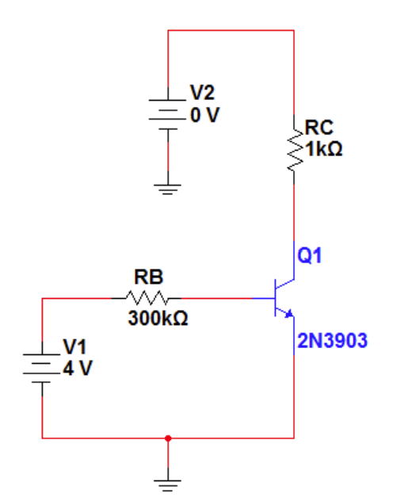
Figure #1: Common Collector Circuit Schematic (Lab Manual)
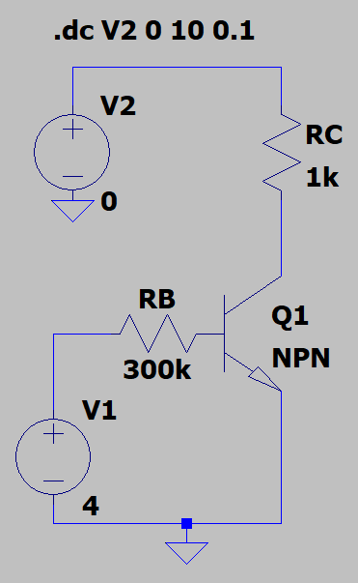
Figure #2: LTSpice Schematic (Common Collector Circuit)
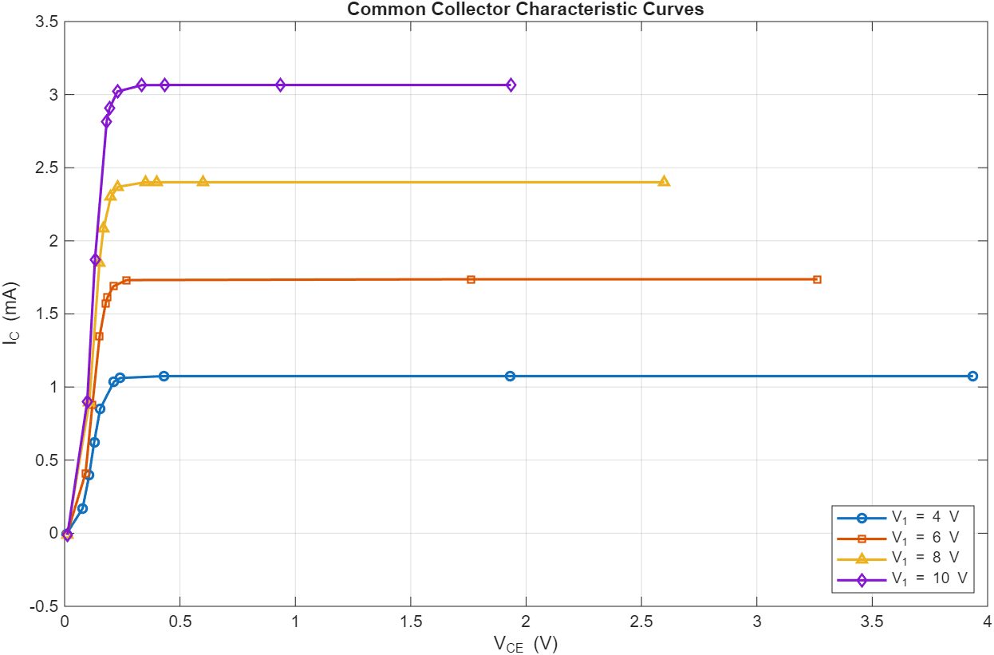
Figure #3: Common Collector Characteristic Curves
V₁ (V) | V₂ (V) | I_{B} (µA) | I_{C} (mA) | I_{E} (mA) | V_{CE} (V) | $$β$$
4 | 0 | 11.117079 | -0.007359 | -0.0037571 | 0.0073599 | -0.000662
4 | 0.25 | 10.899143 | 0.169282 | -0.1801830 | 0.0778308 | 0.015532
4 | 0.5 | 10.829636 | 0.395721 | -0.4065514 | 0.1062680 | 0.036541
4 | 0.75 | 10.792602 | 0.621101 | -0.6318938 | 0.1279331 | 0.057549
4 | 1 | 10.76553 | 0.849843 | -0.8606096 | 0.1539531 | 0.078941
4 | 1.25 | 10.749063 | 1.0369467 | -1.0476961 | 0.2139410 | 0.096469
4 | 1.3 | 10.747213 | 1.0617948 | -1.0745447 | 0.2410873 | 0.098797
4 | 1.5 | 10.746357 | 1.0746281 | -1.0853745 | 0.4311629 | 0.099999
4 | 3 | 10.746357 | 1.0746357 | -1.0853821 | 1.9292254 | 0.100000
4 | 5 | 10.746357 | 1.0746359 | -1.0853822 | 3.936947 | 0.100000
6 | 0 | 17.7361000 | -0.0096130 | -0.0081231 | 0.0096130 | -0.000542
6 | 0.5 | 17.4909000 | 0.4094280 | -0.4269180 | 0.0905744 | 0.023408
6 | 1 | 17.4287000 | 0.8794090 | -0.8968370 | 0.1205910 | 0.050458
6 | 1.5 | 17.3930000 | 1.3482200 | -1.3656100 | 0.1517810 | 0.077515
6 | 1.75 | 17.3800000 | 1.5721500 | -1.5895300 | 0.1778330 | 0.090457
6 | 1.8 | 17.3778000 | 1.6139300 | -1.6313100 | 0.1860300 | 0.092873
6 | 1.9 | 17.3740000 | 1.6886600 | -1.7060400 | 0.2113360 | 0.097195
6 | 2 | 17.3719000 | 1.7316700 | -1.7490400 | 0.2683260 | 0.099682
6 | 3.5 | 17.3716000 | 1.7371600 | -1.7545300 | 1.7628400 | 0.100000
6 | 5 | 17.3716000 | 1.7371600 | -1.7545300 | 3.2628400 | 0.100000
8 | 0 | 24.3704000 | -0.0111156 | -0.0132548 | 0.0111156 | -0.000456
8 | 1 | 24.0928000 | 0.8932120 | -0.9173050 | 0.1067880 | 0.037074
8 | 2 | 24.0324000 | 1.8490600 | -1.8730900 | 0.1509420 | 0.076940
8 | 2.25 | 24.0224000 | 2.0818900 | -2.1059100 | 0.1681090 | 0.086665
8 | 2.5 | 24.0140000 | 2.2996900 | -2.3237100 | 0.2002450 | 0.095765
8 | 2.6 | 24.0115000 | 2.3690900 | -2.3931000 | 0.2309130 | 0.098665
8 | 2.75 | 24.0104000 | 2.4007000 | -2.4247200 | 0.3492820 | 0.099986
8 | 2.8 | 24.0104000 | 2.4009900 | -2.4250000 | 0.3990110 | 0.099998
8 | 3 | 24.0104000 | 2.4010400 | -2.4250500 | 0.5989620 | 0.100000
8 | 5 | 24.0104000 | 2.4010400 | -2.4250500 | 2.5989600 | 0.100000
10 | 0 | 31.0128000 | -0.0121750 | -0.0188378 | 0.0121750 | -0.000393
10 | 1 | 30.7575000 | 0.9019340 | -0.9326920 | 0.0980658 | 0.029324
10 | 2 | 30.6976000 | 1.8686200 | -1.8993200 | 0.1313790 | 0.060872
10 | 3 | 30.6631000 | 2.8175500 | -2.8482200 | 0.1824420 | 0.091887
10 | 3.1 | 30.6605000 | 2.9054600 | -2.9361200 | 0.1945240 | 0.094762
10 | 3.25 | 30.6572000 | 3.0212500 | -3.0519100 | 0.2287460 | 0.098549
10 | 3.4 | 30.6560000 | 3.0648600 | -3.0955200 | 0.3350700 | 0.099976
10 | 3.5 | 30.6560000 | 3.0655800 | -3.0962400 | 0.4344180 | 0.099999
10 | 4 | 30.6560000 | 3.0656000 | -3.0962500 | 0.9344020 | 0.100000
10 | 5 | 30.6560000 | 3.0656000 | -3.0962500 | 1.9344000 | 0.100000
Table #1: Common Collector Simulation Results

 | I_{BQ} (µA) | I_{CQ} (mA) | V_{CEQ} (V) | DC Gain
V₁ = 4V | 10.746 | 1.075 | 3.937 | 100
V₁ = 6V | 17.372 | 1.737 | 3.263 | 100
V₁ = 8V | 24.010 | 2.401 | 2.599 | 100
V₁ = 10V | 30.656 | 3.066 | 1.934 | 100
Q_{mid} | 20.791 | 2.070 | 2.936 | 100
Table #2: Common Collector Q-Point Behavior and Midpoint Biasing Q-Point

