EE 316
Section 3
Pre Lab 08
By: Hannah Kelley
Characteristics of BJT and Amplification Behavior
Introduction:
The purpose of this laboratory is to investigate the characteristics and performance of a small-signal bipolar junction transistor (BJT) amplifier. Using LTSpice, the circuit is simulated to analyze its frequency response, output voltage, and gain. Transient analysis is also performed to identify output clipping at higher frequencies and evaluate circuit modifications intended to reduce distortion.
Simulations and Results:
The small signal BJT amplifier in Figure 1 was built and simulated in LTSpice. Figure 2 shows the BJT amplifier in LTSpice. A 500 mV peak-to-peak signal was applied to the circuit over a range of frequencies from 0.1Hz to 1MHz. The resulting Bode plot is shown in Figure 3. A selection of the output voltage and gain for a subset of frequencies is recorded in Table 1.
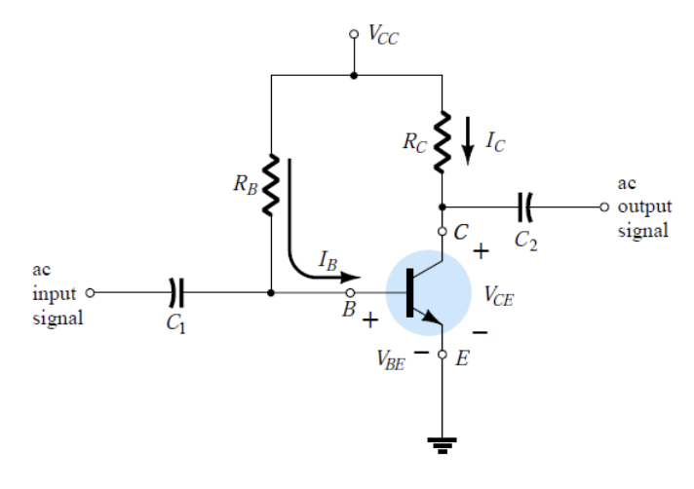
Figure #1: BJT Amplifier (Lab Manual)
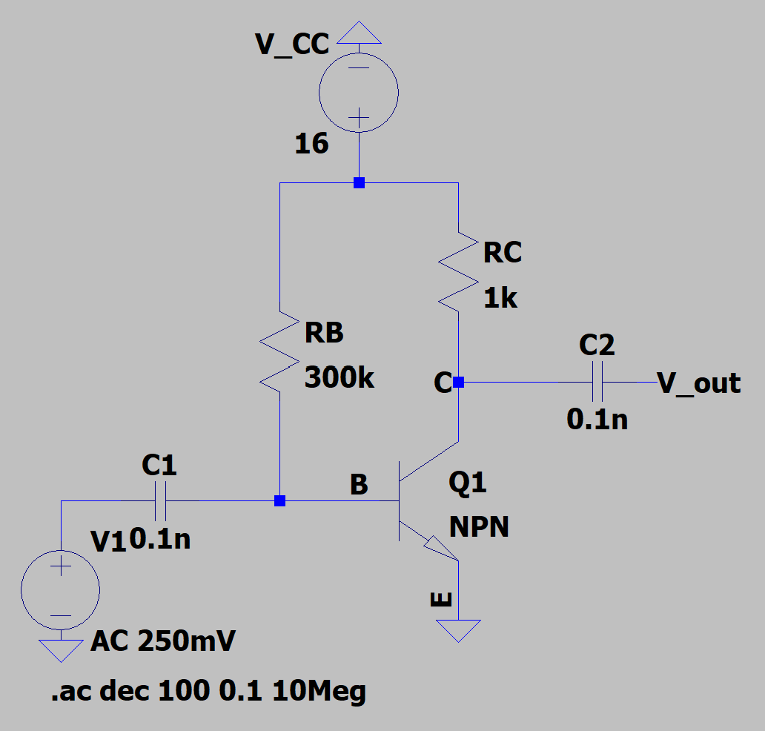
Figure #2: BJT Amplifier Circuit (LTSpice)
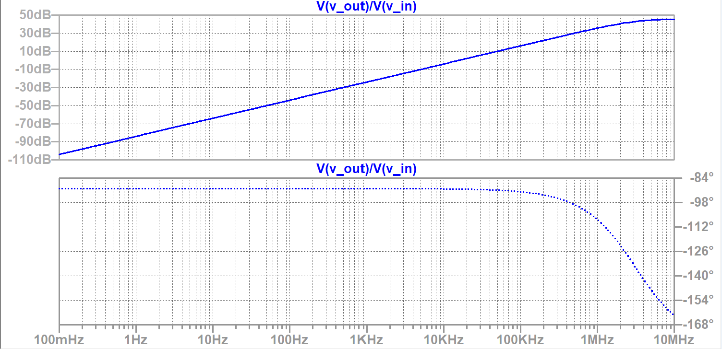
Figure #3: BJT Amplifier Bode Plot
Frequency | V_{out} (V) | Gain (dB)
10 Hz | 0.00064 | -63.8983
30 Hz | 0.00192 | -54.3559
60 Hz | 0.00383 | -48.3353
100 Hz | 0.00638 | -43.8983
200 Hz | 0.01277 | -37.8777
500 Hz | 0.03192 | -29.9189
1 kHz | 0.06384 | -23.8984
2kHz | 0.12767 | -17.8781
5 kHz | 0.31911 | -9.92114
10 kHz | 0.63773 | -3.90721
15 kHz | 0.95538 | -0.396496
20 kHz | 1.27157 | 2.08679
50 kHz | 3.11309 | 9.86382
75 kHz | 4.53336 | 13.1284
100 kHz | 5.81514 | 15.2912
150 kHz | 7.92018 | 17.9747
200 kHz | 9.46204 | 19.5197
500 kHz | 12.89258 | 22.2068
750 kHz | 13.51964 | 22.6193
1 MHz | 13.76179 | 22.7735
1.5 MHz | 13.94232 | 22.8867
2 MHz | 14.00683 | 22.9268
Table #1: Simulation Output Voltage and Gain
Figures 4 and 5 show the transient output of the circuit at 10 Hz and 20 MHz respectively. Figure 5 shows significant clipping as the output waveform reaches 16 V_{pk-pk}. After running the simulation at a variety of frequencies, the clipping seems to first occur at around 400 kHz, as shown in Figure 6.
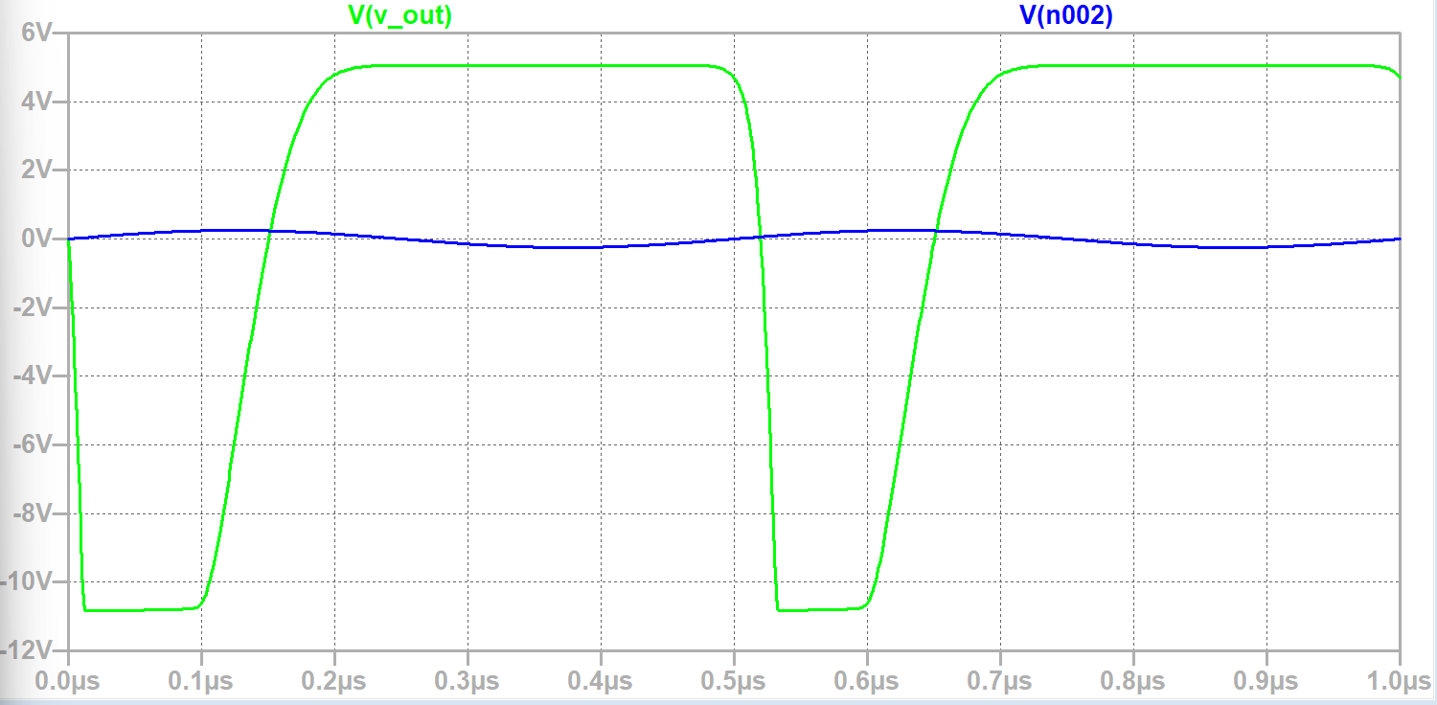
Figure #4: Transient Output at 10 Hz
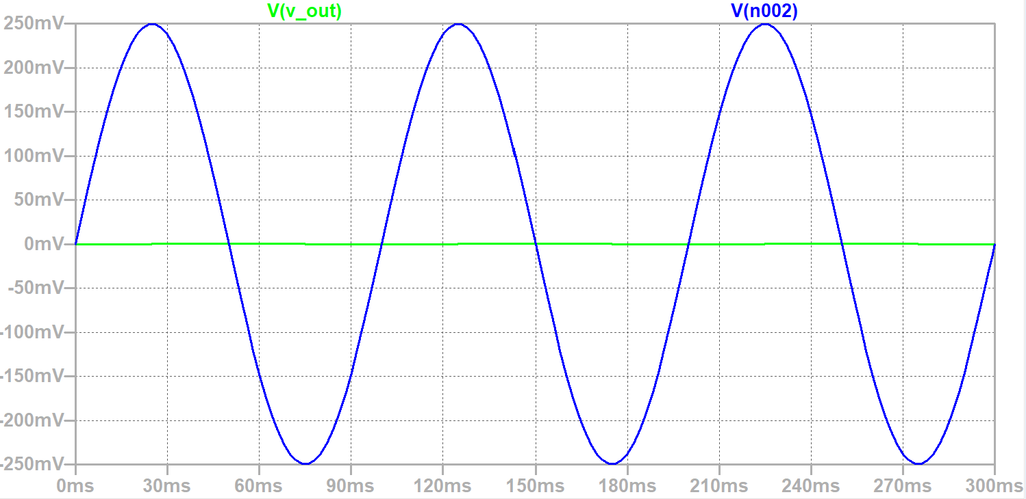
Figure #5: Transient Output at 2 MHz
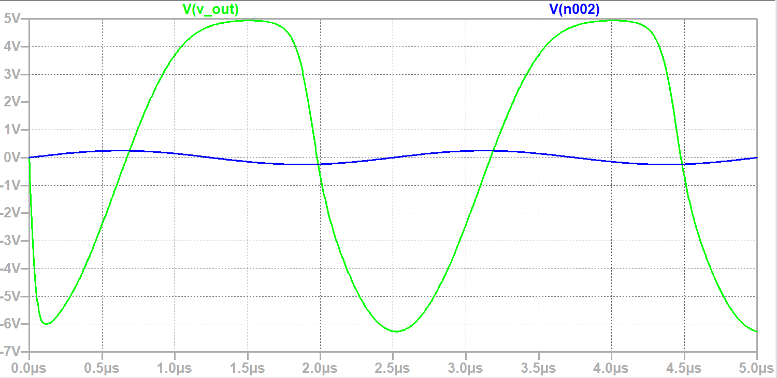
Figure #6: Transient Output at 400 kHz
To reduce this clipping, R_{B} was halved and C₁ was reduced by 0.01 uF. The modified circuit is shown in Figure 7. The transient output of the modified circuit at 2 MHz is shown in Figure 8.
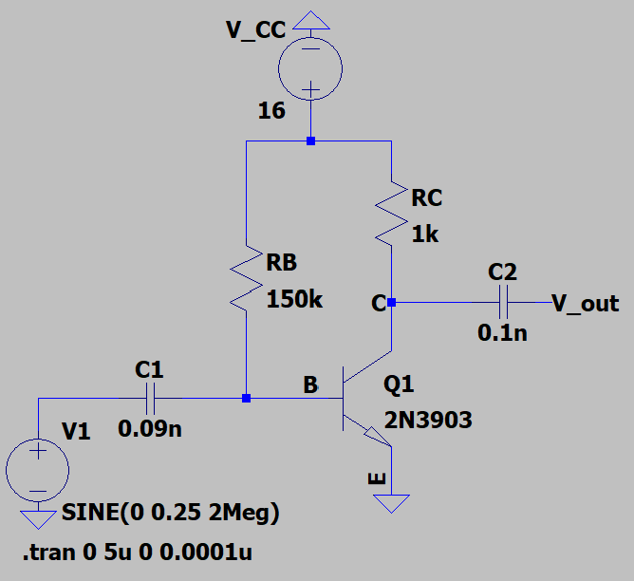
Figure #7: Modified BJT Amplifier Circuit (LTSpice)
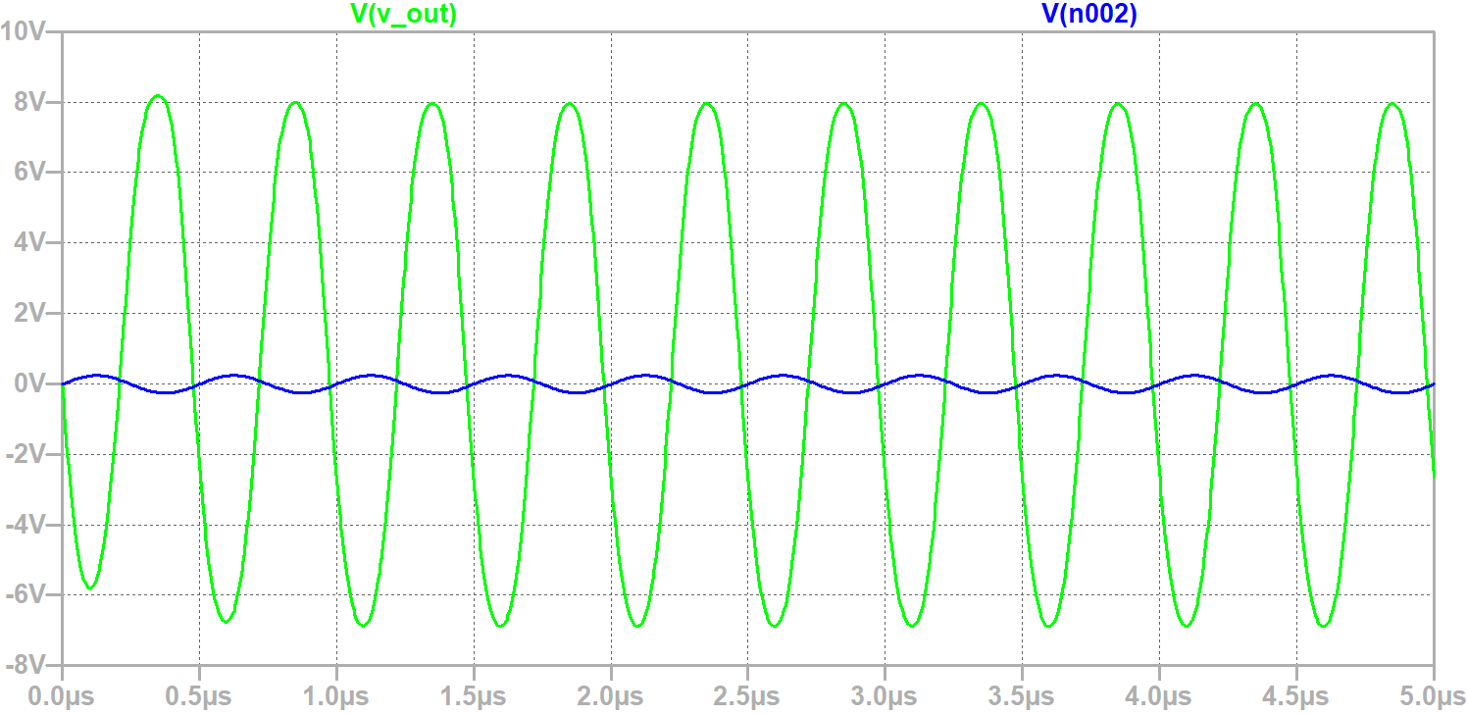
Figure #8: Modified Circuit Transient Output at 2 MHz

