EE 316
Section 3
Pre Lab 01
By: Hannah Kelley
Inverting and Non-Inverting Op Amps

Introduction:
This laboratory investigates inverting and non-inverting operational amplifier (op-amp) configurations using both DC and AC inputs. The lab provides experience analyzing and simulating op-amp circuits while examining closed-loop voltage gain and the effects of load resistance on output voltage.
Simulations and Results:
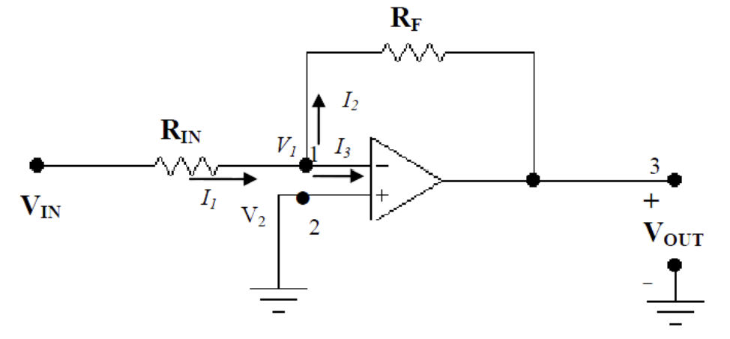
Figure #1: Inverting Op-Amp Schematic from Lab Manual
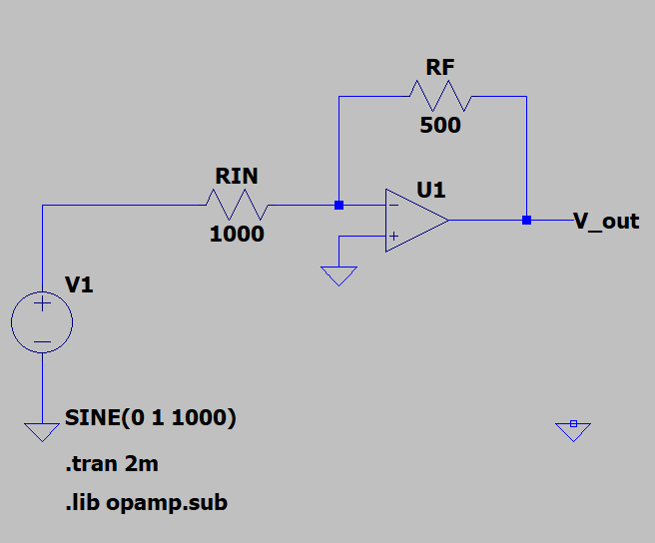
Figure #2: Inverting Op-Amp with $R_{F}=500$ Ohms (LTSpice)
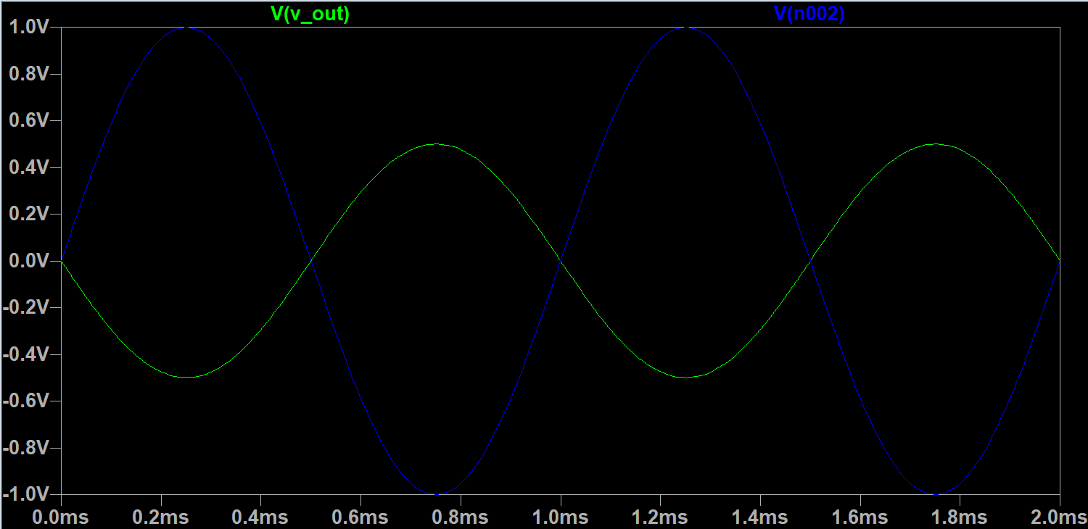
Figure #3: Inverting Op-Amp Oscilloscope Output at $R_{F}=500$ Ohms ($V_{out}$ and $V_{in}$)
$V_{in_{PP}}$ (V) | $R_{IN}$ ($kΩ$) | $R_{F}$ ($kΩ$) | $V_{{out}_{PP}}$ (V) O-scope | Gain (V/V) | $V_{out_{PP}}$ (V) DMM
2 | 1 | 0.5 | 1 | -0.5 | 0.354
2 | 1 | 1 | 2 | -1 | 0.707
2 | 1 | 2 | 4 | -2 | 1.414
2 | 1 | 3 | 6 | -3 | 2.122
2 | 1 | 4 | 8 | -4 | 2.829
Table #1: Inverting Amplifier Simulation Results
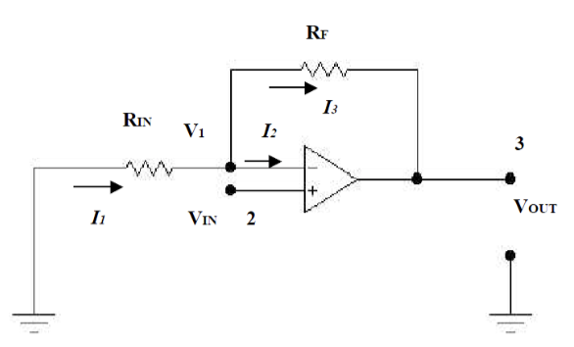
Figure #4: Non- Inverting Op-Amp Schematic from Lab Manual
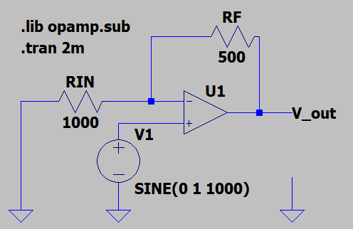
Figure #5: Non-Inverting Op-Amp with $R_{F}=500$ Ohms (LTSpice)
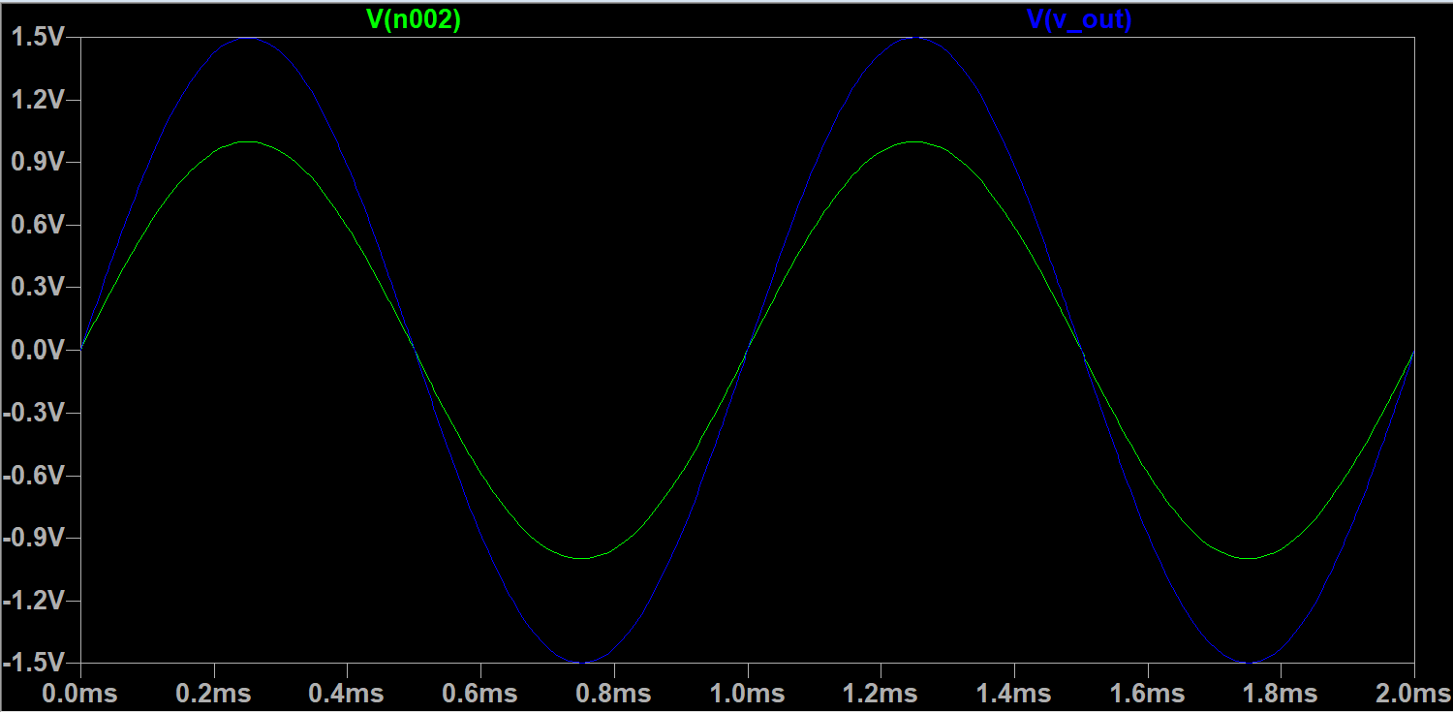
Figure #6: Non-Inverting Op-Amp Oscilloscope Output at $R_{F}=500$ Ohms ($V_{out}$ and $V_{in}$)
$V_{in_{PP}}$ (V) | $R_{IN}$ ($kΩ$) | $R_{F}$ ($kΩ$) | $V_{{out}_{PP}}$ (V) O-scope | Gain (V/V) | $V_{out_{PP}}$ (V) DMM
2 | 1 | 0.5 | 3 | 1.5 | 2.121
2 | 1 | 1 | 4 | 2 | 2.828
2 | 1 | 2 | 6 | 3 | 4.242
2 | 1 | 3 | 8 | 4 | 5.657
2 | 1 | 4 | 10 | 5 | 7.071
Table #2: Non-Inverting Amplifier Simulation Results

