EE 316
Section 3
Lab 07
By: Hannah Kelley
Characteristics of BJT and Amplification Behavior

Introduction:
This laboratory introduces the basic concepts and characteristics of bipolar junction transistors (BJTs), focusing on NPN transistors in a common-collector configuration. The experiment examines the relationship between base current, collector current, and collector-emitter voltage to better understand transistor behavior and operating characteristics.
Simulations and Results:
The circuit in Figure 1 was built and simulated in LTSpice. Figure 2 shows the LTSpice schematic. To get the simulation results in Table 1, V1 was kept constant at four different voltage values (4V, 6V, 8V, and 10V) while V2 was swept from 0-10V in increments of 0.1V. The characteristic curves in Figure 3 were then graphed using the V_{CE} and I_{C} values in Table 1. Table 2 shows the Q-point behavior for each characteristic curve and the midpoint biasing Q-point.
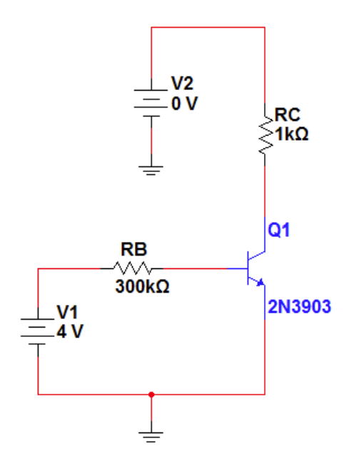
Figure #1: Common Collector Circuit Schematic (Lab Manual)
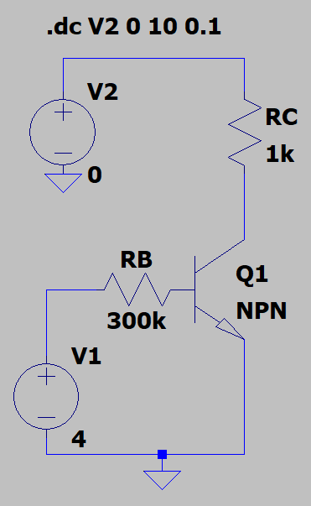
Figure #2: LTSpice Schematic (Common Collector Circuit)
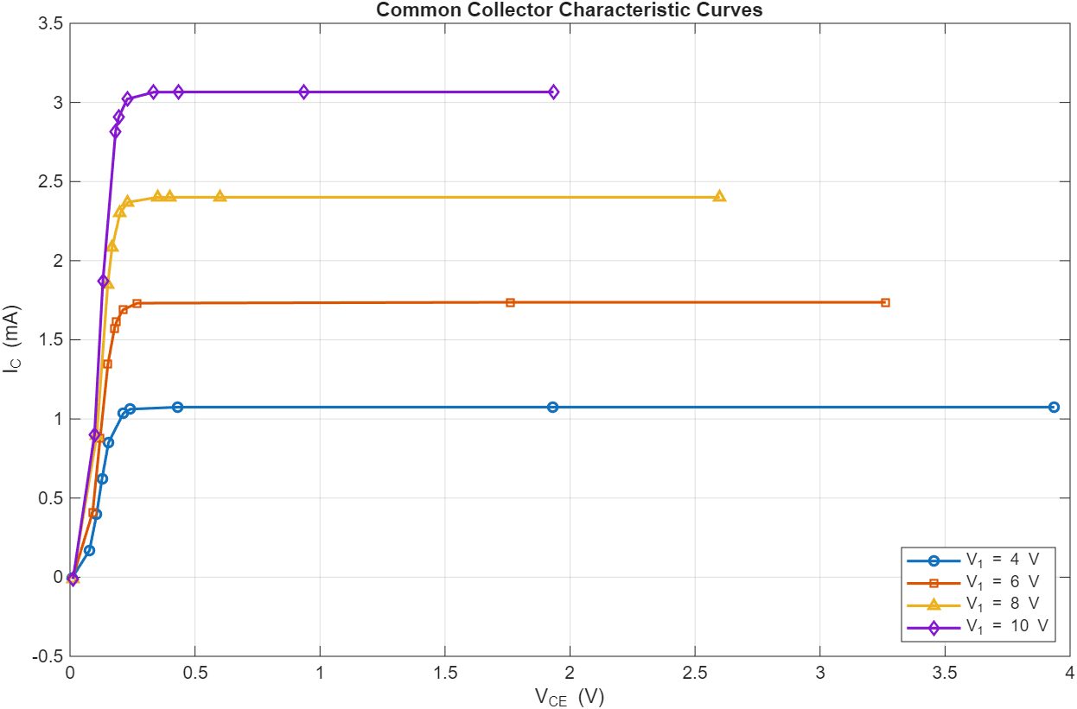
Figure #3: Common Collector Characteristic Curves
V₁ (V) | V₂ (V) | I_{B} (µA) | I_{C} (mA) | I_{E} (mA) | V_{CE} (V) | $$β$$
4 | 0 | 11.117079 | -0.007359 | -0.0037571 | 0.0073599 | -0.000662
4 | 0.25 | 10.899143 | 0.169282 | -0.1801830 | 0.0778308 | 0.015532
4 | 0.5 | 10.829636 | 0.395721 | -0.4065514 | 0.1062680 | 0.036541
4 | 0.75 | 10.792602 | 0.621101 | -0.6318938 | 0.1279331 | 0.057549
4 | 1 | 10.76553 | 0.849843 | -0.8606096 | 0.1539531 | 0.078941
4 | 1.25 | 10.749063 | 1.0369467 | -1.0476961 | 0.2139410 | 0.096469
4 | 1.3 | 10.747213 | 1.0617948 | -1.0745447 | 0.2410873 | 0.098797
4 | 1.5 | 10.746357 | 1.0746281 | -1.0853745 | 0.4311629 | 0.099999
4 | 3 | 10.746357 | 1.0746357 | -1.0853821 | 1.9292254 | 0.100000
4 | 5 | 10.746357 | 1.0746359 | -1.0853822 | 3.936947 | 0.100000
6 | 0 | 17.7361000 | -0.0096130 | -0.0081231 | 0.0096130 | -0.000542
6 | 0.5 | 17.4909000 | 0.4094280 | -0.4269180 | 0.0905744 | 0.023408
6 | 1 | 17.4287000 | 0.8794090 | -0.8968370 | 0.1205910 | 0.050458
6 | 1.5 | 17.3930000 | 1.3482200 | -1.3656100 | 0.1517810 | 0.077515
6 | 1.75 | 17.3800000 | 1.5721500 | -1.5895300 | 0.1778330 | 0.090457
6 | 1.8 | 17.3778000 | 1.6139300 | -1.6313100 | 0.1860300 | 0.092873
6 | 1.9 | 17.3740000 | 1.6886600 | -1.7060400 | 0.2113360 | 0.097195
6 | 2 | 17.3719000 | 1.7316700 | -1.7490400 | 0.2683260 | 0.099682
6 | 3.5 | 17.3716000 | 1.7371600 | -1.7545300 | 1.7628400 | 0.100000
6 | 5 | 17.3716000 | 1.7371600 | -1.7545300 | 3.2628400 | 0.100000
8 | 0 | 24.3704000 | -0.0111156 | -0.0132548 | 0.0111156 | -0.000456
8 | 1 | 24.0928000 | 0.8932120 | -0.9173050 | 0.1067880 | 0.037074
8 | 2 | 24.0324000 | 1.8490600 | -1.8730900 | 0.1509420 | 0.076940
8 | 2.25 | 24.0224000 | 2.0818900 | -2.1059100 | 0.1681090 | 0.086665
8 | 2.5 | 24.0140000 | 2.2996900 | -2.3237100 | 0.2002450 | 0.095765
8 | 2.6 | 24.0115000 | 2.3690900 | -2.3931000 | 0.2309130 | 0.098665
8 | 2.75 | 24.0104000 | 2.4007000 | -2.4247200 | 0.3492820 | 0.099986
8 | 2.8 | 24.0104000 | 2.4009900 | -2.4250000 | 0.3990110 | 0.099998
8 | 3 | 24.0104000 | 2.4010400 | -2.4250500 | 0.5989620 | 0.100000
8 | 5 | 24.0104000 | 2.4010400 | -2.4250500 | 2.5989600 | 0.100000
10 | 0 | 31.0128000 | -0.0121750 | -0.0188378 | 0.0121750 | -0.000393
10 | 1 | 30.7575000 | 0.9019340 | -0.9326920 | 0.0980658 | 0.029324
10 | 2 | 30.6976000 | 1.8686200 | -1.8993200 | 0.1313790 | 0.060872
10 | 3 | 30.6631000 | 2.8175500 | -2.8482200 | 0.1824420 | 0.091887
10 | 3.1 | 30.6605000 | 2.9054600 | -2.9361200 | 0.1945240 | 0.094762
10 | 3.25 | 30.6572000 | 3.0212500 | -3.0519100 | 0.2287460 | 0.098549
10 | 3.4 | 30.6560000 | 3.0648600 | -3.0955200 | 0.3350700 | 0.099976
10 | 3.5 | 30.6560000 | 3.0655800 | -3.0962400 | 0.4344180 | 0.099999
10 | 4 | 30.6560000 | 3.0656000 | -3.0962500 | 0.9344020 | 0.100000
10 | 5 | 30.6560000 | 3.0656000 | -3.0962500 | 1.9344000 | 0.100000
Table #1: Common Collector Simulation Results

 | I_{BQ} (µA) | I_{CQ} (mA) | V_{CEQ} (V) | DC Gain
V₁ = 4V | 10.746 | 1.075 | 3.937 | 100
V₁ = 6V | 17.372 | 1.737 | 3.263 | 100
V₁ = 8V | 24.010 | 2.401 | 2.599 | 100
V₁ = 10V | 30.656 | 3.066 | 1.934 | 100
Q_{mid} | 20.791 | 2.070 | 2.936 | 100
Table #2: Common Collector Simulation Q-Point Behavior and Midpoint Biasing
Experimental Setup and Results:
The circuit in Figure 1 was built using a breadboard, a BJT, and resistors. A picture of the experimental setup can be found in Figure 4. The I_{B}, I_{C}, I_{E}, V_{CE}, and β values were measured using WaveGen for varying values of V₁ and V₂ and recorded in Table 3. Figure 5 shows the characteristic curves for each V₁ and V₂. Table 4 shows the Q-Point behavior and midpoint biasing Q-point for the circuit.
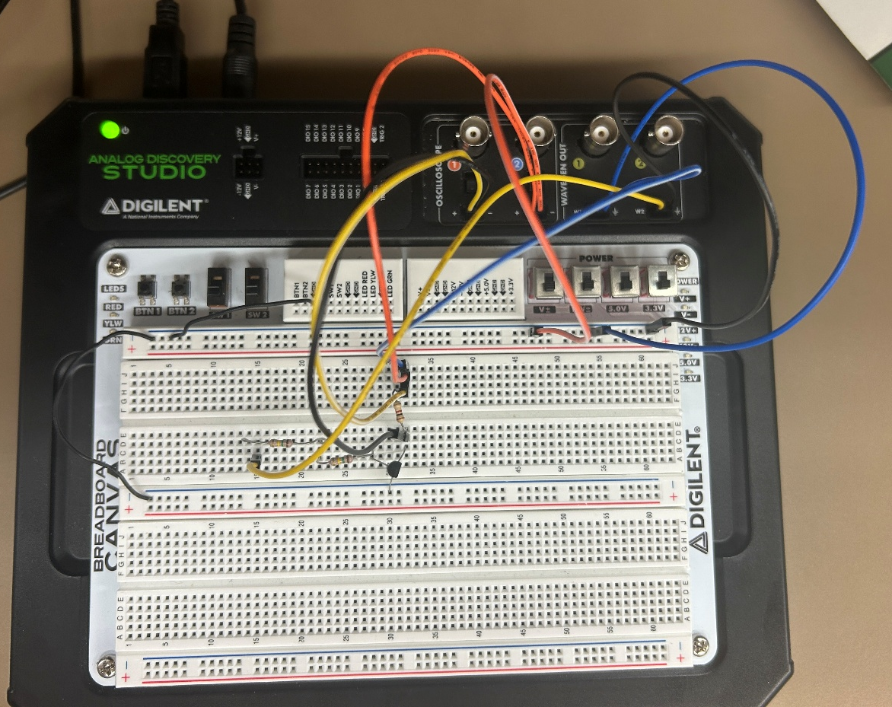
Figure #4: Common Collector Experimental Setup

V₁ (V) | V₂ (V) | I_{B} (µA) | I_{C} (mA) | I_{E} (mA) | V_{CE} (V) | $$β$$
4 | 0 | -0.01 | -0.01 | 0.01 | 0 | -0.01
4 | 0.25 | 10.92 | -0.17 | 0.08 | 0.02 | 10.92
4 | 0.5 | 10.87 | -0.39 | 0.11 | 0.04 | 10.87
4 | 0.75 | 10.81 | -0.61 | 0.13 | 0.06 | 10.81
4 | 1 | 10.79 | -0.83 | 0.15 | 0.08 | 10.79
4 | 1.25 | 10.83 | -1.02 | 0.21 | 0.1 | 10.83
4 | 1.3 | 10.81 | -1.05 | 0.24 | 0.1 | 10.81
4 | 1.5 | 10.8 | -1.06 | 0.43 | 0.1 | 10.8
4 | 3 | 10.82 | -1.06 | 1.91 | 0.1 | 10.82
4 | 5 | 10.81 | -1.06 | 3.92 | 0.1 | 10.81
6 | 0 | -0.01 | -0.01 | 0.01 | 0 | -0.01
6 | 0.5 | 17.51 | -0.42 | 0.09 | 0.02 | 17.51
6 | 1 | 17.48 | -0.88 | 0.12 | 0.05 | 17.48
6 | 1.5 | 17.43 | -1.35 | 0.15 | 0.08 | 17.43
6 | 1.75 | 17.42 | -1.56 | 0.18 | 0.09 | 17.42
6 | 1.8 | 17.41 | -1.6 | 0.19 | 0.09 | 17.41
6 | 1.9 | 17.4 | -1.67 | 0.21 | 0.1 | 17.4
6 | 2 | 17.39 | -1.72 | 0.27 | 0.1 | 17.39
6 | 3.5 | 17.41 | -1.72 | 1.75 | 0.1 | 17.41
6 | 5 | 17.4 | -1.73 | 3.25 | 0.1 | 17.4
8 | 0 | -0.01 | -0.01 | 0.01 | 0 | -0.01
8 | 1 | 24.12 | -0.9 | 0.11 | 0.04 | 24.12
8 | 2 | 24.08 | -1.83 | 0.15 | 0.08 | 24.08
8 | 2.25 | 24.05 | -2.06 | 0.17 | 0.09 | 24.05
8 | 2.5 | 24.03 | -2.28 | 0.2 | 0.1 | 24.03
8 | 2.6 | 24.01 | -2.35 | 0.23 | 0.1 | 24.01
8 | 2.75 | 24.02 | -2.38 | 0.35 | 0.1 | 24.02
8 | 2.8 | 24.02 | -2.38 | 0.4 | 0.1 | 24.02
8 | 3 | 24.03 | -2.39 | 0.6 | 0.1 | 24.03
8 | 5 | 24.02 | -2.39 | 2.58 | 0.1 | 24.02
10 | 0 | -0.01 | -0.02 | 0.01 | 0 | -0.01
10 | 1 | 30.78 | -0.92 | 0.1 | 0.03 | 30.78
10 | 2 | 30.72 | -1.85 | 0.13 | 0.06 | 30.72
10 | 3 | 30.68 | -2.81 | 0.18 | 0.09 | 30.68
10 | 3.1 | 30.69 | -2.89 | 0.2 | 0.09 | 30.69
10 | 3.25 | 30.67 | -3.01 | 0.23 | 0.1 | 30.67
10 | 3.4 | 30.65 | -3.12 | 0.26 | 0.1 | 30.65
10 | 3.5 | 30.66 | -3.14 | 0.36 | 0.1 | 30.66
10 | 4 | 30.65 | -3.15 | 0.85 | 0.1 | 30.65
10 | 5 | 30.66 | -3.15 | 1.84 | 0.1 | 30.66
Table #3: Common Collector Experimental Results

 | I_{BQ} (µA) | I_{CQ} (mA) | V_{CEQ} (V) | DC Gain
V1 = 4 V | 10.851 | 1.039 | 0.215 | 95.77
V1 = 6 V | 17.482 | 1.571 | 0.179 | 89.92
V1 = 8 V | 24.117 | 2.298 | 0.202 | 95.32
V1 = 10 V | 30.754 | 3.024 | 0.230 | 98.33
Q_{mid} | 20.453 | 1.809 | 0.206 | 88.44
Table #4: Common Collector Experimental Q-Point Behavior and Midpoint Biasing
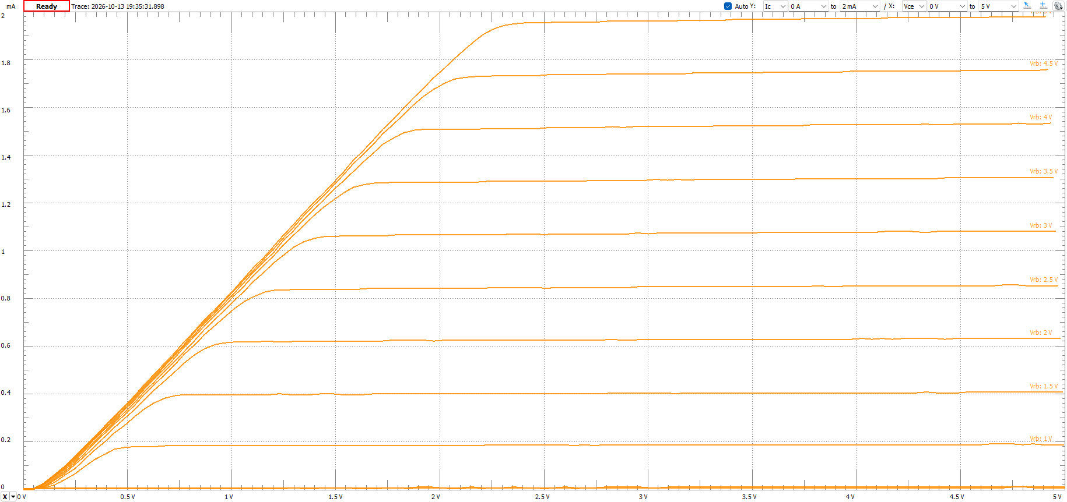
Figure #5: Experimental Characteristic Curves
Discussion:
The simulation and experimental results match well. The characteristic curves in Figures 3 and 5 follow the same curves, with the experimental curves having more definition. It is important to note that the curves in Figure 5 were limited to a range of 0 to 5 V due to the limitations of the lab breadboard and WaveForms software. Table 5 shows the percent errors for I_{B}, I_{C}, I_{E}, V_{CE}, and β. The measured currents and gain match simulation closely (under 10.5% error), The large percent errors (85% and greater) occur when the expected values are close to zero, making the differences seem larger than they are. That Table 6 shows the percent errors for the biasing characteristics. The percent errors are generally very good at under 10.5%. The V_{CEQ} percent errors are much higher due to the saturation point of the physical resistor operating much higher than the simulation.

V₁ (V) | V₂ (V) | I_{B} (µA) | I_{C} (mA) | I_{E} (mA) | V_{CE} (V) | $$β$$
4 | 0 | 99.91% | 35.89% | 35.87% | 100.00% | 99.91%
4 | 0.25 | 0.19% | 0.42% | 2.79% | 28.77% | 0.19%
4 | 0.5 | 0.37% | 1.45% | 3.51% | 9.47% | 0.37%
4 | 0.75 | 0.16% | 1.79% | 1.62% | 4.26% | 0.16%
4 | 1 | 0.23% | 2.33% | 2.57% | 1.34% | 0.23%
4 | 1.25 | 0.75% | 1.63% | 1.84% | 3.66% | 0.75%
4 | 1.3 | 0.58% | 1.11% | 0.45% | 1.22% | 0.58%
4 | 1.5 | 0.50% | 1.36% | 0.27% | 0.00% | 0.50%
4 | 3 | 0.69% | 1.36% | 1.00% | 0.00% | 0.69%
4 | 5 | 0.59% | 1.36% | 0.43% | 0.00% | 0.59%
6 | 0 | 99.94% | 4.03% | 4.03% | 100.00% | 99.94%
6 | 0.5 | 0.11% | 2.58% | 0.63% | 14.56% | 0.11%
6 | 1 | 0.29% | 0.07% | 0.49% | 0.91% | 0.29%
6 | 1.5 | 0.21% | 0.13% | 1.17% | 3.21% | 0.21%
6 | 1.75 | 0.23% | 0.77% | 1.22% | 0.51% | 0.23%
6 | 1.8 | 0.19% | 0.86% | 2.13% | 3.09% | 0.19%
6 | 1.9 | 0.15% | 1.11% | 0.63% | 2.89% | 0.15%
6 | 2 | 0.10% | 0.67% | 0.62% | 0.32% | 0.10%
6 | 3.5 | 0.22% | 0.99% | 0.73% | 0.00% | 0.22%
6 | 5 | 0.16% | 0.41% | 0.39% | 0.00% | 0.16%
8 | 0 | 99.96% | 10.04% | 10.04% | 100.00% | 99.96%
8 | 1 | 0.11% | 0.76% | 3.01% | 7.89% | 0.11%
8 | 2 | 0.20% | 1.03% | 0.62% | 3.98% | 0.20%
8 | 2.25 | 0.11% | 1.05% | 1.12% | 3.85% | 0.11%
8 | 2.5 | 0.07% | 0.86% | 0.12% | 4.42% | 0.07%
8 | 2.6 | 0.01% | 0.81% | 0.40% | 1.35% | 0.01%
8 | 2.75 | 0.04% | 0.86% | 0.21% | 0.01% | 0.04%
8 | 2.8 | 0.04% | 0.87% | 0.25% | 0.00% | 0.04%
8 | 3 | 0.08% | 0.46% | 0.17% | 0.00% | 0.08%
8 | 5 | 0.04% | 0.46% | 0.73% | 0.00% | 0.04%
10 | 0 | 99.97% | 64.27% | 17.86% | 100.00% | 99.97%
10 | 1 | 0.07% | 2.00% | 1.97% | 2.31% | 0.07%
10 | 2 | 0.07% | 1.00% | 1.05% | 1.43% | 0.07%
10 | 3 | 0.06% | 0.27% | 1.34% | 2.05% | 0.06%
10 | 3.1 | 0.10% | 0.53% | 2.82% | 5.03% | 0.10%
10 | 3.25 | 0.04% | 0.37% | 0.55% | 1.47% | 0.04%
10 | 3.4 | 0.02% | 1.80% | 22.40% | 0.02% | 0.02%
10 | 3.5 | 0.01% | 2.43% | 17.13% | 0.00% | 0.01%
10 | 4 | 0.02% | 2.75% | 9.03% | 0.00% | 0.02%
10 | 5 | 0.01% | 2.75% | 4.88% | 0.00% | 0.01%
Table #5: Common Collector Percent Errors

 | I_{BQ} (µA) | I_{CQ} (mA) | V_{CEQ} (V) | DC Gain
V1 = 4 V | 0.78% | 5.12% | 94.67% | 5.82%
V1 = 6 V | 0.28% | 10.19% | 94.48% | 10.45%
V1 = 8 V | 0.08% | 5.04% | 92.30% | 5.12%
V1 = 10 V | 0.05% | 1.83% | 88.11% | 1.86%
Q_{mid} | 0.25% | 10.14% | 92.85% | 10.32%
Table #4: Common Collector Experimental Q-Point Behavior and Midpoint Biasing
Conclusion:
In conclusion, this lab explored the characteristics of NPN bipolar junction transistors (BJTs) in a common-collector configuration. The relationship between base current, collector current, and collector-emitter voltage was examined to better understand transistor behavior and operating conditions. By analyzing these relationships, the experiment demonstrated how changes in current and voltage affect transistor operation. The results also helped illustrate the importance of selecting an appropriate operating point and understanding transistor characteristics when designing and analyzing electronic circuits.

