EE 316
Section 3
Lab 08
By: Hannah Kelley
Characteristics of BJT and Amplification Behavior
Introduction:
The purpose of this laboratory is to investigate the characteristics and performance of a small-signal bipolar junction transistor (BJT) amplifier. Using LTSpice, the circuit is simulated to analyze its frequency response, output voltage, and gain. Transient analysis is also performed to identify output clipping at higher frequencies and evaluate circuit modifications intended to reduce distortion.
Simulations and Results:
The small signal BJT amplifier in Figure 1 was built and simulated in LTSpice. Figure 2 shows the BJT amplifier in LTSpice. A 500 mV peak-to-peak signal was applied to the circuit over a range of frequencies from 0.1Hz to 1MHz. The resulting Bode plot is shown in Figure 3. A selection of the output voltage and gain for a subset of frequencies is recorded in Table 1.
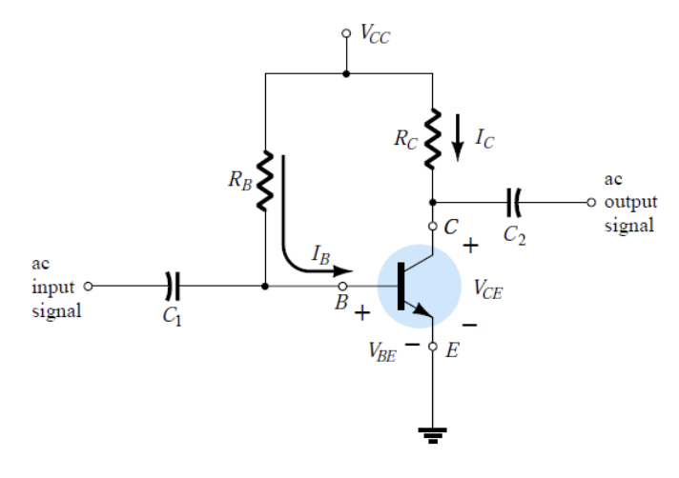
Figure #1: BJT Amplifier (Lab Manual)
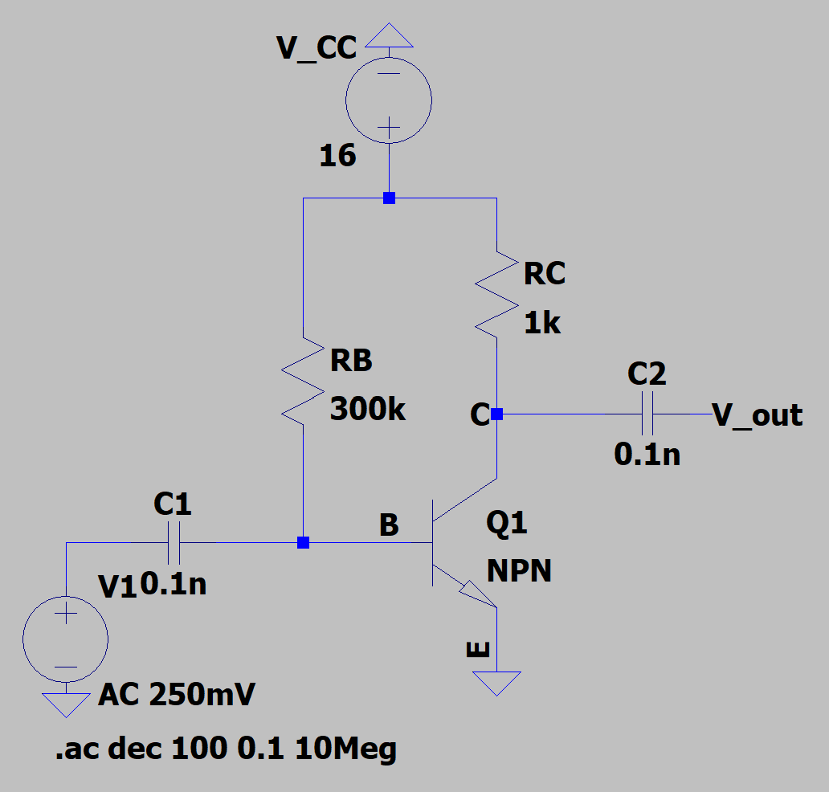
Figure #2: BJT Amplifier Circuit (LTSpice)
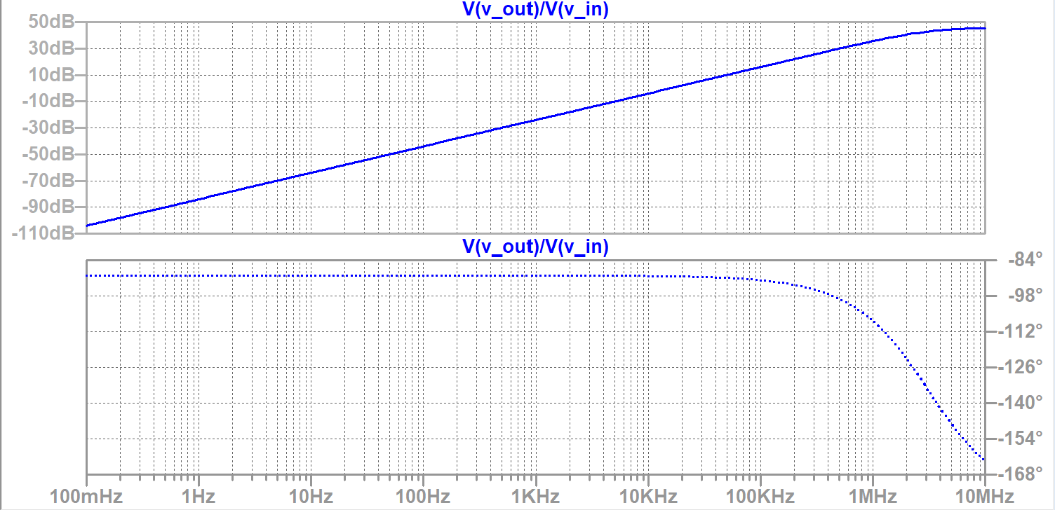
Figure #3: BJT Amplifier Bode Plot

Frequency | V_{out} (V) | Gain (dB)
10 Hz | 0.00064 | -63.8983
30 Hz | 0.00192 | -54.3559
60 Hz | 0.00383 | -48.3353
100 Hz | 0.00638 | -43.8983
200 Hz | 0.01277 | -37.8777
500 Hz | 0.03192 | -29.9189
1 kHz | 0.06384 | -23.8984
2kHz | 0.12767 | -17.8781
5 kHz | 0.31911 | -9.92114
10 kHz | 0.63773 | -3.90721
15 kHz | 0.95538 | -0.396496
20 kHz | 1.27157 | 2.08679
50 kHz | 3.11309 | 9.86382
75 kHz | 4.53336 | 13.1284
100 kHz | 5.81514 | 15.2912
150 kHz | 7.92018 | 17.9747
200 kHz | 9.46204 | 19.5197
500 kHz | 12.89258 | 22.2068
750 kHz | 13.51964 | 22.6193
1 MHz | 13.76179 | 22.7735
1.5 MHz | 13.94232 | 22.8867
2 MHz | 14.00683 | 22.9268
Table #1: Simulation Output Voltage and Gain
Figures 4 and 5 show the transient output of the circuit at 10 Hz and 20 MHz respectively. Figure 5 shows significant clipping as the output waveform reaches 16 V_{pk-pk}. After running the simulation at a variety of frequencies, the clipping seems to first occur at around 400 kHz, as shown in Figure 6.
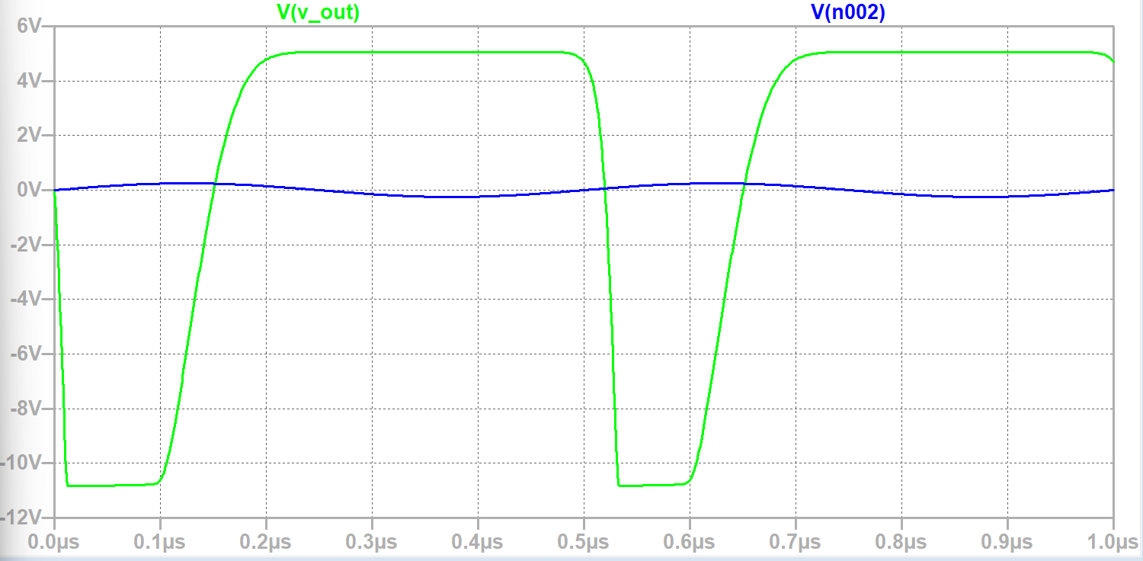
Figure #4: Transient Output at 10 Hz
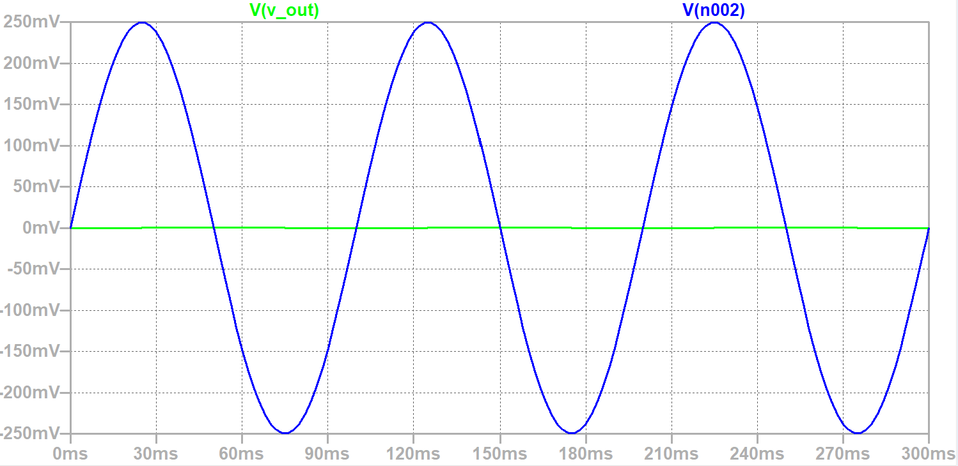
Figure #5: Transient Output at 2 MHz
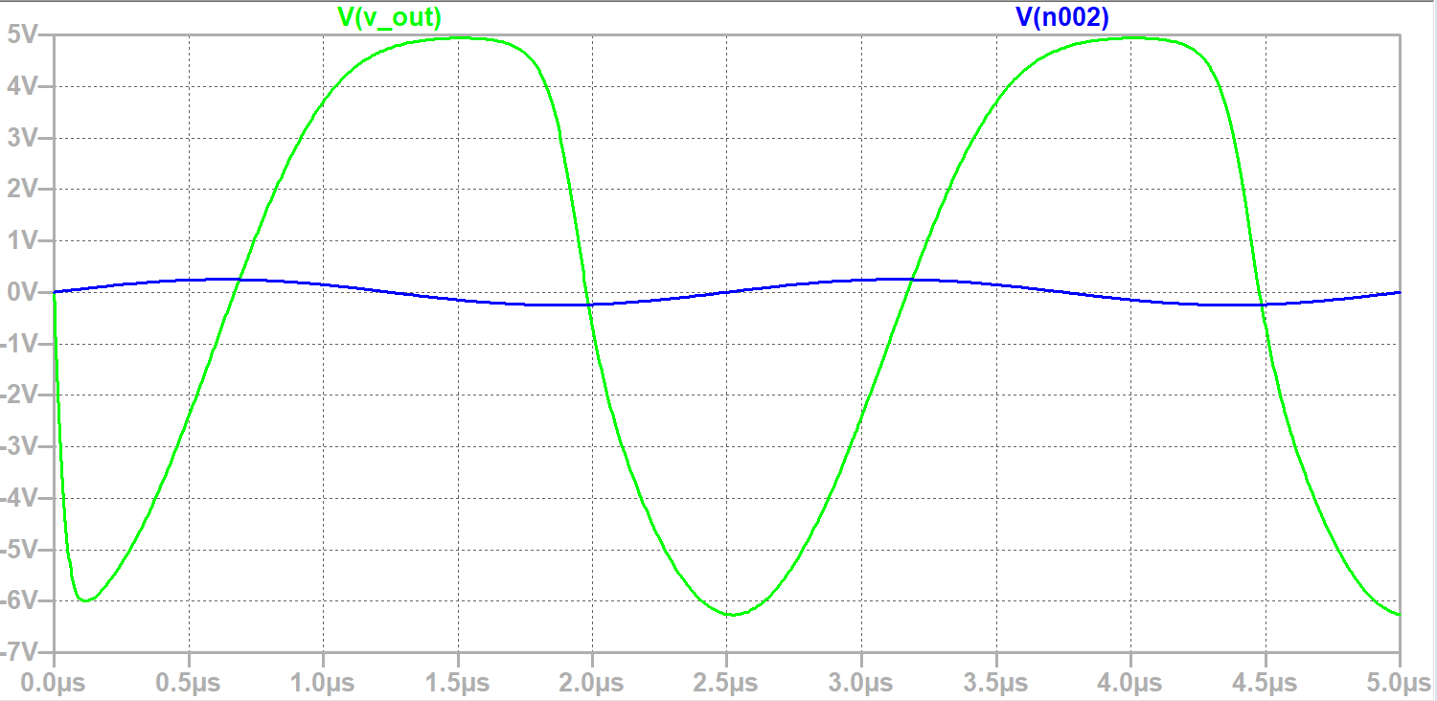
Figure #6: Transient Output at 400 kHz
To reduce this clipping, R_{B} was halved and C₁ was reduced by 0.01 uF. The modified circuit is shown in Figure 7. The transient output of the modified circuit at 2 MHz is shown in Figure 8.
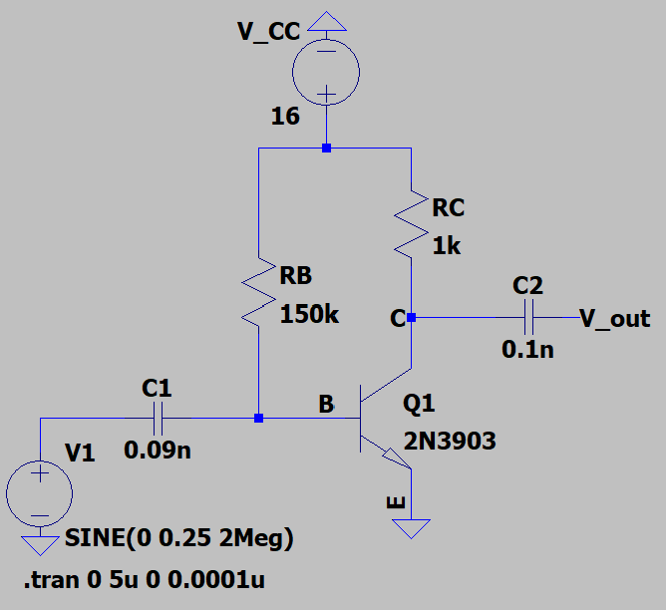
Figure #7: Modified BJT Amplifier Circuit (LTSpice)
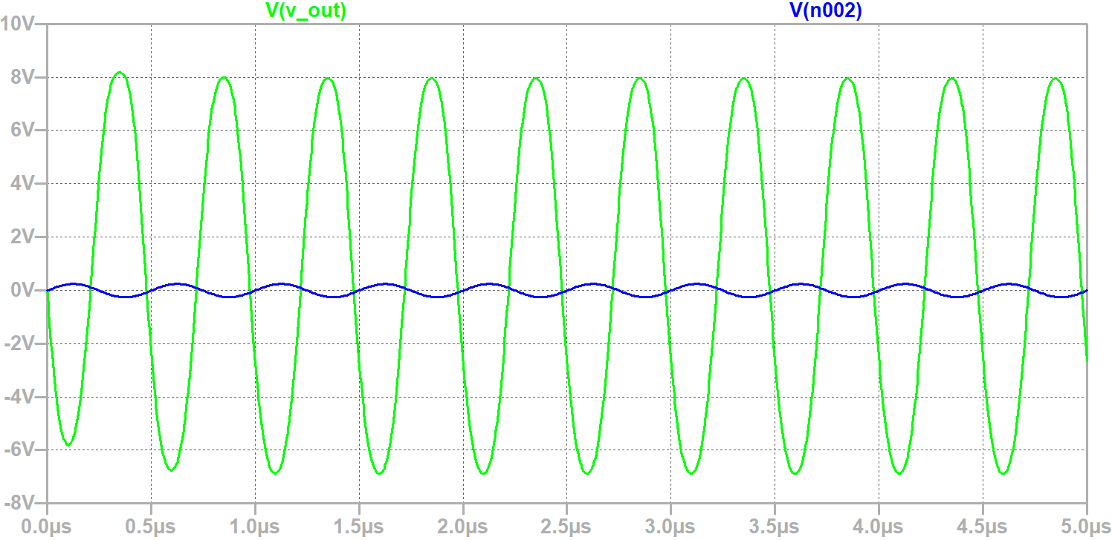
Figure #8: Modified Circuit Transient Output at 2 MHz
Experimental Setup and Results:
The BJT amplifier in Figure 1 was built using a breadboard, resistors, capacitors, and a BJT. Figure 9 shows a picture of the experimental setup. WaveForms was used to record the Bode plot in Figure 10. In Figure 10, the small bumps present at low frequencies are likely caused by the capacitors affecting the signal differently as the frequency changes. They could also be minor simulation irregularities. Table 2 summarizes specific points on the Bode plot and voltage values at varying frequencies.

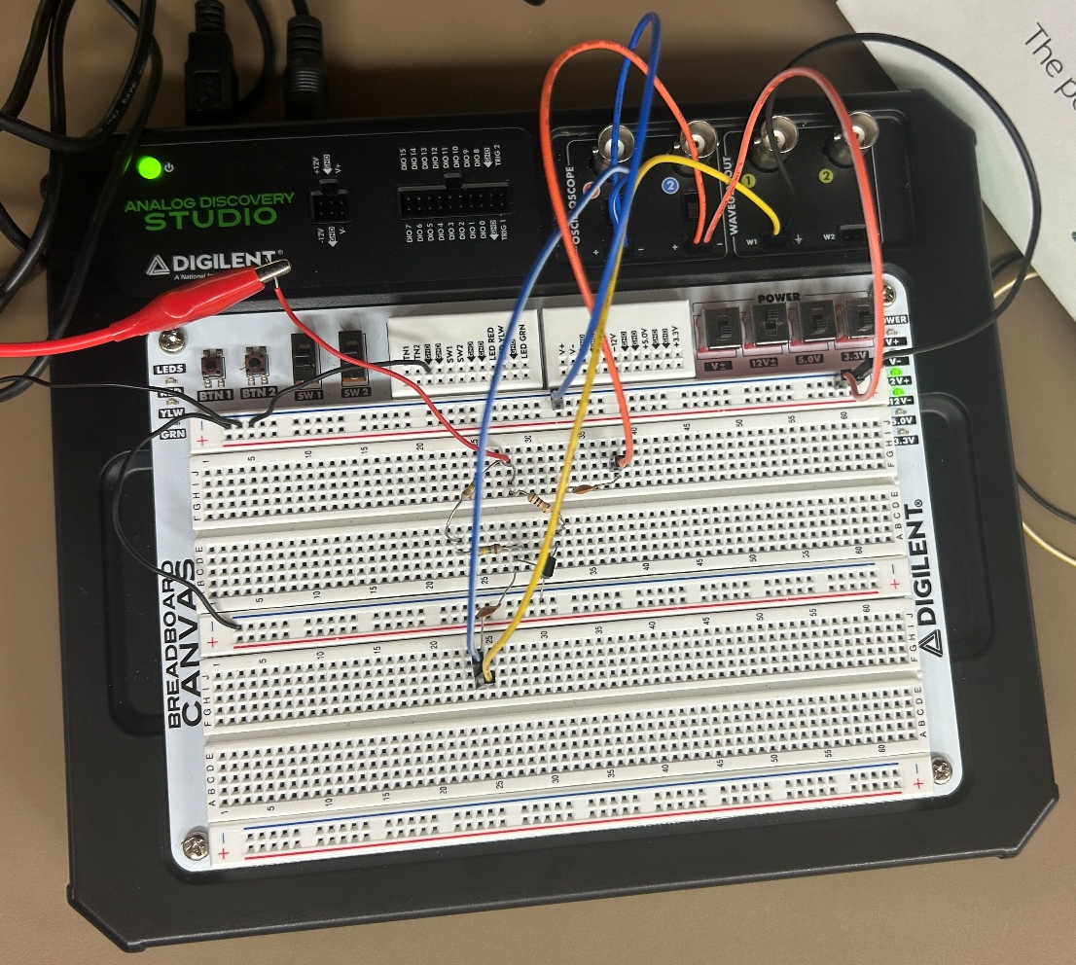
Figure #9: BJT Amplifier Experimental Setup
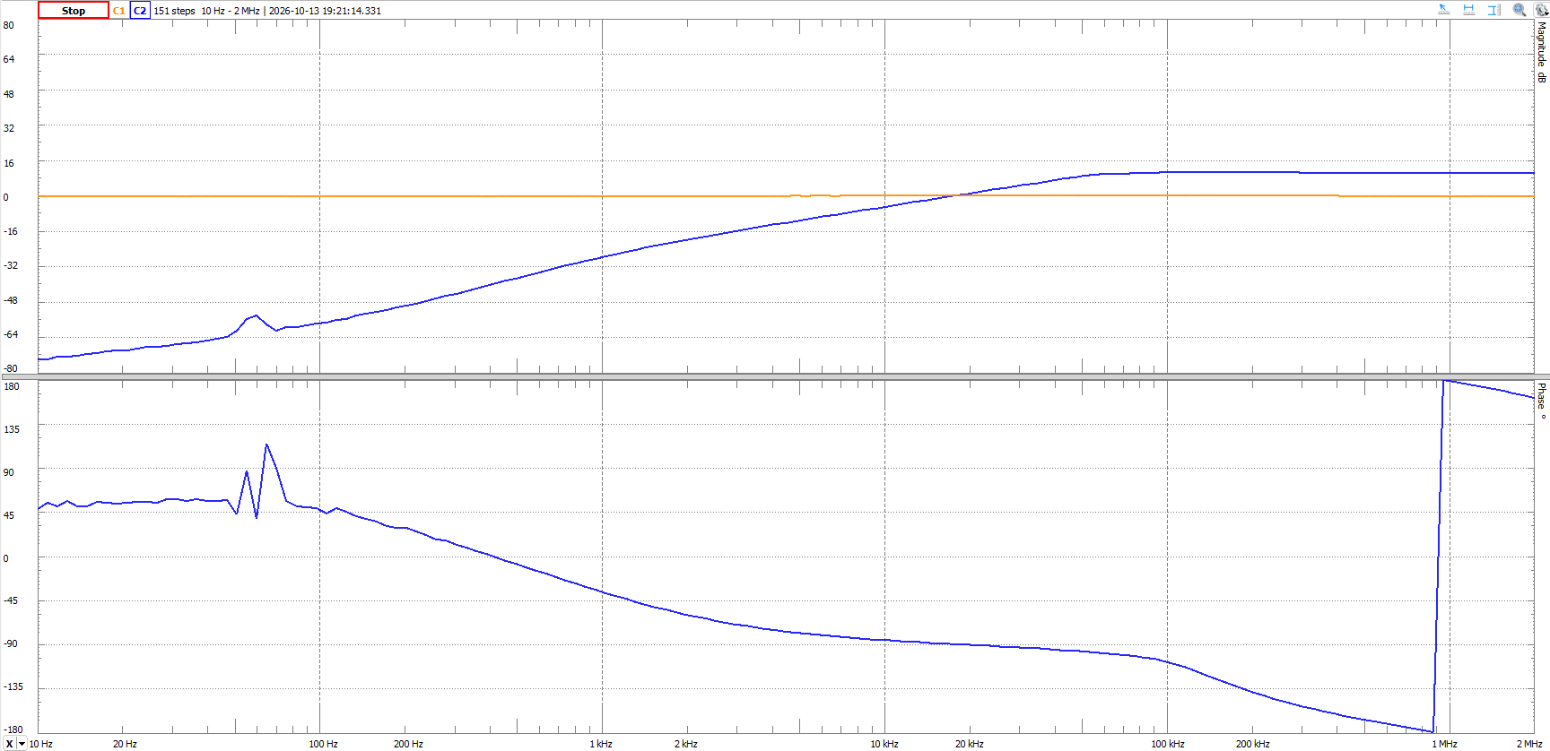
Figure #10: BJT Amplifier Bode Plot

Frequency | V_{out} (V) | Gain (dB)
10 Hz | 0.000103 | -73.723
30 Hz | 0.000216 | -67.295
60 Hz | 0.000976 | -54.193
100 Hz | 0.000675 | -57.394
200 Hz | 0.001641 | -49.677
500 Hz | 0.006919 | -37.179
1 kHz | 0.021636 | -27.276
2kHz | 0.050422 | -19.927
5 kHz | 0.13419 | -11.425
10 kHz | 0.282957 | -4.945
15 kHz | 0.425618 | -1.399
20 kHz | 0.589006 | 1.423
50 kHz | 1.417816 | 9.053
75 kHz | 1.622632 | 10.225
100 kHz | 1.680041 | 10.527
150 kHz | 1.708126 | 10.671
200 kHz | 1.694416 | 10.601
500 kHz | 1.663106 | 10.439
750 kHz | 1.662149 | 10.434
1 MHz | 1.664639 | 10.447
1.5 MHz | 1.669053 | 10.470
2 MHz | 1.670782 | 10.479
Table #2: Experimental Voltage and Gain
Discussion:
The simulation and experimental results matched somewhat closely. The simulation Bode plot was overall much smoother, though the general shape of the simulation and experimental Bode plots matched. Low frequency noise was present in the experimental Bode plot, likely caused by the capacitors affecting the signal differently as the frequency changes. They could also be minor simulation irregularities. Table 3 shows the percent errors for V_{out} and gain. The percent error for V_{out} are all very large, likely due to the voltage values being in the millivolt range. In actuality, the simulation and experimental voltage values were very close. The percent errors for gain were also generally close with larger variations at higher frequencies. The large percent error at 15 kHz was caused by a simulation value of -0.3 dB and an experimental value of -1.399 dB, making the small deviation seem much larger than it actually is.
Frequency | V_{out} | Gain
10 Hz | 83.91% | 15.38%
30 Hz | 88.76% | 23.80%
60 Hz | 74.53% | 12.12%
100 Hz | 89.42% | 30.74%
200 Hz | 87.15% | 31.15%
500 Hz | 78.33% | 24.27%
1 kHz | 66.11% | 14.13%
2kHz | 60.51% | 11.46%
5 kHz | 57.95% | 15.16%
10 kHz | 55.63% | 26.55%
15 kHz | 55.45% | 252.72%
20 kHz | 53.68% | 31.81%
50 kHz | 54.46% | 8.22%
75 kHz | 64.21% | 22.12%
100 kHz | 71.11% | 31.16%
150 kHz | 78.43% | 40.64%
200 kHz | 82.09% | 45.69%
500 kHz | 87.10% | 53.00%
750 kHz | 87.71% | 53.87%
1 MHz | 87.90% | 54.12%
1.5 MHz | 88.03% | 54.20%
2 MHz | 88.07% | 54.28%
Table #3: Voltage and Gain Percent Errors
Conclusion:
In conclusion, this lab investigated the characteristics and performance of a small-signal BJT amplifier using LTSpice. Frequency response, output voltage, and gain were analyzed through simulation, while transient analysis was used to observe clipping and distortion at higher frequencies. The simulated results were compared with experimental measurements, revealing differences likely caused by component tolerances, parasitic effects, and measurement limitations. Overall, the lab demonstrated how frequency and circuit characteristics affect amplifier performance and how circuit modifications can help reduce distortion.

