MA 465: Introduction to Mathematical Modeling

Project 2
Linear and Quadratic Modeling and Optimization

Submitted by: Hannah Kelley
Report Deadline: February 1, 2026
Abstract
This project investigates relationships between physical variables through statistical modeling and regression analysis using experimental data from Tables 1.7 and 1.8 of the course textbook. The first dataset, describing temperature as a function of time, is analyzed using linear regression to determine a best-fit model and to quantify the strength and direction of the relationship via the correlation coefficient. The second dataset, relating concentration to time, is examined using both linear and quadratic regression models in order to compare their effectiveness in representing the observed trend. In each case, graphical visualization and correlation analysis are used to evaluate model performance.
In addition to numerical modeling, a theoretical component is included in which the matrix formulation of multiple linear regression is derived. Following the approach in Section 11.4 of Bonamente (2022), the analytic least-squares solution is proven using matrix algebra. The derivation incorporates weighted least squares based on measurement variance, which reduces to the standard form under the assumption of constant variance for the datasets considered here. Together, the computational and theoretical results demonstrate how regression techniques can be used to model experimental data and provide a mathematical foundation for least-squares fitting.
1. Introduction
This project focuses on modeling and analyzing experimental datasets to explore relationships between physical variables using regression techniques. The data comes from Tables 1.7 and 1.8 of the course textbook. The goal is to apply statistical modeling methods to visualize trends, quantify correlations, and develop mathematical models that best describe the observed behavior.
For the first dataset (Table 1.7), the relationship between time and temperature is examined. A scatter plot is used to visualize the data, and a best-fit linear model is determined. In addition, the correlation coefficient 𝑟 is calculated to quantify the strength and direction of the linear relationship between the variables.
The second dataset (Table 1.8) investigates the relationship between time and concentration. This dataset is modeled using both linear and quadratic regression to compare how well each model represents the data. As with the first dataset, the correlation coefficient 𝑟 is computed to assess the strength of the linear association.
Beyond numerical modeling, this project also includes a theoretical component. The matrix formulation of multiple linear regression is derived using the approach outlined in Section 11.4 of Dr. Bonamente’s 2022 textbook. In particular, Equation 11.14, which provides the analytic least-squares solution, is proven using matrix algebra. The derivation extends the standard least-squares method by incorporating weighting factors based on variance; however, since individual variances are not provided for the datasets in this project, a constant variance is assumed.
2. Methodology
This project investigated trends in two experimental datasets by applying linear and polynomial regression techniques and by deriving the general matrix solution for the least-squares fitting. The analysis combined computational modeling with analytical development of the least squares equations.
For the data in Table 1.7, the relationship between time and temperature was examined using a linear model. The data were plotted in MATLAB to visualize overall trends and assess linearity. A best-fit straight line was obtained using MATLAB’s built-in polyfit function with an argument of $n=1$ (linear polynomial), and the correlation coefficient 𝑟 was calculated—again using MATLAB’s built-in functions—to quantify the strength and direction of the linear relationship between time and temperature.
For the data in Table 1.8, the relationship between time and concentration was analyzed using both linear and quadratic models. The data were plotted to identify curvature and determine whether a higher-order model was justified. Least-squares fits were performed for both linear and quadratic polynomials using MATLAB’s polyfit function with arguments of $n=1$ and $n=2$ respectively. The correlation coefficient 𝑟 between time and concentration was also computed to evaluate the degree of linear association, and model performance was compared by examining how well each fit represented the observed data.
In addition to numerical modeling, the general matrix formulation of multiple linear regression was derived analytically. Following Section 11.4 of Bonamente (2022), the least-squares problem was expressed in matrix form by defining a design matrix containing the basis functions of the model (constant, linear, and quadratic terms). The normal equations were obtained by minimizing the weighted sum of squared residuals, where each term was divided by a constant variance, consistent with an extended least-squares definition. Matrix algebra was then used to derive the analytic solution for the parameter vector, corresponding to Eq. 11.14 in the text. This formulation provides a unified framework for both linear and quadratic regression models used in data analysis.
3. Proof
Given experimental data points of the form $(x_{i}, y_{i}±σ_{i})$ where $i=1, …, n$ and $σ$ represents the uncertainty of measurement $y_{i}$, we seek a method to describe the relationship between $x$ and $y$ using a model. In linear regression, we assume the model is a linear combination of known functions:
$$y\left(x\right)=\sum_{k=1}^{m}{a_{k}f_{x}}(x)$$
Where $a_{k}$ are unknown scalars, $m$ is the number of parameters in the final linear regression equation, and $f_{k}(x)$ are the fit functions of the form
$$f_{k}\left(x\right)= x^{k-1}$$
This model is linear because the unknown parameters $a_{k}$ enter linearly, not because the function $y(x)$ is a polynomial of degree one.
Each measurement $y_{i}$ is assumed to have an uncertainty $σ_{i}$. These uncertainties can differ from point to point, so they are weighed between the data and the model by $\frac{1}{σ_{i}^{2}}$. The quality of the fit is quantifiable through the chi-squared function:
$$χ^{2}\left(a_{1},…,a_{m}\right)=\sum_{i=1}^{n}{\frac{{\left[y_{i}-\sum_{k=1}^{m}{a_{k}f_{k}(x_{i})}\right]}^{2}}{σ_{i}^{2}}}$$
Using this chi-squared function, we want to find the adjustable parameters that minimize the error between the best fit model and the data. To minimize the data, the partial derivative should be taken with respect to the adjustable parameters $a_{l}$ and set to zero:
$\frac{∂χ^{2}}{∂a_{l}}=0$ for $l=1, …, m$
$$\frac{∂χ^{2}}{∂a_{l}}=\sum_{i=1}^{n}{\frac{2\left[y_{i}-\sum_{k=1}^{m}{a_{k}f_{k}(x_{i})}\right]}{σ_{i}}}∙\frac{-f_{l}(x_{i})}{σ_{i}}=0$$
After simplifying, the sum can then be broken into three smaller sums:
$$\sum_{i=1}^{n}{\frac{f_{l}(x_{i})\left[y_{i}-\sum_{k=1}^{m}{a_{k}f_{k}(x_{i})}\right]}{σ_{i}^{2}}}=0$$
$$\sum_{i=1}^{n}{\frac{f_{l}(x_{i})y_{i}}{σ_{i}^{2}}}=\sum_{k=1}^{m}{a_{k}}\sum_{i=1}^{n}{\frac{f_{l}(x_{i})f_{k}(x_{i})}{σ_{i}^{2}}}$$
In simpler terms, this equation can be written as:
$$Aα=β$$
where
$$A_{lk}=\sum_{i=1}^{n}{\frac{f_{l}(x_{i})f_{k}(x_{i})}{σ_{i}^{2}}}$$
$$β_{l}=\sum_{i=1}^{n}{\frac{f_{l}(x_{i})y_{i}}{σ_{i}^{2}}}$$
and the parameter vector $α$:
$$α=\left[\begin{matrix}a_{1} \\ a_{2} \\ \begin{matrix}⋮ \\ a_{m}\end{matrix}\end{matrix}\right]$$
These equations together give $Aα=β$If matrix A is invertible, we can solve for the adjustable parameters:
$$α=A^{-1}β$$
Therefore, multiple linear regression reduces to solving a system of linear equations whose coefficients depend only on the chosen basis functions and the measurement uncertainties.
4. Data
Graphing the experimental data given in Table 1.7 in the textbook produced the plot shown in Figure 1. A linear best fit was imposed on top of the data, and the correlation coefficient was calculated. The equation for the linear fit is visible in the legend. The correlation coefficient can be found in Table 1.
Graphing the experimental data given in Table 1.8 in the textbook produced the plot shown in Figure 2. Both a linear and quadratic best fit were imposed on top of the data, and the correlation coefficient was calculated. The equations for both polynomial fits are visible in the legend. The correlation coefficient can be found in Table 1.
Source Table | Correlation Coefficient
Table 1.7 (temp vs year) | 0.7712
Table 1.8 (conc. vs year) | 0.9938
Table 1 – Tables 1.7 and 1.8 Correlation Coefficients
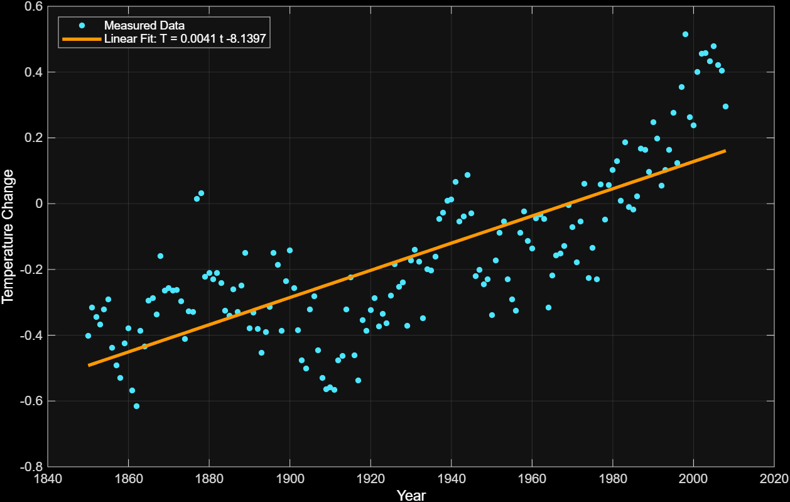
Figure 1 – Temperature vs. Year with Linear Best Fit
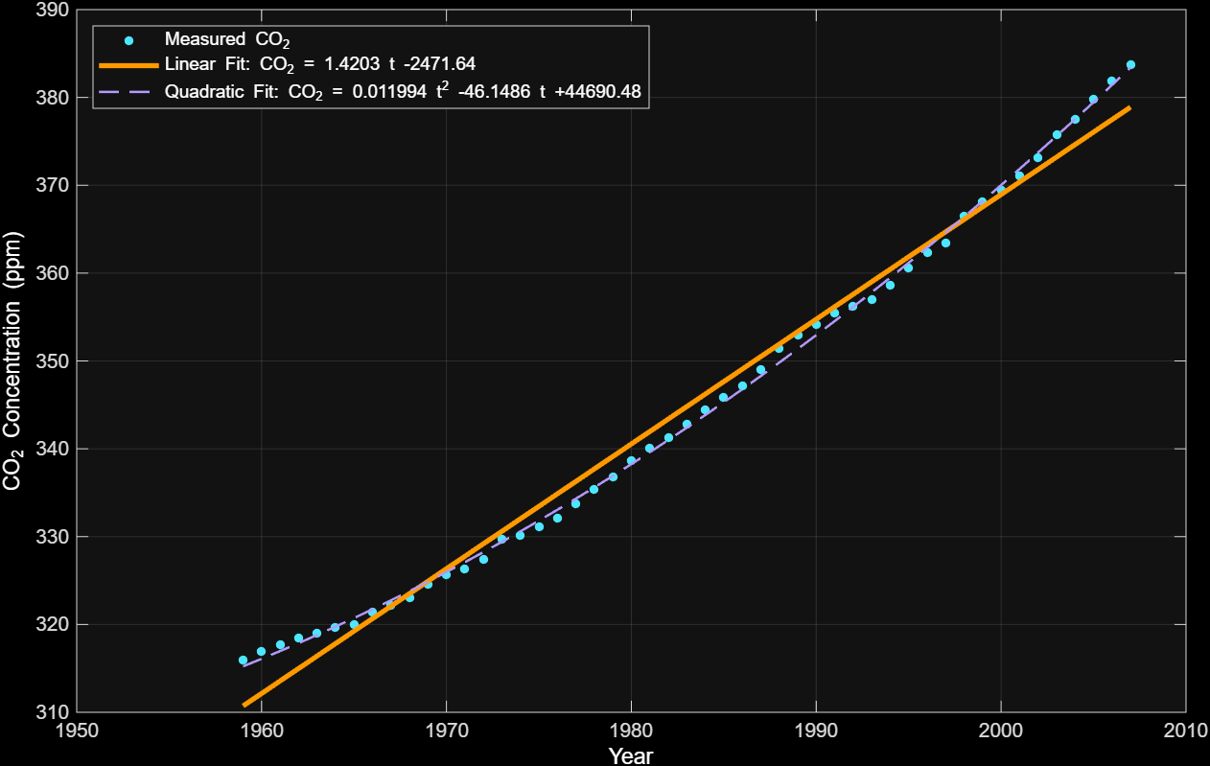
Figure 2 – CO₂ Concentration vs. Year with Linear and Quadratic Fits
4. Discussion
Figure 1 shows temperature change as a function of year (Table 1.7), along with the best-fit linear regression model. The data display noticeable variability, with short-term fluctuations from year to year. Despite this scatter, an overall upward trend is evident, as indicated by the positive slope of the fitted line. This suggests that average temperature change has generally increased over the time span of the dataset, even though natural variability introduces deviations from a simple linear pattern.
The correlation coefficient between year and temperature change was calculated to be
$$r=0.7712$$
This value indicates a moderate to strong positive linear relationship, confirming that temperature change tends to increase over time despite the variability in the data. While a quadratic fit was not considered for this dataset, a quadratic fit would likely fit the data better than the linear fit.
Figure 2 shows atmospheric CO₂ concentration as a function of year (Table 1.8), along with the best-fit linear and quadratic regression models. The data exhibit a strong and consistent upward trend over time. The linear fit captures the general increase, while the quadratic model more closely follows the curvature in later years, where the slope becomes steeper. This behavior indicates that the rate of increase in CO₂ concentration is itself increasing, suggesting an accelerating trend.
The correlation coefficient between year and CO₂ concentration was found to be
$$r=0.9938$$
This value indicates a very strong positive linear relationship between time and CO₂ concentration. While the quadratic model provides an improved fit to the curvature of the data, the correlation coefficient shows the strength of the linear association between the two variables. The much larger correlation coefficient for CO₂ compared to temperature indicates that CO₂ concentration follows a more consistent long-term trend, whereas temperature is influenced by additional sources of short-term variability.
5. Conclusion
This project demonstrated how regression techniques can be used to model and interpret relationships in experimental data. For the temperature dataset, linear regression provided a clear quantitative description of the overall trend over time, while the correlation coefficient confirmed the strength and direction of the linear relationship. For the concentration dataset, comparing linear and quadratic models showed how higher-order regression can better capture nonlinear behavior, highlighting the importance of selecting an appropriate model based on the data’s structure.
Beyond numerical results, the project reinforced the theoretical foundation of regression analysis through the derivation of the matrix least-squares solution. Proving the analytic form of the multiple linear regression equation illustrated how both linear and quadratic models arise naturally from the same mathematical framework.
Overall, this work combined computational tools, statistical interpretation, and mathematical theory to provide a comprehensive understanding of regression modeling and its application to physical data.
6. Appendices
Appendix A: Complete MATLAB code for graphing and calculations:
% Temperature vs Year (Table 1.7)
t = (1850:2008)';
Temp = [
-0.402; -0.315; -0.345; -0.368; -0.321; -0.291; -0.438; -0.491; -0.529; -0.424;
-0.378; -0.568; -0.616; -0.386; -0.434; -0.295; -0.287; -0.336; -0.16; -0.264;
-0.257; -0.265; -0.262; -0.296; -0.412; -0.328; -0.33; 0.015; 0.031; -0.222;
-0.21; -0.229; -0.211; -0.242; -0.325; -0.34; -0.261; -0.33; -0.249; -0.15;
-0.378; -0.332; -0.381; -0.453; -0.391; -0.313; -0.15; -0.185; -0.386; -0.235;
-0.142; -0.257; -0.384; -0.477; -0.501; -0.321; -0.281; -0.446; -0.529; -0.564;
-0.559; -0.566; -0.476; -0.463; -0.322; -0.225; -0.461; -0.538; -0.354; -0.387;
-0.323; -0.287; -0.374; -0.335; -0.364; -0.279; -0.184; -0.253; -0.24; -0.372;
-0.173; -0.141; -0.177; -0.349; -0.199; -0.203; -0.161; -0.046; -0.028; 0.008;
0.013; 0.066; -0.055; -0.038; 0.087; -0.03; -0.221; -0.202; -0.245; -0.23;
-0.339; -0.172; -0.088; -0.055; -0.23; -0.291; -0.326; -0.089; -0.023; -0.114;
-0.137; -0.044; -0.033; -0.047; -0.315; -0.219; -0.157; -0.151; -0.129; -0.004;
-0.072; -0.178; -0.054; 0.06; -0.226; -0.134; -0.229; 0.059; -0.049; 0.056;
0.102; 0.13; 0.008; 0.187; -0.011; -0.018; 0.022; 0.167; 0.163; 0.096;
0.248; 0.197; 0.055; 0.102; 0.163; 0.276; 0.123; 0.355; 0.515; 0.262;
0.238; 0.4; 0.455; 0.457; 0.432; 0.479; 0.422; 0.404; 0.296
];

% Linear Best-Fit
p = polyfit(t, Temp, 1);
Temp_fit = polyval(p, t);

% Linear Fit Equation
eqn = sprintf('Linear Fit: T = %.4f t %+ .4f', p(1), p(2));

% Correlation Coefficient
cov_matrix_temp = cov(t, Temp); % 2x2 covariance matrix
r_temp = cov_matrix_temp(1,2) / sqrt(cov_matrix_temp(1,1) * cov_matrix_temp(2,2));

% Plot Temperature
figure
set(gcf,'Color','k')
ax = gca;
set(ax,'Color','k','XColor','w','YColor','w')

plot(t, Temp, 'o', 'Color', [0.3 0.9 1], 'MarkerFaceColor', [0.3 0.9 1], 'MarkerSize', 4, 'DisplayName', 'Measured Data')
hold on
plot(t, Temp_fit, '-', 'LineWidth', 2.5, 'Color', [1 0.6 0], 'DisplayName', eqn)

xlabel('Year','Color','w')
ylabel('Temperature Change','Color','w')
legend('TextColor','w','Location','northwest')
grid on
set(gca,'GridColor',[0.5 0.5 0.5])

% CO2 vs Year (Table 1.8)
t2 = (1959:2007)';
CO2 = [
315.98; 316.91; 317.64; 318.45; 318.99; 319.62; 320.04; 321.38; 322.16; 323.04;
324.62; 325.68; 326.32; 327.45; 329.68; 330.17; 331.08; 332.05; 333.78; 335.41;
336.78; 338.68; 340.11; 341.22; 342.84; 344.41; 345.87; 347.19; 348.98; 351.45;
352.90; 354.16; 355.48; 356.27; 356.95; 358.64; 360.62; 362.36; 363.47; 366.50;
368.14; 369.40; 371.07; 373.17; 375.78; 377.52; 379.76; 381.85; 383.71
];

% Linear and Quadratic Fits
p_lin = polyfit(t2, CO2, 1);
CO2_lin = polyval(p_lin, t2);

p_quad = polyfit(t2, CO2, 2);
CO2_quad = polyval(p_quad, t2);

% Equations
eqn_lin = sprintf('Linear Fit: CO_2 = %.4f t %+ .2f', p_lin(1), p_lin(2));
eqn_quad = sprintf('Quadratic Fit: CO_2 = %.6f t^2 %+ .4f t %+ .2f', p_quad(1), p_quad(2), p_quad(3));

% Correlation Coefficient
cov_matrix_CO2 = cov(t2, CO2); % 2x2 covariance matrix
r_CO2 = cov_matrix_CO2(1,2) / sqrt(cov_matrix_CO2(1,1) * cov_matrix_CO2(2,2));

% Plot CO2
figure
set(gcf,'Color','k')
ax = gca;
set(ax,'Color','k','XColor','w','YColor','w')

plot(t2, CO2, 'o', 'Color', [0.3 0.9 1], 'MarkerFaceColor', [0.3 0.9 1], 'MarkerSize', 4, 'DisplayName', 'Measured CO_2')
hold on
plot(t2, CO2_lin, '-', 'LineWidth', 2.5, 'Color', [1 0.6 0], 'DisplayName', eqn_lin)
plot(t2, CO2_quad, '--', 'LineWidth', 1.2, 'Color', [0.7 0.6 1], 'DisplayName', eqn_quad)

xlabel('Year','Color','w')
ylabel('CO_2 Concentration (ppm)','Color','w')
legend('TextColor','w','Location','northwest')
grid on
set(gca,'GridColor',[0.5 0.5 0.5])

% Correlation Coefficients Table
corr_fig = figure('Color','k','Name','Correlation Coefficients');

t_fig = uitable('Data', [r_temp; r_CO2], 'RowName', {'Temperature','CO_2'}, 'ColumnName', {'Correlation r'}, 'ColumnWidth',{150}, 'Units','normalized', 'Position',[0 0 1 1]);

t_fig.BackgroundColor = [0.1 0.1 0.1; 0.2 0.2 0.2]; % alternating dark gray rows
t_fig.ForegroundColor = [1 1 1]; % white text
t_fig.FontSize = 14;

