MA 465: Introduction to Mathematical Modeling

Project 1
Vehicular Stopping Distance

Submitted by: Hannah Kelley
Report Deadline: January 18, 2026
Abstract
This report investigates the relationship between vehicle speed and stopping distance, separating the contributions of driver reaction and braking. The stopping-distance model was derived as $D=D_{R}+D_{B}=vT_{R}+\frac{1}{2}\frac{mv^{2}}{F_{B}},$ where $D_{R}=vT_{R}$is the reaction distance and $D_{B}=\frac{1}{2}mv^{2}/F_{B}$ is the braking distance. Experimental data were analyzed using linear regression on $D$vs $v$and $D/v$vs $v$, with the latter producing a linear trend and relative errors below 0.7%, confirming the model’s validity. Comparison with the textbook equation $D=(2+v/20)v$ demonstrates agreement under reasonable assumptions for reaction time, vehicle mass, and braking force, validating the physical plausibility of the derived model and its applicability for predicting stopping distances.
1. Introduction
This assignment investigates vehicular stopping distance, denoted $D$, which is the total distance a vehicle travels from the moment a driver perceives a need to stop and applies the brakes until the vehicle comes to rest. Stopping distance is influenced by vehicle speed ($v$), driver reaction time ($T_{R}$), braking force ($F_{B}$), and vehicle mass ($m$). We will assume the braking force and the speed of the car to be constant.
The dataset provided in Table 1.3 of the textbook represents measured stopping distances for various speeds, as described in Section 1.2.3. Theoretical guidance on modeling these distances is provided in Section 3.3.1, including the simplified empirical model given in Eq. 1.9. The data in the textbook is given in units of feet and miles per hour. All data was converted to SI units before any calculations and graphing.
1-1 Formation of Equations and Interpretation of Terms
The vehicular stopping distance $D$ is dependent on two separate distances, the distance travelled before the driver reacted and applied the brakes (reaction distance) $D_{R}$ and the distance travelled before the car comes to a complete stop (braking distance) $D_{B}$. The reaction distance can be written as the product of the car’s speed and the driver’s reaction time:
$D_{R}=vT_{R}$ (eq 1)
When the brakes are applied, the car decelerates from its initial speed $v$ to rest. During this process, the car’s initial kinetic energy is dissipated by the work done by the braking force. The initial kinetic energy of the vehicle is:
$$K=\frac{1}{2}mv^{2}.$$
Assuming the braking force $F_{B}$ is approximately constant, the work done by the brakes over the braking distance $D_{B}$ is:
$$W=F_{B}D_{B}.$$
By the work–energy theorem, the work done by the braking force equals the change in kinetic energy. Since the final kinetic energy is zero, the following equation results:
$$F_{B}D_{B}=\frac{1}{2}mv^{2}.$$
Solving for the braking distance gives:
$D_{B}=\frac{\frac{1}{2}mv^{2}}{F_{B}}$ (eq 2)

The total stopping distance $D$ must then be the sum of the reaction distance (eq 1) and braking distance (eq 2):
$D= D_{R}+D_{B}$ (eq 3)
$$D= vT_{R}+ \frac{\frac{1}{2}mv^{2}}{F_{B}}$$
$D=v\left(T_{R}+\frac{mv}{{2F}_{B}}\right)$ (eq 4)
This model suggests a quadratic relationship between the stopping distance $D$and the vehicle speed $v$, where the linear term arises from the driver’s reaction distance and the quadratic term results from the energy dissipated by the braking force. This equation is assumed to be the model equation and will be compared with the textbook’s solution by means of dimensional analysis in the methodology section.
2. Methodology
The relationship between vehicular stopping distance and speed was investigated using a physically motivated model consisting of reaction and braking components. The stopping-distance equation was derived by combining the reaction distance and a braking distance obtained from the work–energy theorem.
Dimensional analysis was used to compare the derived model equation with the stopping-distance relationship presented in the textbook, ensuring consistency of units and functional dependence on velocity. Experimental stopping-distance data were then analyzed by plotting $D$and $D/v$as functions of vehicle speed in MATLAB. The “polyfit” function was applied to assess agreement between the experimental data and the derived model.
Relative errors between measured and predicted stopping distances were calculated to evaluate model performance. Additional comparisons were made by examining how well the experimentally fitted parameters aligned with those implied by the textbook expression.
3. Analysis
Dimensional analysis was used to examine the derived stopping-distance equation and compare it with the textbook model. This analysis verifies the consistency of the equation’s units and functional dependence on velocity, providing a theoretical basis for the form of the model prior to comparison with experimental data.
The stopping distance $D_{B}$ is a function of the following variables and their units:
- Braking force $F_{B}$ in Newtons $\left(\frac{kg∙m}{s^{2}}\right)$
- Speed of the car $v$ in meters per second
- Mass of the car $m$ in kilograms
The combination of the variables will take the following form, assuming a proportional relationship between the variables where $a, b, c, d$, and $k$ are arbitrary constants:
$${D_{B}}^{a}∙{F_{B}}^{b}∙v^{c}∙m^{d}=k$$
Representing the variables in terms of their units gives the following:
$m^{a}∙{\left[\frac{kg∙m}{s^{2}}\right]}^{b}∙{\left[\frac{m}{s}\right]}^{c}∙{kg}^{d}=k^{0}$ (eq 5)
Equation 5 can then be split into a set of three simultaneous equations to solve for the arbitrary constants $a, b, c,$ and $d$:
$$a+b+c=0$$
$$b+d=0$$
$$-2b-c=0$$
Parameterizing these equations in terms of $a$ yields the following relationships:
$$b=a$$
$$c=-2a$$
$$d=-a$$
Using this parameterization in equation 4 gives the following:
$${D_{B}}^{a}∙{F_{B}}^{a}∙v^{-2a}∙m^{-a}=k$$
$${D_{B}}^{a}=k∙{F_{B}}^{-a}∙v^{2a}∙m^{a}$$
Assuming $a=1$, we get the following equation:
$D_{B}=\frac{kmv^{2}}{F_{B}}$ (eq 6)
From equations 1, 3, and 6, we get:
$D=vT_{R}+\frac{kmv^{2}}{F_{B}}$ (eq 7)
$D=\left(T_{R}+\frac{kmv}{F_{B}}\right)v$ (eq 7’)
The work-energy theorem tells us that $k=\frac{1}{2}$ for kinetic energy, meaning equation 7 is functionally the same as equation 4 in the introduction. This shows that equation 7 has the correct units, reflects the underlying physics of stopping distance, and matches the functional form derived in the methodology section.
Equation 1.9 in the book is:
$D=\left(2+\frac{v}{20}\right)v$ (eq 8)
Equation 8 and equation 7’ prime match so long as the driver’s reaction time $T_{R}=2$ seconds, the mass of the car $m=1$ kg, $k=\frac{1}{2}$, and the braking force $F_{B}=10$ Newtons. This comparison confirms that the derived stopping-distance model is physically reasonable and provides a valid foundation for analyzing the experimental data.
4. Data
Graphing the experimental data given in Table 1.3 in the textbook produced the plots shown in Figures 1–4. Figures 1 and 2 correspond to a linear stopping-distance model. Figure 1 shows the measured stopping distance $D$ plotted as a function of vehicle speed $v$ along with a linear least-squares best-fit line. Figure 2 shows the relative error associated with the linear fit shown in Figure 1.
Figures 3 and 4 correspond to a quadratic stopping-distance model. Figure 3 shows the quantity $D/v$ plotted as a function of vehicle speed $v$ along with a linear best-fit line. Although the best fit in Figure 3 is linear, this result implies a quadratic relationship between $D$ and $v$, since $D=v (D/v)$and $D/v$ varies linearly with $v$. Figure 4 shows the relative error associated with the best-fit line shown in Figure 3.
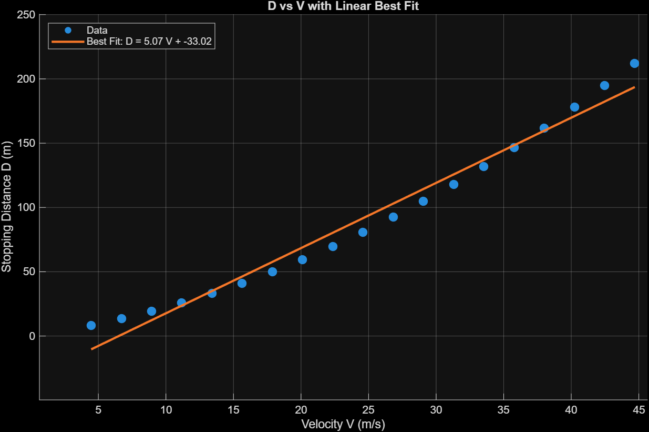
Figure 1 – Distance (m) vs Velocity (m/s) with Linear Best Fit
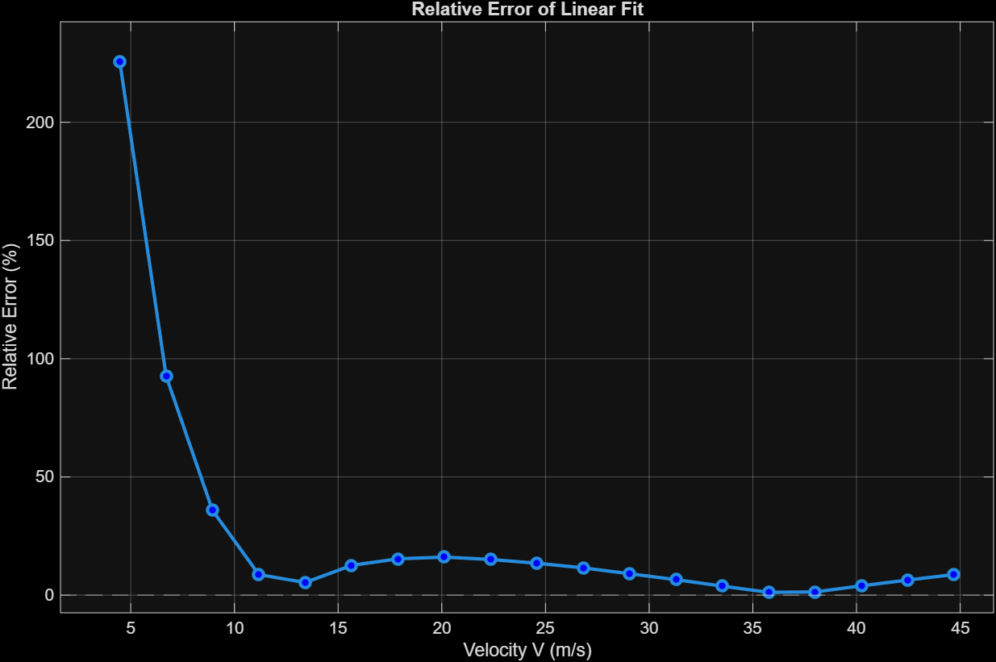
Figure 2 – Relative Error of Linear Model
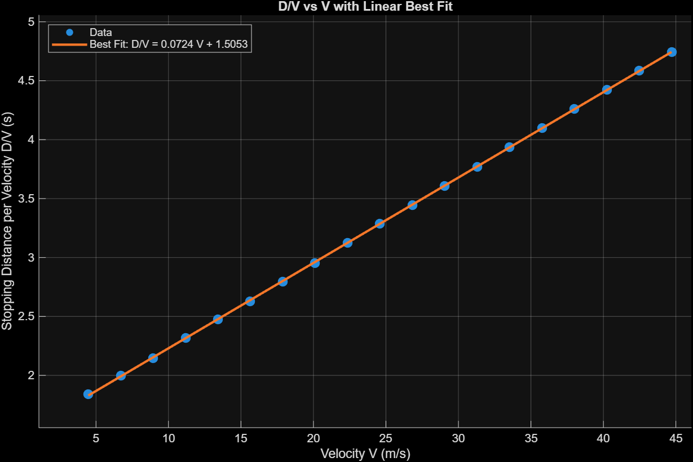
Figure 3 – Distance/Velocity (m/s) vs Velocity (m/s) with Linear Best Fit
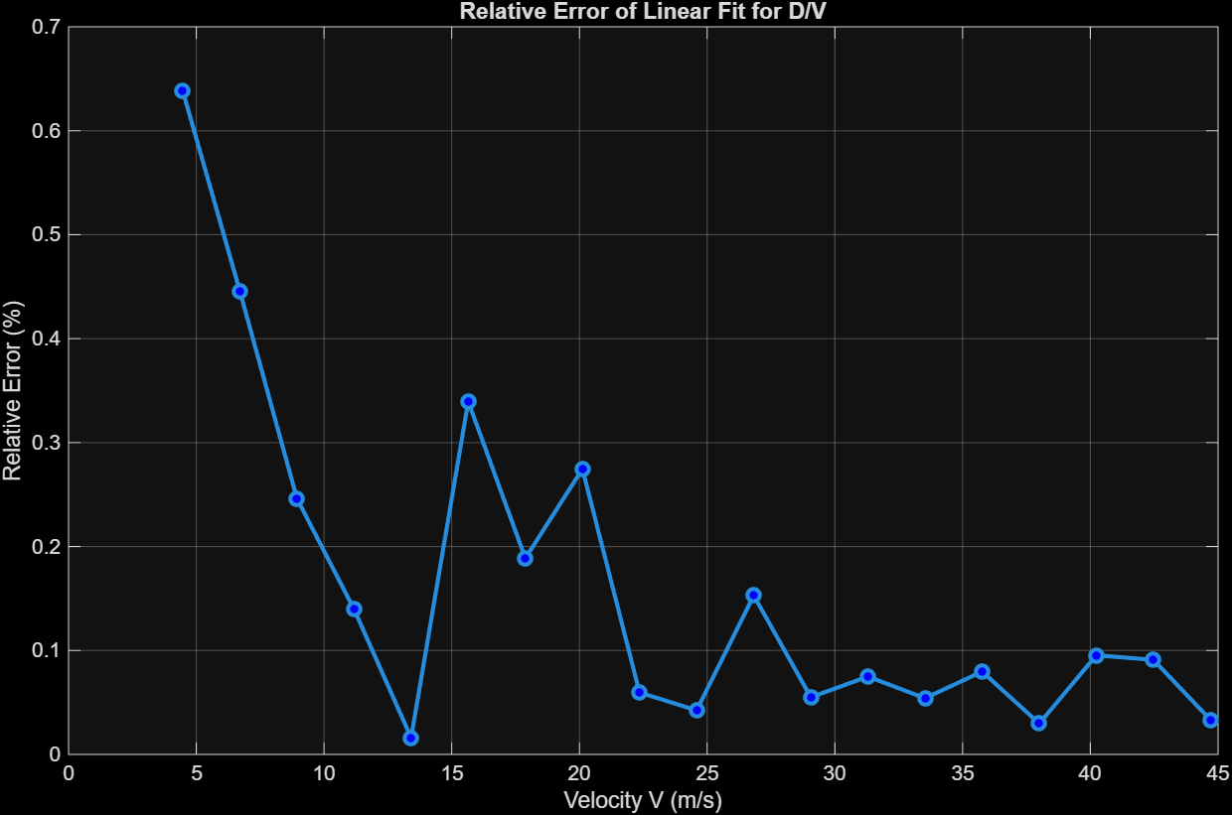
Figure 4 – Relative Error of Quadratic Model

4. Discussion
The $D$ vs $v$ graph in Figure 1 cannot be represented by a linear model. The relative error plot in Figure 2 shows the magnitude of the discrepancy between measured stopping distances and those predicted by the linear model. Error is large at low speeds (<10 m/s) and decreases around 35 m/s, reflecting the fact that the linear model intersects the data in only a few points. This variation highlights the model’s limitation: it cannot capture the nonlinear increase in stopping distance with speed due to the quadratic dependence of braking distance. While the linear model provides a rough approximation at intermediate speeds, it significantly underestimates or overestimates stopping distances at the extremes, indicating that a more accurate prediction requires a nonlinear model.
The $D/v$ vs $V$plot in Figure 3 with a linear fit shows excellent agreement with the data, with all relative errors below 0.7% as shown in Figure 4. This indicates that a linear model is highly effective at capturing the trend in $D/v$ across the measured speeds. This is further emphasized by equations 4, 7, and 8 all representing a quadratic relationship between $D$ and $v$.
The numerical data given in the textbook matches the best fit curve well, however, this is unreasonable for real-world experimental data. Likewise, the values for mass (1 kg) the braking force (1 N) are unreasonable for a real-world car. This suggests that the experimental data was given in such a way to allow for easy modeling rather than real-world accuracy. This does not affect the validity of the model derived for this data, rather it suggests that the model would likely need to be changed for cars closer to real-life norms.
5. Conclusions
The experimental data and analysis demonstrate that vehicular stopping distance depends on both the driver’s reaction time and the braking process. The derived stopping-distance model, which combines a linear reaction-distance term with a quadratic braking-distance term, is physically consistent and dimensionally correct, and it matches the functional form of the textbook model. Experimental data analysis shows that plotting $D/v$ versus $v$produces a linear trend with small relative errors, confirming that this approach effectively captures the quadratic relationship between $D$ and $v$. Overall, the results validate the theoretical model and demonstrate that separating reaction and braking contributions provides a clear framework for understanding and predicting stopping distances under different conditions.
6. Appendices
Appendix A: Complete graphing code (MATLAB):
% Original data
V_mph = [10 15 20 25 30 35 40 45 50 55 60 65 70 75 80 85 90 95 100]; % mph
D_ft = [27 44 63 85 109 135 164 195 229 265 303 344 387 433 481 531 584 639 696]; % feet

% Convert to SI units
V = V_mph * 0.44704; % velocity in m/s
D = D_ft * 0.3048; % distance in meters

%% --- Figure 1: D vs V with linear best fit ---
figure(1)
scatter(V, D, 70, 'filled')
hold on
p1 = polyfit(V, D, 1); % Linear fit
Vfine = linspace(min(V), max(V), 200);
Dfit = polyval(p1, Vfine);
plot(Vfine, Dfit, 'LineWidth', 2)
xlabel('Velocity V (m/s)')
ylabel('Stopping Distance D (m)')
title('D vs V with Linear Best Fit')
grid on
legend('Data', sprintf('Best Fit: D = %.3f V + %.3f', p1(1), p1(2)), 'Location','northwest')

%% --- Figure 2: Relative error of D vs V fit ---
Dmodel1 = polyval(p1, V);
rel_error1 = abs((Dmodel1 - D) ./ D) * 100;
figure(2)
plot(V, rel_error1, 'o-', 'LineWidth', 2, 'MarkerFaceColor','b')
yline(0,'--')
xlabel('Velocity V (m/s)')
ylabel('Relative Error (%)')
title('Relative Error of Linear Fit for D vs V')
grid on

%% --- Figure 3: D/v vs V with linear best fit ---
D_over_v = D ./ V;
figure(3)
scatter(V, D_over_v, 70, 'filled')
hold on
p2 = polyfit(V, D_over_v, 1); % Linear fit
D_over_v_fit = polyval(p2, Vfine);
plot(Vfine, D_over_v_fit, 'LineWidth', 2)
xlabel('Velocity V (m/s)')
ylabel('Stopping Distance per Velocity D/V (s)')
title('D/V vs V with Linear Best Fit')
grid on
legend('Data', sprintf('Best Fit: D/V = %.4f V + %.4f', p2(1), p2(2)), 'Location','northwest')

%% --- Figure 4: Relative error of D/v vs V fit ---
Dmodel2 = polyval(p2, V);
rel_error2 = abs((Dmodel2 - D_over_v) ./ D_over_v) * 100;
figure(4)
plot(V, rel_error2, 'o-', 'LineWidth', 2, 'MarkerFaceColor','r')
yline(0,'--')
xlabel('Velocity V (m/s)')
ylabel('Relative Error (%)')
title('Relative Error of Linear Fit for D/V vs V')
grid on

