MA 465: Introduction to Mathematical Modeling

Project 4
Model Selection

Submitted by: Hannah Kelley
Report Deadline: March 15, 2026
1. Abstract
This study uses regression analysis to investigate long-term global temperature changes from 1850 to 2008. Linear and quadratic models are fitted to the data, both before and after grouping measurements into bins of ten points to account for statistical variability. Weighted regressions and associated error bars provide a more accurate representation of uncertainties. Model performance is evaluated using the chi-squared (χ²) statistic, and the necessity of the quadratic term is tested with the Δχ² statistic at the 99% confidence level (p = 0.01). Results show that the quadratic model significantly improves the fit, indicating that temperature trends over this period are not strictly linear.
2. Introduction
Regression analysis is a fundamental tool used to model relationships between measured variables and to evaluate how well a theoretical model describes experimental data. In many physical systems, temperature variation over time can often be approximated using simple mathematical models such as linear or quadratic functions. Determining the most appropriate model requires both fitting the data and evaluating the statistical significance of additional model parameters.
In this project, temperature data from Table 1.7 are analyzed using both linear and quadratic regression models. The initial analysis determines best-fit parameters without considering measurement uncertainties. To better account for statistical variation in the data, the measurements are then grouped into bins of ten data points, and the sample mean and standard deviation of each bin are used to represent the data and associated errors. These binned data are subsequently used to perform weighted linear and quadratic regressions.
The quality of each model is evaluated using the chi-square ($χ^{2}$) statistic, which measures the discrepancy between the model predictions and the observed data relative to the measurement uncertainties. The minimum chi-square values for both regressions are calculated and compared. Finally, the necessity of the additional quadratic term is assessed using the $Δχ^{2}$ statistic at the 99% confidence level (p = 0.01). This statistical test determines whether the quadratic model provides a significantly better description of the data than the simpler linear model.
3. Methodology
The temperature data from Table 1.7 were analyzed using regression techniques to determine whether a linear or quadratic model best describes the relationship in the dataset. All calculations and plots were performed using MATLAB.
First, the original temperature data were used to determine best-fit linear and quadratic models without considering measurement errors. A linear regression of the form $T\left(x\right)=a+bx$ and a quadratic regression of the form $T\left(x\right)=a+bx+cx^{2}$ were computed using least-squares fitting. The resulting regression curves were plotted along with the original data to visually compare the models.
Next, the dataset was grouped into bins containing ten data points each, except for the final bin, which contained the remaining points. For each bin, the sample mean of the independent variable time and the sample mean of the temperature values were calculated to represent the central value of the bin. The sample standard deviation of the temperature values within each bin was also computed and used as the uncertainty (error) associated with that binned data point.
Using these binned values, weighted linear and quadratic regressions were performed. The standard deviation of each bin was incorporated into the fitting process to account for measurement uncertainty. Error bars corresponding to the calculated standard deviations were included in the plots to visualize the variability within each bin.
To evaluate the goodness of fit for each regression, the chi-square statistic was calculated using
$χ^{2}=$
where represents the measured binned data values, represents the predicted values from the regression model, and represents the standard deviation of each bin. The minimum chi-square values for both the linear and quadratic regressions were determined.
Finally, the necessity of including the quadratic term in the model was evaluated using the difference in chi-square values,
This value was compared to the chi-square distribution at the 99% confidence level (p = 0.01) with one additional degree of freedom corresponding to the extra parameter in the quadratic model. If the calculated Δχ² exceeded the critical value, the quadratic term was considered statistically significant; otherwise, the linear model was deemed sufficient to describe the data.
4. Data
The dataset used in this analysis is taken from Table 1.7 in the course textbook. Each data point represents the deviation of the global average temperature from a reference baseline, expressed in degrees Celsius. The dataset contains 159 annual temperature anomaly measurements.

Figure 1 shows the temperature anomaly as a function of year. In addition to the raw measurements, the figure includes binned data formed by grouping the values into sets of ten points. For each bin, the mean year and mean temperature anomaly are plotted, and the standard deviation within the bin is used as the uncertainty. The figure also includes the linear and quadratic regression curves used in the analysis.
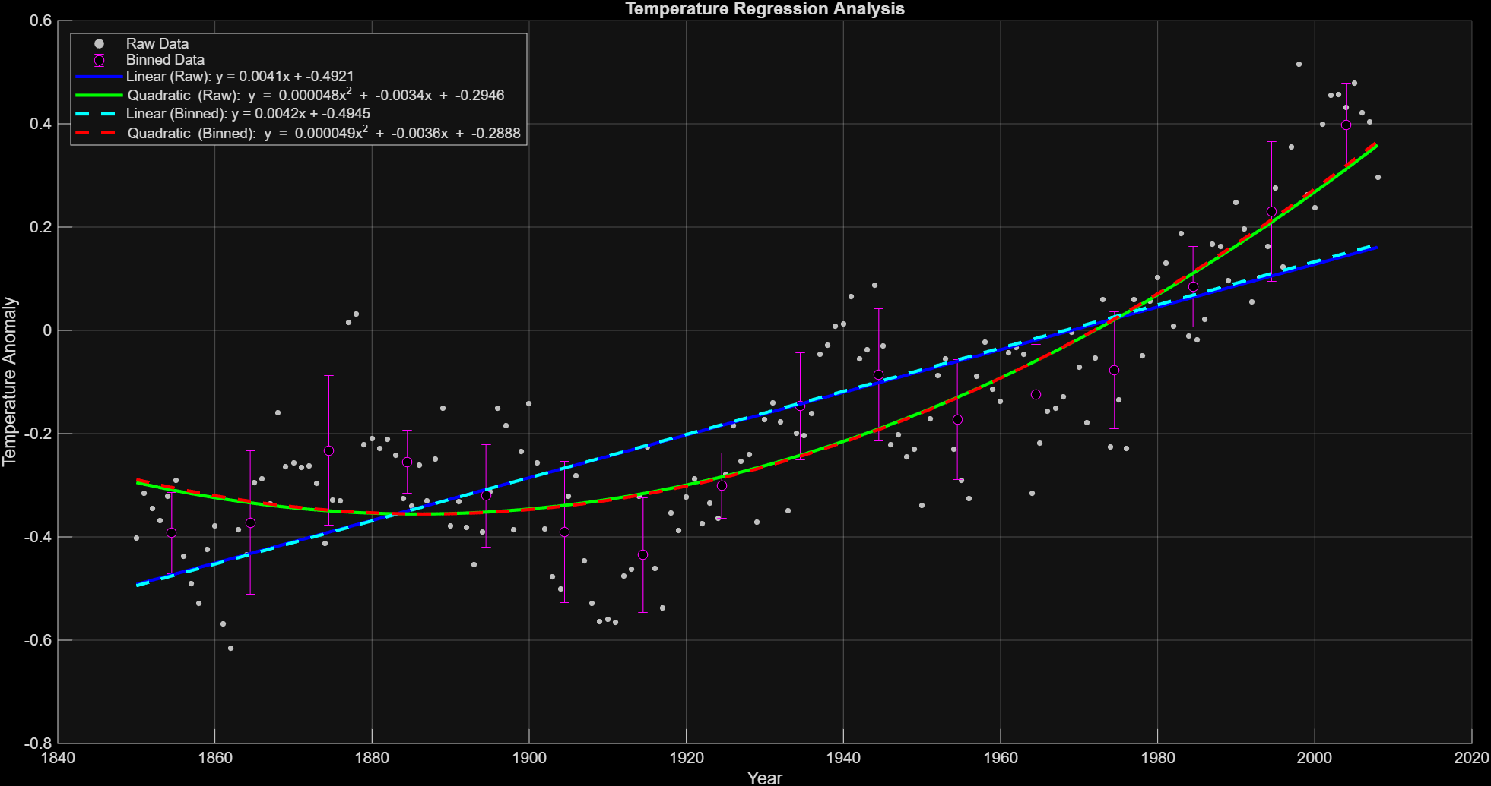
Figure 1: Temperature vs. Time with Raw and Binned Data
Using the binned data and their associated uncertainties, the chi-squared values obtained from the regression fits are
$$χ_{min, linear}^{2}=26.4064$$
$χ_{min, quadratic}^{2}=10.1318$.
The difference in chi-squared between the two models is
$Δχ^{2}=16.2746$.
This value was then compared to the critical value 6.63, corresponding to one additional degree of freedom at the 99% confidence level.
5. Discussion
Figure 1 shows that global temperatures have generally increased from 1850 to 2008. Grouping the data into bins helps smooth out short-term ups and downs, making the overall trend easier to see. By calculating the mean and standard deviation for each bin, we get representative values with a sense of the uncertainty, which makes the regression models easier to interpret. The error bars on the binned data show how much variation there is within each group and give a visual sense of how well the models match the actual measurements.

The chi-squared values for the linear and quadratic models can be used to test whether the additional quadratic term is statistically justified. By comparing the difference in chi-squared ($Δχ^{2}$) to the critical value for a 99% confidence level (p = 0.01), we can determine whether the quadratic term is necessary ($Δχ^{2}>χ_{crit}^{2}=6.6$). In this case, the test shows that the quadratic component significantly improves the model, indicating that it is justified.
6. Conclusion
In conclusion, the analysis shows that global temperature data from 1850 to 2008 are well described by both linear and quadratic models, but the quadratic model provides a statistically significant improvement. Binning the data helped reduce the impact of short-term fluctuations and clarified the overall trend, while the error bars highlighted the variability within each group of measurements. Comparison of the chi-squared values and the Δχ² test at the 99% confidence level demonstrates that the additional quadratic term is justified, indicating that temperature changes over this period are not strictly linear. Overall, this study illustrates how regression analysis, combined with proper statistical evaluation, can reveal meaningful trends in complex physical data.
7. Appendices
Appendix A: Complete MATLAB code for graphing and calculations:
% model_selection.m
%% Temperature Data

t = (1850:2008)';
t0 = t - 1850; % shift year for later calcs

Temp = [
-0.402; -0.315; -0.345; -0.368; -0.321; -0.291; -0.438; -0.491; -0.529; -0.424;
-0.378; -0.568; -0.616; -0.386; -0.434; -0.295; -0.287; -0.336; -0.16; -0.264;
-0.257; -0.265; -0.262; -0.296; -0.412; -0.328; -0.33; 0.015; 0.031; -0.222;
-0.21; -0.229; -0.211; -0.242; -0.325; -0.34; -0.261; -0.33; -0.249; -0.15;
-0.378; -0.332; -0.381; -0.453; -0.391; -0.313; -0.15; -0.185; -0.386; -0.235;
-0.142; -0.257; -0.384; -0.477; -0.501; -0.321; -0.281; -0.446; -0.529; -0.564;
-0.559; -0.566; -0.476; -0.463; -0.322; -0.225; -0.461; -0.538; -0.354; -0.387;
-0.323; -0.287; -0.374; -0.335; -0.364; -0.279; -0.184; -0.253; -0.24; -0.372;
-0.173; -0.141; -0.177; -0.349; -0.199; -0.203; -0.161; -0.046; -0.028; 0.008;
0.013; 0.066; -0.055; -0.038; 0.087; -0.03; -0.221; -0.202; -0.245; -0.23;
-0.339; -0.172; -0.088; -0.055; -0.23; -0.291; -0.326; -0.089; -0.023; -0.114;
-0.137; -0.044; -0.033; -0.047; -0.315; -0.219; -0.157; -0.151; -0.129; -0.004;
-0.072; -0.178; -0.054; 0.06; -0.226; -0.134; -0.229; 0.059; -0.049; 0.056;
0.102; 0.13; 0.008; 0.187; -0.011; -0.018; 0.022; 0.167; 0.163; 0.096;
0.248; 0.197; 0.055; 0.102; 0.163; 0.276; 0.123; 0.355; 0.515; 0.262;
0.238; 0.4; 0.455; 0.457; 0.432; 0.479; 0.422; 0.404; 0.296
];

%% (a) Linear and Quadratic Fits for RAW DATA

p_linear_raw = polyfit(t0,Temp,1);
p_quad_raw = polyfit(t0,Temp,2);

%% (b) Bin Data (n = 10)

bin_size = 10;
N = length(Temp);
num_bins = ceil(N/bin_size);

t_bin = zeros(num_bins,1);
Temp_bin = zeros(num_bins,1);
sigma_bin = zeros(num_bins,1);

for i = 1:num_bins

start_index = (i-1)*bin_size + 1;
end_index = min(i*bin_size,N);

idx = start_index:end_index;

t_bin(i) = mean(t(idx));
Temp_bin(i) = mean(Temp(idx));
sigma_bin(i) = std(Temp(idx));

end

t0_bin = t_bin - 1850;

%% Fits for BINNED DATA

p_linear_bin = polyfit(t0_bin,Temp_bin,1);
p_quad_bin = polyfit(t0_bin,Temp_bin,2);

%% Smooth curves for plotting

tfit = linspace(min(t),max(t),400);
tfit0 = tfit - 1850;

linear_raw_fit = polyval(p_linear_raw,tfit0);
quad_raw_fit = polyval(p_quad_raw,tfit0);

linear_bin_fit = polyval(p_linear_bin,tfit0);
quad_bin_fit = polyval(p_quad_bin,tfit0);

%% Chi-Square Calculation (Binned)

linear_bin_vals = polyval(p_linear_bin,t0_bin);
quad_bin_vals = polyval(p_quad_bin,t0_bin);

chi2_linear = sum(((Temp_bin - linear_bin_vals).^2) ./ (sigma_bin.^2));
chi2_quad = sum(((Temp_bin - quad_bin_vals).^2) ./ (sigma_bin.^2));

disp('Chi-square Linear:')
disp(chi2_linear)

disp('Chi-square Quadratic:')
disp(chi2_quad)

%% Delta Chi-Square Test

delta_chi2 = chi2_linear - chi2_quad;
chi2_crit = 6.63;

disp('Delta Chi-square:')
disp(delta_chi2)

if delta_chi2 > chi2_crit
disp('Quadratic model is necessary at 99% confidence')
else
disp('Linear model is sufficient')
end

%% Plot Everything

figure
hold on

scatter(t,Temp,12,[0.75 0.75 0.75],'filled')
errorbar(t_bin,Temp_bin,sigma_bin,'mo','MarkerFaceColor','k')
plot(tfit,linear_raw_fit,'b','LineWidth',2)
plot(tfit,quad_raw_fit,'g','LineWidth',2)
plot(tfit,linear_bin_fit,'c--','LineWidth',2)
plot(tfit,quad_bin_fit,'r--','LineWidth',2)

xlabel('Year')
ylabel('Temperature Change')
title('Temperature Regression Analysis')

lin_raw_eq = sprintf('Linear (Raw): y = %.4fx + %.4f', p_linear_raw(1), p_linear_raw(2));

quad_raw_eq = sprintf('Quadratic (Raw): y = %.6fx^2 + %.4fx + %.4f', ...
p_quad_raw(1), p_quad_raw(2), p_quad_raw(3));

lin_bin_eq = sprintf('Linear (Binned): y = %.4fx + %.4f', ...
p_linear_bin(1), p_linear_bin(2));

quad_bin_eq = sprintf('Quadratic (Binned): y = %.6fx^2 + %.4fx + %.4f', ...
p_quad_bin(1), p_quad_bin(2), p_quad_bin(3));

legend('Raw Data','Binned Data',...
lin_raw_eq, quad_raw_eq,...
lin_bin_eq, quad_bin_eq,...
'Location','northwest')

grid on

