MA 465: Introduction to Mathematical Modeling

Project 3
The SIR Model of Infectious Diseases
Based on Kermack and McKendrick 1927

Submitted by: Hannah Kelley
Report Deadline: February 18, 2026
1. Abstract
This report investigates the behavior of an epidemic using the SIR model through analytical interpretation and numerical simulation. The governing equations are examined to identify the roles of key model parameters, and numerical solutions are computed for a fixed population under varying recovery rates. Time-dependent solutions for the susceptible, infected, and recovered populations are used to characterize epidemic duration, peak infection levels, and total disease spread.
The results show that changes in the recovery rate lead to significant differences in epidemic outcomes, even when all other parameters are held constant. Higher recovery rates suppress disease spread and shorten epidemic duration, while lower recovery rates produce prolonged outbreaks with substantially larger peak infection levels and near-total population exposure. These trends are interpreted using the basic reproduction number $R_{0}$, which provides a threshold criterion for epidemic growth. The findings demonstrate the sensitivity of epidemic dynamics to disease parameters and reinforce the usefulness of mathematical modeling for understanding infectious disease behavior.
2. Introduction
This report analyzes one of the most influential and widely used frameworks in epidemiology: the Susceptible–Infected–Recovered (SIR) model, first introduced by Kermack and McKendrick in 1927. The SIR model divides a closed population into three compartments: susceptible individuals $S(t)$, who are at risk of infection; infected individuals $I(t)$, who are actively transmitting the disease; and recovered individuals $R(t)$, who have gained immunity and no longer participate in transmission. The time evolution of these populations is described by a system of coupled nonlinear differential equations that incorporate the effects of disease transmission and recovery. The terms illness, disease, and infection are used interchangeably in this report.
3. Methodology
In this report, the classical SIR model is examined both analytically and numerically. First, the structure of the governing equations is explained, with particular attention given to the physical interpretation of each term and the assumptions underlying the model formulation, following the original work of Kermack and McKendrick. The role of key parameters—population size, transmission rate, recovery rate, and initial number of infections—is discussed in the context of disease dynamics.
The model is then solved numerically for a community of fixed size with varied parameters. Time-dependent solutions for the susceptible, infected, and recovered populations are computed and visualized, allowing the progression of an epidemic to be analyzed in detail. Special emphasis is placed on the basic reproduction number $R_{0}$, which serves as a threshold parameter determining whether an epidemic grows or dies out. By comparing simulations with different recovery rates, the report illustrates how changes in disease duration influence epidemic severity, duration, and total number of infections.
4. Explanation of Equations and Fixed Parameters
The key set of equations in the SIR Model is:
$$\begin{aligned}\left\{\begin{aligned}\frac{dS\left(t\right)}{dt}=-β\frac{S\left(t\right)I\left(t\right)}{N} \\ \frac{dR\left(t\right)}{dt}=μI\left(t\right) \\ \frac{dI\left(t\right)}{dt}=β\frac{S\left(t\right)I\left(t\right)}{N}-μI\left(t\right)\end{aligned}\right.\#(1)\end{aligned}$$
The parameters in these equations are:
$$\begin{aligned}\left\{\begin{matrix}N:total population \\ y_{0}:initial infections \\ β:transmission rate \\ μ=\frac{1}{T}:recovery rate\end{matrix}\right.\#(2)\end{aligned}$$
The SIR Model considers a closed population of fixed size $N$ where no births, deaths, or migrations occur during the time period considered, consider in terms of days for this report. In other words, the population considered by the model is constant. The greater population $N$ is divided into three smaller populations: susceptible individuals $S(t)$, who are at risk of infection; infected individuals $I(t)$, who are actively transmitting the disease; and recovered individuals $R(t)$, who have gained immunity and no longer participate in transmission. Since the population is constant in the period considered, we know that:
$$\begin{aligned}N=S\left(t\right)+I\left(t\right)+R\left(t\right)\#(3)\end{aligned}$$
The mechanism driving the epidemic is contact between susceptible and infected individuals. This contact transmits disease or infection from person to person. The rate at which susceptible persons are infected is the transmission rate $β$. Because transmission requires contact between a susceptible and infected individual, the rate of new infections is proportional to $S(t)$ and $I(t)$. To consider the transmission rate relative to the entire population, the following relationship can be used:
$$\begin{aligned}\frac{βS\left(t\right)I\left(t\right)}{N}\#(4)\end{aligned}$$
The change in the susceptible persons is the number of persons currently susceptible minus the number of people who were susceptible but have contracted the infection. In math terms, the rate of change in the susceptible population is the negative of the rate of infection shown in equation 4. This rate of change is the differential equation found on the first line of equation 1:
$$\frac{dS\left(t\right)}{dt}=-β\frac{S\left(t\right)I\left(t\right)}{N}$$
The recovered population are those that were infected but recovered from the illness and have gained immunity (ie they can no longer be infected). Recovery is said to happen only because persons have gained immunity and not because of death or other removal from the population. The rate at which a person recovers—or the recovery rate $μ$—is defined as the inverse of the average duration of the illness $T$:
$$\begin{aligned}μ=\frac{1}{T}\#(5)\end{aligned}$$
The initial infected population is $y_{0}$. If an initial infection is not present, then the epidemic has no starting point. Likewise, if the initial infected population is too small, the entire population may recover before the chance to infect a susceptible person occurs. The rate of change of the recovered population depends only on the number of infected individuals who recover per unit time. The rate at which the infected population recovers is then the product of the recovery rate $μ$ and the number of infected individuals. This is expressed in the differential equation found on the second line of equation 1.
$$\frac{dR\left(t\right)}{dt}=μI\left(t\right)$$
Since the total population must always equal $N$ as shown in equation 3, we know that the change in the infected population must equal the number of new infection minus the number of recoveries. This rate of change is the differential equation found on the third line of equation 1.
$$\frac{dI\left(t\right)}{dt}=β\frac{S\left(t\right)I\left(t\right)}{N}-μI\left(t\right)$$
Combining all three of these differential equations gives the classical SIR Model with four parameters: the total population size $N$, the initial infections $y_{0}$, the transmission rate $β$, and the recovery rate $μ$.
A key quantity used to describe the behavior of the model is the basic reproduction number $R_{0}$ which represents the average number of secondary infections a single infected individual introduces into a fully susceptible population. The basic reproduction number is defined in terms of $β$ and $μ$:
$$R_{0}=\frac{β}{μ}$$
5. Data
The SIR Model was evaluated numerically three times using the differential equations and parameters found in equations 1 and 2 of part 4 of this report. The specific values of the parameters used are shown in Table 1.
Evaluation | N | $$y_{0}$$ | $$β$$ | $$μ$$
1 | 1000 | 100 | 1 | 0.5
2 | 1000 | 100 | 1 | 1.1
3 | 1000 | 100 | 1 | 0.1
Table 1: Parameter Values for Each Numerical Evaluation
The data was evaluated in MATLAB using the ode45 function to evaluate the ordinary differential equations. Figures 1 through 3 show the resulting graphs of Evaluations 1 through 3.
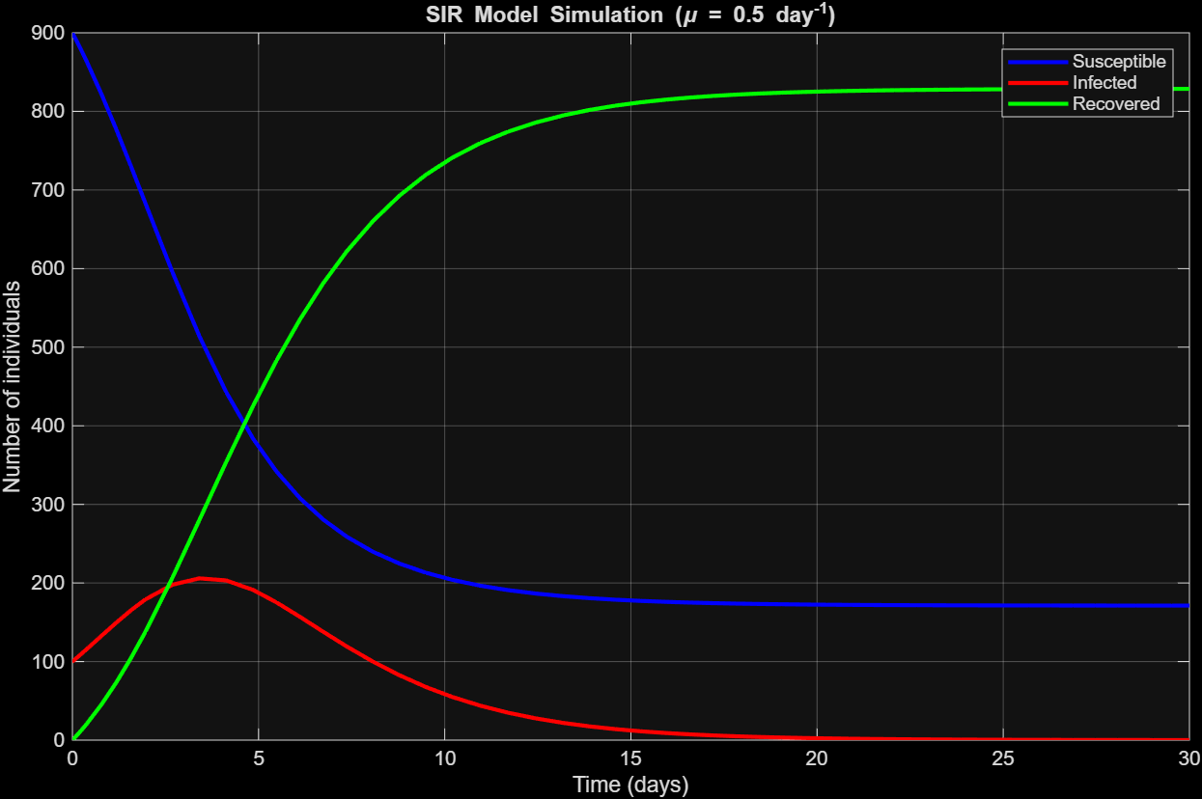
Figure 1: Evaluation 1 Graph
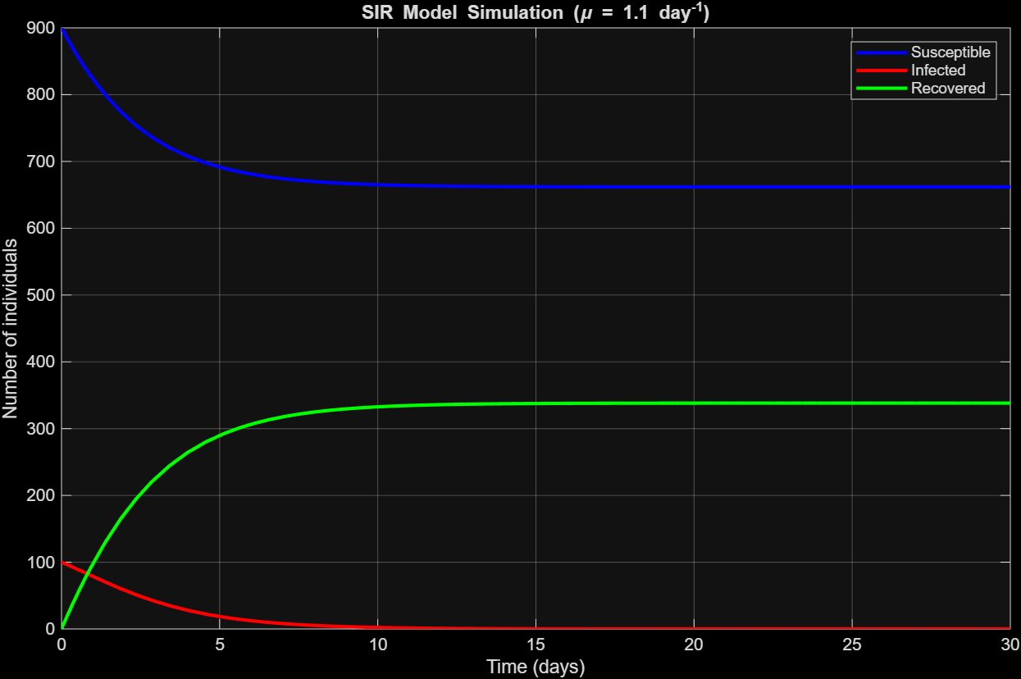
Figure 2: Evaluation 2 Graph
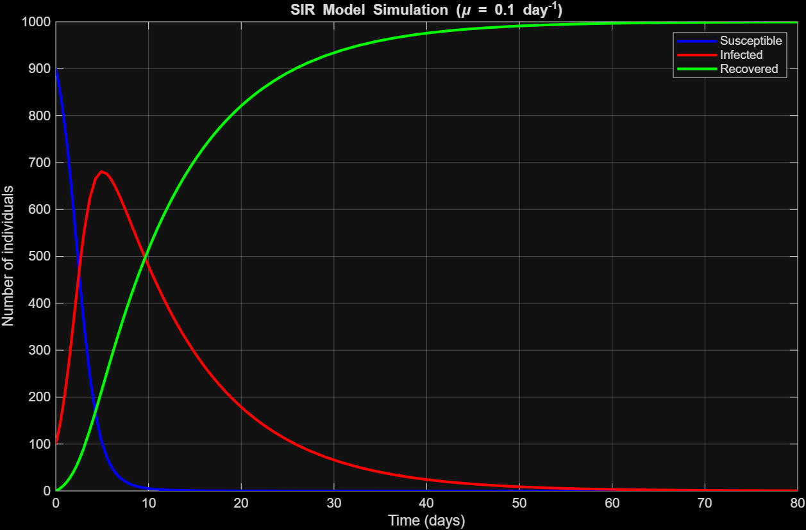
Figure 3: Evaluation 3 Graph

6. Discussion
In Evaluation 1 (shown in Figure 1), the epidemic lasted approximately 22 days. Around 827 individuals were infected over the course of the outbreak, with the remaining 173 individuals never contracting the disease. The number of infected individuals peaked at roughly 205 near day 3. With a moderate recovery rate, the epidemic developed quickly but was unable to infect the entire population before the susceptible pool was sufficiently depleted.
In Evaluation 2 (shown in Figure 2), the epidemic lasted approximately 10 days, with only 335 individuals infected throughout the duration of the outbreak. The peak number of infected individuals occurred at the initial condition, indicating that the disease failed to spread significantly beyond the initially infected population. This behavior is consistent with the higher recovery rate used in this evaluation, which reduces the basic reproduction number $R_{0}$and causes infected individuals to recover before transmitting the disease to many susceptible individuals.
In Evaluation 3 (shown in Figure 3), the epidemic persisted for nearly 60 days, with approximately 996 individuals contracting the disease at some point. The peak number of infected individuals was significantly higher than in the previous cases, reaching approximately 680 individuals around day 4. The substantially smaller recovery rate in this evaluation results in a larger value of $R_{0}$, allowing infected individuals to remain infectious for longer periods and transmit the disease to a larger portion of the population. As a result, the epidemic both lasted longer and infected nearly the entire community.
7. Conclusion
In this report, the classical SIR model was analyzed to study the spread of an infectious disease within a closed population. The model equations were derived from basic assumptions about disease transmission and recovery, and the physical meaning of each term was discussed in the context of the original formulation by Kermack and McKendrick. This framework provides a simple yet powerful mathematical description of epidemic dynamics using only a small number of parameters.
Numerical solutions of the SIR system were obtained for a population of fixed size under several recovery-rate scenarios. The results demonstrated how variations in the recovery rate significantly influence epidemic duration, peak infection levels, and the total number of individuals infected. Higher recovery rates led to shorter outbreaks with reduced spread, while lower recovery rates produced longer-lasting epidemics with substantially higher peak infection levels and near-total population exposure. These trends were shown to be closely linked to changes in the basic reproduction number $R_{0}$, which governs whether an epidemic grows or declines.
Overall, this study illustrates how mathematical modeling can provide valuable insight into the mechanisms that govern infectious disease spread. Despite its simplifying assumptions, the SIR model captures key qualitative features of real epidemics and highlights the critical role of recovery-related parameters in controlling disease transmission. Such models serve as a foundational tool for understanding epidemic behavior and for informing strategies aimed at mitigating the impact of infectious diseases.
8. Appendices
Appendix A: Complete MATLAB code for graphing and calculations:
% SIR MODEL SIMULATIONS

% Fixed parameters
N = 1000;
beta = 1; % day^-1
y0 = 100; % initial infections

% Initial conditions
S0 = N - y0;
I0 = y0;
R0 = 0;
Y0 = [S0; I0; R0];

% Time span (days)
tspan = [0 30];

% Recovery rates
mu_values = [0.5, 1.1, 0.1];

% Loop over cases
for k = 1:length(mu_values)

mu = mu_values(k);

% Extend time span for slow recovery case
if mu == 0.1
tspan = [0 80]; % allow plateau to appear
else
tspan = [0 30];
end

% Solve ODE system
[t, Y] = ode45(@(t,Y) model(t, Y, beta, mu, N), tspan, Y0);

S = Y(:,1);
I = Y(:,2);
R = Y(:,3);

% Plot results
figure;
plot(t, S, 'b', 'LineWidth', 2); hold on;
plot(t, I, 'r', 'LineWidth', 2);
plot(t, R, 'g', 'LineWidth', 2);
grid on;

xlabel('Time (days)');
ylabel('Number of individuals');
legend('Susceptible', 'Infected', 'Recovered');

title(sprintf('SIR Model Simulation (\\mu = %.1f day^{-1})', mu));
end

% SIR model function
function dYdt = model(t, Y, beta, mu, N)
S = Y(1);
I = Y(2);
R = Y(3);

dSdt = -beta * S * I / N;
dIdt = beta * S * I / N - mu * I;
dRdt = mu * I;

dYdt = [dSdt; dIdt; dRdt];
end

