# ContextHub

ContextHub is a framework for storing and retrieving client-side data. It is a JavaScript API which is replacement of clientContext (classic UI) used in older versions of AEM.

ContextHub has to be added to a page for using its data.

It has various stores (default + custom) to store data about user. This stores hold the data which can be accessed at users desire.

Mostly it is used to attain personalization in AEM.

Personalization can be attained in 2 ways

1. In built targeting engine – AEM ContentHub
2. Adobe Target

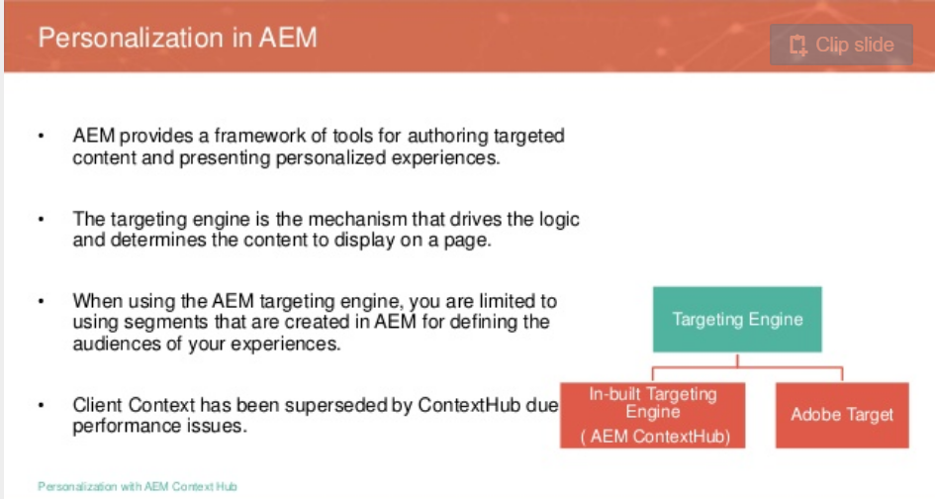

# Disabling contextHub

Edit the ContextHub's configuration and check the option **Disable ContextHub**

1. In the rail click or tap **Tools > Sites > ContextHub**
2. Click or tap the default **Configuration Container**
3. Select the **ContextHub Configuration**and click or tap **Edit Selected Element**
4. Click or tap **Disable ContextHub**and click or tap **Save**

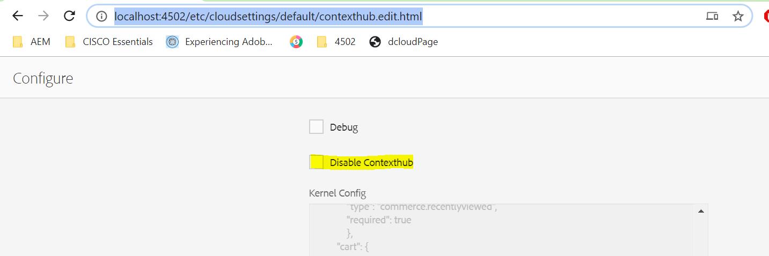

Adobe Granite ContextHub OSGi service can be configured to show/hide the contentHub in UI.

PID is : com.adobe.granite.contexthub.impl.ContextHubImpl

# Adding ContextHub to a Page Component

Add the component **/libs/granite/contexthub/components/contexthub** to the head section to enable contextHub and to use its data

<sly data-sly-resource=*"${‘context_hub', resourceType='***/granite/contexthub/components/contexthub** *'}"* />s

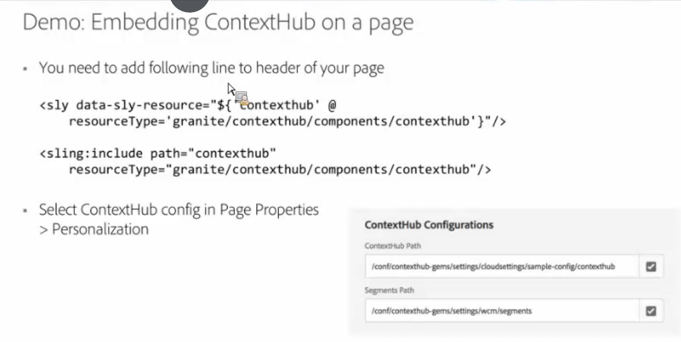

# Creating a custom Store

1. Navigate to <http://localhost:4502/etc/cloudsettings/default/contexthub.html>. It has all the available stored created till now
2. Click on **Create** at top right corner and select **ContextHub Store Configuration**

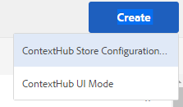

1. The new store is created at **/etc/cloudsettings/default/contexthub/configuration_learni**

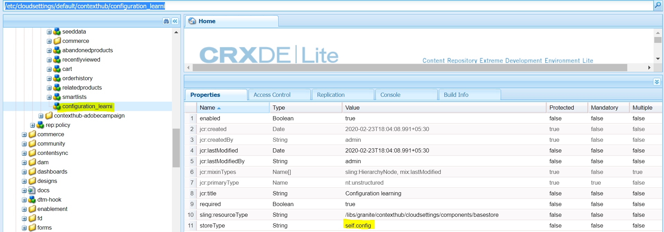

1. The storeType **self.config** is what we will be registering a new store
2. Now create a clientlibs folder where we register the above created store

The important part is to give the clientlibs a **categories** property of **contexthub.store.X contexthub.store.[storeType]** where **X** is the storeType property value of above created store .i.e, **self.config.** So the clientlibs should be registered with **categories** of **contexthub.store.self.config.**

1. This clientlibs has the js file which holds custom store logic for registering a new store

* To create a store candidate, you use the [ContextHub.Utils.inheritance.inherit](https://github.com/AdobeDocs/experience-manager-65.en/blob/master/help/sites-developing/contexthub-api.md" \l "inherit-child-parent) function to extend one of the base stores:
* [ContextHub.Store.PersistedStore](https://github.com/AdobeDocs/experience-manager-65.en/blob/master/help/sites-developing/contexthub-api.md#contexthub-store-persistedstore)
* [ContextHub.Store.SessionStore](https://github.com/AdobeDocs/experience-manager-65.en/blob/master/help/sites-developing/contexthub-api.md#contexthub-store-sessionstore)
* [ContextHub.Store.JSONPStore](https://github.com/AdobeDocs/experience-manager-65.en/blob/master/help/sites-developing/contexthub-api.md#contexthub-store-jsonpstore)
* [ContextHub.Store.PersistedJSONPStore](https://github.com/AdobeDocs/experience-manager-65.en/blob/master/help/sites-developing/contexthub-api.md#contexthub-store-persistedjsonpstore)

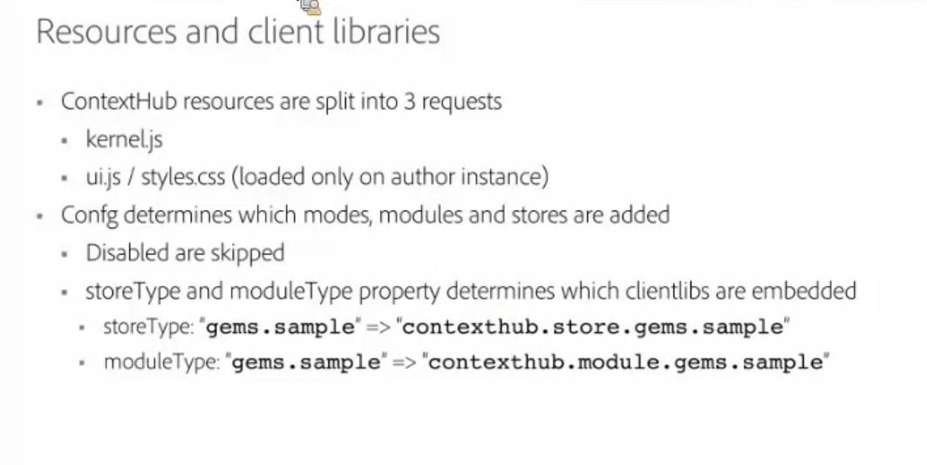

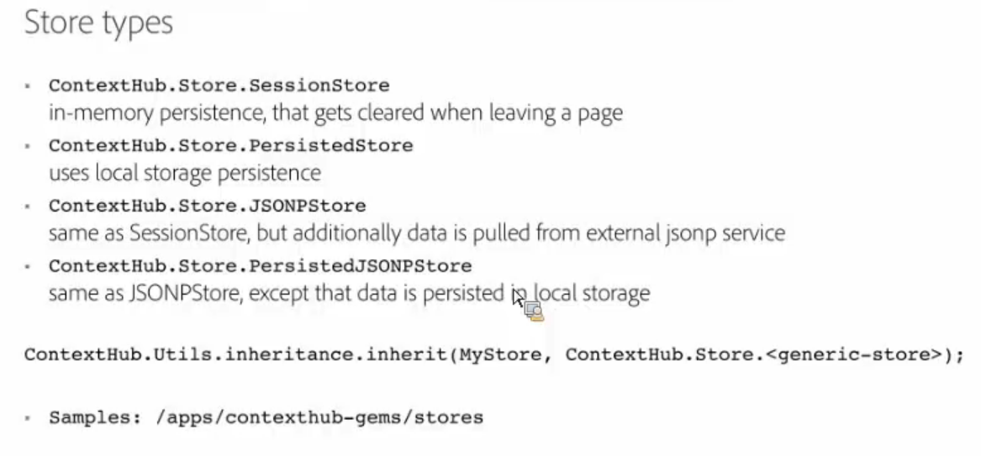

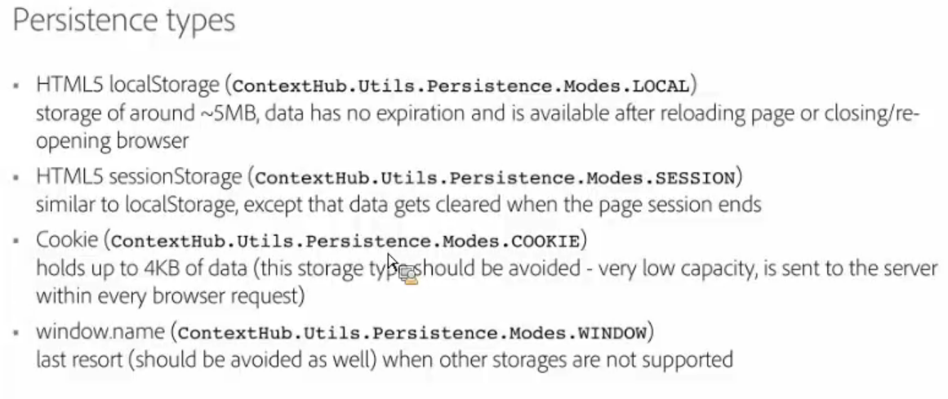

For contextHub.Utils API refer to <https://docs.adobe.com/content/help/en/experience-manager-64/developing/personlization/contexthub-api.html>

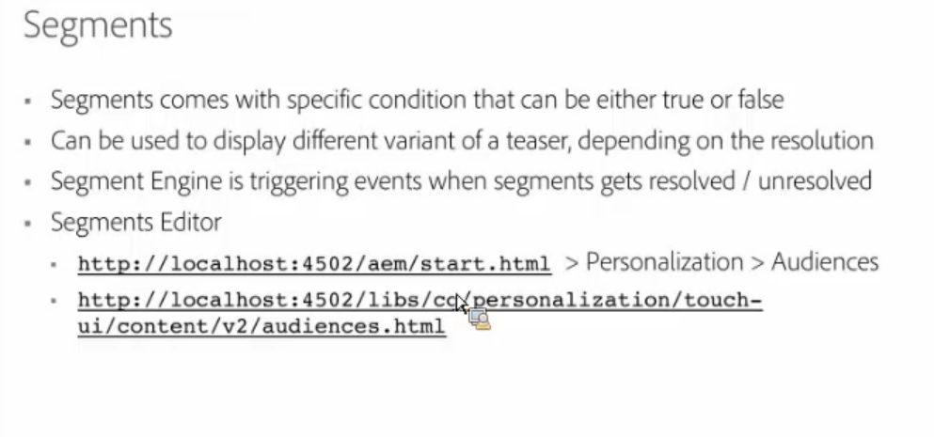

note

**contexthub** is the type of store based on which we group accordingly in diagnostics screen. Refer to below snapshot in Diagnostics section

# Diagnostics

The below screen is visible only when we set the configurations ***debug*** property to ***true.*** In this case, debug property of contentHub configuration has to be set to true

<http://localhost:4502/etc/cloudsettings/default/contexthub.diagnostics.html> 🡪 ***diagnostics*** selector to be used with the contextHub configuration under /etc/cloudsettings

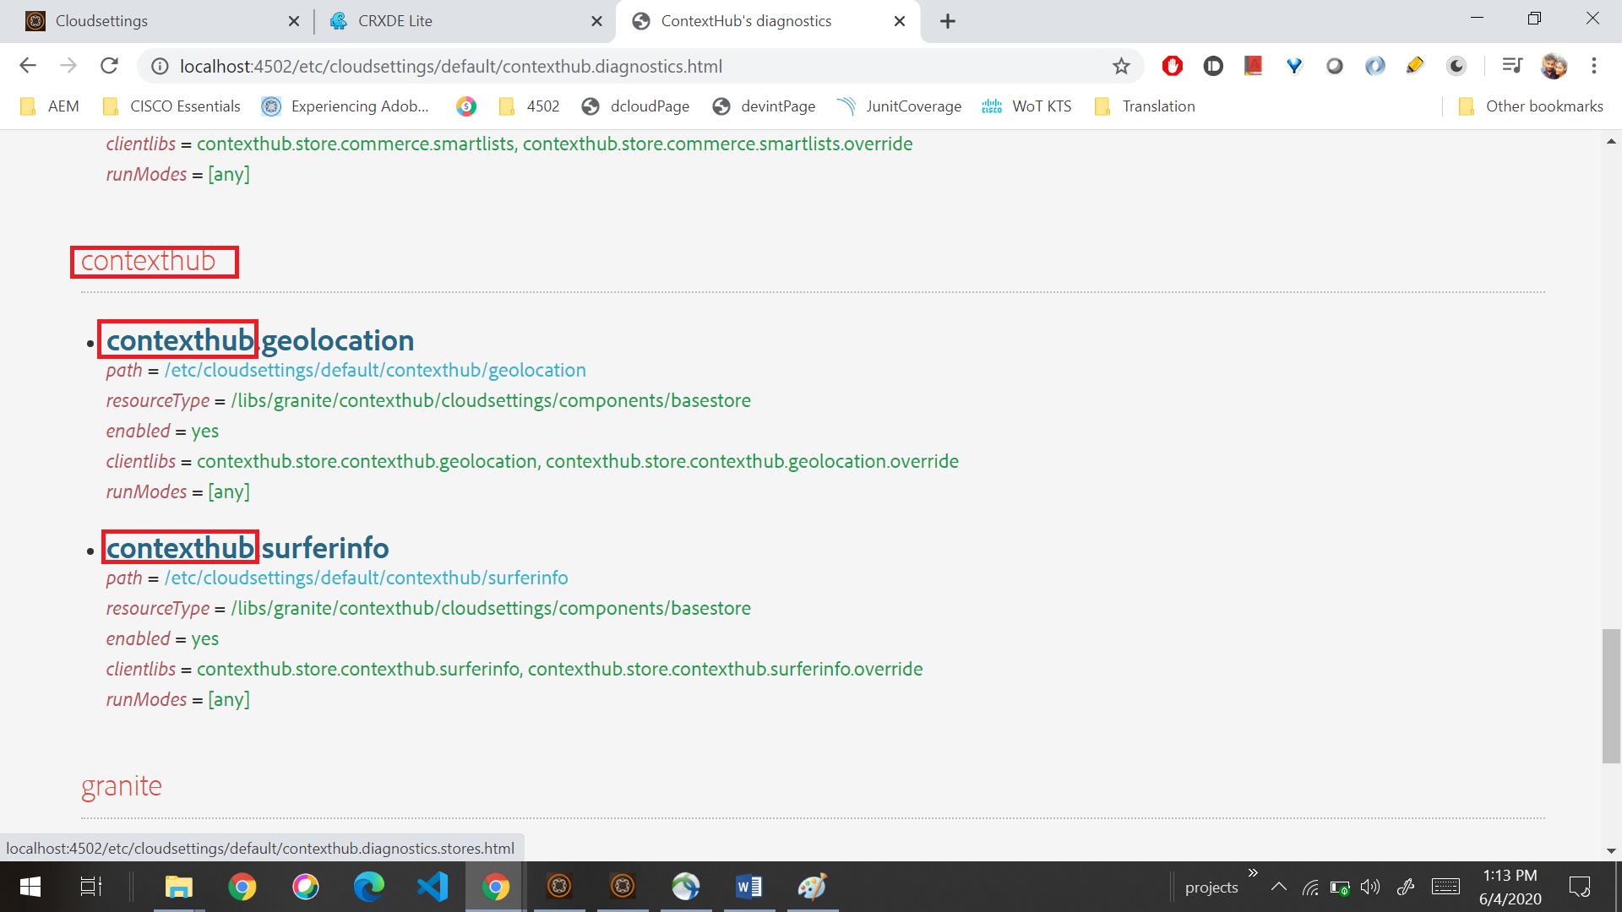

<http://www.basef.com.br/index.php/Configuring_Contexthub_to_Segment_pages_with_Adobe_AEM>

<https://www.conexiogroup.com/personalization-in-aem/>

Adobe Target Integration with AEM - <https://www.bounteous.com/insights/2019/05/20/guide-integrating-aem-adobe-target/>