# apachectl

Configtest – to test the module configuration is valid or not

# Dispatcher

* The Dispatcher stores the cached document in a structure equal to the requested URL.
* Caching methods
  1. Content Updates remove the pages that have changed, as well as files that are directly associated with them.
  2. Auto-Invalidation automatically invalidates those parts of the cache that may be out of date after an update. i.e. it effectively flags relevant pages as being out of date, without deleting anything. Dispatcher compares the requested content’s cached Date & stat file touched date and whichever is newer will be rendered.

# Dispatcher Configuration

Dispatcher has below fields which constitute its behavior

/farms 🡪 array of /farm

Single farm for your entire web content

Multiple farms handling specific parts of website (similar to salesconnect,Techguidance,dclouddocs in Cisco)

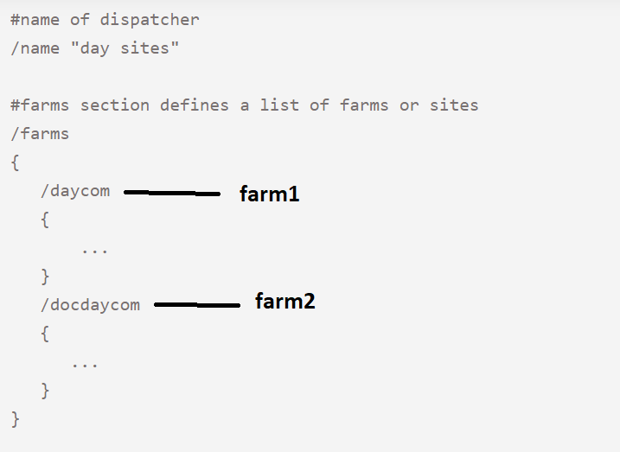

If you use more than one render farm, the list is evaluated bottom-up.

|  |  |
| --- | --- |
| **Property name** | **Description** |
| [/homepage](https://docs.adobe.com/content/help/en/experience-manager-dispatcher/using/configuring/dispatcher-configuration.html#specify-a-default-page-iis-only-homepage) | Default homepage (optional)(IIS only) |
| [/clientheaders](https://docs.adobe.com/content/help/en/experience-manager-dispatcher/using/configuring/dispatcher-configuration.html#specifying-the-http-headers-to-pass-through-clientheaders) | Dispatcher takes care of headers to be passed/removed from the requests based on the configuration in this section for this farm. |
| [/virtualhosts](https://docs.adobe.com/content/help/en/experience-manager-dispatcher/using/configuring/dispatcher-configuration.html#identifying-virtual-hosts-virtualhosts) | The virtual hosts for this farm.  It comprises of [scheme]host[uri][*]  Scheme – http /https  Uri – path to resources   * Evalution of incoming requests starts from last farm to first * And in each farm, top to down fashion is followed for matching   We should place your default virtual host at the top of the virtualhosts property in the topmost farm of your dispatcher.any file. |
| [/sessionmanagement](https://docs.adobe.com/content/help/en/experience-manager-dispatcher/using/configuring/dispatcher-configuration.html#enabling-secure-sessions-sessionmanagement) | If pages in this farm are to be accessed securely, this section takes care of session management by enabling |
| [/renders](https://docs.adobe.com/content/help/en/experience-manager-dispatcher/using/configuring/dispatcher-configuration.html#defining-page-renderers-renders) | Which publish instance takes part in serving the requests when this farm is resolved for incoming request. This property can have multiple publish instances configured |
| [/filter](https://docs.adobe.com/content/help/en/experience-manager-dispatcher/using/configuring/dispatcher-configuration.html#configuring-access-to-content-filter)  When multiple filter patterns apply to a request, the last filter pattern that applies is effective. | Defines the URLs to which Dispatcher enables access. Any rule looks like below  /001 {/type “deny” /method “POST” /url "/content/[.]*.form.html"  }   * Type : allow /deny * Element of the Request Line: */method , /url , /query , or /protocol* * Advanced Elements of the Request Line: new filter elements like */path, /selector,/extension, /suffix* |
| [/vanity_urls](https://docs.adobe.com/content/help/en/experience-manager-dispatcher/using/configuring/dispatcher-configuration.html#enabling-access-to-vanity-urls-vanity-urls) | Configures access to vanity URLs. |
| [/propagateSyndPost](https://docs.adobe.com/content/help/en/experience-manager-dispatcher/using/configuring/dispatcher-configuration.html#forwarding-syndication-requests-propagatesyndpost) | Support for the forwarding of syndication requests. |
| [/cache](https://docs.adobe.com/content/help/en/experience-manager-dispatcher/using/configuring/dispatcher-configuration.html#configuring-the-dispatcher-cache-cache) | Configures caching behavior. |
| [/statistics](https://docs.adobe.com/content/help/en/experience-manager-dispatcher/using/configuring/dispatcher-configuration.html#configuring-load-balancing-statistics) | Defining statistic categories for load-balancing calculations. |
| [/stickyConnectionsFor](https://docs.adobe.com/content/help/en/experience-manager-dispatcher/using/configuring/dispatcher-configuration.html#identifying-a-sticky-connection-folder-stickyconnectionsfor) | The folder that contains sticky documents. |
| [/health_check](https://docs.adobe.com/content/help/en/experience-manager-dispatcher/using/configuring/dispatcher-configuration.html#specifying-a-health-check-page) | The URL to use to determine server availability. |
| [/retryDelay](https://docs.adobe.com/content/help/en/experience-manager-dispatcher/using/configuring/dispatcher-configuration.html#specifying-the-page-retry-delay) | The delay before retrying a failed connection. |
| [/unavailablePenalty](https://docs.adobe.com/content/help/en/experience-manager-dispatcher/using/configuring/dispatcher-configuration.html#reflecting-server-unavailability-in-dispatcher-statistics) | Penalties that affect statistics for load-balancing calculations. |
| [/failover](https://docs.adobe.com/content/help/en/experience-manager-dispatcher/using/configuring/dispatcher-configuration.html#using-the-failover-mechanism) | Resend requests to different renders when the original request fails. |
| [/auth_checker](https://docs.adobe.com/content/help/en/experience-manager-dispatcher/using/configuring/permissions-cache.html) | For permission-sensitive caching, see [Caching Secured Content](https://docs.adobe.com/content/help/en/experience-manager-dispatcher/using/configuring/permissions-cache.html). |

# Cache clearance

Content Update & Auto Invalidation

Content Update touches the ***.stat*** file after every content update.

If cache clearance is configured to be done via **content update**

1. all files with same handle will be removed
2. .stat file is touched to update the recent modification time.

If cache clearance is configured to be done via **auto invalidation,** when the same file is next requested -

1. Dispatcher uses .stat file which is updated at **content update**
2. Dispatcher has list of all files which are configured for auto invalidation
3. It compares the content update time and the recent modification of cached content. Which ever is newer is returned

**NOTE : Only Content Update can delete the old content but not auto Invalidation.** **Documents in the cache that are not auto-invalidated will remain in the cache until a content update explicitly deletes them.**

* Dispatcher creates .stat files in each folder from the docroot folder to the level that you specify. The docroot folder is level 0.
* When a file located at a certain level is invalidated then **all**.stat files from the docroot **to**the level of the invalidated file or the configured statsfilevel (whichever is smaller) will be touched.
* If /statfileslevel is configured, Dispatcher ignores the /statfile property and uses .stat as the name.

# Useful Resources :

<https://helpx.adobe.com/experience-manager/kt/platform-repository/using/dispatcher-macos-technical-video-setup.html>

<https://www.askapache.com/htaccess/mod_rewrite-variables-cheatsheet/#RewriteRule_Flags>

Sling Dynamic Include : <https://docs.adobe.com/content/help/en/experience-manager-learn/foundation/development/set-up-sling-dynamic-include.html>

controlling caching on a page : <https://aemcorner.com/aem-avoid-page-caching-through-request-headers/#:~:text=AVOID%20PAGE%20CACHING%20VIA%20REQUEST,the%20response%20to%20the%20client>