# Schedulers

The scheduler is a service for scheduling other services/jobs. Scheduler jobs are not persisted.

We register schedulers by 2 ways

1. White board pattern – which we normally use
2. Scheduler API –

# White board pattern

After registering the scheduler as a component, we specify a property

‘***scheduler.expression***’ with some value as below

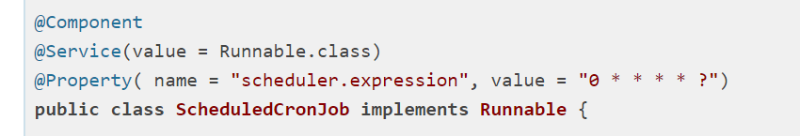

Below table shows the way we should schedule a job with a space after each value

|  |  |  |  |  |  |  |
| --- | --- | --- | --- | --- | --- | --- |
| Seconds | Minutes | Hours | Day of Month | Month | Day of week | year |

Cron job - “0 * * * * ”

Periodic job – *(name = “scheduler.expression” , longValue = “10”)*

To prevent concurrent execution - (name = “scheduler.concurrent” , boolValue = false)