Of Damietta: Maqamat 4

Author: Sophia Stewart

The assembly begins with al-Harith who is wealthy and is journeying with his caravan. When the travelers finally arrive in the middle of the night, al-Harith overhears a conversation on moral behaviors’. al-Harith discoveres that it is Abu Zayd and his son. Al-Harith moves towards Abu-Zayd who is a conversation with his son. Abu-Zayd is speaking to his son, “before the camels have risen”. al-Harith is surprised and pleased to have found his friend and this expression can be seen through the typical gesture of the finger being held to the mouth which can be seen here in the image.

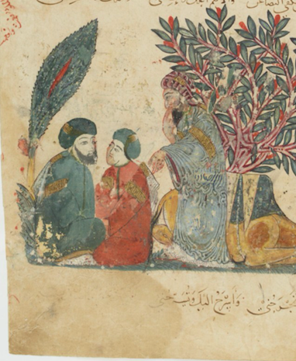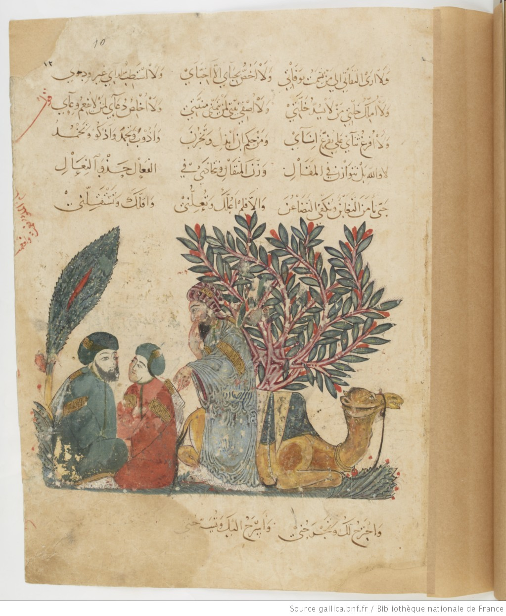

This expression can be seen in other assemblies and has a general meaning of joy or pleasure. This image is depicting when al-Harith pleasantly discovers the two men who were speaking about moral stories the night before. He gives the two money and gifts and encourages the other members of the caravan to give them the same. Abu Zayd who now has been showered with gifts, announces he is going to a nearby village to wash and then he would return. However, he does not return. After some time, al-Harith finds a note on the saddle of his camel, the notes reveals Abu Zayds trick of taking the gifts and leaving.

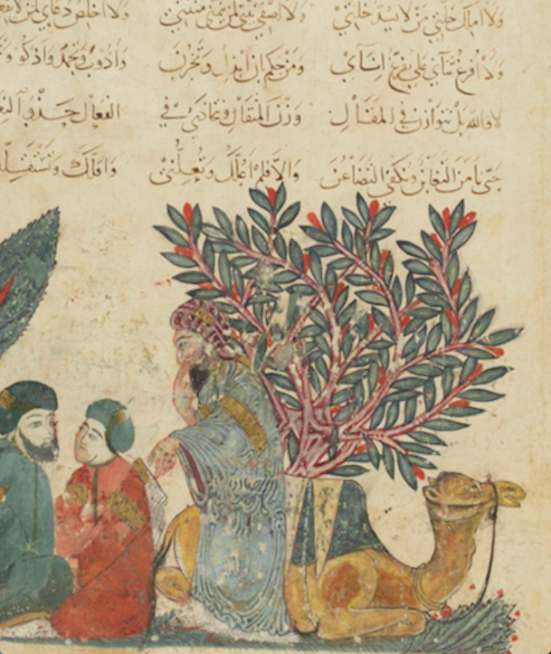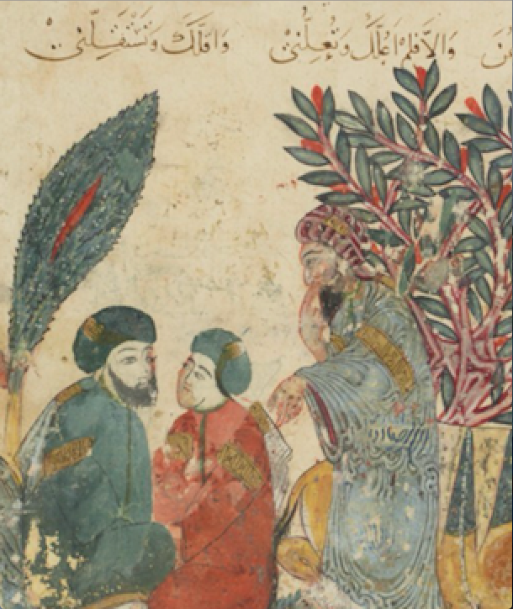

The image is depicting an intimate scene of close conversation between Abu-Zayd and his son and as well illustrating al-Harith joining them in the conversation. The lush landscape that surrounds them is representing a forest with its leafy greens and red branches. The forest also seems to offer protection enabling Abu Zayd and his son to be semi discrete in their moral conversation. Abu-Zayd’s son appears very young and youthful next to the two men with beards. He seems very engaged in the conversation between himself and Abu-Zayd. Al-Hariths has the notion of reaching through is hand as if he is reaching for the son and Abu Zayd whom he has just stumbled upon.



