**Evaluation Evidence: Coding Screenshots**

**KaseiCoin.Sol**

**Crowdsale Code Screenshot**

**Create KaseiCoin Deployer Contract**

**KSCoin Deploy**

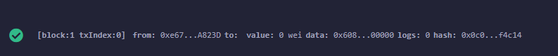

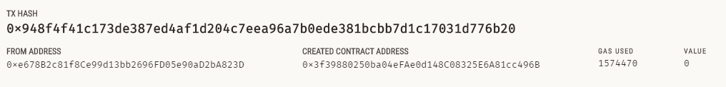

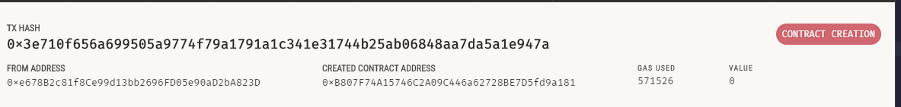

**Evaluation Evidence: Transaction Screenshots**

The transaction is carried out in the following 3 steps:

1-) Deployer

2-) Crowdsale

3-) Buy Tokens

The Screenshots for each of these 3 steps are demonstrated below:

**1-) Deployer**

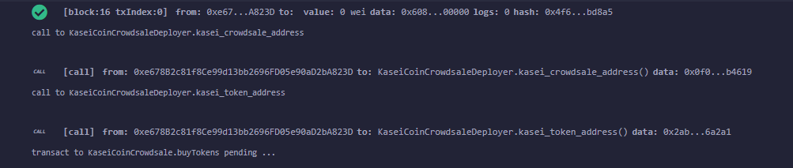

**2-) Crowdsale:**

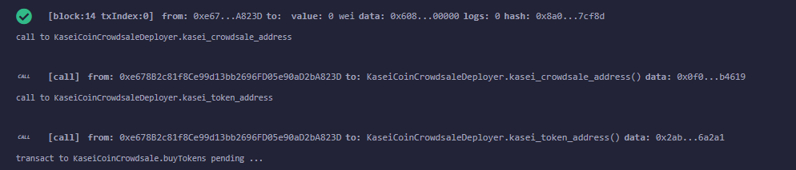

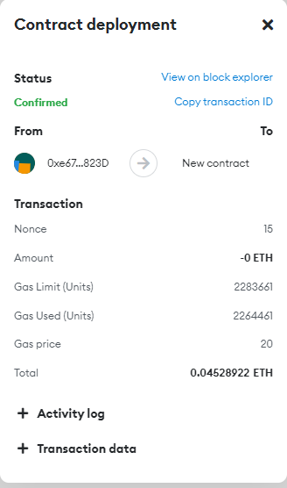

**3-) Token:**

**Transaction Summary**

