Project 1: Static Foundations
Feedback for hatem.dev
Student: Hatem Alkhatib Course: CSC 436, Fall 2026 Reviewed at: 235d8cb
Repo: github.com/hkhatib005/Hatem Live: hkhatib005.github.io/Hatem

Your grade is posted in Brightspace. This document is the reasoning behind it, category by category.

How this review was made
Your instructor reviewed this project with Claude (Anthropic's AI) as a second set of eyes. Claude cloned the repo, read the 702-line page including its embedded stylesheet and script, ran the W3C validator, loaded the live site in real viewports at 320, 375, 768 and 1280 pixels, opened and closed the mobile menu, scrolled to check the active-link highlight and the fade-in, compared the live site to the repo, and read all 32 commits and both stale branches. Every note in this document was read and approved by your instructor.

The short version
As a portfolio, this is one of the strongest pages in the class. The content is specific and real: a named internship with a concrete system and a scale figure, a previous role, six projects with live links and repos, a press mention, certifications. The design is a coherent dark theme built on fifteen custom properties, with Flexbox for every row and Grid for the about, projects and programs sections. The mobile menu sets aria-expanded correctly and closes itself when you pick a link. The active-link highlight and the fade-in both work. Nothing scrolls sideways at 375, 768 or 1280, and the validator finds one error, which is a favicon.
As a submission for this assignment, it has a different problem, and it is the one to talk about first. The repository's last commit is July 19. The course started in late August and Project 1 was due September 15. There is no commit in that window, so the history does not show this project being built; it shows a portfolio that already existed. The brief's repository requirements are written around the history of the assignment itself. The README is a title and the single word "Profolio." The site is on GitHub Pages where the brief specifies Netlify. And the repo carries four unrelated standalone pages from May, an unused 311 KB image, two stale branches and five commits that only edit a CNAME file.
In the code, the gaps are about structure rather than looks. The nav is not inside a header, the seven sections are not inside a main, and every company name, job title and project name is a div instead of a heading, so the page's outline is one h1 and six h2s with nothing underneath. All 360 lines of CSS and all 47 lines of JavaScript are embedded in the HTML while a styles.css and a script.js sit in the repo unused by this page. There are no images at all. Twelve links open new tabs without rel="noopener". There is no focus style and no reduced-motion rule for the fade-ins.

What Claude measured
Check | Result
W3C HTML validator | 1 error (a space inside the data-URI favicon), 13 info notes
Horizontal scroll at 375 / 768 / 1280 px | None. At 320 px the page is 32 px wider than the screen
Heading order | One h1, six h2, zero h3. Company, role and project names are divs
Semantic elements | nav (ul of 4), 7 section, footer. No header, no main, no article
Layout | 19 Flexbox containers, 3 Grids (about 1 to 2, projects 2 to 3, programs 2 to 3), 2 with auto-fit
Media queries | 1, max-width: 768px (desktop-first)
Custom properties / !important | 15 defined, 76 uses / 5, all hero animation delays
Focus styles / reduced motion | 0 / 0
Mobile menu | Opens with aria-expanded="true", closes on link click; Escape does nothing
Active-link highlight | Works on scroll; plain scroll listener, no throttle
Fade-in | IntersectionObserver on 4 card types, writes inline styles; runs regardless of motion preference
Console errors | 0
Images | 0 on the page. coursework-avatar.png (549 by 652, 311 KB) is committed and unused
External links | 12 with target="_blank", 0 with rel="noopener"
Where the CSS and JS live | 360 lines of CSS and 47 of JS inside index.html; styles.css and script.js are used only by requirements.html
Commits | 32, Feb 10 to Jul 19 2026. None after the course began
Other files | 4 standalone pages from May, none linked from the site
README | "# Hatem / Profolio" (1 of 4 items, with a typo)
Hosting | GitHub Pages from main; the brief specifies Netlify
Live vs repo | Identical

The site, phone and desktop
Phone, 375 by 667, full page. Hamburger, stacked hero, one-column cards. | 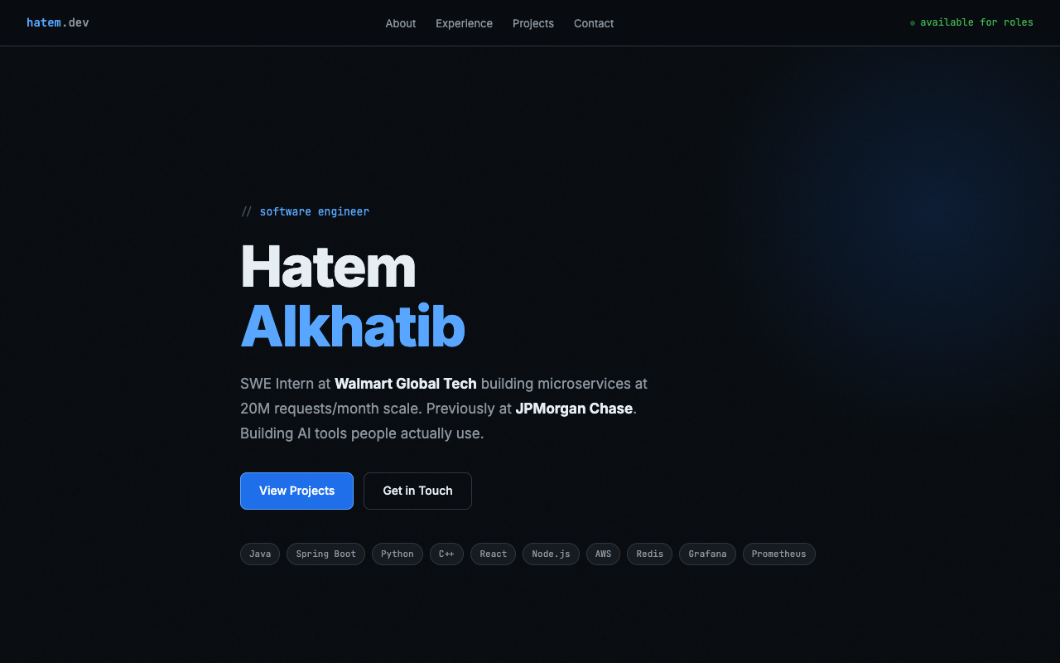  Desktop, 1280 by 800. Nav bar with status pill, full-height hero.

Semantic HTML

What is working
- One h1, a real nav with a ul of links and a button for the toggle that carries aria-label and aria-expanded (index.html lines 381 to 393). Seven sections, each with an id the nav targets and an h2. A footer. lang="en", a viewport tag, a description, Open Graph and Twitter tags, an inline SVG favicon. The experience bullets are a real ul.

What to change
- No header, no main. The nav sits directly in body and so do the seven sections (lines 381 and 396). Wrap the nav in header and the sections in main. Those two elements are the landmarks a screen-reader user jumps between, and the brief lists both by name.
- Every card title is a div. "Walmart Global Tech," "Software Engineering Intern," "Dolphin Planner": all div.exp-company, div.exp-role, and so on (lines 463 to 471). The document outline is one h1 and six h2s with nothing under them, so nobody can jump to a job or a project by heading. Make each card an article with an h3 for its name. The look does not have to change; the classes stay.
- The one validator error (line 14): the data-URI favicon contains raw spaces. Encode them as %20 or move the SVG to a file.
- Twelve links open new tabs with no rel. Add rel="noopener noreferrer" to every target="_blank". It is a security default, and it is one find-and-replace.
- Small: the strong tag with an inline color on line 525 is the only inline style in the source. Give it a class.
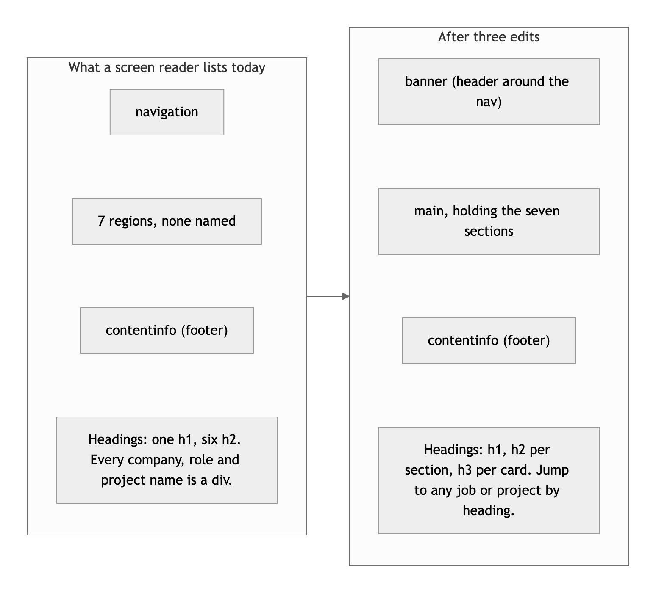
Diagram 1. What a screen reader lists today, and after header, main and h3s.

CSS layout

What is working
- A real token system. Fifteen custom properties for the palette, borders and accents (lines 20 to 36), used 76 times, so the GitHub-dark look is consistent from the nav to the footer. Nineteen Flexbox containers do the rows. Three Grids do the two-dimensional work, and two of them are repeat(auto-fit, minmax(...)), so the project and program cards go from three columns to two to one without being told. Hover states, a hero entrance animation, and clamp() on the display type.

What to change
- The stylesheet is in the wrong file. All 360 lines of CSS are in a style block inside index.html (lines 18 to 377), and the 47 lines of JavaScript are in a script block at the bottom (lines 655 to 701). Meanwhile styles.css and script.js exist in the repo and are loaded only by requirements.html, a page the site never links to. The brief asks for separate CSS and JS files. Move the block into styles.css, the script into script.js, and link them. The HTML drops from 702 lines to about 300.
- Desktop-first, single breakpoint. The one media query is max-width: 768px (line 358). The brief asks for mobile-first: base rules for the phone, min-width queries adding columns. With two of your three grids already using auto-fit, the flip is mostly the nav and the about grid.
- No focus styles, no reduced-motion rule. Tab through the page and the links get the browser default ring, which is hard to see on #080c10. One :focus-visible rule fixes it. The hero animates in and the cards fade in for every visitor; wrap those in a prefers-reduced-motion query. The five !importants (lines 318 to 322) are animation delays that would not need forcing if the base rule did not set a delay.

Responsive design

What is working
- No horizontal scroll at 375, 768 or 1280, measured in real viewports. The nav collapses to a hamburger, the about grid goes from two columns to one, the project and program grids reflow on their own, and the hero type scales with clamp().

What to change
- Tablet is the phone layout. With one breakpoint at 768, a 768-wide screen gets the hamburger and single-column about, the same as a phone. A min-width: 600px step for the about grid and the nav would use the width a tablet has.
- At 320 px the page is 32 px wider than the screen. The brief's bar is 375, so this is a note, not a deduction; the hero tags or the nav status pill are the likely cause.

JavaScript interaction

What is working
- Three interactions, all verified, all vanilla. The menu toggle flips a class and aria-expanded from the same boolean and closes on any link click (lines 657 to 670), which is the cleanest toggle pattern in the class. The active-link highlight compares scroll position to section offsets and moves an active class (lines 673 to 684); Claude scrolled to 2,500 px and "Experience" lit up. The fade-in uses an IntersectionObserver rather than a scroll handler (lines 686 to 700). Zero console errors.

What to change
- The scroll listener runs on every scroll event with no throttle, and it never unobserves. Wrap the highlight in requestAnimationFrame, or better, use a second IntersectionObserver for it too; you already have the pattern.
- The fade-in writes inline styles (opacity, transform, transition) onto every card at load. Toggle a class instead and keep the styling in CSS, which also lets a reduced-motion rule switch it off; today the animation runs for everyone, and there is no matchMedia check.
- Small: Escape does not close the open menu, and focus is not returned to the button. Four lines.

Repository and deployment

What is working
- The live site is public and matches the repo byte for byte. Most of the later commit messages say what changed: "Strip generic template gimmicks from portfolio," "Fix stat inaccuracy, add DealBox and Park Ave Jewelers projects." Two branches were merged through pull requests, which is a good habit.

What to change
- The history does not show this project being built. All 32 commits fall between February 10 and July 19, 2026. The course began in late August and the project was due September 15; there is no commit in that window. The brief's repository category is written around the history of the assignment: a README for it, commits that show it developing, a deploy of it. Your instructor will decide how the pre-existing work is treated; that is not a call this review makes. What the review can say is that if Project 1 work was done, it is not in the repo, and the fix for next time is to commit the work as it happens.
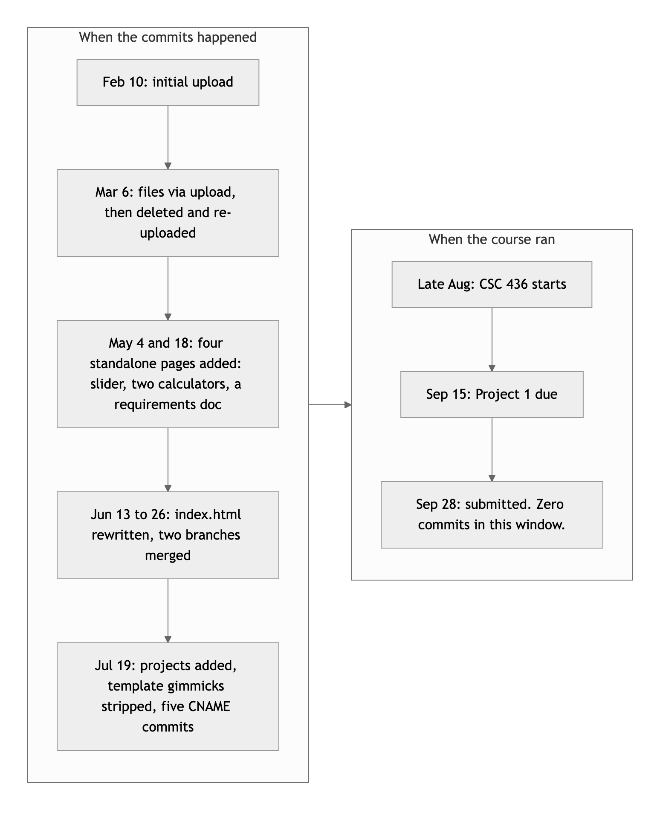
Diagram 2. When the commits happened, next to when the course ran.
- The README is one word: "Profolio." The brief asks for a title, a description, how to run it, and the live URL. Ten minutes.
- The brief says Netlify. It names Netlify as the deploy target three times. The site is on GitHub Pages, which works and is public, so this is a small deduction, but connecting the repo to Netlify is a five-minute task the rest of the semester builds on.
- Housekeeping. Four unrelated standalone pages from May sit in the repo and nothing links to them. coursework-avatar.png is 311 KB and used nowhere. Two branches are fully merged and should be deleted. Five of the last six commits only touch a CNAME file that was then removed. There is no .gitignore. Commits are signed by three different identities. A recruiter who clicks through to this repo from the portfolio sees all of that before they see the site.

Content and polish

What is working
- This is the best content in the class. Every claim is specific: what was built, at what scale, with which tools, and where to see it. Six projects with both live links and repos. A press mention with a link. Certifications named. An "available for roles" status, contact links, and Open Graph tags so the page previews correctly when shared. The writing is confident and short. The design is consistent, the favicon is custom, and the footer is signed.

What to change
- There are no images. The brief asks for real images with alt text, and the page has none: no photo, no project screenshots, no logos. The avatar you committed in June was removed from the page two days later and is still in the repo. One photo in the hero and a screenshot per project card would cover it and would make the projects section far more convincing than tag pills alone.
- Small: the four hidden pages from May carry their own titles with your name in them and are reachable by URL. Either link them from the portfolio as coursework or remove them.

Your next moves
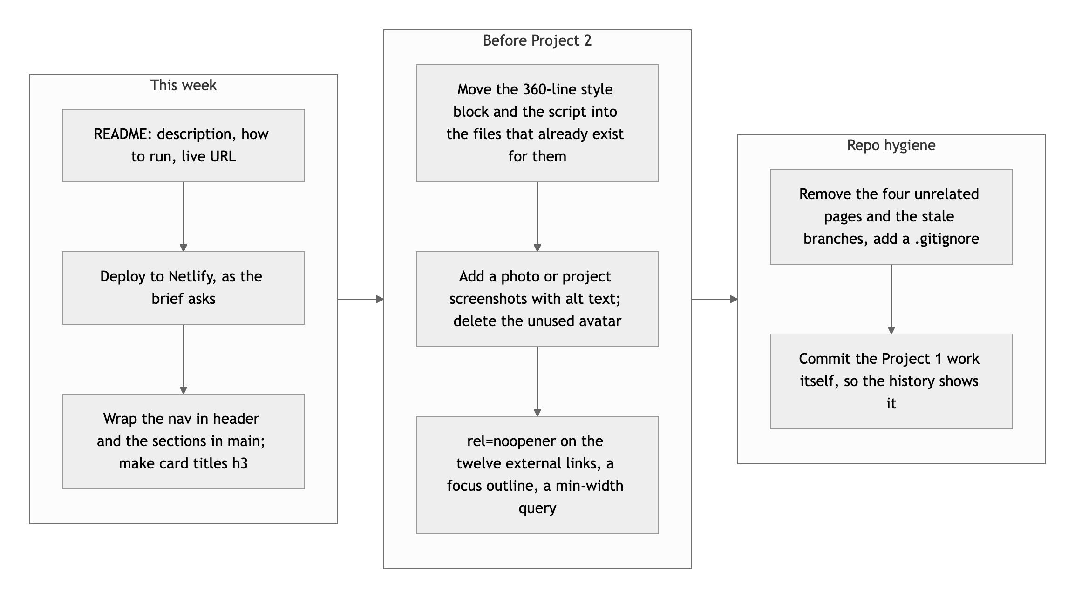
Diagram 3. This week, before Project 2, and the repo.
- Do the paperwork. README, Netlify, header and main, h3 on the cards. Under an hour, and it is most of what the rubric is missing.
- Put the CSS and JS in their files, and add images. The files already exist. A photo and six screenshots with alt text.
- Clean the repo. Remove what is not the portfolio, delete merged branches, add a .gitignore, and from now on commit the coursework as you do it.

The portfolio is already doing its job, Hatem; the assignment asks for the scaffolding around it.
This review lives in a pull request on your repo. It only adds feedback files and does not touch your code. Your grade is in Brightspace. Questions go to office hours or the Brightspace board.

