Eliminating Support Escalations Through Human-in-the-Loop Feedback Loops and Persistent State Memory
By Hari Krishnan, Lead Orchestration and Autonomous Agent Engineer, Autofix-AI

About the Author
Hi, I'm Hari Krishnan. On Autofix-AI, I built the back half of the system: the autonomous execution engine, the Human-in-the-Loop (HITL) gatekeeper, and the real-time Memory Inspector UI. My teammate Harini built the ingestion side, the multimodal vision pipeline, the Error Signature Synthesizer, and the Hindsight memory indexer. She covers that in her article, "How We Built a Multimodal Vision Pipeline That Indexes Error Screenshots into Persistent Memory."
This article covers what happens after an incident has been turned into a clean diagnostic signature: how the agent decides whether to act, how humans teach it, and how every fix becomes permanent memory.

The Brittle Execution Problem
The main failure mode of autonomous AI agents in enterprise operations is brittle execution. An agent with tool-calling is often fine on linear tasks in pristine environments. In live corporate infrastructure, though, it meets transient network latency, permission drops, and outdated configurations. A stateless agent that hits a failed step either loops forever or terminates abruptly, leaving the ticket unresolved.
We built the Autofix-AI orchestrator to avoid both outcomes. It combines three things:
- Autonomous tool execution
- A strict human-in-the-loop safety policy
- A closed-loop persistent memory mechanism built on Vectorize Hindsight
Every human intervention becomes a training signal that permanently updates the agent's long-term operational memory.

The Orchestrator Engine: Balancing Autopilot with Safety
The orchestrator sits downstream of the visual ingestion pipeline. When it receives a normalized diagnostic signature, it queries Hindsight for historical matches and past success rates, then applies a deterministic decision gate:
C_threshold = 0.85
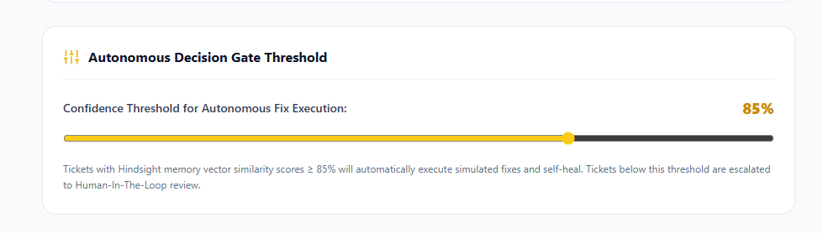
Fig. 1. Autonomous Decision Gate Threshold
Autonomous Execution Path (C ≥ 0.85). The ticket is routed to autonomous execution. The agent selects the right tool payload, such as a remote PowerShell command to clear print spoolers or an OAuth token refresh call, using Groq function calling with openai/gpt-oss-120b. After the tool runs, it verifies recovery with a health-check probe, marks the ticket RESOLVED_AUTONOMOUSLY, and writes an execution log to memory.
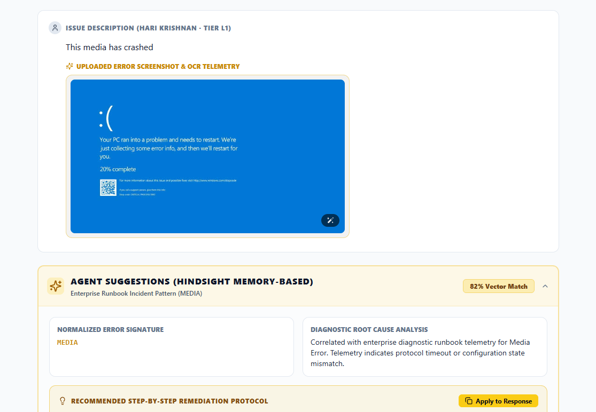
Fig. 2. Confidence less than 85 marked with review
Human-in-the-Loop Path (C < 0.85). The agent pauses, generates a tentative diagnostic hypothesis, and presents the ticket to a human engineer on the triage dashboard. The engineer can approve the proposed action with one click or replace it with the exact command sequence.
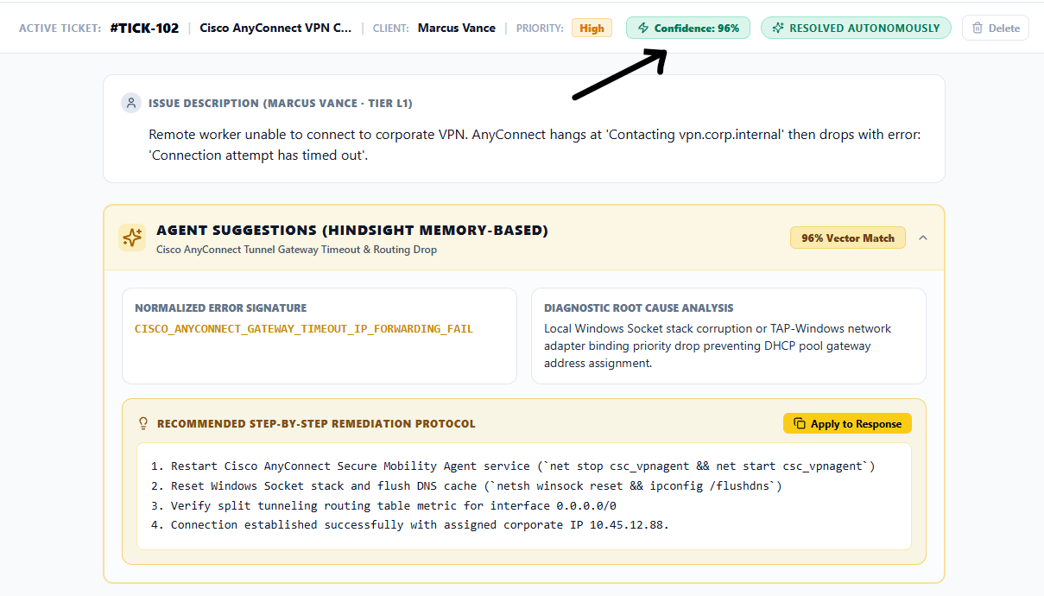
Fig. 3. Confidence above 85 put in the verification phase to HIL

Closed-Loop Memory Retention
The core idea of Autofix-AI is that it learns from human interventions. When an engineer resolves an escalated ticket or corrects an agent hypothesis, the orchestrator intercepts that action and fires a retention hook to Hindsight.
import os
import json
from fastapi import FastAPI, HTTPException
from pydantic import BaseModel
from hindsight_sdk import HindsightClient
app = FastAPI(title="Autofix-AI Remediation Engine")
hindsight_client = HindsightClient(api_key=os.getenv("HINDSIGHT_API_KEY"))
class FeedbackPayload(BaseModel):
ticket_id: str
error_signature: str
human_approved_command: str
engineer_notes: str
@app.post("/api/v1/tickets/feedback")
async def process_human_feedback(payload: FeedbackPayload):
try:
# Step 1: Execute the human-verified remediation command
execution_result = execute_system_command(payload.human_approved_command)
if execution_result["status"] == "SUCCESS":
# Step 2: Formulate runbook payload for memory retention
memory_payload = {
"error_signature": payload.error_signature,
"verified_runbook": payload.human_approved_command,
"resolution_notes": payload.engineer_notes,
"confidence_rating": 1.0,
}
# Step 3: Permanently retain resolution memory in Hindsight
hindsight_client.retain(
bank_id="it_ops_runbooks",
document=json.dumps(memory_payload),
metadata={
"source": "HUMAN_ENGINEER_VERIFIED",
"ticket_id": payload.ticket_id,
},
)
return {
"status": "RESOLVED_AND_LEARNED",
"message": "Hindsight operational memory successfully updated.",
}
else:
raise HTTPException(
status_code=500, detail="Remediation command failed execution."
)
except HTTPException:
raise
except Exception as e:
raise HTTPException(status_code=500, detail=str(e))
def execute_system_command(cmd: str) -> dict:
# Simulated secure system action command runner
return {"status": "SUCCESS", "output": f"Executed: {cmd}"}
Note: execute_system_command is a simulated runner for this article. In production it should be sandboxed, allow-listed, and fully audit-logged. The retention step only fires after a successful execution, so a failed command never pollutes memory.
Because verified outputs are persisted straight into agent memory, human expertise is institutionalized at once. The engineer doesn't write documentation, update a wiki, or edit static config. Resolving the ticket is the training.
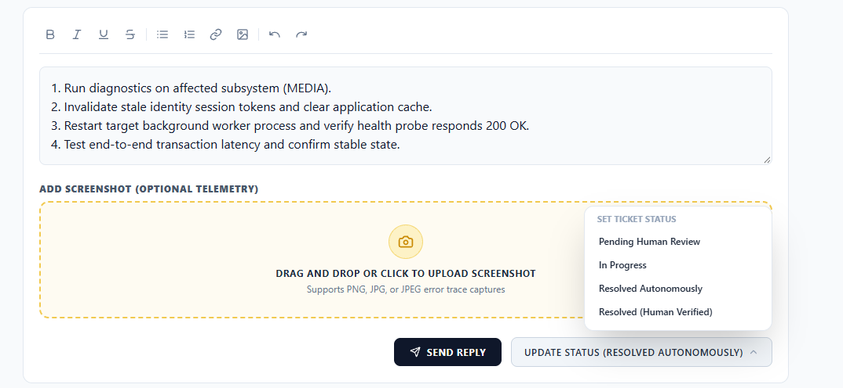
Fig. 4. Human in Loop Operations

Production Lifecycle: From Cold Run to Autonomous Healing
Consider a database connection pool exhaustion error: ERR_POOL_EXHAUSTED_MAX_CONN.
Interaction 1 (cold start). A user submits a ticket with that error log. The orchestrator queries Hindsight, finds no history, and gets a maximum confidence of 41.2%, well below the 85% gate. The ticket goes to a human. A Senior DBA runs pg_terminate_backend() to kill idle zombie connections, raises the pool size in pgbouncer.ini, and clicks Approve & Teach Agent. Hindsight ingests the event.
Interaction 5 (autonomous). Three days later, a different server hits the same exhaustion. The orchestrator queries Hindsight and gets a 98.6% similarity match to the Interaction 1 signature. The agent skips escalation, runs the PgBouncer connection reset tool autonomously, verifies service health, and closes the ticket in under two seconds.
Interaction Phase | Memory State | Match Confidence | Execution Path | Resolution Time
Interaction 1 (Cold Start) | Unindexed event | 41.2% | Human-in-the-Loop escalation | 14.5 minutes (human fix)
Interaction 2 (Learning Phase) | Initial vector retained | 72.0% | Human verification required | 1.2 minutes (one-click approval)
Interaction 5 (Autonomous State) | High-confidence runbook | 98.6% | Autonomous tool execution | 1.8 seconds (self-healing)

The Interface: Mission Control and the Memory Inspector
Auditability drives adoption. IT teams reject black-box agents, so we built a three-column "Mission Control" workspace that makes the agent's memory visible.
Column | Purpose | Key Components
1. Incoming Ticket Stream | Real-time queue monitoring and triage | Status badges (🤖 Autonomous, ⏳ Pending HITL, 👤 Human Verified); severity tags (Critical, High, Low); queue filters
2. Active Ticket Workspace | Incident review and HITL intervention | Drag-and-drop screenshot upload; extracted OCR trace and error signature; step-by-step agent reasoning; interactive terminal for command edits; one-click Approve & Teach Agent
3. Hindsight Memory Inspector | Live view of memory state | Similarity score meter (e.g., 98.6% match); recalled ticket references (e.g., Ticket #104); learning timeline (Interaction 1 vs. 5); runbook memory counter
The Memory Inspector (MemoryInspector.tsx) is what turns "the agent did something" into "the agent did this because of Ticket #104, at 98.6% confidence." That traceability is what lets operators trust autonomy.
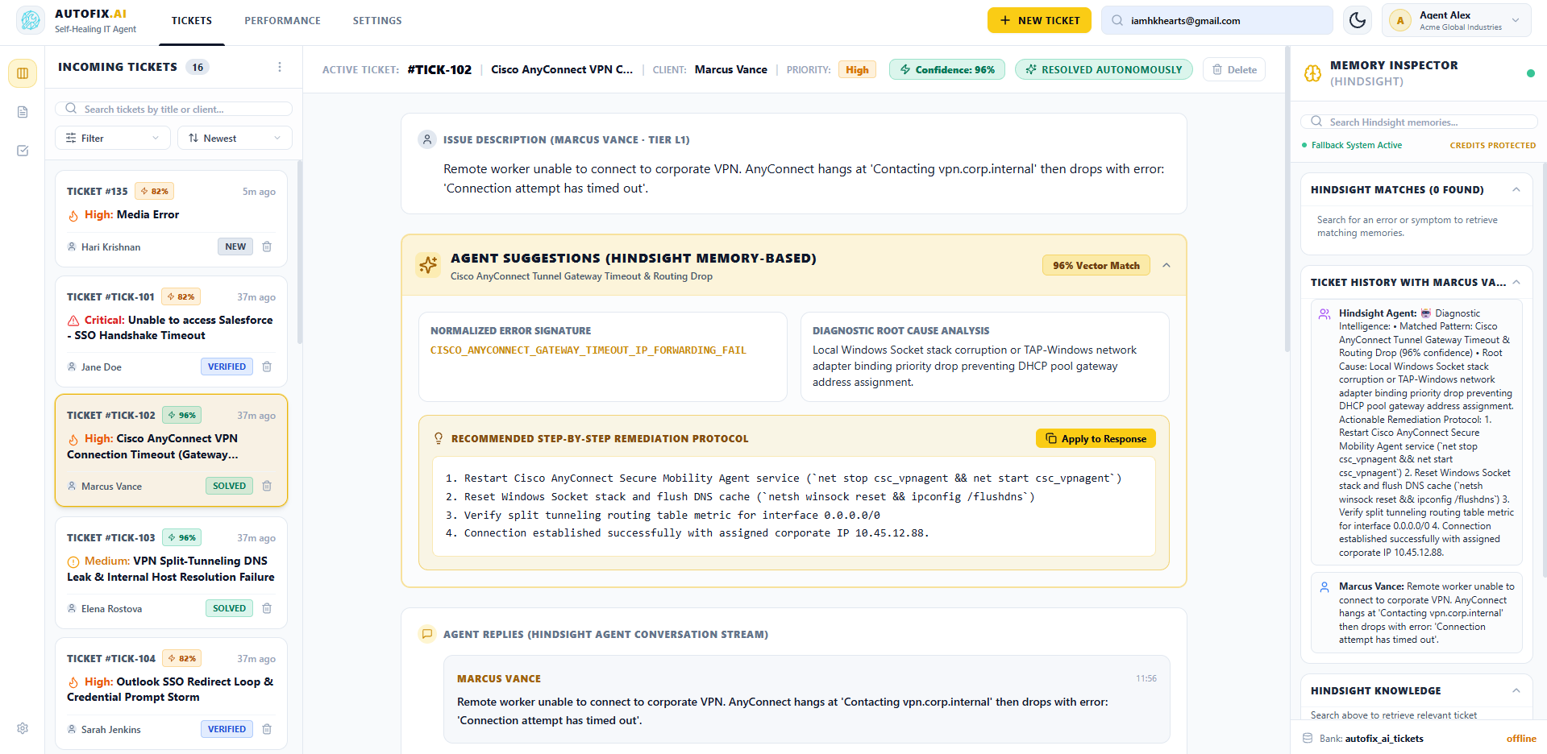
Fig. 5. The three window sections

Reusable Lessons for AI Operations Architecture
- Deterministic gates prevent agent drift. Never let an LLM agent run destructive infrastructure actions on loose contextual probability. Set a hard similarity threshold (C ≥ 0.85) before granting tool execution.
- Human interventions are high-value data. Treat every engineer click and manual command as a training event, and capture it at the moment of resolution.
- Auditability drives production adoption. Show vector scores and source ticket IDs in a dedicated panel. Without that, operators won't trust the agent.

Where This Fits in the Bigger Picture
The orchestrator is only as good as the signatures it receives. Harini's ingestion pipeline handles that side: OCR extraction from screenshots, normalization of dynamic values, and the first Hindsight recall. Read her article for how that layer works.
For API specifications and full documentation, see the official Hindsight documentation. The open-source engine is on the Hindsight GitHub repository.
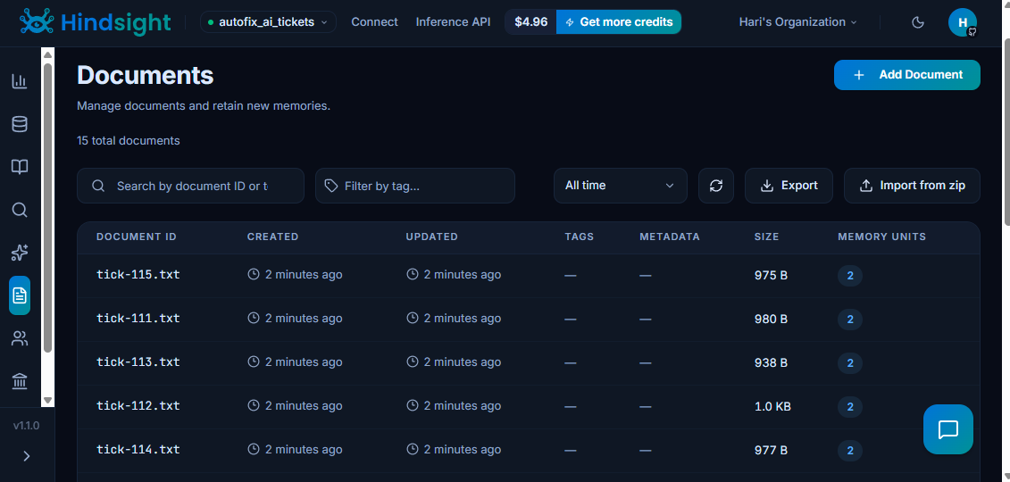
Fig. 6. HindSight Cloud Knowledge base

Hari Krishnan is the orchestration and autonomous agent engineer on Autofix-AI, working on tool execution, HITL safety policy, and the Memory Inspector UI.

