Developer’s report

*Task: Implementation*

1. A database wrapper for Sqlite

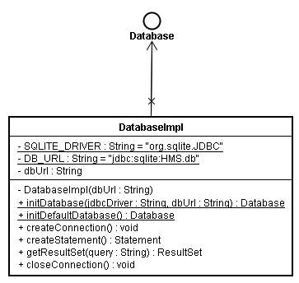

* + DatabaseImpl connects to Sqlite through JDBC (there’remany proprietary SQLite wrappers in public domain), but I decide to use an Sqlite JDBC driver because this data access technology is standard, and we can easily extend our abstract database wrapper to other enterprise RDBMS later (who knows)
  + The selected JDBC driver is from Xerial (<http://www.xerial.org/trac/Xerial/wiki/SQLiteJDBC>), an advantage is that this driver has been already packaged with 3 versions of Sqlite (Windows, Linux, Mac OS), so we don’t need to have Sqlite already
  + I configured POM file so that the project depends on Xerial JDBC driver

1. Implementation of class model
   * I have implemented the UML class diagram to Java classes
   * But most of them are still data structures (MedicalRecord, User ...) without business logic, these business behaviors are going to implemented in next iteration
2. Next iteration
   * For next iteration, the followings must be finished:
     1. Most of business logics of hms model (puf.m2.hms.model), low level data (JDBC-compliant data) should be hidden, user of this model needs to deal with abstract objects only
     2. Refactor the database wrapper, I intend to use Factory pattern (there’ll be DatabaseFactory)