The Features of Java (Java BUZZWORDS)

**Java language is the most powerful and high level programming language. The power of Java is described by the following 12 buzzwords.**

**1) Simple**

**2) Platform Independent**

**3) Architecture Neutral**

**4) Portable**

**5) Secure**

**6) Object-Oriented**

**7) Multithreaded**

**8) Robust**

**9) Distributed**

**10) Interpreted**

**11) High Performance**

**12) Dynamic**

1) Simple:

**Java is very simple and easy to learn (Nursery Level) programming language.We can write Java programs very easily. To learn Java no prior knowledge is required.** **Most of the complex or confusing**

**features of other languages C,C++ like Pointers etc .. are removed in Java.**

# 2) Platform Independent:

**If we write Java program once, we can run on any platform. i.e Java follows Write Once Run and Anywhere(WORA) principle.**

# 3) Architecture-Neutral:

**Java program never communicates with the platform directly. Changes and upgrades in operating systems, processors and system resources will not force any changes in Java Programs.**

4) Portable:

**We can carry the java byte code to any platform without making any changes.**

5) Secure:

**Java programs never communicate directly with the machine. First converted into byte code and then converted into machine code by the JVM. If the byte code contains any problem, then JVM won't allow that code to run and will raise VerifyError. Intenally inside JVM, ByteCode verifier is responsible to verify the byte code.**

**Hence Java programs won't cause any problem to the System.**

6) Object Oriented Programming Language:

**Java is Object Oriented Programming Language like C++.Most of the times in java, we have to handle everything in terms of Object. Java provides support for the following OOP features :**

**Encapsulation**

**Inheritance**

**Polymorphism**

**Etc…**

7) Multithreaded:

**In the case of multithreading, multiple threads can run simultaneously and can perform specified tasks simultaneously, so that performance of the application will be improved.**

**Java provides inbuilt support for multi threading by providing a rich API(application programming interface).**

8) Robust:

**Java is strongly typed language. Compiler will check each and every declaration and assignments at compile time only for type compatibility. If any problem wrt types, then at compile time only we can identify the problem.**

**Java provides Garbage Collector for automatic memory management. Hence there is no chance of memory related problems. Java provides inbuilt Exception hanlding, which prevents abnormal termination of the program at runtime.**

**Java is platform independent and it can run on any platform.**

**Because of all these facilities, the chance of failing the program at runtime is very very less and Hence Java is Robust.**

9) Distributed:

**If the application is distributed across multiple machines (JVMs), such type of application is called Distributed Application. Java provides inbuilt support for Distributed programming with RMI(remote method invocation) and EJB(enterprise java beans).**

By using JAVA we are able to prepare two types of applications

1. Standalone Applications
2. Distributed Applications
3. **Standalone Applications:**

If we design any java application with out using client-Server arch then that java application is called as Standalone application.

1. **Distributed Applications:**

If we design any java application on the basis of client-server arch. then that java application is called as Distributed application.

To prepare Distributed applications, JAVA has provided a seperate module that is "J2EE/JAVA EE".

10) Compiled and Interpreted:

**Java is both Compiled and Interpreted Programming language. First Java compiler compiles java code and generates machine independent Byte Code. At runtime JVM interprets this byte code into machine code and executes that machine code.**

11) High Performance:

**Java is relatively faster than traditional interpreted languages, since byte code is "close" to native code. But Java is still somewhat slower than C or C++.**

12) Dynamic:

**In the case of Java programs, all .class files won't be loaded at the beginning. At runtime if JVM required any class then only the corresponding .class file will be loaded(Dynamic Loading).The main advantage is program will always get latest version of .class file and memory utilization will be improved.**

Explain Platform Independent Nature of Java:

**Java follows Write Once and Run anywhere policy (WORA). i.e Once we write a java program, we can run on any platform without making any changes.**

**First Java Source File will be compiled into ByteCode. Bytecode is an intermediate and machine independent code. JVM will interpret byte code into the corresponding machine dependent code and executes that machine code.**

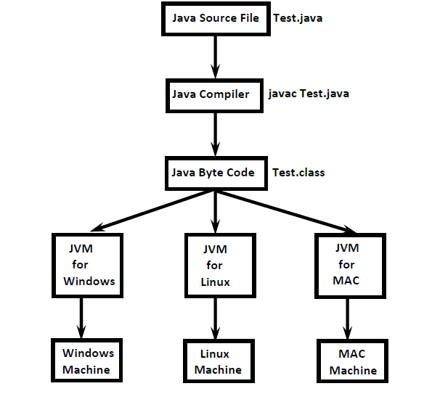

**Note:**

**Java is platform independent where as JVM is platform dependent.**

**JDK vs JRE vs JVM:**

**JDK (Java Development Kit) provides environment to develop and run java applications.**

**JRE (Java Runtime Environment) provides environment to run java applications.**

**JVM (Java Virtual Machine) is an interpreter which is responsible to run java applications line by line.**

**Note:**

**JVM is the part of JRE where as JRE is the part of JDK**

**JDK =JRE + Development Tools**

**JRE = JVM + Libraries**

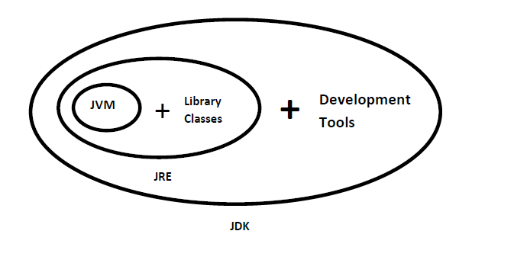

**Note:**

**On the Developer's Machine we have to install JDK, where as on the client machine we have to install JRE.**

**Q. Which of the following is true?**

**A) Java is platform dependent but JVM is platform independent**

**B) Java is platform independent but JVM is platform dependent**

**C) Java Byte code is platform dependent but JVM is platform independent**

**D) Java Byte code is platform independent but JVM is platform dependent**

**Answer: B and D**

**Q. Which Statement is true about Java Byte code?**

**A) It can run on any platform**

**B) It can run on any platform only if it was compiled for that platform**

**C) It can run on any platform that has the Java Runtime Environment (JRE)**

**D) It can run on any platform that has a Java Compiler**

**E) It can run on any platform only if that platform has both JRE and Java Compiler**

**Answer: C**