# Introduction

This web portal is designed for rent a car services provider where user can visit and book their required vehicle online they can select their vehicle, duration, with driver option etc. A complete list of vehicles with detail description along with the images is available for users. User can easily pay online or at user location user need to make account so that he/she can check his records and current status.  
This system include complete content management system so that client can easily add update or delete any vehicle, check payment details, check users detail etc. Payment gateway is also integrated for online transaction.

# Purpose

This web portal will increase clients because customers who live far from showroom can also approach and vehicle can be delivered at his/her doorstep

# Scope

A comprehensive web portal for rental car services where user can become member and book any car for rental user can pay through credit/Debit card also all description of vehicles should be available along with the rental rates and terms and conditions.

# System Overview

This system comprises 3 types of users and 2 modules which is listed below

## System Users

* Admin
* Staff
* Member/Customer

## Modules

* Registration and booking
* Billing and Payment

# Logical Design

**Vehicle**Vehicle ID (PK)  
Vehicle Make  
Vehicle Model  
Vehicle Registration No  
Vehicle Engine No  
Vehicle Fuel Type

**Member**  
Member ID (PK)  
Member Name  
Member Address  
Member Contact 1  
Member Contact 2

**Rent**Rent ID (PK)  
Vehicle ID (FK)  
Rent Per Day  
Rent Per Week  
Rent Per Month  
Rent Per Year

**Driver**  
Driver ID (PK)  
Driver Name  
Driver Address  
Driver Contact 1  
Driver Contact 2  
Driver NIC NO  
Driver Timings

**Booking**Booking ID (PK)  
Member ID(FK)  
Rent ID (FK)  
Driver ID (FK) Vehicle ID (PK)  
Booking Date  
Booking Per Day/Week/Month/Year  
Rent Rate  
Date & Time Of Handover  
Date & Time of return   
Meter Reading  
Fuel Reading

**Payment** PaymentID(PK)Booking ID(FK)  
Date & Time Of Handover  
Advance  
Remaining  
Total  
Status

# Physical design

|  |  |
| --- | --- |
| **Fields** | **Data Types** |
| **Rent_ID (PK)** | **Auto** |
| Vehicle_ID (FK) | Auto |
| Rent_Per_Day | Double |
| Rent_Per_Week | Double |
| Rent_Per_Month | Double |
| Rent_Per_Year | Double |

|  |  |
| --- | --- |
| **Fields** | **Data Types** |
| **Vehicle_ID (PK)** | **Auto** |
| Vehicle_Make | Varchar(50) |
| Vehicle_Model | Varchar(50) |
| Vehicle_Registration No | Varchar(50) |
| Vehicle_Engine No | Varchar(50) |
| Vehicle_Fuel_Type | Varchar(50) |

|  |  |
| --- | --- |
| **Fields** | **Data Types** |
| **Member_ID (PK)** | **Auto** |
| Member_Name | Varchar(50) |
| Member_Address | Varchar(50) |
| Member_Contact_1 | Varchar(20) |
| Member_Contact_2 | Varchar(20) |
|  |  |

|  |  |
| --- | --- |
| **Fields** | **Data Types** |
| PaymentID(PK) | Auto |
| Booking ID(FK) | Auto |
| DateTime_Of_Handover | DateTime |
| Advance | Double |
| Remaining | Double |
| Total | Double |
| Status | Varchar(10) |

|  |  |
| --- | --- |
| **Fields** | **Data Types** |
| Booking_ID (PK) | Auto |
| Member_ID(FK) | Auto |
| Rent_ID (FK) | Auto |
| Driver_ID (FK) | Auto |
| Vehicle_ID (PK) | Auto |
| Booking_Date | DateTime |
| Booking_Per | VarChar(10) |
| Rent_Rate | Double |
| Date_Time_Of_Handover | DateTime |
| Date_Time_of_return | DateTime |
| Meter_Reading | Varchar(50) |
| Fuel_Reading | Varchar(50) |

|  |  |
| --- | --- |
| **Fields** | **Data Types** |
| Driver_ID (PK) | Auto |
| Driver_Name | Varchar(50) |
| Driver_Address | Varchar(50) |
| Driver_Contact_1 | Varchar(20) |
| Driver_Contact_2 | Varchar(20) |
| Driver_NIC | Varchar(20) |
| Driver_Timings | DateTime |

# Use Cases

**User Account and Booking**

**Member**

**Payments**

**Member**

**Employees**

**Staff**

**Manager**

**Admin**

# Context Diagram

Payment and Outstandings

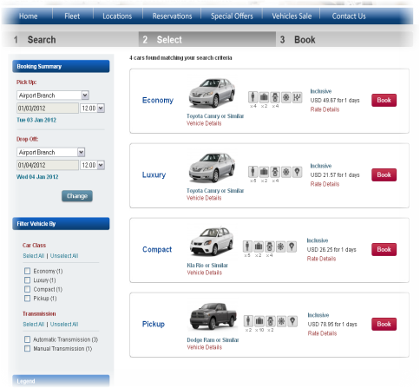

Customer

Staff

Registration and become a member

Check vehicle and rental details

Book a vehicle

Payment

Update Vehicle info

Manage Orders

Produce Bill

Billing and Payment Details

Admin/Manager

Manage users

Apply payment terms

# Data Flow diagram

Car records

Add Car

Registration

Customer

Customer detail

Customer record

**D1: Members**

Login

Customer login

Admin

**D2: Admin**

**D3:Car**

View Car Detail

View car

Book Car

Rent a car

Staff

Car

Payment

Makes

Staff

Customer

Admin

Person

Automobile

Booking

Reg.

User can create account  
user can book vehicle online  
user can track his current rent status  
user can check his previous records  
user can pay online  
user can send feedback  
invoice generated for user which can be printed

Client can check all members record  
Client can manage orders  
client can check add, update and delete members  
client can add, update and delete vehicles and its description  
Separate login area for admin and other employees  
Invoice generated for client which can be printed