ECE PULSE: Biometrics/Signal Processing Competition

Prompt:

John Smith is an ECE student at UIUC, and likes to play with instruments. No, not musical instruments, but stuff that you’d imagine being in the cockpit of an aircraft or in a high-tech laboratory such as Bell Labs. He has taken ECE 110 and ECE 210 and really enjoyed learning about how an oscilloscope worked and its applications to building autonomous agents and AM radios. There was one problem though: Smith spent so much time in the lab and so little time exercising that he became very fat. He needed to lose weight fast to appear desirable to members of the opposite sex in any hopes of getting a date for Valentine’s Day, so he decides to use his signal processing skills to aid in his mission to lose weight, or at least learn a little bit more about his own body’s functions.

After doing some research online, he found a pulse sensor and a few EMG probes that were compatible with the Arduino microcontroller to play around with. Smith doesn’t have much practical experience regarding the application of these biometrics, so he decides to enlist the help of a few of his peers involved in competing in the ECE PULSE: Biometrics/Signal Processing Competition. Help John Smith get a date for Valentine’s Day!

Rules:

You are allowed to use the Internet in all capacities so long as you do not actively sabotage others’ work or break the network, any applicable laws, etc. We have provided some resources for you to take advantage of, but you are free to use whatever you have at your disposal to create the best and most exciting application of the biometrics that you can think of. There are proctors in the room that will be able to help you in regards to get the provided hardware and software up and running, as well as some signal processing and web development. If you have any questions or concerns, please feel free to speak with one of them as they are there to help you.

Parts List:

1 Pulse sensor

1 Muscle Sensor v3 Kit

1 Arduino

2 9v batteries

1 2.2”x6.5”breadboard

Some wires

Suggested layout:

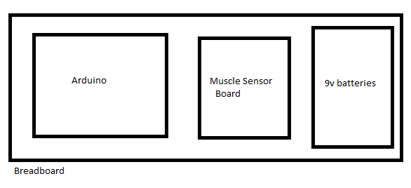

Resources:

Given Code for pulse sensor (outputs in formats such as XML, JSON, CSV for web applications if you want to go that route): <https://github.com/hkiang01/pulse_prototype> 🡨 primarily for pulse sensor

Pulse Sensor Documentation: <http://pulsesensor.com/> 🡨 very detailed and comprehensive

EMG User Manual: <https://dlnmh9ip6v2uc.cloudfront.net/datasheets/Sensors/Biometric/Muscle%20Sensor%20v3%20Users%20Manual.pdf>

EMG board schematic: <https://dlnmh9ip6v2uc.cloudfront.net/datasheets/Sensors/Biometric/Muscle%20Sensor%20Platinum%20v3.3.pdf>

EMG Arduino code: <http://dlnmh9ip6v2uc.cloudfront.net/datasheets/Sensors/Biometric/MuscleSensor_Arduino.zip>

EMG Processing code: <http://dlnmh9ip6v2uc.cloudfront.net/datasheets/Sensors/Biometric/MuscleSensor_Processing.zip>

Processing reference: <https://processing.org/reference/>

Arduino reference: <http://arduino.cc/en/Reference/HomePage>

Fabric Electrode tutorial: <http://www.advancertechnologies.com/2013/03/diy-conductive-fabric-electrodes.html>

Web/Development Environment/VM Hosting Resources:

Note that due to security reasons, scripting languages like JavaScript within the context of web browsers are typically not able to read from or write to local files on your system. However, the given code for the pulse sensor has been tested to be readable in XML format for Firefox v35, but we suggest you use either a separate development environment such as Vagrant or some other hosting methods such as virtual machines or web hosting  
Vagrant: <https://vagrantup.com/>

Github student developer pack: <https://education.github.com/pack>

Oracle VM VirtualBox: <https://www.virtualbox.org/>

QEMU: <http://wiki.qemu.org/Main_Page>

Mozilla Development Network: <https://developer.mozilla.org/en-US/>

Miscellaneous Resources:

Free programming books: <https://github.com/vhf/free-programming-books/blob/master/free-programming-books.md>

Judging:

Minimum Criteria: Representation of biometric data either in serial or some visual effect.

Bonus points will be given for difficulty of application and creativity. Finalized judging criteria will be announced during the event.

Prizes:

TBD