**RESEARCH METHODOLOGY**

**CIA - 3**

A report submitted in partial fulfilment of the requirements for the degree of master of business administration

Under the guidance of

**Submitted To**

Dr. BECKY MARY THOMAS

Dr. DANISH HUSSAIN

**Submitted by**

Hemanath Kumar J - 21121015

Prajwal S Divate - 21121035



MBA PROGRAMME

SCHOOL OF BUSINESS MANAGEMENT

CHRIST (DEEMED TO BE UNIVERSITY), LAVASA

JANUARY 2022

**ABSTRACT**

Protecting the global environment has emerged as one of the primary concerns in international relations over the last three decades. Environmental protection is a fundamental requirement for the general growth of any country on the planet. Biodiversity must be supplied if economic growth and development are to be established, which no country in the world does not want to do. As human understanding of environmental protection grows, so does human awareness of the need to maintain the environment by limiting negative impacts on nature. Better late than never, we must now alter, if only slightly, by avoiding causing further harm to nature. There are some positive signals, as the ozone hole's spread has slowed significantly during the last two years. This positive energy can charge us, and we must alter. It does not imply that there will be no development. We need progress, without a doubt, but it must be scientific, practical, and environmentally friendly. This is a viewpoint that should be revised in light of new circumstances, but only in a good way.

This study is conducted to know the awareness among the consumers on green products that are considerably less harmful to the environment. Data collection was conducted by means of self-administered questionnaires among students. The data was analysed by using statistical methods such as ANOVA and regressions. The results from the study indicated that social influence, environmental awareness and price, influence individuals’ attitudes towards green products. The effect of attitude on buying intention; hence consumers with positive attitudes towards green products are more likely to purchase green products.

**INTRODUCTION**

This study looks at how subjective knowledge, environmental awareness, the role of social influence, and perceived monetary value affect customer perception toward the environment and products. The study examines the behaviour of environmentally conscious consumers and focuses mainly on the examination of non‐product specific environmental knowledge and attitudes or environmental knowledge and attitudes. The green industry has become popular in recent years. With an increase in the public’s environmental awareness, the trend of green consumption is moving into the mainstream market. Most people in developed countries regard environmental protection as an important factor in purchase decisions. Therefore, most companies offer green products to meet and satisfy consumer requirements and conduct green marketing initiatives to drive green consumption. Environmentally responsible purchasing is vital as unplanned purchasing of goods can severely damage the environment. Consumer household purchases were responsible for the environmental damage. Consumers possess the capability to prevent or decrease environmental damage by purchasing green products.

**KEY TERMINOLOGIES**

**Product attitude**: Attitude refers to a specific observed subject’s evaluation and state of likes and dislikes, the feelings and opinions generated based on the evaluation of affairs, or the durable and stable evaluation and preference. In addition to expressing the positive and negative evaluation and feelings, attitude also reflects the action intention of agree or disagree. product attitude could be learned; according to specific subjects, the learned persistent reaction intention stood for personal standards of likes and dislikes, right and wrong. Product attitude as individual belief, emotion, and behavioural intention to others, affairs, and environments and individual behavioural intention of closeness because of likes and avoidance due to dislikes to specific people, affairs, and objects; attitude was stable and learned individual behavioural intention. In other words, it was individual perception, evaluation, feeling, and behavioural intention to agree or disagree with certain affairs or concepts. Brand attitude (or product attitude) refers to consumer preference for specific brands (or brands). Product attitude was consumer preference for specific products. Consumers’ product attitude was the comprehensive result of the product in various brand attribute evaluation. Product attitude would affect consumers’ product purchase intention

**Purchase Intention**: the possibility of a consumer considering purchasing a certain brand; consumers with higher agreement and sensory value of the brand would enhance the intention to purchase the products. According to the above definitions, purchase intention is the key in consumers’ decision-making process. Consumers would search for information related to the purchased products according to their experiences or external environments; after accumulating such information to some degree, consumers would start to consider and evaluate and then judge and compare to eventually generate the purchase behaviour. Consumers would follow the preferred product attitude as the purchase reference of brands when making purchase decisions, that product attitude would directly affect consumers’ purchase intention and purchase behaviour.

**Social influence**: Social influences refer to how other people influence a person’s behavioural decisions. Social influences are related to the external pressure (from important people in the person's life, such as family, friends, and supervisors at work) a person perceives to use or not use a system. Social influence is the extent to which social networks influence people’s behaviour through messages and signals from others that facilitate the formation of people’s perceived value of a technology system. Furthermore, social influence affects individuals through both messages about social expectations and the observed behaviour of others. Regarding social expectations, subjective norms are related to one's perception that salient referents think and expect he or she should or should not perform a certain behaviour. The information people receive from others typically affects their perception of using a green product. Referent opinions in society also affect perceptions regarding green products.

**LITERATURE REVIEW**

This study explored consumer behaviour in terms of intent to purchase green products using a decision-making model that incorporates cognitive, affective, and behavioural intentions. In the present market, these barriers prevent consumers from understanding how green products affect the environment. Consumer purchase intention toward green products, based on the choice behaviour model. Choice behaviour is a continual decision-making process that involves initial purchase intention, accepted information, motivation, characteristic, plan evaluation, selection, and purchase before buying. People are paying increasing attention to environmental concerns (e.g., global warming and destruction of the ozone layer and natural habitats), and this may affect consumers’ decisions to purchase green products. In this study, environmental awareness is defined as “the level to which environmental effects influence consumer cognition when purchasing green products.”

“Exploring consumer perceptions of green restaurants in the US” - By this research we found that there is a potential market for restaurants which do green practice. There is a large consumer base who wants to spend more for this kind of restaurant and they want to protect the environment. It is also clear that though they want, they don't want to sacrifice the quality part of the food. The green practices are often unrecognized by the consumers, which the restaurants should focus on. This practice increased employee satisfaction as well as consumer satisfaction. So, the main concern for the consumers in the research was quality, product satisfaction.

“Creating the Responsible Consumer: Moralistic Governance Regimes and Consumer Subjectivity”- The paper deals with the identities and experiences of asking how family, religion, ethnicity, activism, and other institutions are re-articulated as market and consumption systems. The findings from this paper are limited to the creation of a responsible consumer. The reason is because of the wide range of ideologies and views which consumers have with regards to moral significance. This is known by bringing in the theory of responsibilities on a longitudinal ethnographic analysis. This has demonstrated the impact of moralistic governance regimes on the formation of the responsible consumer. The main concern for the consumers in the research was social, family influence which affected the consumer purchase intention and awareness of green products.

“Double Standard: The Role of Environmental Consciousness in Green Product Usage”- The study from this research says that the consumers perception on product effectiveness are critical to choose at a given instance. To satisfy the perceived inferiority, they may use environmentally friendly products which are considered as green. But when the perceived effectiveness is boosted by a credible endorsement, the difference between green products and normal products disappears among consumers. The product type plays an important role in the consumer usage for a single instance of that product, to gain the expected outcome by the consumer. The consumer also encounters various barriers to use green products because of high price and low availability.

“Factors affecting consumers' green product purchase decisions”- In spite of the fact that natural awareness in Indian customers is watched within the writing, their buy behaviour towards green items isn't clearly caught on. So, the reason for this paper is to consider the components influencing consumers’ green item buy choices in India. The investigation utilizes a survey-based strategy to test a hypothetically grounded set of speculations. It seems that the respondents have the eagerness to back environmental protection, the realization of natural duties, and slant towards looking at green product-related data and learning around green items. Supporting natural security, drive for natural obligation, green item encounter, natural invitingness of companies, and social requests are recognized as critical variables influencing green item buy choices. This investigation gives profitable experiences into green buyer conduct in an Indian setting by analysing the components that impact their decision.

**RESEARCH GAP**

Subjective norms depict the social influence of others' perceived expectations. Green products are perceived to be more environmentally friendly than other products and consumers will support or resist green products in the face of social pressure in Lavasa.

**OBJECTIVES**

1) To understand the effect of social influence on the consumers’ purchase intention of green products.

2) To understand the effect of the product attitude impacts the consumers’ purchase intention of green products.

3) To understand the impact of subjective knowledge on consumers’ purchase intention of green products.

**HYPOTHESIS**

H0: Social influence has a statistically significant impact on the consumers’ purchase intention of green products.

H1: Product attitude has a statistically significant impact on the consumers’ purchase intention of green products.

H2: Subjective knowledge has a statistically significant impact on the consumers’ purchase intention of green products.

**METHODOLOGY**

The data we are collecting is basically the primary data. The method we used to collect the data is by creating online survey forms, to get the consumer purchase intentions for green products. Online survey, is one of the most popular data-collection sources, where a set of survey questions is sent out to a target sample and the members of this sample can respond to the questions over the world wide web. This online survey is circulated among the peers from Christ (Deemed to be University), Lavasa Campus.

The responses are measured using Likert scale. The Likert scale question is a psychometric scale where questions based on this scale are used in a survey. It is one of the most widely used question types in a survey. In our survey, respondents don't choose between 'yes/no,' there are specific choices based on 'Strongly agreeing' or 'Strongly disagreeing' for a particular survey question. We chose this scale because it is very much helpful in measuring a respondent's opinion or attitude towards a given subject and is the integral part of our market research.

To measure the internal reliability of our test results, we used Cronbach's Alpha test. Reliability is a measure of the stability or consistency of the survey results. Cronbach’s alpha is a measure of internal consistency, that is, how closely related a set of items are as a group. It is considered to be a measure of scale reliability. As per the Alpha Cronbach's Value (Konting et al., 2009), 0.91-1.00 is considered as Excellent, 0.81-0.90 is Good, 0.71-0.80 is Good and Acceptable, 0.61-0.70 is Acceptable and 0.01-0.60 is non-Acceptable.

To find the relationship between two variables, we used Regression Analysis. Regression analysis is a quantitative research method which is used when the study involves modelling and analysing several variables, where the relationship includes a dependent variable and one or more independent variables. In simple terms, regression analysis is a quantitative method used to test the nature of relationships between a dependent variable and one or more independent variables.

**ANALYSIS**

As mentioned in methodology, there were different analysis which are mentioned further. So, first we added the response ratio through pie-chart we got from our survey form. There were 4 sections in the form, which are Subjective Knowledge, Product Attitude, Social Influences and finally the Purchase Intention. With the responses, we performed Cronbach’s alpha test & Regression.

**Subjective Knowledge**

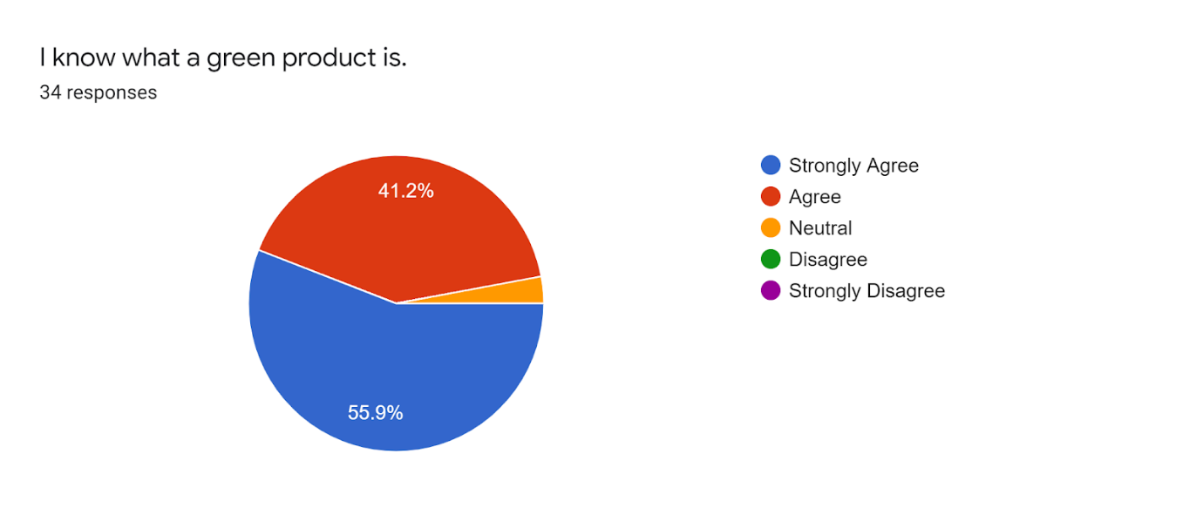

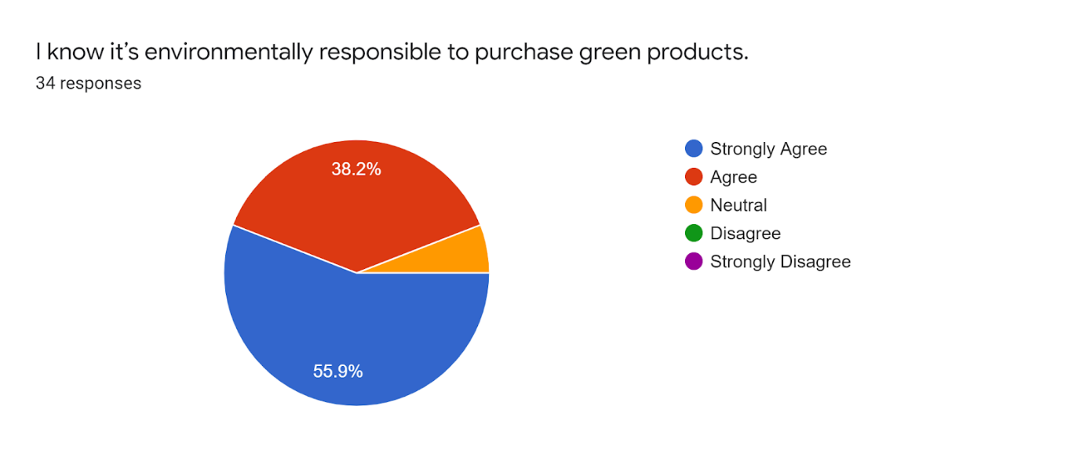

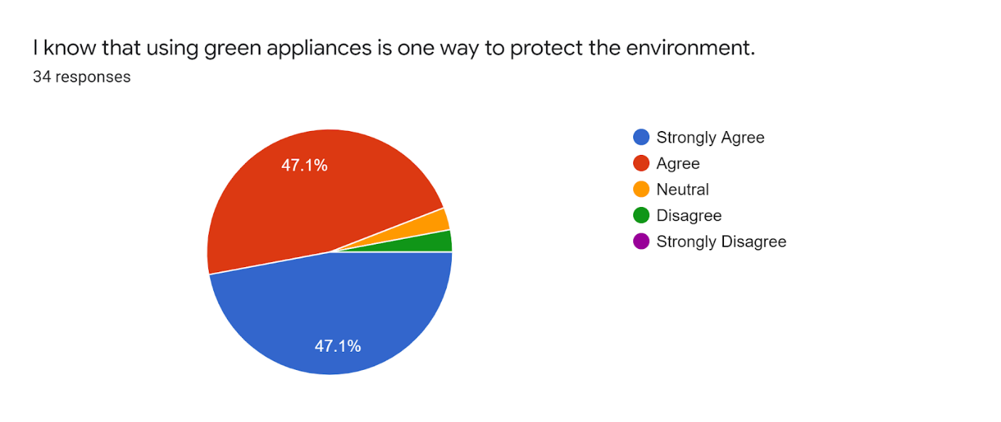

From the responses, we can infer that almost 50% of the audience have a goof knowledge about what the green product is.

**Product Attitude**

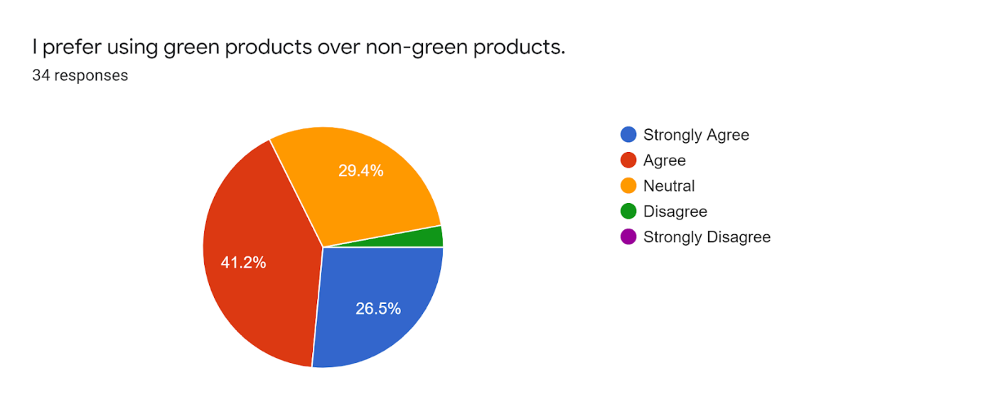

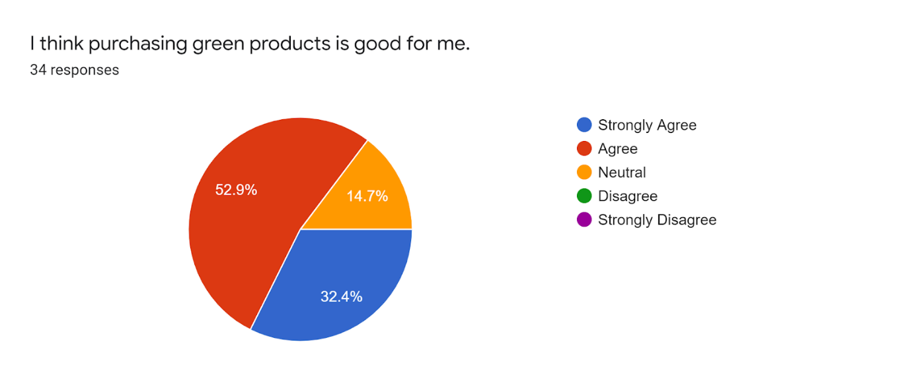

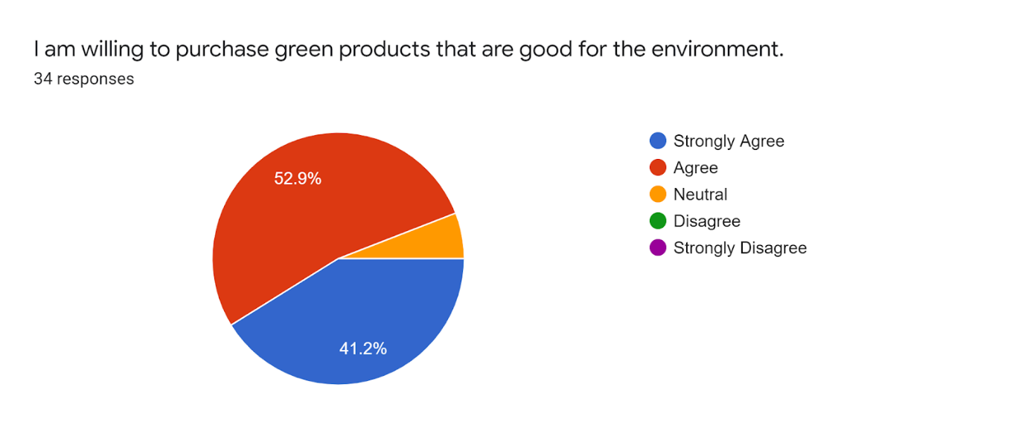

When it comes to product attitude, the responses were a bit mixed. But half of the audience had good attitude when it comes to product. They were aware that the purchase of green product is good for environment.

**Social Influence**

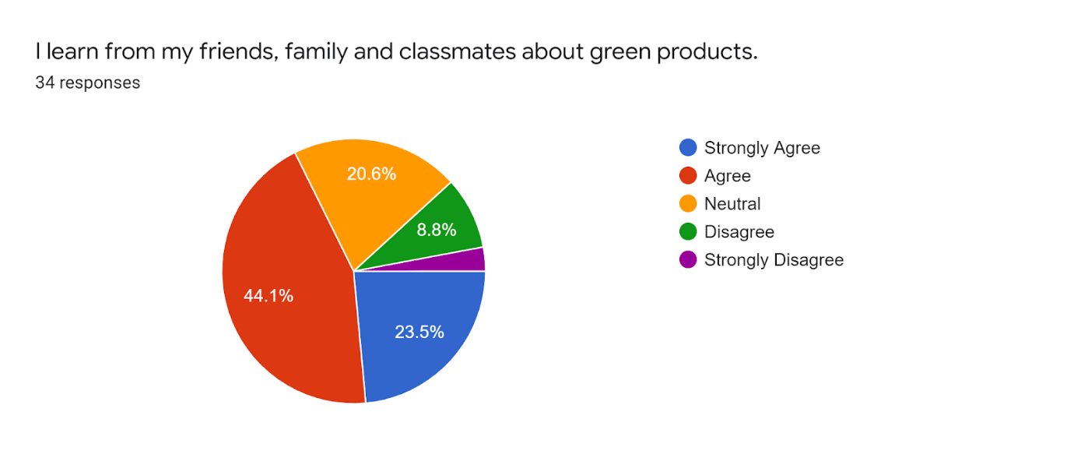

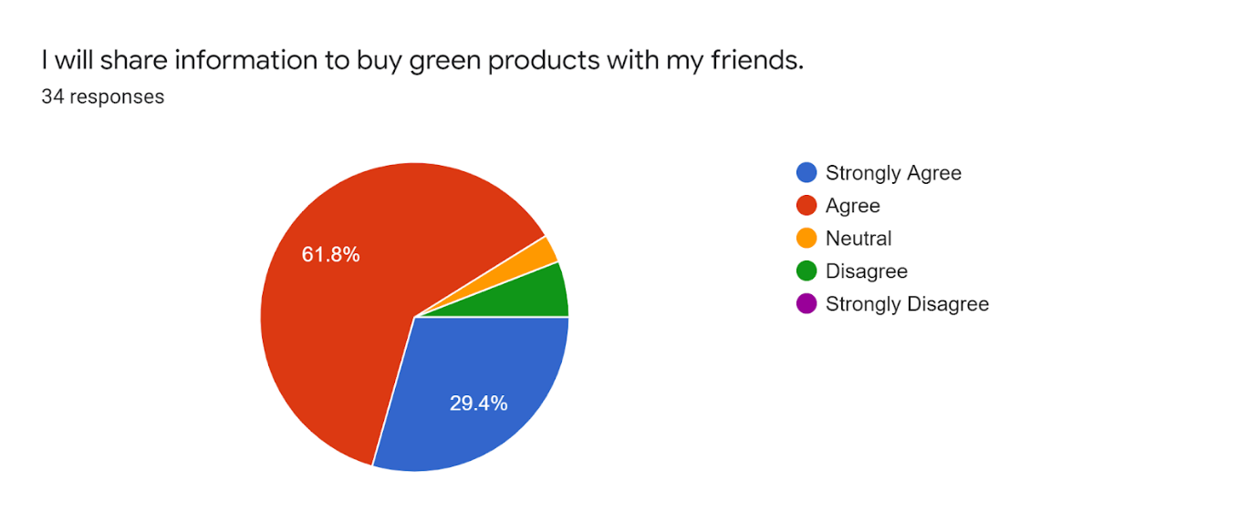

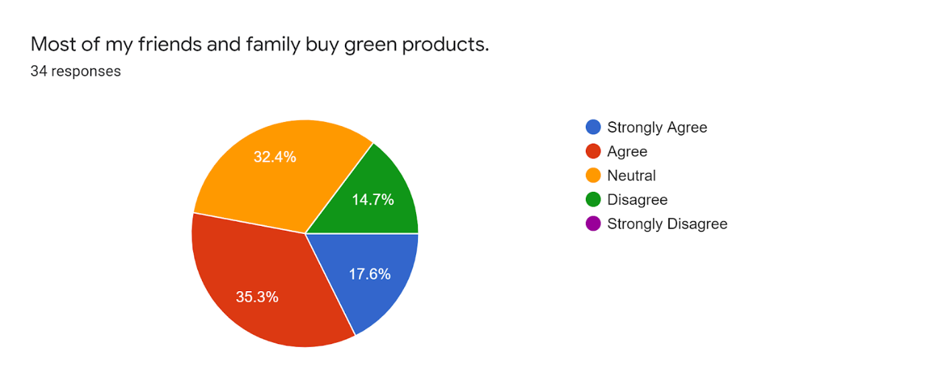

From the responses, it is seen that there more impact of social influence on the audience. When the friends or family purchases green product there is a good chance for an individual to buy the green product.

**Purchase Intention**

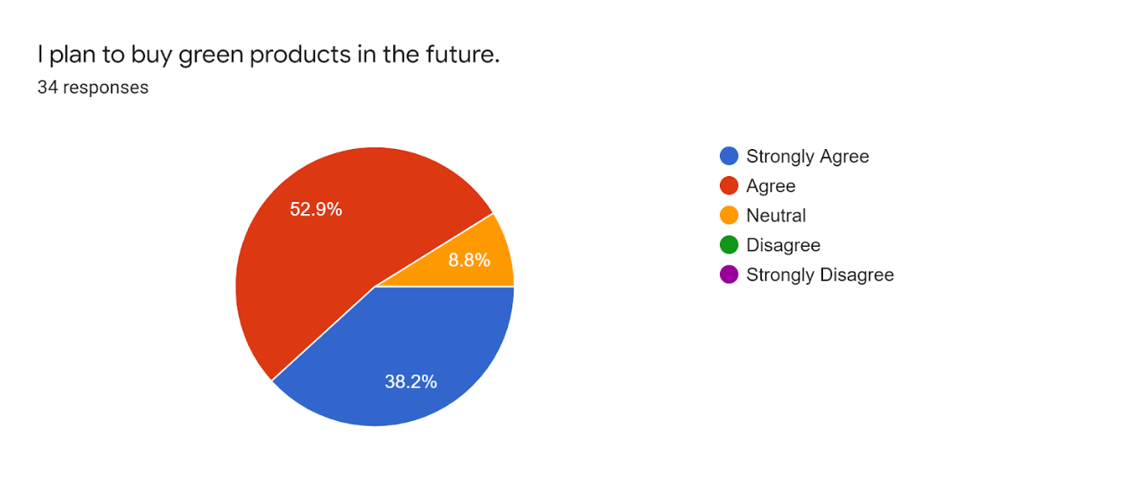

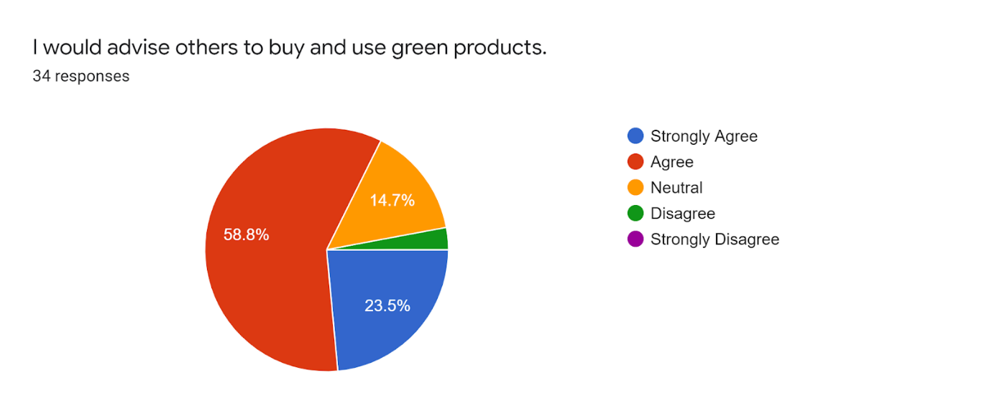

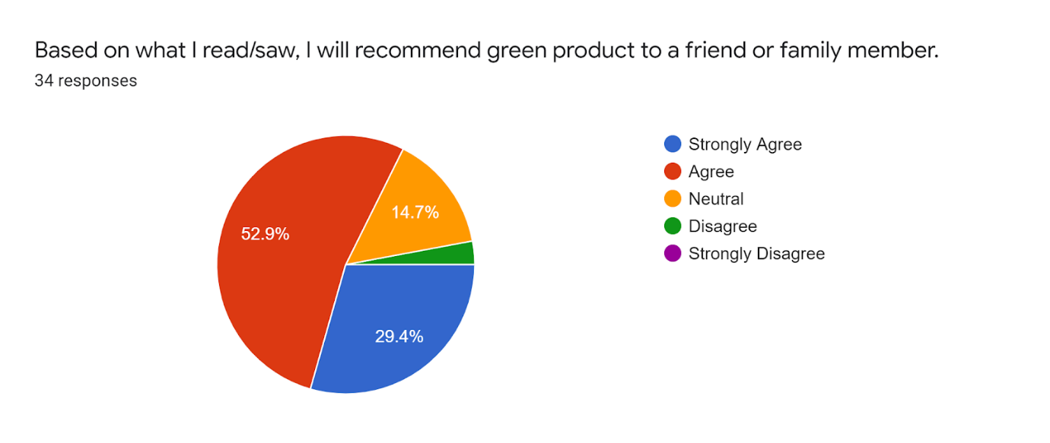

The purchase intention of green product seems to be positive based on the response. So, based on regression we will confirm which factor has more impact in making an individual buy a green product.

**Cronbach’s Alpha**

Cronbach’s Alpha value is determined by 1-(MSe/MSr),

Where MSe – Mean square of error & MSr is Mean square of Rows

MSe & MSr is found out by running ANOVA, which is mentioned in the below table.

|  |  |  |  |  |  |  |
| --- | --- | --- | --- | --- | --- | --- |
| ANOVA |  |  |  |  |  |  |
| *Source of Variation* | *SS* | *df* | *MS* | *F* | *P-value* | *F crit* |
| Rows | 105.6470588 | 33 | 3.201426025 | 9.265079365 | 4.94E-33 | 1.463717 |
| Columns | 35.33613445 | 13 | 2.718164189 | 7.866496599 | 3.93E-14 | 1.743009 |
| Error | 148.2352941 | 429 | 0.345536816 |  |  |  |
|  |  |  |  |  |  |  |
| Total | 289.2184874 | 475 |  |  |  |  |
|  |  |  |  |  |  |  |

Cronbach’s Alpha value is 0.892067843.

**Regression**

In this research, regression is conducted to find out the impact of dependent variable on 3 independent variables. First, regression is done for Purchase Intention and Social Influence.

Purchase Intention and Social Influence

|  |  |  |  |  |  |  |  |  |
| --- | --- | --- | --- | --- | --- | --- | --- | --- |
| SUMMARY OUTPUT |  |  |  |  |  |  |  |  |
|  |  |  |  |  |  |  |  |  |
| *Regression Statistics* | |  |  |  |  |  |  |  |
| Multiple R | 0.375298751 |  |  |  |  |  |  |  |
| R Square | 0.140849152 |  |  |  |  |  |  |  |
| Adjusted R Square | -0.718301695 |  |  |  |  |  |  |  |
| Standard Error | 13.30357375 |  |  |  |  |  |  |  |
| Observations | 3 |  |  |  |  |  |  |  |
|  |  |  |  |  |  |  |  |  |
| ANOVA |  |  |  |  |  |  |  |  |
|  | *df* | *SS* | *MS* | *F* | *Significance F* |  |  |  |
| Regression | 1 | 29.01493 | 29.01493 | 0.163939956 | 0.755080237 |  |  |  |
| Residual | 1 | 176.9851 | 176.9851 |  |  |  |  |  |
| Total | 2 | 206 |  |  |  |  |  |  |
|  |  |  |  |  |  |  |  |  |
|  | *Coefficients* | *Standard Error* | *t Stat* | *P-value* | *Lower 95%* | *Upper 95%* | *Lower 95.0%* | *Upper 95.0%* |
| Intercept | 243.3731343 | 280.1116 | 0.868844 | 0.544605202 | -3315.782071 | 3802.528 | -3315.78 | 3802.528 |
| X Variable 1 | -0.805970149 | 1.990566 | -0.40489 | 0.755080237 | -26.09850742 | 24.48657 | -26.0985 | 24.48657 |

It is seen that the value of R square is 0.140849152296768, which is approximately 14%.

Second regression analysis is done between Product Attitude and Purchase Intention.

Purchase Intention and Product Attitude

|  |  |  |  |  |  |  |  |  |
| --- | --- | --- | --- | --- | --- | --- | --- | --- |
| SUMMARY OUTPUT | |  |  |  |  |  |  |  |
|  |  |  |  |  |  |  |  |  |
| *Regression Statistics* | |  |  |  |  |  |  |  |
| Multiple R | 0.812800189 |  |  |  |  |  |  |  |
| R Square | 0.660644148 |  |  |  |  |  |  |  |
| Adjusted R Square | 0.321288295 |  |  |  |  |  |  |  |
| Standard Error | 6.219852664 |  |  |  |  |  |  |  |
| Observations | 3 |  |  |  |  |  |  |  |
|  |  |  |  |  |  |  |  |  |
| ANOVA |  |  |  |  |  |  |  |  |
|  | *df* | *SS* | *MS* | *F* | *Significance F* |  |  |  |
| Regression | 1 | 75.31343284 | 75.31343 | 1.946759 | 0.395884 |  |  |  |
| Residual | 1 | 38.68656716 | 38.68657 |  |  |  |  |  |
| Total | 2 | 114 |  |  |  |  |  |  |
|  |  |  |  |  |  |  |  |  |
|  | *Coefficients* | *Standard Error* | *t Stat* | *P-value* | *Lower 95%* | *Upper 95%* | *Lower 95.0%* | *Upper 95.0%* |
| Intercept | 323.6567164 | 130.9612626 | 2.471393 | 0.244775 | -1340.36 | 1987.677 | -1340.36 | 1987.677 |
| X Variable 1 | -1.29850746 | 0.930654165 | -1.39526 | 0.395884 | -13.1236 | 10.52657 | -13.1236 | 10.52657 |

It is seen that the value of R square is 0.660644147682639, which is approximately 66%.

Finally, the regression analysis is performed between Purchase Intention and Subjective Knowledge and the results are mentioned below.

Purchase Intention and Subjective Knowledge

|  |  |  |  |  |  |  |  |  |
| --- | --- | --- | --- | --- | --- | --- | --- | --- |
| SUMMARY OUTPUT | |  |  |  |  |  |  |  |
|  |  |  |  |  |  |  |  |  |
| *Regression Statistics* | |  |  |  |  |  |  |  |
| Multiple R | 0.479872 |  |  |  |  |  |  |  |
| R Square | 0.230277 |  |  |  |  |  |  |  |
| Adjusted R Square | -0.53945 |  |  |  |  |  |  |  |
| Standard Error | 3.2827 |  |  |  |  |  |  |  |
| Observations | 3 |  |  |  |  |  |  |  |
|  |  |  |  |  |  |  |  |  |
| ANOVA |  |  |  |  |  |  |  |  |
|  | *df* | *SS* | *MS* | *F* | *Significance F* |  |  |  |
| Regression | 1 | 3.223881 | 3.223881 | 0.299169 | 0.681366 |  |  |  |
| Residual | 1 | 10.77612 | 10.77612 |  |  |  |  |  |
| Total | 2 | 14 |  |  |  |  |  |  |
|  |  |  |  |  |  |  |  |  |
|  | *Coefficients* | *Standard Error* | *t Stat* | *P-value* | *Lower 95%* | *Upper 95%* | *Lower 95.0%* | *Upper 95.0%* |
| Intercept | 114.209 | 69.11844 | 1.652366 | 0.346467 | -764.024 | 992.4421 | -764.024 | 992.4421 |
| X Variable 1 | 0.268657 | 0.491179 | 0.546963 | 0.681366 | -5.97236 | 6.509672 | -5.97236 | 6.509672 |

It is seen that the value of R square is 0.2302771855010669, which is approximately 23%.

**RESULTS**

Based on the inferences from the responses, we can see that the customers were aware that the purchase of green product is good for environment. Also, half of them have positive subjective knowledge about the green product. The purchase intention of green product seems to be positive based on the response we got. There is also more impact by their friends or family.

As per The Alpha Cronbach's Value (Konting et al., 2009) value, the range 0.81-0.90 is considered to be GOOD, which assures the data which we collected is reliable and consistent, since the Cronbach’s Alpha value which we evaluated is 0.892067843.

H0. The regression analysis is performed between Purchase Intention and Social Influence resulted in the value of approximately 14%. This value indicates that the Social Influence has a very less significant effect on the purchase intention of the green product.

H1. The regression analysis is performed between Purchase Intention and Product Attitude resulted in the value of approximately 66%. This value indicates that the Product Attitude has a very high significant effect on the purchase intention of the green product.

H2. The regression analysis is performed between Purchase Intention and Subjective Knowledge resulted in the value of approximately 23%. This value indicates that the Subjective Knowledge has statistically less significant effect on the purchase intention of the green product.

**REFERENCES**

1. Schubert, F., Kandampully, J., Solnet, D., & Kralj, A. (2010). Exploring consumer perceptions of green restaurants in the US. *Tourism and Hospitality Research*, *10*(4), 286-300.

2. Giesler, M., & Veresiu, E. (2014). Creating the responsible consumer: Moralistic governance regimes and consumer subjectivity. *Journal of Consumer Research*, *41*(3), 840-857.

3. Lin, Y. C., & Chang, C. C. A. (2012). Double standard: The role of environmental consciousness in green product usage. *Journal of Marketing*, *76*(5), 125-134.

4. Kumar, P., & Ghodeswar, B. M. (2015). Factors affecting consumers’ green product purchase decisions. *Marketing Intelligence & Planning*.

5. Hallström, E., Röös, E., & Börjesson, P. (2014). Sustainable meat consumption: A quantitative analysis of nutritional intake, greenhouse gas emissions and land use from a Swedish perspective. *Food Policy*, *47*, 81-90.

6. Sanchez-Sabate, R., & Sabaté, J. (2019). Consumer attitudes towards environmental concerns of meat consumption: a systematic review. *International journal of environmental research and public health*, *16*(7), 1220.

7. Bin, S., & Dowlatabadi, H. (2005). Consumer lifestyle approach to US energy use and the related CO2 emissions. *Energy policy*, *33*(2), 197-208.

8. Hoolohan, C., Berners-Lee, M., McKinstry-West, J., & Hewitt, C. N. (2013). Mitigating the greenhouse gas emissions embodied in food through realistic consumer choices. *Energy Policy*, *63*, 1065-1074.

9. Clonan, A., Wilson, P., Swift, J. A., Leibovici, D. G., & Holdsworth, M. (2015). Red and processed meat consumption and purchasing behaviours and attitudes: impacts for human health, animal welfare and environmental sustainability. *Public health nutrition*, *18*(13), 2446-2456.

10. Albert, O. O. K., Marianne, T., Jonathan, L., Nino, J. L., & Dario, C. (2020). Tracking the carbon emissions of Denmark's five regions from a producer and consumer perspective. *Ecological Economics*, *177*, 106778.

11. Grebitus, C., Steiner, B., & Veeman, M. M. (2016). Paying for sustainability: A cross-cultural analysis of consumers’ valuations of food and non-food products labeled for carbon and water footprints. *Journal of Behavioral and Experimental Economics*, *63*, 50-58.

12. Martindale, W. (2014). Using consumer surveys to determine food sustainability. *British Food Journal*.

13. Bureau of Energy, Ministry of Economic Affairs in Taiwan. 2012. Available online: https://www.moeaboe.gov.tw/ECW/populace/content/wHandMenuFile.ashx?file_id=511 (accessed on 10 October 2017).

14. UNEP. Decoupling Natural Resource Use and Environmental Impacts from Economic Growth; United Nations Environment Programme: Nairobi, Kenya, 2011.

15. Ayadi, N.; Lapeyre, A. Consumer purchase intentions for green products: Mediating role of WTP and moderating effects of framing. J. Mark. Commun. 2016, 22, 367–384.