## Overview of all P1x Exception Codes

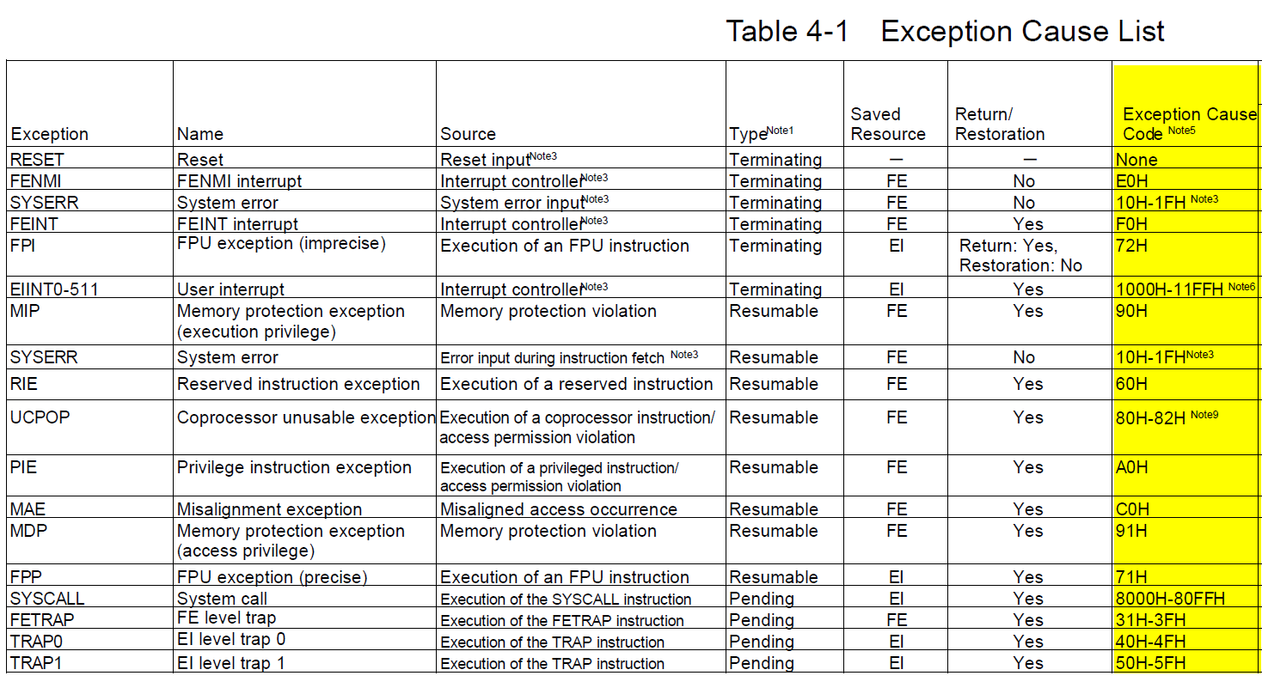

### EIINT 0x1000-0x11FF: see corresponding Interrupt table

### SYSERR

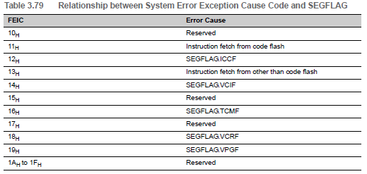

### UCPOP

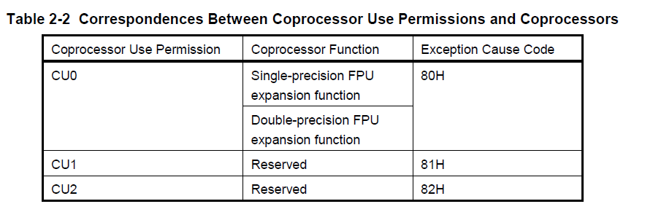

### SYSCALL

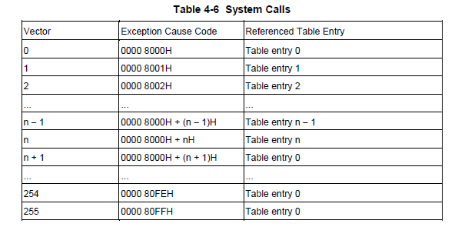

### FETRAP

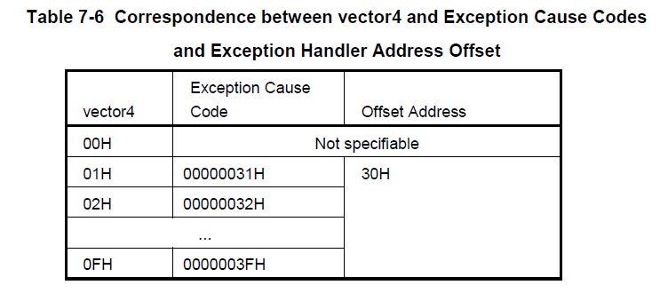

### TRAP0 & TRAP1

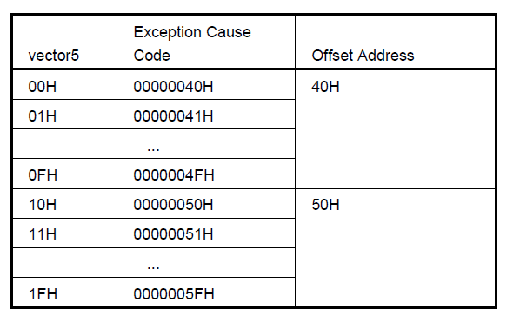

## Overview of all U2A Exception Cause Codes

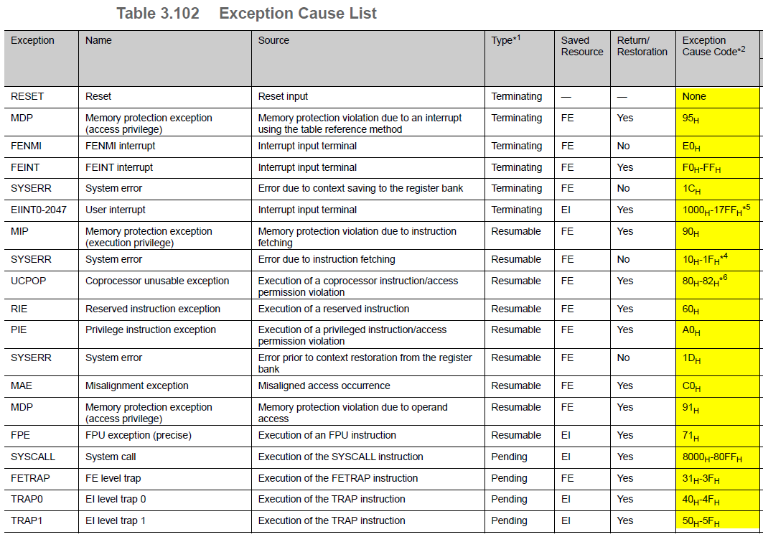

### FEInt

* Info missing.

### EIINT0-2047: see corresponding Interrupt List inside Manual

### SYSERR

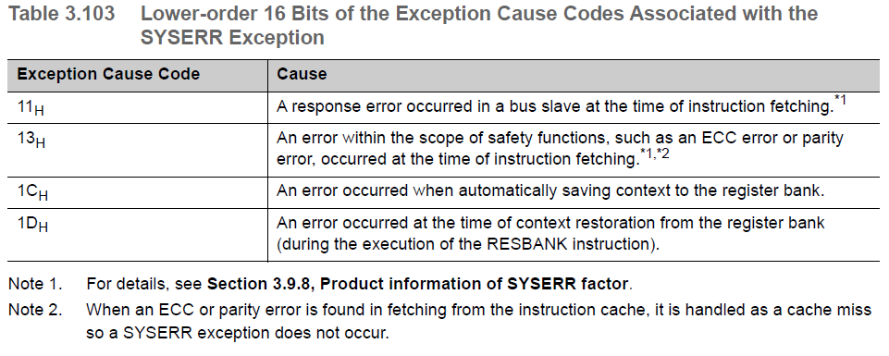

### MIP/MDP

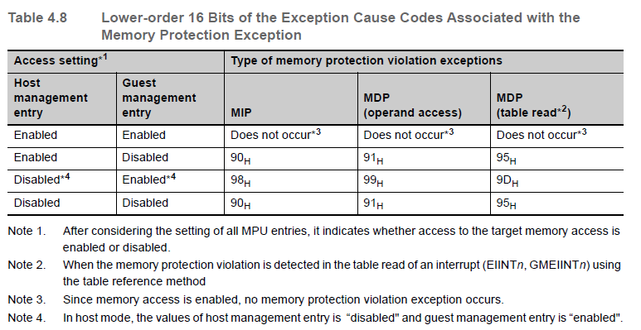

### UCPOP

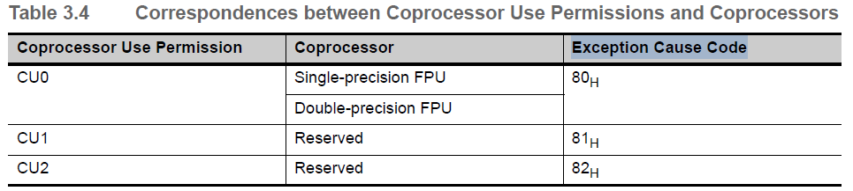

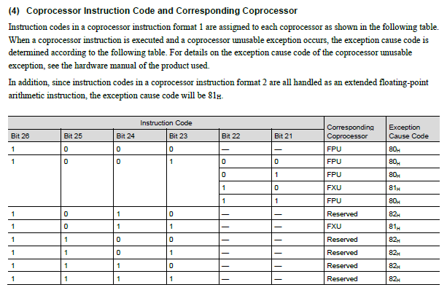

### SYSCALL

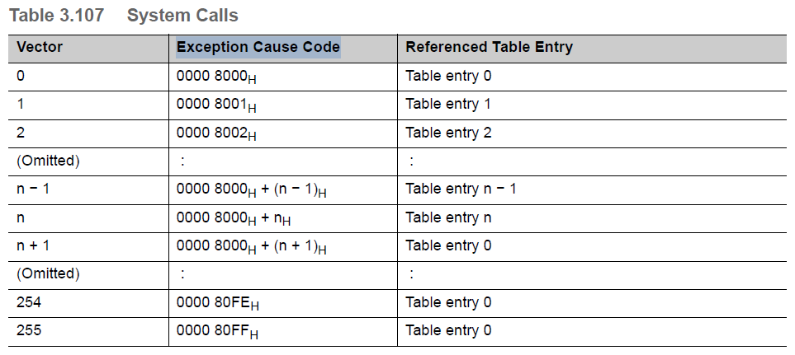

### FETRAP

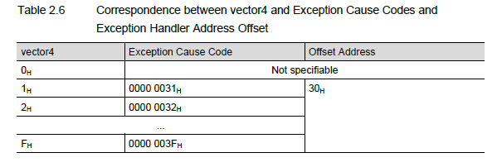

### TRAP0 and TRAP1

