When density p=0.15, there is no gridlock on 100\*100 grid. I observed free traffic after 2000 iterations. It returns value FASlE(second list). To make sure, I did the simulation for p=0.15 twice, but result was same. Below picture is traffic after 20000 iterations when p=0.15



When density p=0.5, I got a gridlock after 317 iterations. It returns value TRUE (second list). I repeated the simulation again, and I also got a gridlock. However, this time I got a gridlock after 412 iterations. The picture of plot was little bit different each other. Below plot is a gridlock after 317 iterations.

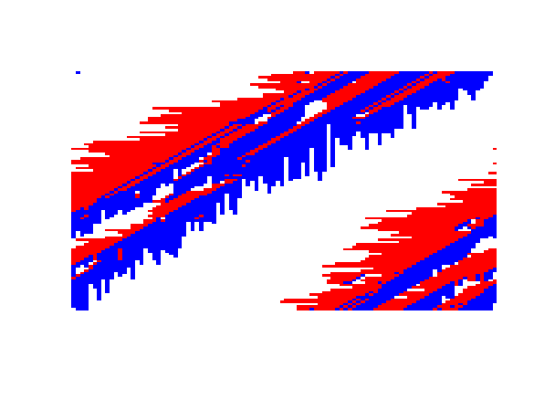

When density p=0.9, it didn’t take a long time to see a gridlock. I got a gridlock after 27 iterations. Like above experiments, I did it again. And I got a gridlock after 37 iterations. Both simulation for p=0.9 got a gridlock after few iterations.

After the simulations, I made a conclusion that traffic got a gridlock easily as density p is high.

