1. Installing Miniconda

1.1. Open terminal

Windows
Search “Windows PowerShell” in the Windows Search Bar and open it.
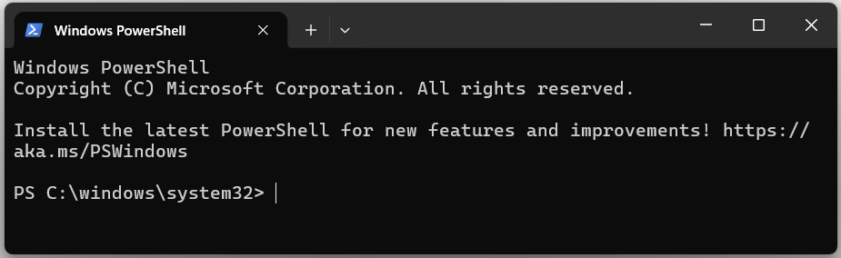
Follow the instructions for “Windows PowerShell” in 1.2.

MacOs
Type “Terminal” in the Search bar or look for it in Utilities and open. You should see a terminal like this:
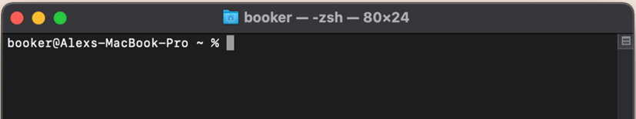
Follow the instructions for “macOS” in 1.2.

Linux
Look for “Terminal” in the Activities item and open. Alternatively try Ctrl + Alt + T. You should see a terminal like this:
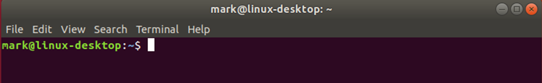
Follow the instructions for “Linux” in 1.2.

1.2. Download and Install Miniconda. Go to “https://www.anaconda.com/docs/getting-started/miniconda/install” and select your OS in the “Quickstart install instructions” tab:
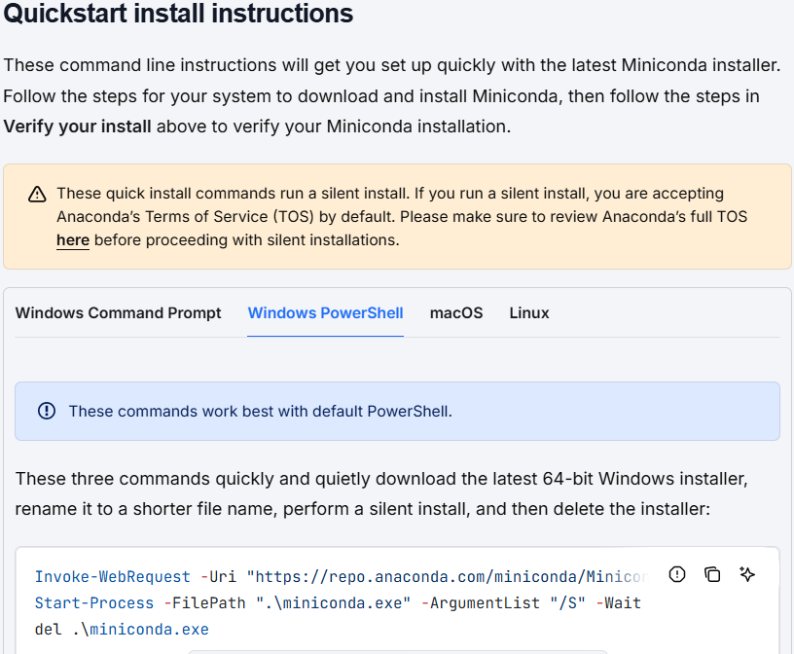
* VERY IMPORTANT! Follow all the instructions that they provide in 3 steps, DO NOT stop after executing the commands from step 1. It is recommended to run line by line.

Potential error in Windows 11
During the Miniconda installation, if you get error messages like these:
Invoke-WebRequest : Access to the path 'C:\windows\system32\Miniconda3-latest-Windows-x86_64.exe' is denied.
At line:1 char:1
+ Invoke-WebRequest -Uri "https://repo.anaconda.com/miniconda/Miniconda ...
+ ~~~~~~~~~~~~~~~~~~~~~~~~~~~~~~~~~~~~~~~~~~~~~~~~~~~~~~~~~~~~~~~~~~~~~
+ CategoryInfo : NotSpecified: (:) [Invoke-WebRequest], UnauthorizedAccessException
+ FullyQualifiedErrorId : System.UnauthorizedAccessException,Microsoft.PowerShell.Commands.InvokeWebRequestCommand
You need to run this command on the PowerShell terminal:
cd $HOME
and then try again with the commands suggested in the miniconda webpage (step 1.2).

2. Visual Studio Code installation

2.1. Installing Visual Studio Code (3 min)

Download and install Visual Studio Code (VSC) using this link:

https://code.visualstudio.com/Download

2.2. Installing extensions of Visual Studio Code (3 min)

2.2.1. Open VSC

2.2.2. Go to the extensions panel (squares icon in the left sidebar) and search for all the next extensions.
- Jupyter
- Prettier - Code formatter
- Python
- Python Indent
- Rainbow CSV

3. Downloading Workshop Materials (when available)

3.1. Download the files needed for these lessons.

3.2. Create a folder called “ML_course” on your computer.

VERY IMPORTANT 1! To avoid issues, do not create the folder in a OneDrive folder with cloud synchronization.
VERY IMPORTANT 2! To avoid issues, do not create the folder too deep within your system (i.e., long PATHs such as “C:/Users/Folder_1/Folder_2/Folder_3/…/ML_course”).
VERY IMPORTANT 3! To avoid issues, do not create the folder inside other folders with names containing characters other than unaccented English letters (A–Z, a–z), numbers or underscores “_”. Examples:
Good: “C:/Users/jv/Desktop/ML_course”
Problematic characters: á, é, í, ó, ú, ñ, spaces, periods, commas...

3.3. Move the downloaded materials to the new folder.

3.4. Unzip the file.
3.5. Delete all the files and folders except for these two folders: “Prerequisites” and “Sessions”. MAKE SURE that the ML_course folder only contains these two folders.

4. Virtual Environment Configuration

Python’s virtual environment is a tool that creates an independent space to manage projects and its modules and versions. In other words, it creates various workspaces on one serve/computer

4.1. Open a new terminal:
4.1.A. Windows: after installing Miniconda (Step 1.2), you can now open an “Anaconda prompt”. Look for this tool in your applications and open it.

4.1.B. In macOS and Linux, open a terminal as you did in step 1.1.

4.2. Create New Conda Environments

4.2.1. Go to the “ML_course/Prerequisites/Setup_and_testing” folder created in step 3. For this, you need to use the “cd” command in the terminal. For example, if your “ML_course/Prerequisites/Setup_and_testing” folder is in:
C:/Users/ML_course/Prerequisites/Setup_and_testing
You need to type the following command in your terminal:
cd C:/users/ML_course/Prerequisites/Setup_and_testing

HELP: At this point, your terminal should be in the “Setup_and_testing” folder. Your terminal shows the working folder on the left. For example, in the image below, the terminal is on the “C:/Users” folder.
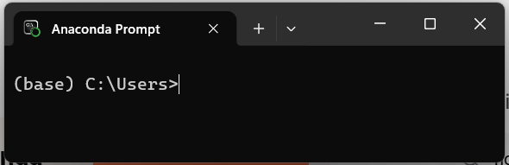

4.2.2. Execute the two following commands separately. Note some installations may take a few minutes.
conda env create -f env4camlc_cheminf.yaml
conda env create -f env4camlc_baybe.yaml

4.2.3. Additionally, you will also need to execute the following commands (just follow the instructions for your operating system):

Windows
Execute these two commands:
envrun_laplaza_windows.bat
env4heid_windows.bat

Linux/macOS
First, grant execution permissions with these two commands:
chmod +x envrun_laplaza_linuxmac.sh
chmod +x env4heid_linuxmac.sh

Then, execute the two scripts:
./envrun_laplaza_linuxmac.sh
./env4heid_linuxmac.sh

5. How to use Visual Studio Code and check the set up
Open, using VSC, the “check_workshop_envs.ipynb” Jupyter Notebook unzipped from the previous step (in the “ML_course/Prerequisites/Setup_and_testing” folder).
* (.ipynb means Interactive Python Notebook)

VERY IMPORTANT! To open the notebook, do not double-click the file with your mouse. Instead, first open VSC and select “Open Folder” (image below). You will then see the files in your folder listed on the left side of the screen. From there, select the notebook to open it.
If you don’t follow this process, VSC might not be able to detect the kernels from the points below.
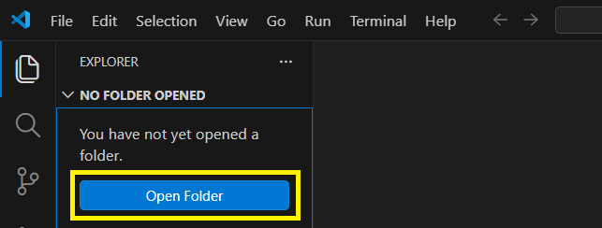
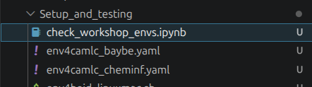

5.1. When VSC opens, select each time the created environment kernel and run the corresponding cell.
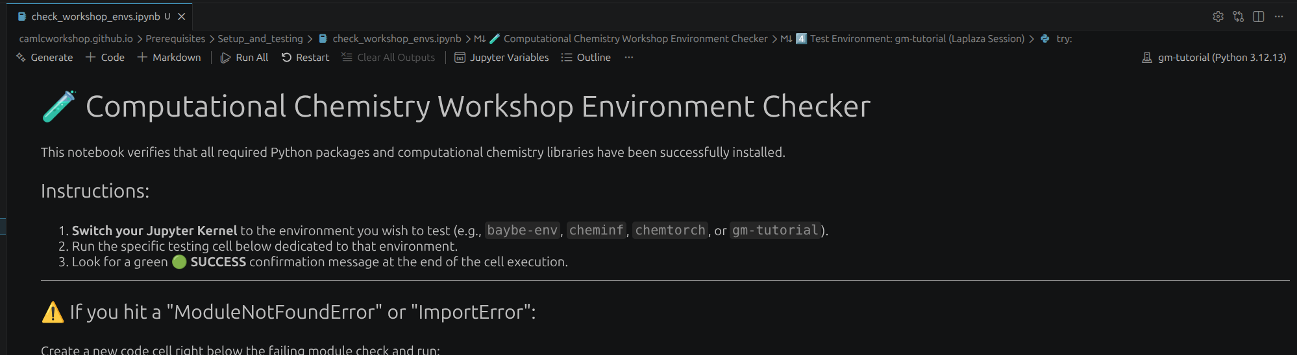
VERY IMPORTANT! If you do not see the Jupyter kernel directly, just click on Python Environments and select the one you want to use.

5.2. Check that each cell indicates that the library or program has been installed correctly.

VERY IMPORTANT! Especially on Windows, there is a high chance of installation errors. If, when running “check_workshop_envs.ipynb”, you see the message:
“Dependency check failed! No module named ‘XX’.”
(where XX is the name of the missing library), a useful troubleshooting step is to create a new code cell and type:

5.3. Close the “check_workshop_envs.ipynb” Jupyter Notebook and, then, close VSC.

6. Checking CSV files

A CSV (Comma-Separated Values) file is a simple text file used to store tabular data, where each line represents a row and values are separated by commas. It's commonly used for exchanging data between programs like spreadsheets and databases.

Possible errors when working with CSV files in Windows:
Try to open a CSV file from the course folder, for example: test.csv (from set_up folder)
If when opening a CSV file everything is condensed into a single column, you can change this in your system’s settings.
Moreover, in Excel to change the decimal separator in File à Options à Advanced, and in the “editing options” section (first one), uncheck the “use system separators” and change the decimal separator to a period instead of a comma. You can erase the thousand separator. Then click ok, and the settings should have changed so that the .csv files function correctly.

7. Testing easyROB

7.1. Portable Version (Windows)
Option A — Video Tutorial (Recommended)
If you prefer a visual step-by-step explanation, please watch the installation video using the hyperlink provided in this document.
How to install EasyROB
The video explains how to download the correct file, extract it, launch easyROB, and what to do if Windows shows a security warning.

Option B — Written Installation Instructions
For Windows users, installation is simple and takes only a few minutes.
7.1B.1.Go to the Releases page and scroll down to the “Assets” section.
https://github.com/MiguelMartzFdez/easyROB/releases

7.1B.2. Download the file called: easyROB_win.zip

7.1B.3. Once downloaded, right-click the ZIP file and select “Extract All…”. Choose a simple location (for example, the Desktop).

7.1B.4. Open the extracted folder and double-click launcher.vbs. The program will start automatically

Fallback Method! (If the Portable Version Does Not Start)
If the portable version does not launch correctly (for example, nothing happens, the window closes immediately, or you see environment/Qt errors), you can run easyROB using the standard Terminal method.
Please follow the instructions described in Section 7.3.
If this situation occurs, please let us know and include:
- Your operating system and version
- A brief description of what happens
- Any error message shown
- The file easyrob_process.log generated in the folder

7.2. Portable Version (Linux)

7.2.1. Go to the Releases page and scroll down to the “Assets” section.
https://github.com/MiguelMartzFdez/easyROB/releases

7.2.2. Download the file called: easyROB_linux.zip

7.2.3. Once downloaded, right-click the ZIP file and select “Extract All…”. Choose a simple location (for example, the Desktop).

7.2.4. First-time setup only: right-click inside the folder (in an empty area), select “Open in Terminal”, and run:

chmod +x run_easyrob.sh

7.2.5. In the same Terminal window, run:

./run_easyrob.sh

Fallback Method! (If the Portable Version Does Not Start)
If the portable version does not launch correctly (for example, nothing happens, the window closes immediately, or you see environment/Qt errors), you can run easyROB using the standard Terminal method.
Please follow the instructions described in Section 7.3.
If this situation occurs, please let us know and include:
- Your operating system and version
- A brief description of what happens
- Any error message shown
- The file easyrob_process.log generated in the folder

7.3. Testing easyROB from Terminal (macOS / Fallback Method)
This method runs easyROB using a standard ROBERT installation (non-portable).

Steps

7.3.1. Open a Terminal.

Windows:
Open Anaconda Prompt (do not use the standard Windows Command Prompt).

macOS:
Press Cmd + Space, type Terminal, and press Enter.

Linux:
Press Ctrl + Alt + T or search for “Terminal” in your applications menu

7.3.2. Activate the conda environment where ROBERT is installed:

conda activate cheminf

7.3.3. Download easyrob.py from:

https://github.com/jvalegre/robert/blob/master/GUI_easyROB/easyrob.py
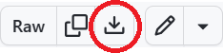
Click the 'Download raw file' button (top-right area of the page).

7.3.4. Navigate to the folder where you saved the file:

cd /path/to/your/folder

7.3.5. Launch easyROB by running:

python easyrob.py

