**Presentation Layer**

**Service Layer**

Customer interface

User Interface Components

HTML

Web Server

Side scripts

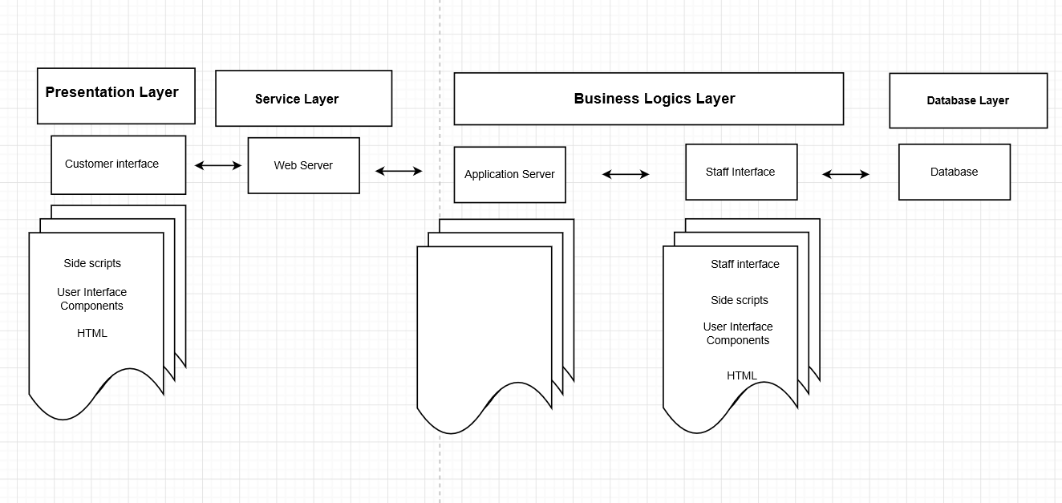**Business Logics Layer**

Application Server

Staff Interface

Staff interface

Side scripts

User Interface Components

HTML

**Database Layer**

Database