Helps riders using a power meter improve time trial performance by showing real-time power variability. The key idea is smaller power and energy fluctuations result in faster times and lower fatigue.
The Power Stability Field supports "steady-state" effort by providing visual feedback on how smooth and consistent your power and kinetic energy are in real-time. Here is how a cyclist experiences the data field during a ride:

1. The Core Metric: 3-Second Power
At the center of the display, you see your standard 3-second average power. This provides the immediate feedback on current effort.

2. The Dynamic Background: Effort Trending
The background color acts as a "trend indicator." By comparing 3-second power to your 10-second power, the field changes color to tell you if your effort is currently surging or fading.
Background shifts, indicate the absolute Percent Difference, % Diff, between the rolling 3s and 10s mean average powers. Blue indicates the lowest difference (e.g., below 10%), red exceeds max value, (e.g., 20%), green in-between. Under a lower power limit, 100 Watts, the display is plain. Limits are configurable.

3. Stability Gauges: The "Purple Bars"
Visualize Stability % (Coefficient of Variation), purple bars grow or shrink based on two metrics:
- Left: Kinetic Energy (KE) stability: This is useful for time trialists or solo riders; it measure how KE is changing, (delta Velocity Squared). Rate of KE change is a component of power consumption, or addition, i.e., adds power.

- Right: Power Stability (Pwr): Shows how consistent your power output is over a rolling 10-second window. A smaller bar indicates a steady output style, while a larger bar suggests an erratic effort with frequent micro-surges.

4. Post-Ride Analysis
The data field records both the Power Stability (CV_Pwr) and KE Stability (CV_KE) directly into your activity's FIT file.

Summary for the Athlete
Instead of just asking "How hard am I pushing?", this field answers "How steady is my effort?". It’s a tool designed to improve their efficiency and maintain a smooth flow.

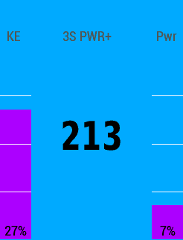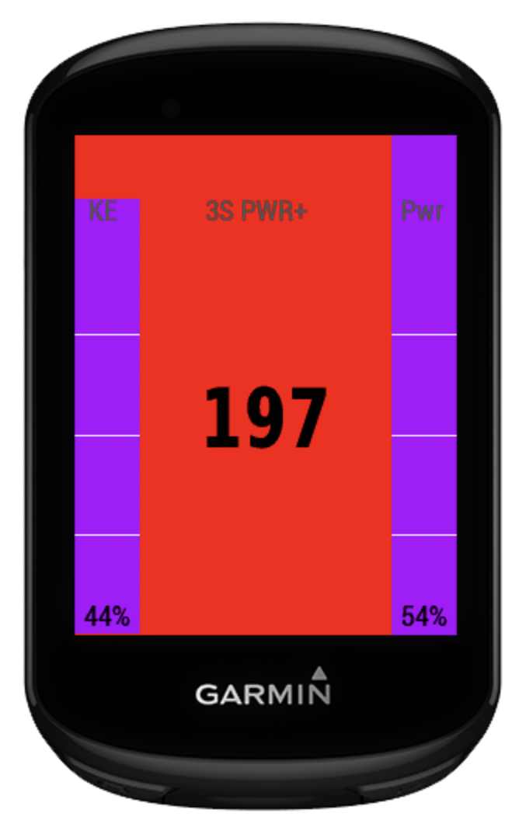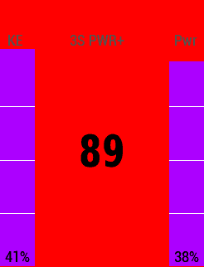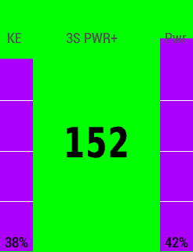

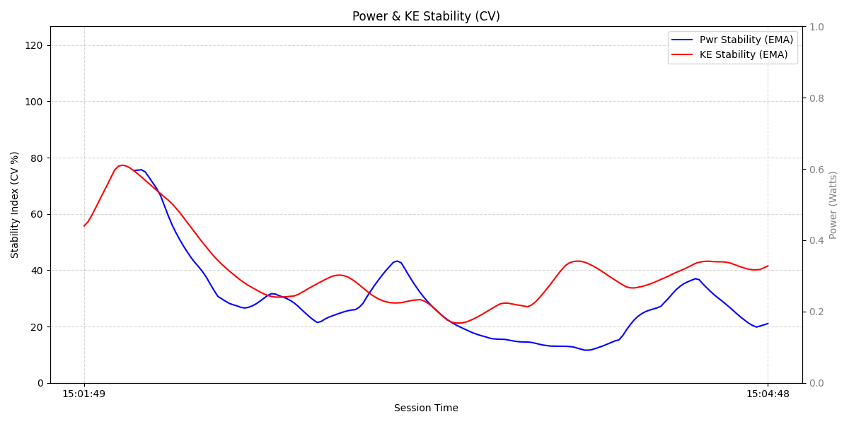

1 https://velo.outsideonline.com/road/road-training/how-to-ride-the-perfect-time-trial-constant-power-vs-variable-power/

