Helps riders using a power meter improve Time Trial performance by showing real-time power variablity. The key idea is smaller power fluctuations result in faster times and lower fatigue. Two real-time actionable metrics are available together with the 3s average power (3S+ PWR):
Background Color
Indicates the absolute Percent Difference, % Diff, between the rolling 3s and 10s mean average powers. Blue indicates the lowest difference (e.g., below 10%), red exceeds max value, (e.g., 30%), green in-between. Under a lower power limit, 100 Watts, the display is plain. Limits are configurable.
Coefficient of Variation (CV) ( right bar in % marked to at 10,20, 30)
Rolling 10s Standard Deviation to 10s Mean power ratio. Constant power output would show as 0%. CV is also output to the FIT file. The background color is more volitile at lower power output, whereas the CV has a consistent meaning.
Feedback Interpretation
The "Smooth Ramp": If you slowly and steadily increase your power (e.g., 200W -> 210W -> 220W), your % Diff will be high because the 3s mean is significantly higher than the 10s mean. However, your CV might remain relatively low because the power delivery is "smooth" and rather than jumping erratically.
The "Erratic Constant": If you are trying to hold 200W but your pedaling is "choppy" (e.g., jumping between 170W and 230W every second), your % Diff might be near 0% (because the 3s and 10s means both center around 200W). However, your CV will be very high because the standard deviation of those individual seconds is large.
In summary:
Background Color (% Diff), tells the rider "Am I currently changing my effort level?" (Red for high drift, Blue for steady).
Purple Bar (CV), tells the rider "How smooth is my power delivery?"
This field’s use case is to provide real time feedback to the rider about power variability in an actionable form, the rider can focus on output that stays in the blue/green, and the CV bar low, for their targeted average power.

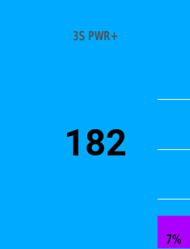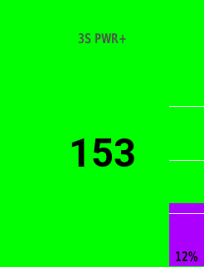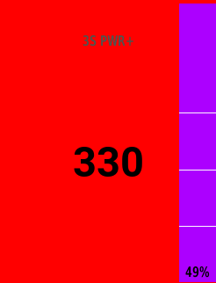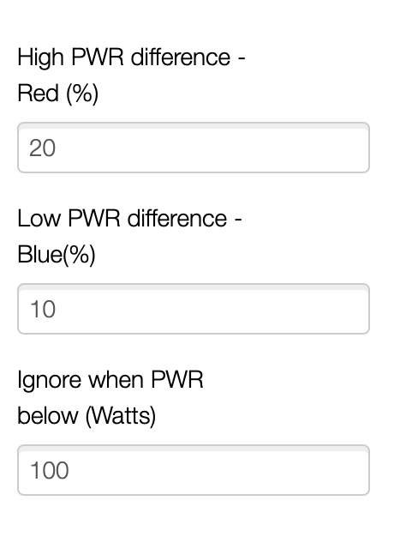

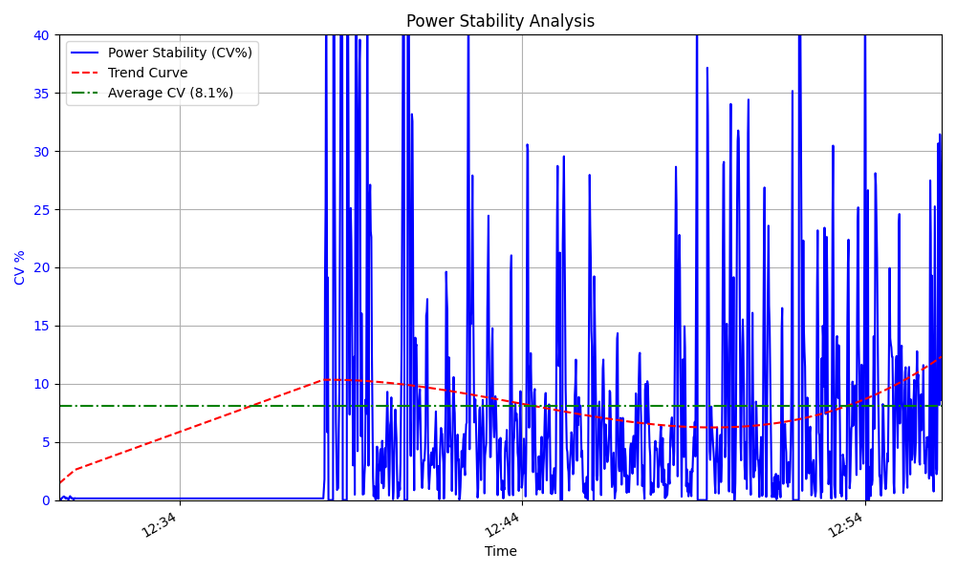

1 https://velo.outsideonline.com/road/road-training/how-to-ride-the-perfect-time-trial-constant-power-vs-variable-power/

Helps riders using a power meter improve Time Trial performance by showing real-time power variablity. The key idea is smaller power fluctuations result in faster times and lower fatigue. Two real-time actionable metrics are available together with the 3s average power (3S+ PWR):

Background Color

Indicates the absolute Percent Difference, % Diff, between the rolling 3s and 10s mean average powers. Blue indicates the lowest difference (e.g., below 10%), red exceeds max value, (e.g., 30%), green in-between. Under a lower power limit, 100 Watts, the display is plain. Limits are configurable.

Coefficient of Variation (CV) ( right bar in % marked to at 10,20, 30 upto 50)

Rolling 10s Standard Deviation to 10s Mean power ratio. Constant power output would show as 0%. CV is also output to the FIT file. The background color is more volitile at lower power output, whereas the CV has a consistent meaning.

Feedback Interpretation

The "Smooth Ramp": If you slowly and steadily increase your power (e.g., 200W - 210W - 220W), your % Diff will be high because the 3s mean is significantly higher than the 10s mean. However, your CV might remain relatively low because the power delivery is "smooth" and rather than jumping erratically.

The "Erratic Constant": If you are trying to hold 200W but your pedaling is "choppy" (e.g., jumping between 170W and 230W every second), your % Diff might be near 0% (because the 3s and 10s means both center around 200W). However, your CV will be very high because the standard deviation of those individual seconds is large.

In summary:

Background Color (% Diff), tells the rider "Am I currently changing my effort level?" (Red for high drift, Blue for steady).

Purple Bar (CV), tells the rider "How smooth is my power delivery?"

This field’s use case is to provide real time feedback to the rider about power variability in an actionable form, the rider can focus on output that stays in the blue/green, and the CV bar low, for their targeted average power.

Additional metric coefficient of variance added with side bar chart. Contribution to FIT file for CV data.

