**Abstract**

Over the last 20 years as the severity of climate change has increased, progress toward reducing greenhouse gas emissions has stalled as a result of political gridlock. While researchers have studied the effects of many institutional variables on a wide array of environmental outcomes such as greenhouse gas emissions, my paper is the first to consider the impact of political donations. I examine the effects of political contributions on clean electricity production using a panel data set for U.S. states from 2001 to 2018. Using Jordà projections, I find that overall donations are a significant short- and long-term driver of clean electricity production. Donations to Democratic politicians and donations attempting to sway politicians away from their ideological positions have especially strong effects. This result contributes to the discussion surrounding the effectiveness of political donations; researchers still have not reached a consensus regarding the impact of donations on voting behavior, but donations clearly can affect environmental outcomes through legislative mechanisms. Additionally, it highlights a mechanism that has the potential to both aid and hinder the transition to clean electricity production necessary to avoid the worst effects of climate change.

**Introduction**

Many major political issues, such as climate change, share a common characteristic: they consistently gather consensus support around potential solutions, yet remain unaddressed by legislative bodies (Howe, et al., 2015). The inaction of these bodies has a real cost when it comes to climate change. By 2090, the United States will save $224 billion in economic damages every year if global warming is limited to 2.8°C (5°F), compared to the current path of 4.5°C (8°F) (Office of Research and Development, 2017). The Intergovernmental Panel on Climate Change, a scientific panel created by the United Nations to study climate change, recommends even stronger action, estimating that limiting warming to 2°C (3.6°F) would avoid the worst impacts of climate change (Solomon, 2007). Meeting this target requires that the world reach net zero emissions of greenhouse gases by 2050. The widespread diffusion of clean, clean energy will be critical to achieving this goal.

Despite the threat of climate change to the present and future health of the planet, most American politicians continue to oppose climate action. I examine one facet of this larger concern by identifying the political and economic variables that affect the composition of electricity production in the United States. Specifically, my paper traces the effect of the energy sector’s political donations on clean electricity production at the state level. I focus on clean electricity production because, according to the Energy Information Administration, 38% of the United States’ greenhouse gas emissions came from the electricity generation industry in 2018 (Energy Information Administration, 2021). Without major changes to this industry, it will likely be impossible for the United States to meet its long-term climate change goals, including those set forth in the Paris Agreement[1].

I utilize panel estimation techniques to examine the effects of political and economic variables on a state’s production of clean electricity. I include both state and year fixed effects to control for unobserved variation. Additionally, I construct an instrumental variable for the price of electricity because the price of electricity is endogenous to electricity output. The instrument is the average of a state’s neighbors’ prices of electricity, which captures much of the variation in a state’s electricity price while being exogenous of the state’s production (Kneifel, 2009). Finally, I utilized the Jordà projection technique to examine how the effects of political and economic variables on clean electricity production evolve over time. This method involves estimating the same model on different time horizons in order to estimate an impulse response function of clean electricity to political contributions.

Using these techniques, I find that political donations affect clean electricity production in both the short- and long-term. However, the firm making the donation and the ideological stance of the recipient are both important in determining the size and direction of the effect. There appears to be minimal long-term returns to donating to a politician whose ideological stance already supports a firm’s business interests. Specifically, donations to Democrats from clean energy firms only have a statistically significant effect in the short-term and donations to Republicans from dirty energy firms have no statistically significant effect. In contrast, donations to politicians who hold political views in opposition to a firm’s interest have a larger effect, especially in the long term. This could result from these donations swaying congresspeople to support legislation that they would otherwise oppose. Following these patterns, I find that dirty energy donations to Democrats and clean donations to Republicans strongly influence clean electricity production in the long run. This finding helps to remedy the lack of papers examining impact of institutional quality variables on environmental outcomes.

**Literature Review**

Many political science studies establish a strong theoretical relationship between the political environment and environmental outcomes. Political actors rarely make decisions that affect the electricity industry, such as whether or not to pass a clean electricity subsidy, based solely on what would maximize consumer surplus (Mayer, 2019). Pressure from party leadership, special interest groups, and constituents all play a role in legislative decision making, along with any ideological beliefs the legislator may have about the best economic policies. This establishes a clear link between political pressures, like party ideology and campaign contributions from special interest groups, that a legislator might consider when deliberating on legislation and the success or failure of legislation (Dumas, et al., 2016). Additionally, a well-established link exists in the environmental economics literature between different types of environmental legislation, such as renewable portfolio standards or carbon taxes, and environmental outcomes like greenhouse emissions (Dasgupta and Cian, 2018). Because these pieces of legislation can have their passage or failure determined by political pressures on legislators, these pressures have a clear theoretical avenue of influence on actual environmental outcomes.

Researchers, however, debate more hotly the role of donations in legislative decision making. Stratman (2005) summarizes the disagreement in the literature as a debate over how to account for the endogeneity between donations and politician’s votes in statistical models. Contributors give to politicians with whom they more closely align on the ideological spectrum, and politicians may be more likely to vote in line with the ideology of those who contribute to them (Powell, 2014). If this endogeneity problem is not addressed correctly, the strength of the effect of contributions on vote would be necessarily overestimated. Other researchers have concluded that the entire premise of the question is too narrow. Powell (2014) posits that much of the effect of contributions comes in the form of legislators influencing which bills are passed out of committee or come to a vote. Additionally, Powell points out that contributions result in increased effectiveness of lobbying later on, making political donations essentially an investment that pays out over time.

By using political donations to explain a real-world outcome instead of politicians’ voting behavior, I avoid the endogeneity issues surrounding voting and donations. Political donations are not endogenous with clean electricity output, so my model does not have a potential upward bias in the estimation of the effects of donations. Additionally, my model captures the entire real effect of contributions on the passage of legislation because studying clean electricity production does not exclude the influence of lobbying or the snuffing out of nascent legislation in the way that voting behavior does.

On both the international and US state level, there is a well-established empirical body of literature examining the impact political variables on the passage of environmental legislation and environmental indicators, such as the level of air pollution. The political variables used in this literature include the percentage of left-leaning officials in government, strength of environmental group activity in a region, level of corruption, party in power, and public opinion on environmental issues. Lyon and Yin (2010) find that both the percentage of Democrats in a state legislature and the presence of an environmental special interest group in the state influence whether the state will pass renewable portfolio standard legislation. Schaeffer and Bernauer (2014) and Agnone (2007) find the left-leaning party’s amount of control affects the passage of environmental legislation. Public opinion on whether the government allocates too many resources to protecting the environment and the strength of environmental protest activity are both also found to influence the political fate of environmental legislation in Agnone (2007). Finally, Jenner et al. (2012) finds that educational level and the presence of neighboring states that have already passed environmental legislation predict whether a government will pass environmental legislation.

Environmental economics papers that attempt to link political factors with actual environmental outcomes utilize many of the same variables as papers aimed at predicting passage of legislation, in addition to variables such as environmental special interest group membership. Neumayer (2003) uses the left wing’s relative strength in government to predict air pollution while Binder and Neumayer (2005) predicts air pollution using the membership of environmental special interest groups and the literacy rate of a region. Motivated in similar ways, these wide-ranging political variables broadly measure the different political forces that determine whether a government will take pro- or anti-clean energy stances, which often changes actual environmental outcomes.

Alongside these political factors, economic variables also prove to be important in predicting passage of environmental legislation. Natural gas production, nuclear energy production, and the share of gross domestic product generated by the energy industry are utilized to predict the passage of environmental legislation in Lyon and Yin (2010), Schaeffer and Bernauer (2014), and Neumayer (2003), respectively. Additionally, Lyon and Yin (2010) and Jenner et al. (2012) find that both the state’s unemployment rate and solar energy potential affect the passage of environmental legislation. Schaeffer and Bernauer (2014) use the per capita income of a state to predict the passage of environmental legislation while Neumayer (2003) uses it to predict the amount of air pollution in a state. This usage of a state’s income is motivated by the environmental economics literature concerning the environmental Kuznets curve, which posits that as a society gets richer, its environmental damage increases until it hits a maximum. After this maximum value, the additional income is used by the society to abate more environmental damage than is caused in generating that income, thereby lowering the overall environmental damage. Additionally, Binder and Neumayer (2005) utilizes the Gini coefficient in its prediction of a state’s air pollution, as a state’s income distribution correlates strongly with its distribution of political power. Finally, Jenner et al. (2012) utilizes electricity price in its prediction of the passage of environmental legislation motivated by the theory that states with high electricity prices may favor legislation that could reform the energy industry.

I use Jordà projections to determine not only the strength of the effects of these political and economic variables on clean electricity production, but also the duration of each effect. In order to permanently positively influence the environment, an effect not only needs short-term strength but also long-term durability; therefore, the duration of these effects has a large impact on the environment. I construct impulse responses using Jordà projections, which are frequently used in macroeconomics to examine the impact of economic variables on the health of the economy over the long term (Jordà 2005). Jordà projections have many advantages over the more traditional VAR models used to create impulse responses, most notably that they can be created with standard regression models (Jordà, 2005). Romer and Romer (2017) presents a canonical example of the usage of Jordà projections; they examine whether an interest rate above the zero lower bound and a low debt-to-output ratio impacts the severity of the aftermath of a recession in the long term. Since I aim to determine the long-term effects of political donations on clean electricity production, I employ Jordà projections in a similar way to Romer and Romer (2017).

In their extensive review of empirical papers relating political and economic factors to environmental outcomes, Dasgupta and Cian (2018) identify four main gaps in this literature. My paper fills two of these gaps: 1) it examines the influence of institutional quality on environmental performance, and 2) it investigates “the interplay between economic, political, institutional, and socio-cultural changes” (Dasgupta and Cian, 2018). Broadly defined in political economic literature in ways ranging from strength of property rights to ability to effectively leverage taxes, “Institutional quality” is often measured using the World Governance Indicators (WGI) (Dasgupta and Cian, 2018). In order to accurately measure aspects of institutional quality, I follow the methodology used by the World Bank to calculate the WGI. In order to address the second gap, I make use of a wide array of economic, political, institutional, and societal variables that are enumerated in the Data section.

**Data**

To shed light on which factors drive the production of clean electricity, I use relevant political and economic variables for each of the lower 48 states over the 18-year period from 2001-2018. The political variables include three broad categories: measures of public opinion, partisanship, and institutional quality. The economic variables are grouped in two broad categories: energy market variables and general economic health indicators. These are discussed in more detail below.

**Political Variables**

*Measures of Public Opinion*

Because it is well established in political science literature that legislators attempt to conform to the views of their constituents, I use the League of Conservation Voters’ scorecards, which like the National Rifle Association’s grades on gun legislation, grade congresspeople based on their votes on environmental legislation to act as a potential proxy variable for the public’s interest in environmental legislation. Because this proxy relies on politicians tailoring their stances to fit the preferences of their electorate, I follow the example of Kneifel (2009) by using only scorecards for members of the US House of Representatives, who are much less insulated from public opinion than their senatorial counterparts due to their 2-year terms in office.

Data that directly measures public opinion on environmental issues is not available at the state level because many traditional pollsters either do not ask environmental policy preference questions regularly or they only make national, not state level, data available. Instead, I use Google Trends data to measure the public’s interest in the three major news networks: CNN, Fox News, and MSNBC with the theory that viewers’ choice of news network corresponds to their political point of view and thus their view on environmental issues. This data consists of indices comparing each state’s relative interests in these search terms during each year in my dataset. Unfortunately, this data is only available from 2005 onward. When I include this data in my model, the loss in observations results in low predictive power, so I exclude it from my final model. Future research could focus on constructing an accurate measure of environmental public opinion, especially as pollsters conduct more and more environmental polling.

*Measures of Partisanship*

Data on each state’s elected offices, including the party affiliations of governors, senators, and representatives and which party had control of the chambers of their state’s legislature act as proxies for the state’s partisanship as a whole since these officials are elected by the state’s populace. I collect these proxies from the National Conference of State Legislatures. Since the Democratic and Republican parties have such polarized positions on environmental policies, including clean energy subsidies, the ideology of the party that controls a state’s government can have considerable effects on clean electricity production. Given that a political party often needs complete control of a state’s government to pass major legislation, I use this party affiliation data to create three dummy variables representing control of the executive branch and two legislative chambers: complete Democrat control, complete Republican control, or split party control. These dummy variables do a better job of capturing the effects of state government partisanship than, for example, the Democratic percentage of a state legislature because even a heavily Democratic state legislature can be effectively shut down by a Republican governor.

*Measures of Institutional Quality*

Finally, I include political variables that measure the level of institutional quality in a state. As previously discussed, the WGI are often used as a measure of institutional quality on the international level, but unfortunately, there is not a directly comparable source of data on the US state level. I instead use proxies for the level of corruption in a state and regulatory quality, two important factors used in the calculation of the WGI.

Regulatory capture occurs when a special interest group can somehow cause a regulatory body to act in accordance with its interest instead of the public interest and is the exact type of governmental issue that the WGIs are designed to capture. Although political donations are legal, I assert that they nonetheless serve as a reasonable proxy for electricity-relevant corruption as they are both attempts at regulatory capture by special interest groups. For data on donations from clean and dirty energy related companies to congressional campaigns, I use OpenSecrets, a watchdog group run by the Center for Responsive Politics that attempts to promote transparency and accountability by publishing as much data as possible on political campaign financing and politicians’ personal finances. Since these donations can indicate industry attempts at regulatory capture, I hypothesize that as clean energy industry donations to either party’s politicians increase, so will clean electricity production. On the other hand, I posit that increased dirty energy donations will decrease clean electricity production.

To collect the donation data at the candidate-industry-cycle level, I use an R package that I built for this purpose (downloadable at github.com/hkarp1) and sum this data to create variables representing the total amounts of clean energy industry and dirty energy industry donations to Democrats and Republican members of Congress. I only include donations to candidates who actually won their races because only the winners of these races have a direct impact on the legislative process. Additionally, this data comes in 2-year cycles, which does not match the rest of my annual data. In order to create variables of annual donations, I assume that 75% of an election cycle’s spending occurs in the election year while 25% occurs in the non-election year because, according to OpenSecrets, the majority of donations to Congressional campaigns have come from individual donors in each cycle from 2000-2020. Individual donors have their spending capped per election cycle, unlike companies which are capped per year, and it is reasonable to assume that donors would make most of these capped donations during the election year when they have a clearer idea of policy stances and campaign viability. However, I also test both a 90-10 and 50-50 split as robustness checks. Finally, I aggregate these donations into clean and dirty energy firm donations. The clean energy firm donations include donations only from firms directly involved in producing clean energy. The dirty energy firm donations include dirty energy producing firms, as well as donations from firms in related industries like mining or natural gas transmission.

Additionally, I use estimates of legislative effectiveness compiled by the University of Virginia’s Center for Effective Lawmaking (CEL). The CEL collects data on every member of Congress, including the sponsor, proposed amendments, and how the bill progressed through the Congressional process. Using this data and its own grading of a bill’s significance, the CEL compiles an estimate of the legislative effectiveness for every member of Congress each year. This measure captures how efficiently a politician introduces, promotes, and eventually passes the legislation and especially rewards members who garner passage for significant legislation. Since this variable measures the effectiveness of a significant facet of the Federal government, it qualifies as an important institutional quality measure. As such, the political and economic literature would predict that increased legislative effectiveness would result in greater clean electricity production. In order to get state-chamber-year data from politician-year data, I sum all of a state’s senators and representatives and find the average legislative effectiveness.

Overall, finding state-level measures of institutional quality proves challenging because of limited data availability or accuracy concerns. Other institutional quality variables that I do not use in the model for those reasons include the Cato Institute measure of “economic freedom,” voter participation rate, literacy rates, high school graduation rate, and violent crime rates. Finding accurate and consistently available sources of these and other institutional quality variables is a possible extension of the work in this paper.

**Economic Variables**

*Energy Market Variables*

From the Energy Information Administration’s (EIA) State Energy Data System (SEDS), I use each state’s total reserves of oil and coal. While these variables may seem static, they vary significantly as energy producers deplete or discover new deposits of these natural resources over time.

The retail price of electricity is available from the EIA’s SEDS on the state level. This variable is a strongly theoretically relevant variable in the production of clean electricity, but price and quantity consumed are simultaneously determined. Therefore, I create an instrumental variable for the price of electricity in my models. I follow the example of Kneifel (2009) and take the average of the prices of electricity paid by consumers in neighboring states. This variable captures much of the important variation in the retail price of electricity while remaining exogenous of the production of electricity in a state.

I also collect data on utility-scale clean electricity production, my dependent variable, from the EIA’s SEDS. The EIA defines clean electricity as electricity produced using hydropower, wind power, solar power, geothermal energy, and biomass such as wood. Dirty electricity is defined as being generated using natural gas, coal, or nuclear fuel. The EIA defines ‘utility-scale’ power plants as those with at least one megawatt of generating capacity and classifies power plants with less capacity as ‘small-scale’ (Energy Information Administration, 2021). Data on the production of small-scale power plants, most often individual rooftop solar power systems, is only available for part of the study period, so I did not include it in my calculation of total clean electricity production. While it would be ideal to include small-scale power plants, the EIA estimates they only generated around 5% of total clean electricity production in 2020 (Energy Information Administration, 2021).

Finally, I use the clean energy production data to calculate the average clean electricity production of a state’s neighborhood, defined as any state that shares a border with the home state. The possibility of spillover of clean electricity technology or legislation from a state’s neighbors motivates the inclusion of this variable. The usage of this neighborhood spillover variable and the neighborhood electricity price instrumental variable limits my dataset to the lower 48 states.

*General Economic Indicators*

I use three general economic indicators, namely employment percentage, per capita income, and the top 1% income share, to control for the relative health of a state’s economy. These variables are also motivated by the theory that officials in economically struggling states may attempt to stimulate the economy using clean energy production legislation. Because the U3 unemployment rate underestimates the real level of unemployment when discouraged workers leave the labor force, I use the Bureau of Labor Statistics’ employment rate data, which does not suffer from underestimation. I also use the per capita income data from the Bureau of Economic Analysis because of the well-established environmental economics literature on the Environmental Kuznets Curve. Finally, I use the percentage of income that a state’s top 1% earns, which measures the inequality of a state’s income distribution (Frank, 2009**).** Income inequality is well established in political economic literature to be closely related to a society’s political power, as higher income tends to be correlated with higher political influence. Although using the Gini coefficient would be ideal, data are available for only part of the study period.

**Methodology**

Using the Jordà projection technique, I regress clean electricity production for state *s* in years *t* to *t + 8* on economic and political controls in year *t* using the model specification below.

*Renew* s,t + i = s + t + ***Political Controls***s,t+ ***Economic Controls***s,t+ *RenewDem*s,t+ *Non-RewDem* s,t+ *RenewRep*s,t+ *Non-RenewRep* s,t+ *e*s,t

s is a vector of state effects. t is a vector of year effects. *Political Controls* is a matrix of variables including the average League of Conversation Voters score and two dummy variables, one representing a split state government and the other representing a unified Democratically controlled government. *Economic Controls* is a matrix of variables including oil and coal reserves, average neighborhood clean electricity production, employment rate, per capita income, and top 1% income share. *RenewDem* and *RenewRep* are the average total clean energy donations to Democratic and Republican politicians in an election cycle. *Non-RenewDem* and *Non-RenewRep* are the average total dirty energy donations to Democratic and Republican politicians in an election cycle. Since election cycles span two years, I assign 75% of the average total donations to election years and 25% to non-election years.

Because many of the variables included in the model, including the dependent variable, have heavily skewed distributions and a large number of zeroes, I take the inverse hyperbolic sine of each variable. Economists commonly use this technique as a replacement for log transformations when they are working with data with many zeroes (Bellemare and Wichman 2020). The inverse hyperbolic sine closely approximates the natural log and also creates relationships that can be interpreted as elasticities, just like the natural log, when used in regression modeling (Bellemare and Wichman, 2020). Additionally, I include both year and state fixed effects, as represented in the model by $α$ and $υ$ respectively, in my regressions in order to control for correlation between the explanatory variables and time invariant factors such as the amount of solar radiation that a state experiences in a year. I also estimate my regressions using robust standard errors to account for heteroskedasticity.

**Results**

Clean electricity production varies widely across states (Figure 1A). The average state produced 9838 megawatts of clean electricity per year in my sample. Delaware, the lowest producing state, generated only 87 megawatts per year while Washington produced the most clean electricity at 82,275 megawatts per year. Clean electricity production also follows a fairly predictable spatial pattern as it is more prevalent in states that have passed environmental legislation, such as California’s 2006 Global Warming Solutions Act. Texas also ranks highly in clean electricity production, with production rising by almost 100,000,000 megawatts from 2000 to 2018. This increase is almost entirely caused by expansion in wind energy, likely driven in part by the state’s renewable portfolio standard and legislation to expand transmission infrastructure. These patterns suggest that environmental legislation is correlated with clean energy production, possibly through political donations.

The size of political donations in my dataset also varies widely. Clean energy companies donated an average of $13,757 per election cycle to Democratic legislators compared to $10,552 to Republicans. Dirty energy companies tended to donate much more, giving on average $649,382 to Republican politicians and $225,573 to Democratic politicians per election cycle. This large difference in the amount of average donations across industries is partially driven by the enormous size of the dirty electricity production industry relative to the clean electricity production industry. In addition, the inclusion of donations from dirty energy firms that do not directly produce electricity such as coal mining companies increases the amount of dirty donations.

However, the distributions of clean electricity production and energy industry political donations vary greatly from state to state (Figure 1B-E). Clean electricity production follows a fairly predictable distribution pattern with greater prevalence in states that have passed environmental legislation, such as Washington and California. Texas, however, ranks surprisingly high in clean electricity production; Texas’s clean electricity production grew by almost 100,000,000 megawatts from 2000 to 2018. The distribution of energy industry political donations seems to be concentrated in states containing valuable natural resources such as West Virginia, Colorado, and the Dakotas. Additionally, there seems to be a correlation between the opportunity to sway a political enemy and the energy industry donations. For example, clean energy donations to Republicans and all types of donations to Democrats are concentrated in North Dakota and West Virginia, hotspots for fracking and coal mining. Clean energy firms may be attempting to induce Republican legislators in such states to change their anti-environmentalist stances in order to more readily make use of natural resources like North Dakota’s high wind energy generation potential, whereas both clean and dirty firms may be trying to sway Democrats on fracking bans or taxes on greenhouse gas emissions. Similar logic applies to the large donations to Colorado’s Republican politicians that hold sway over the state’s ample mining industry.

More careful casual analysis shows that contemporaneous clean energy industry donations to Democrats have a statistically significant positive effect on clean electricity production, while dirty energy industry donations to Democrats have a statistically significant negative impact on clean electricity production (Table 1, 0 Year Lag). A 1% increase in clean energy donations to Democrats is associated with a .018% increase in clean electricity production. A 1% increase in dirty energy donations to Democrats is associated with a .041% decrease in clean electricity production. In contrast, contemporaneous clean and dirty energy industry donations to Republicans have no statistically significant effect on clean electricity production.

With the Jordà projection technique, I can determine not only the strength and significance of political donations on clean electricity output, but also how quickly the impact appears and how long it lasts (Table 1, 0 Year Lag to 8 Year Lag and Figure 2A-D). I conclude that clean energy donations to Democrats have a fast-acting, short-lasting, and statistically significant positive effect on clean energy production. This positive effect begins in the year the donation is given and extends for five years afterward, progressively becoming weaker. On the other hand, clean energy donations to Republicans have a slow-acting, long-lasting, and statistically significant positive impact on clean energy production. This effect begins four years after the donation, becomes stronger for two years, and loses strength over the last three years. Additionally, I find that dirty energy donations to Democrats have an immediate and enduring statistically significant negative effect on clean electricity production while donations to Republicans have no statistically significant effect.

These results are robust to different assumptions around allocating political donations over years. To check for bias stemming from my assumption that 75% of political donations occur in election years, I test the same model with two different constructions of the political donation variables. In the first test I assume that only 50% of donations occur in election years (Table 2; Figure 3); and in the second test, I assume that 90% of donations occur in election years (Table 3; Figure 4). In both tests, the estimated coefficients on donations remain relatively unchanged, both in terms of direction and magnitude.

Additionally, I test whether the results are peculiar to clean electricity production or whether similar effects can be observed when studying clean electricity consumption (Table 4; Figure 5). In this test, I use my base case assumption that 75% of donations occur in election years. The only change to the model other than the change of dependent variable is that instead of the neighborhood clean electricity variable measuring neighborhood clean energy production, it now measures consumption. The statistical significance of the variables of interest changes slightly in some of the time horizons in the sample, but the same overall trend observed in clean electricity production seems to exist for clean electricity consumption as well.

**Discussion**

The inherent slowness of both the political system and changes made to the electricity grid complicate the interpretations of these regressions. Additionally, the positions on the political spectrum that both the donor and the politician occupy affect the outcome greatly. Because the installation of new, clean electricity producing utility-scale power plants can take up to three years, it is unlikely that the immediate effects of clean donations to Democrats are derived from new installation. (International Renewable Energy Agency, 2019). These donations stop having a statistically significant impact in the sixth year after a donation, just as power plants that would have been built as a result of the donation would be in their first years of operation. This suggests that clean energy donations to Democrats do not result in durable changes such as the installation of new utility-scale clean electricity capacity. Fast-acting renewable energy legislation, such as the passage of renewable portfolio standards, could be the source of these effects because it could be implemented relatively quickly. However, clean energy donations to Democrats have a relatively fleeting effect. Therefore, these donations are more likely caused by a more short-term political benefit clean energy firms receive in return for their donations, such as increased pressure exerted by clean energy receiving Democrats on state regulators. This interpretation is not only consistent with the timing of the effect on clean electricity production, but also conforms to the larger trend of diminishing marginal returns of increasing political support when donating to already supportive politicians. Democratic politicians likely already support legislation that would lead to the construction of new clean electricity production capacity, so clean energy donations may not have a substantial effect on the actual votes of Democratic legislators.

In contrast, the long-term effect of clean energy donations to Republicans lines up neatly with the interpretation that it is caused by the construction of new clean electricity capacity; the effect does not begin until the new power plants would come online, around 4 years after the donation, and persists 8 years after the initial donation. Republicans have opposed environmental legislation that would cause an increase in clean electricity production capacity, such as the 2009 Waxman-Markley cap-and-trade bill that failed to pass the Senate, so clean energy donations to Republicans may be more likely to sway the opponent for critical votes, unlike donations to Democrats who already tend to support these bills.

Dirty energy donations to Democrats are similar to clean energy donations to Republicans in that they have a long-term impact on clean electricity production. Also, both types of donations attempt to sway politicians away from their party’s policy stances on environmental issues and thus do not suffer from the same diminishing marginal returns as donations to already supportive politicians. As with clean donations to Republicans, this implies that these donations have a long-lasting effect because of the bipartisan support create through persuading the opposition party. In the case of dirty energy donations to Democrats, this bipartisan support decreases clean electricity production, probably by blocking the passage of legislation such as renewable portfolio standards or cap-and-trade. By swaying Democrats against such legislation, these donations would lower clean electricity production in the long-term relative to states in which no such influence exists. This is because dirty donation free state would be less likely to pass up the renewable electricity production increases that environmental legislation would create.

The effects of donations intended to sway the opposition are relatively predictable when considering the divided nature of state governments. States had a split government, defined by the governor and both chambers of a state’s legislature not all sharing the same majority party, in almost 40% of the observations in my dataset. In a divided government, controversial policies such as impactful environmental legislation would have to garner the support of both parties to earn passage. In this environment in which bipartisan support is necessary, renewable energy donations affecting passage of environmental legislation when given to Republicans and non-renewable energy donations given to Democrats makes political sense.

The long-standing Republican opposition to environmental legislation and the apparent diminishing marginal returns of donating to already supportive politicians help to explain the statistical insignificance of dirty energy donations to Republicans. These donations can only marginally increase high levels of opposition to environmental legislation. Even in heavily Republican states with high levels of dirty energy donations, Republican politicians do not introduce legislation that would decrease the overall level of clean output. Possible legislation that achieves this goal, such as increased taxes or regulation on clean electricity production, is not consistent with mainstream Republican ideology and could negatively impact economic output, making it unlikely to be introduced.

The majority of the robustness checks I employ change the previous interpretations very little. Changing the assumption governing the partitioning of election cycle spending into different years results in no loss of statistical significance in the variables of interest and only minor changes to the estimated coefficients. The loss of statistical significance on some of the time horizons when using consumption of renewable electricity instead of production can be traced back to the nature of the United State’s interconnected electricity grid. Because neighboring states often have shared transmission, as can be seen by the increased level of statistical significance of the neighborhood variable in the consumption model as compared to the production model, each state has less control over their consumption than they do their production of electricity. Predictably then, a state’s politicians and donations to those politicians can exert less influence over consumption of electricity than production. Accounting for this fundamental difference between measurement of electricity production and consumption is consistent with the general trends we observe in the production model.

The stronger effects of donations to Democrats relative to donations to Republicans can be interpreted as arising from a higher level of polarization among Republican lawmakers on environmental issues. This higher level of polarization can be seen by examining the data from the League of Conservation Voters’ ratings of legislators**.** A t-test using this data shows that Republicans oppose environmental legislation at a statistically significantly higher rate than the rate of Democratic support for the same bills. This stronger commitment to their political ideology could make Republicans harder to influence with political donations.

As stated in the literature review, the political economic literature has not come to a consensus regarding the effects of campaign donations on legislator voting behavior. Researchers mainly disagree about how to approach the issue of causality regarding donations. Do donations induce politicians to vote a certain way? Or, do donors contribute to politicians who vote a certain way? By examining the impact of political contributions on a real environmental outcome, my analysis does not suffer from this endogeneity problem as renewable electricity production likely does not drive political donations.

**Conclusion**

Examining data from 2001-2018, I find strong evidence to support the conclusion that political contributions, especially contributions to Democrats and those attempting to sway politicians away from their current ideological positions, influence renewable electricity production. As the first use of campaign contributions to measure institutional quality and predict an environmental outcome, this result contributes to the environmental economics literature and provides a possible pathway to alter the grim environmental projections put forth by the Intergovernmental Panel on Climate Change. In order to avoid the worst consequences of climate change, industries like the electricity generation industry, the single largest emitter of greenhouse gasses in the United States, must be reformed. Since market forces have not led to a rapid shift toward renewable fuels, as some predicted, large government interventions such as cap-and-trade or a carbon tax may be necessary to curb the large negative externalities posed by the electricity generation industry’s greenhouse gas pollution. As my analysis shows, political contributions could powerfully affect attempts to hurry the shift to renewable electricity generation. By leveraging the effects of renewable donations to Republicans or curbing the effect of non-renewable donations to Democrats, supporters of climate change reform could increase the level of renewable electricity production and move closer to a sustainable economy.

**Tables**

**1 – Production Regressions with 75%25% Split Assumption**

**2 – Production Regressions with 50%50% Split Assumption**

**3 – Production Regressions with 90%10% Split Assumption**

**4 – Consumption Regressions with 75%25% Split Assumption**

**Figures**

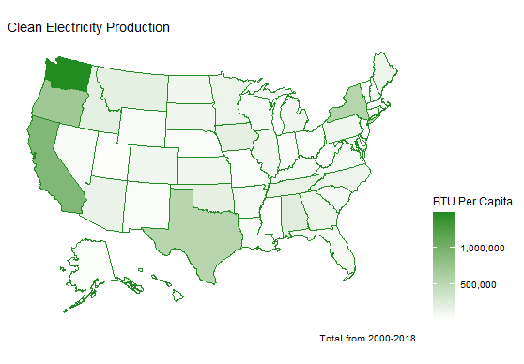**Figure 1. Geographic Distributions of Key Variables**

**A.**

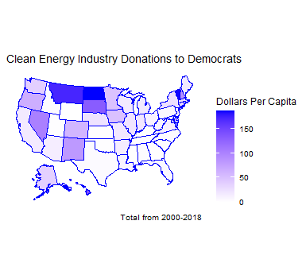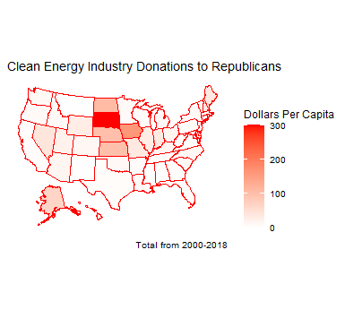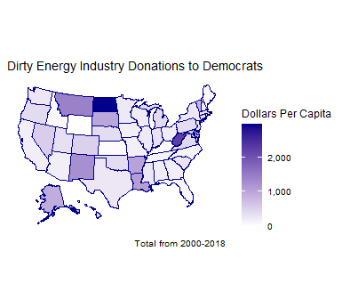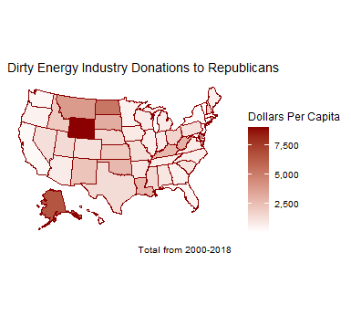

**B. C.**

**D. E.**

**Figure 2. Clean Electricity Production with a 75%/25% Split Assumption**

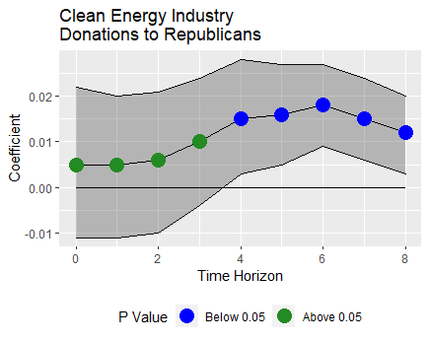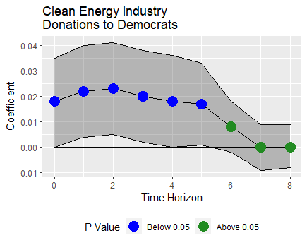**A. B.**

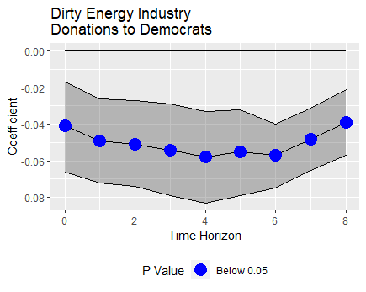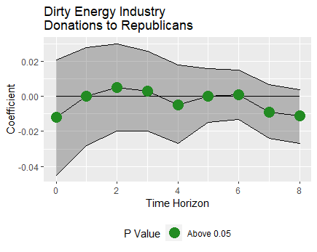**C. D.**

**Figure 3. Clean Electricity Production with a 50%/50% Split Assumption**

**A. B.**

**C. D.**

**Figure 4. Clean Electricity Production with a 90%/10% Split Assumption**

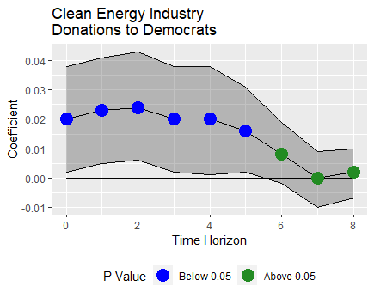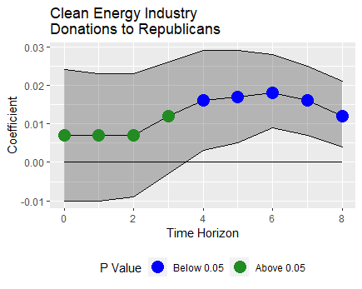**A. B.**

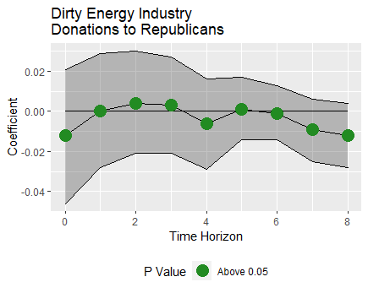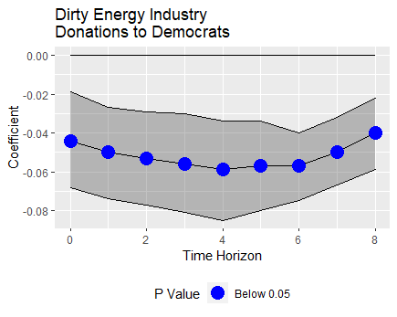**C. D.**

**Figure 5. Clean Electricity Consumption with a 50%/50% Split Assumption**

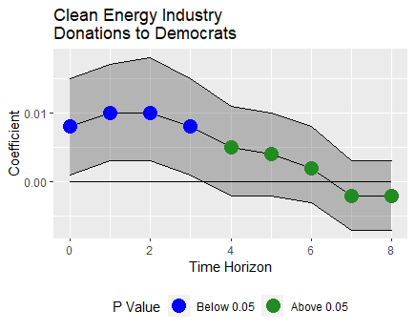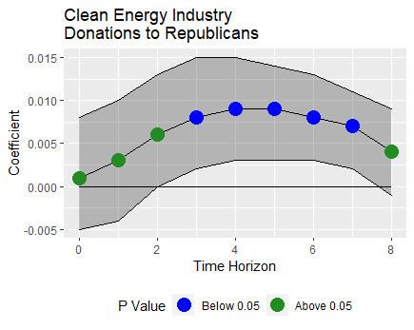**A. B.**

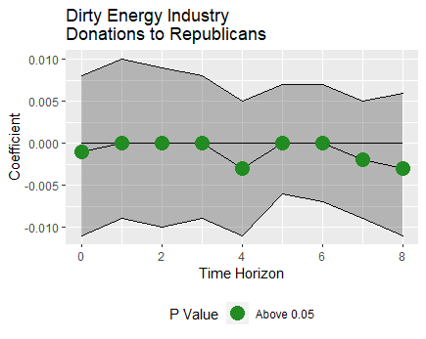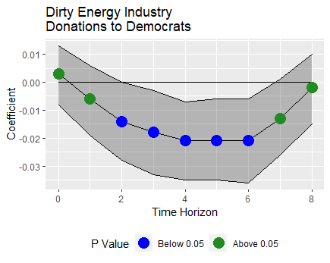**C. D.**

**References**

Agnone, Jon. “Amplifying Public Opinion: The Policy Impact of the U.S. Environmental Movement.” *Social Forces*, vol. 85, no. 4, Oxford University Press, 2007, pp. 1593–620.

Bellemare, Marc F., and Casey J. Wichman. “Elasticities and the Inverse Hyperbolic Sine Transformation.” *Oxford Bulletin of Economics and Statistics*, vol. 82, no. 1, Feb. 2020, pp. 50–61.

Binder, Seth, and Eric Neumayer. “Environmental Pressure Group Strength and Air Pollution: An Empirical Analysis.” *Ecological Economics*, vol. 55, no. 4, Dec. 2005, pp. 527–38.

Bureau of Economic Analysis. “GDP and Personal Income.” 2020. https://apps.bea.gov/iTable/iTable.cfm?reqid=70&step=1&acrdn=2.

Bureau of Labor Statistics. “Local Area Unemployment Statistics.” 2020. https://www.bls.gov/lau/rdscnp16.htm.

Center for Effective Lawmaking. “Legislative Effectiveness Data from 93rd-110th Congress (1973-2008).” 2020. https://thelawmakers.org/data-download.

Center for Responsive Politics. “Open Secrets Interest Group Data.” *Open Secrets*. 2021. https://www.opensecrets.org/industries.

Dasgupta, Shouro, and Enrica De Cian. “The Influence of Institutions, Governance, and Public Opinion on the Environment: Synthesized Findings from Applied Econometrics Studies.” *Energy Research & Social Science*, vol. 43, Sept. 2018, pp. 77–95.

Dumas, Marion, et al. “Political competition and renewable energy transitions over long time horizons: A dynamic approach.” *Ecological Economics*, 2016, pp. 175-184.

Energy Information Administration. “EIA API.” *Energy Information Administration Open Data*. 2021. https://www.eia.gov/opendata.

Frank, Mark W. “Inequality and Growth in the United Stata: Evidence From A New State-Level Panel of Income Inequality Measures.” *Economic Inquiry*, vol. 47, no. 1, Jan. 2009, pp. 55–68.

Howe, Peter D., et al. “Geographic Variation in Opinions on Climate Change at State and Local Scales in the USA.” *Nature Climate Change*, vol. 5, no. 6, June 2015, pp. 596–603.

International Renewable Energy Agency. “Renewable Power Generation Costs in 2018.” 2019.

Jenner, Steffen, et al. “What Drives States to Support Renewable Energy?” *The Energy Journal; Cleveland*, vol. 33, no. 2, International Association for Energy Economics, 2012, pp. 1–12.

Jordà, Òscar. “Estimation and Inference of Impulse Responses by Local Projections.” *American Economic Review*, vol. 95, no. 1, Feb. 2005, pp. 161–82.

Kneifel, Joshua. “Eﬀects of State Government Policies on Electricity Capacity from Non-Hydropower Renewable Sources.” 2009.

League of Conservation Voters. “National Environmental Scorecard.” 2020. https://scorecard.lcv.org/scorecard.

Lyon, Thomas P., and Haitao Yin. “Why Do States Adopt Renewable Portfolio Standards?: An Empirical Investigation.” *The Energy Journal*, vol. 31, no. 3, International Association for Energy Economics, 2010, pp. 133–57.

Mayer, Adam. “Partisanship, Politics, and the Energy Transition in the United States: A Critical Review and Conceptual Framework.” *Energy Research & Social Science*, 2019.

National Conference of State Legislatures. “State Partisan Composition.” 2020. https://www.ncsl.org/research/about-state-legislatures/partisan-composition.aspx#Timelines

Neumayer, Eric. “Are Left-Wing Party Strength and Corporatism Good for the Environment? Evidence from Panel Analysis of Air Pollution in OECD Countries.” *Ecological Economics*, vol. 45, no. 2, June 2003, pp. 203–20.

Office of Research & Development. “Multi-Model Framework for Quantitative Sectoral Impacts Analysis: A Technical Report for the Fourth National Climate Assessment”. May 2017. https://cfpub.epa.gov/si/si_public_record_Report.cfm?Lab=OAP&dirEntryId=335095.

Powell, Lynda W. “The Influence of Campaign Contributions on the Legislative Process.” *Public Policy*, vol. 9, 2014, pp. 27.

Romer, Christina, and David Romer. “Why Some Times Are Different: Macroeconomic Policy and the Aftermath of Financial Crises.” *National Bureau of Economic Research*, 2017.

Schaffer, Lena Maria, and Thomas Bernauer. “Explaining Government Choices for Promoting Renewable Energy.” *Energy Policy*, vol. 68, 2014, pp. 15–27.

Solomon, Susan, et al., editors. “Climate Change 2007: The Physical Science Basis: Contribution of Working Group I to the Fourth Assessment Report of the Intergovernmental Panel on Climate Change.” *Intergovernmental Panel on Climate Change*, 2007.

Stratmann, Thomas. “Some Talk: Money in Politics. A (Partial) Review of the Literature.” *Public* Choice, 2005.

1. The Paris Climate Accords are an international agreement that attempts to address climate change by setting ambitious climate goals and subsidizing poorer countries’ shift to clean energy