How many nets are needed to reach universal coverage - an update

Hannah Koenker[1]

Josh Yukich[2]

Marcy Erskine[3]

Robert Opoku[4]

Eleanore Sternberg[5]

Albert Kilian[6]

Draft of 27 October, 2022; do not circulate

# Abstract

[350 words max]

# Background

Insecticide treated nets (ITNs) have served as the cornerstone of malaria vector control in sub-Saharan Africa for the past two decades. Over 2.5 billion ITNs have been delivered to countries [1], primarily through periodic mass distribution campaigns scheduled at approximately three-year intervals, aligning with the expected lifespan of nets. Recent work has shown significant variation in ITN durability across geographic zones, and while some studies support a three-year median lifespan, multi-country analyses of ITN retention times indicate half of countries can expect two years or less of useful life for the majority of nets they distribute [2]. The implications of shorter-than-expected retention times have important implications for the way countries quantify ITN commodity needs for mass campaigns, and raise several key questions. First, what is the projected impact of the mismatch in campaign cycle and ITN retention in terms of overall ITN coverage? Second, if mass campaigns every three years are insufficient due to ITNs lasting only 1-2 years, is switching to a two-year campaign cycle indicated, or are there alternative or supplemental ways to distribute ITNs to ensure high rates of ITN access are maintained over time? Third, with what we know now about ITN retention and ITN distribution modalities, is “population divided by 1.8” (as recommended since 2010 [4]) the correct quantification approach for mass campaigns for all countries? Finally, what would optimum ITN quantification look like for countries given their particular ITN retention times, aiming to sustain high levels of ITN access (the necessary, but not sufficient, precursor to ITN use)?

In practical terms, quantification for ITN distribution refers to a process whereby national malaria programmes estimate the number of ITNs required for mass campaigns by dividing the total population (or population living within areas targeted for the ITN campaign) by 1.8, which is intended to achieve an end result of households owning 1 ITN for every 2 people. The quantifier 1.8 was selected to account for the 46.9-58.9% of households who have an odd number of household members, reflecting the need to round up in these cases [3]. Kilian et al originally recommended dividing by 1.6, in order to accommodate distribution challenges including outdated census information and the need to preposition full bales of nets rather than precisely subdividing them. In practice, WHO recommends “population divided by 1.8”, and allows a buffer of up to 10% when the previous census is over 5 years old.

Quantification for continuous ITN distribution lacks a “population divided by X” quantifier. It is most straightforward for distribution to pregnant women and infants, as a) these populations are relatively consistent at around 4% and 3% of the population in sub-Saharan Africa at any given time, respectively, and b) attendance rates at antenatal care visits (ANC) and immunization visits (EPI) are generally well-monitored through the national health management information system (HMIS). Annual procurements of ITNs for these channels are thus quite predictable. However, for ITN distribution through schools or community channels, quantification has been particularly challenging. The first large-scale pilots of these channels relied on modeling with NetCALC [5], running individual scenarios to fine-tune the number of nets that would produce desired levels of ITN access. No rule of thumb quantifier was produced. It is likely that this gap has contributed in part to the limited scale-up of continuous distribution channels across malaria-endemic countries.

This paper explores the above questions using an existing stock and flow model [6] to project population ITN access for countries in sub-Saharan Africa over five different distribution scenarios, using estimated ITN retention times from Bertozzi-Villa et al [2] and varying quantification approaches within each distribution scenario. Recommended quantifiers for each country are presented for each scenario and at different target levels of population ITN access.

# Methods

## Projections of future coverage

ITNs were distributed in the model for each scenario as shown in Table 1.

Table 1: Distribution Scenarios and their ITN inputs

| **Scenario** | **Mass Campaign** | **ANC/EPI (routine)** | **Annual school/ community** | **Number of different models per scenario** |
| --- | --- | --- | --- | --- |
| 1. “Status Quo” | In 2022, 2025, 2028, 2031, 2034 at population / 1.8 | 2020-2035, varying from population x 5% to population x 7% | none | 3 |
| 2. “Full-scale continuous” | In 2020, to establish high coverage at population / 1.8 | 2021-2035 using population x 6% | 2022-2032 varying the CD quantifier from population x 0% to population x 50% | 51 |
| 3. “Mass plus continuous” | In 2022, 2025, 2028, 2031, 2034 at population / 1.8 | 2020-2035 using population x 6% | Only in years between campaigns, varying the CD quantifier from population x 0% to population x 40% | 41 |
| 4. “Varying 3-year mass” | In 2022, 2025, 2028, 2031, 2034, varying from population / 0.1-2.0 | 2020-2035 using population x 6% | none | 21 |
| 5. “Varying 2-year mass” | In 2022, 2024, 2026, 2028, 2030, 2032, 2034 varying from population / 0.5-2.0 | 2020-2035 using population x 6% | none | 16 |
|  |  |  | Total models | 132 |

For each year, the stock and flow model used a country-specific estimated median lifespan from Malaria Atlas Project (MAP) estimates published in Bertozzi-Villa et al [2], shown in blue in Fig. 1A, to decay each crop of distributed nets in one-year time steps. Fig. 1A also presents estimated median lifespans from ITN durability monitoring (DM) activities gathered from www.pmi.gov and published literature [7–14]. The net decay functions rely on smooth-compact loss function developed by Nakul Chitnis and described in Koenker et al and Bhatt et al [5, 6, 15], and are shown in Fig. 1B. Each country was assigned an indicative population of 10 million people in the database, starting in 2020, and an annual population growth rate of 3%, as the model outputs are adjusted for population and thus do not require specific population estimates. The model was built and run in Stata (17, StataCorp LLC, College Station, TX).

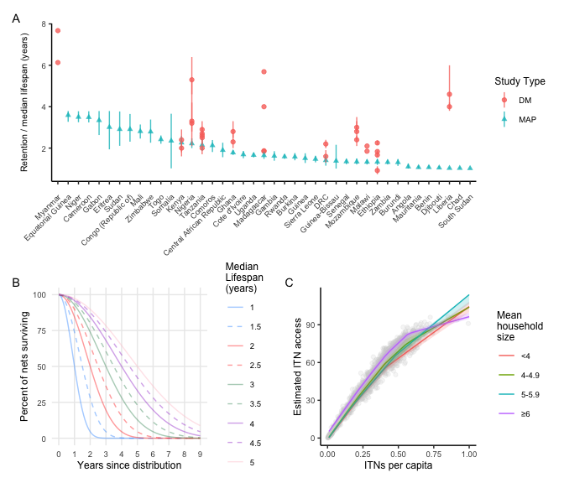

Figure 1: A) ITN retention times and median lifespans estimated from durability monitoring studies B) Smooth-compact loss function for net decay C) nonparametric conditional quartile function for ITN access as a function of NPC

The total net crop (consisting of all surviving nets from various channels to date) was summed for each year and country. This was then divided by the projected population to calculate nets-per-capita (NPC). To estimate ITN access from NPC, a nonparametric conditional quantile function for ITN access as a function of NPC was estimated from 151 Demographic and Health Surveys (DHS) and Malaria Indicator Surveys (MIS), stratifying by average household size, using the “quantreg” R package (v5.93; Koenker 2022) [16–18]. A grid of 100 points was produced and used to predict ITN access from NPC (Fig. 1C). Confidence intervals for both estimated median lifespan and the function of ITN access vs NPC were used to generate an overall confidence interval around the estimate of ITN access.

Recommended quantifiers were obtained by identifying the scenario that provided the greatest number of years of ITN access at or above the target level; if multiple scenarios provided the same number of years, the scenario requiring the fewest nets was selected.

## Scenarios

To inform recommendations for quantification of ITNs, the above process was used to model ITN distributions under five typical ITN distribution scenarios, varying quantification approaches within each scenario. The majority of malaria-endemic countries currently implement Scenario 1; Tanzania has implemented Scenario 2 since 2013 in a subset of regions, while Ghana has implemented Scenario 3 since 2012. While countries aim to deliver mass campaigns every three years, some have recently argued for campaign every two years to offset shorter median net lifespans.

1. “Status Quo”: Mass campaigns every three years with routine distribution of ITNs to pregnant women and infants through antenatal clinics (ANC) and immunization visits (EPI). Quantification of the mass campaigns was fixed at population / 1.8 while quantification of routine distribution varied from population x 5%-7%.
2. “Full-scale continuous”: Full-scale annual school distribution of ITNs with routine distribution of ANC and EPI ITNs, fixing the routine distribution at population x 6% and varying the quantification of school distributions from population x 0-50%
3. “Mass plus continuous”: Mass campaign every three years with ongoing routine distribution of ANC and EPI ITNs and with annual school distribution in a limited number of classes (or limited community distribution) in the years between campaigns. Quantification of the mass campaigns was fixed at population / 1.8 and routine distribution at population x 6%, varying the annual school/community distribution between population x 0-40%.
4. “Varying 3-year mass”: Mass campaigns every three years with routine distribution of ITNs to pregnant women and infants through antenatal clinics (ANC) and immunization visits (EPI). Quantification of routine distribution was fixed at 6%, and quantification of the mass campaigns was varied from population / 0.1 (10 nets per person) to population / 2.0 in increments of 0.1.
5. “Varying 2-year mass”: Mass campaigns every two years with routine distribution of ITNs to pregnant women and infants through antenatal clinics (ANC) and immunization visits (EPI). Quantification of routine distribution was fixed at 6%, and quantification of the mass campaigns was varied from population / 0.5 (2 nets per person) to population / 2.0 in increments of 0.1.

All scenarios with mass campaigns began with a mass campaign in 2022 and ended in 2035. The “full scale continuous” scenario assumed a mass campaign in 2020, quantified with population / 1.8, to scale up coverage prior to switching over to a fully continuous ITN strategy.

To assess feasibility of large-scale school distribution in relation to optimal quantification factors, the proportion of the population that are primary school students currently attending school was calculated from the most recent DHS for each country, obtained with permission from dhsprogram.com.

# Results

Given a target of 80% ITN access, the recommended quantification approaches for each scenario varied considerably across countries. Adjustments in quantification for ANC-EPI distribution did not lead to large differences in ITN access in Scenario 1. The key factors driving variation across countries within a given scenario were the estimated retention times for each country and the mean household size. Recommended quantification approaches are summarized for the scenarios that include continuous distribution in Table 2, for 3-year mass campaigns in Table 3, and for 2-year mass campaigns in Table 4.

For Scenario 2, which relies on full-scale annual continuous distribution in combination with routine ANC/EPI ITN delivery to maintain access, the annual quantifier needed to maintain ITN access at 70% ranged from 7% of the population in Eritrea (estimated net retention time of 3.01 years), to 29% of the population in Djibouti, South Sudan, and Chad (retention times of 1.05, 1.02, and 1.03 years, respectively). Similarly, to maintain ITN access at 80%, the quantifier ranged from 10% of the population in Eritrea, to 42% of the population in Mauritania. In only a few countries was ITN access able to reach 90% - requiring a quantification factor of 14% of the population in Equatorial Guinea (retention time of 3.59 years), to 46% of the population in Liberia and Mauritania (1.03 and 1.07 years retention time, respectively).

For Scenario 3, where mass campaigns are conducted every three years, routine ITNs through ANC/EPI are conducted consistently, and continuous distribution supplements ITN access in the years between campaigns, there was also a range of quantifiers for the annual continuous distribution channels. At the 70% target, ten countries required ITNs equivalent to 0% of the population, essentially indicating that 3-year campaigns with ANC and EPI distribution would maintain ITN access at 70%, but for South Sudan, continuous distribution quantified using population x 28% was needed to maintain ITN access between campaigns. At the 80% target, four countries still achieved this with no continuous distribution ITNs between campaigns, while Liberia, South Sudan, and Chad were estimated to need 35% of the population in ITNs. Seven countries, all with estimated net retention times of at least 2.81 years, were able to maintain ITN access at 90% with only 0% of the population, including Congo - Brazzaville, Cameroon, Gabon, Equatorial Guinea, Mali, Niger, and Sudan.

Table 2: Recommended annual quantifiers for continuous distribution channels. All scenarios assume that ANC and EPI delivery of ITNs is ongoing in addition and provides nets to 6% of the population (not shown in table).

| **Minimum quantifier (population x quantifier, annually) to sustain ITN access at or above specified target level** | | | | | | | |
| --- | --- | --- | --- | --- | --- | --- | --- |
|  | | **Scenario 2 (full continuous distribution strategy)** | | | **Scenario 3 (continuous distribution between mass campaigns)** | | |
|  | | **Targeted ITN access level:** | | | | | |
| **Country Code** | **Retention time (years)** | **70%** | **80%** | **90%** | **70%** | **80%** | **90%** |
| LBR | 1.0 | 28% | 36% | 46% | 27% | 35% | 39% |
| GIN | 1.5 | 20% | 30% | 38% | 11% | 16% | 31% |
| TZA | 2.1 | 14% | 20% | 29% | 4% | 11% | 19% |
| TGO | 2.4 | 12% | 20% | 25% | 1% | 8% | 16% |
| COG | 2.9 | 10% | 15% | 21% | 0% | 4% | 0% |
| CMR | 3.5 | 8% | 11% | 15% | 0% | 1% | 0% |

## [1] "/Users/hannahkoenker/Dropbox/R Directory/Quantification/figs/Tab_Scen23.png"

For Scenario 4, the quantifier used for 3-year mass campaigns (in combination with routine ITN distribution at ANC/EPI clinics) was varied from 0.1 to 2.0. The lowest level of ITN access between campaigns is shown in Table 3. Under the current recommended quantifier of 1.8, only Eritrea and Equatorial Guinea, both with net retention times of over three years, were estimated to maintain ITN access at or above 80% between campaigns. Even at population divided by 1.6, only five countries (12.5% of countries in the sample) maintained ITN access above 80%, likewise all with net retention times of at least three years. In Guinea, with the standard quantifier of population / 1.8 and an estimated retention time of 1.51, the country reaches a low point of 46% ITN access between campaigns. Using population / 1.1 would result in an estimated low point of 60% population ITN access between campaigns.

Table 3: Lowest level of ITN access between 3-year campaigns at different population quantifiers. Routine ITN delivery to pregnant women and infants is assumed.

| **Lowest ITN access between 3-year campaigns for each quantifier** | | | | | | | | | | | | |
| --- | --- | --- | --- | --- | --- | --- | --- | --- | --- | --- | --- | --- |
|  | | **Population divided by:** | | | | | | | | | | |
| **Cty** | **Retention time (years)** | **1.0** | **1.1** | **1.2** | **1.3** | **1.4** | **1.5** | **1.6** | **1.7** | **1.8** | **1.9** | **2.0** |
| LBR | 1.0 | 22 | 21 | 21 | 19 | 19 | 19 | 19 | 18 | 18 | 18 | 18 |
| GIN | 1.5 | 63 | 60 | 57 | 54 | 53 | 50 | 49 | 47 | 46 | 44 | 44 |
| TZA | 2.1 | 83 | 80 | 77 | 75 | 72 | 69 | 67 | 65 | 64 | 62 | 61 |
| TGO | 2.4 | 88 | 85 | 82 | 80 | 77 | 76 | 73 | 71 | 69 | 67 | 66 |
| COG | 2.9 | 96 | 92 | 88 | 86 | 83 | 81 | 79 | 78 | 76 | 74 | 73 |
| CMR | 3.5 | 100 | 100 | 99 | 95 | 91 | 88 | 85 | 82 | 80 | 78 | 76 |

## [1] "/Users/hannahkoenker/Dropbox/R Directory/Quantification/figs/Tab_Scen4.png"

Table 4 provides a similar picture but for campaigns conducted every 2 years. Under a population / 1.8 quantifier, eighteen countries (45%) including Central African Republic, Rep. Congo, Cameroon, Eritrea, Gabon, Gambia, Guinea, Equatorial Guinea, Kenya, Comoros, Mali, Niger, Nigeria, Sudan, Somalia, Togo, Tanzania, and Zimbabwe would all maintain ITN access at or above 80% between campaigns. In other countries, 2-yearly campaigns closer to one ITN per person would be needed in order to maintain ITN access at the 80% target. Continuing with the Guinea example, with the standard quantifier of population / 1.8, the country reaches a low point of 81% ITN access in the year between campaigns. Using population / 1.2 would result in an estimated low point of 89% population ITN access between campaigns.

Table 4: Lowest level of ITN access between 2-year campaigns at different population quantifiers. Values of 100 indicate excess nets in the system (for example Cameroon). Routine ITN delivery to pregnant women and infants is assumed.

| **Lowest ITN access between 2-year campaigns for each quantifier** | | | | | | | | | | | | |
| --- | --- | --- | --- | --- | --- | --- | --- | --- | --- | --- | --- | --- |
|  | | **Population divided by:** | | | | | | | | | | |
| **Cty** | **Retention time (years)** | **1.0** | **1.1** | **1.2** | **1.3** | **1.4** | **1.5** | **1.6** | **1.7** | **1.8** | **1.9** | **2.0** |
| LBR | 1.0 | 78 | 74 | 71 | 67 | 65 | 62 | 60 | 57 | 54 | 53 | 51 |
| GIN | 1.5 | 93 | 91 | 89 | 87 | 86 | 85 | 84 | 83 | 81 | 78 | 75 |
| TZA | 2.1 | 100 | 100 | 100 | 100 | 99 | 96 | 92 | 90 | 88 | 86 | 84 |
| TGO | 2.4 | 100 | 100 | 100 | 100 | 100 | 100 | 98 | 95 | 92 | 90 | 88 |
| COG | 2.9 | 100 | 100 | 100 | 100 | 100 | 100 | 100 | 100 | 99 | 96 | 94 |
| CMR | 3.5 | 100 | 100 | 100 | 100 | 100 | 100 | 100 | 100 | 100 | 100 | 100 |

## [1] "/Users/hannahkoenker/Dropbox/R Directory/Quantification/figs/Tab_Scen5.png"

The below figures illustrate scenario results for each country, for scenarios 1 (Fig. 2), scenario 2 (Fig. 3), and scenario 3 (Fig. 4), with predicted population ITN access estimates shown in green and target levels of ITN access highlighted in red at 80% and 90%. The typical rise and fall of ITN access is apparent in Fig. 2 and Fig. 4, while ITN access is maintained at a steady rate in Fig. 3 where distributions are annual through continuous channels.

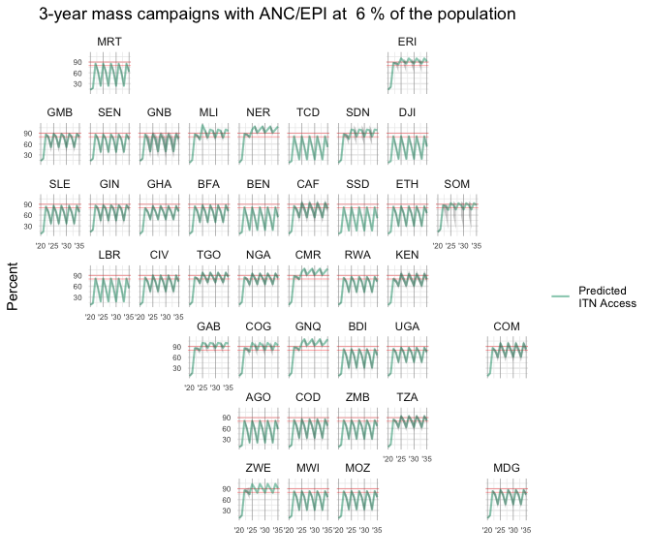

Figure 2: ITN access estimated for 3-year mass campaign strategy, with ANC/EPI distribution at 6% of the population annually

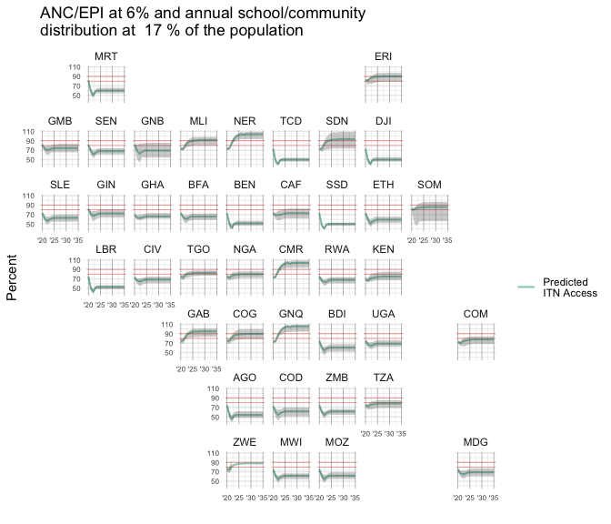

Figure 3: Estimated ITN access with annual ANC/EPI at 6% and full continuous distribution strategy at 17% of the population in nets each year. Shaded areas indicate 95% confidence intervals accounting for both net retention times and ITN access as a function of nets-per-capita (NPC)

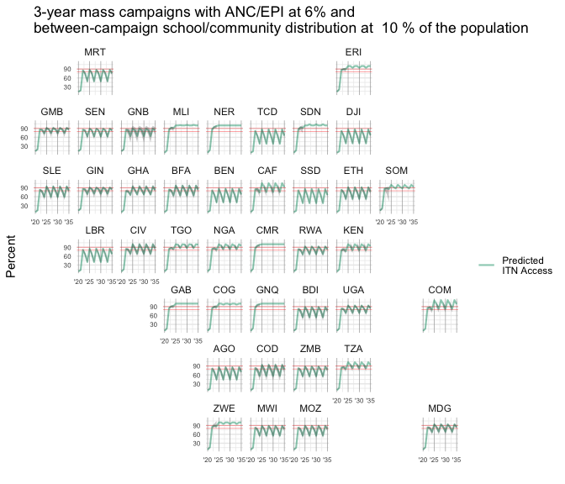

Figure 4: Scenario 3 - three-year mass campaigns with ANC/EPI distribution at 6%, and between-campaign continuous distribution at 10%

The complete set of graphs for all 132 scenarios is included as Supplemental File 1.

Table 5 summarizes the recommended quantifiers under each scenario, given a target of maintaining 80% population ITN access. For Liberia, with a median retention time of 1 year, a full scale continuous distribution strategy would need have an annual ITN need of population x 36%, and a strategy implementing mass campaigns every three years using population/1.8 and adding continuous distribution between campaigns would need to quantify the continuous distribution channel in each non-campaign year using population x 35%. Both strategies assume that ITN delivery to pregnant women and infants is ongoing, reaching about 6% of the population. Under tailored mass campaign scenarios, the models suggest that when net lifetimes are around 12 months, no three-year campaign strategy can achieve universal access; a strategy of campaigns every two years would only maintain ITN access above 80% if the quantification approach is to multiply the population by 0.9 - delivering, in essence, one net per person every other year. In contrast, countries with longer retention times such as Republic of Congo or Cameroon are able to sustain 80% ITN access with full scale continuous strategies that quantify the annual ITN need using population x 15% and 11%, respectively, and could implement continuous distribution between campaigns to sustain access with only population x 4% and 1%, respectively. Alternately, they could implement three-yearly campaigns with no continuous distribution, using population divided by 1.5 and 1.7, along with ITN delivery to pregnant women and infants.

Table 5: Summary of recommended quantifiers for scenarios, to maintain ITN access at or above 80%. The quantifiers are for only the continuous distribution channel or mass campaign; annual ANC/EPI distribution equivalent to 6% of the population is assumed in each scenario, but is not part of the listed quantifiers

|  | | **Continuous Distribution ITNs = Population x X, annually** | | **Mass Campaign ITNs = Population / X** | |
| --- | --- | --- | --- | --- | --- |
| **Country** | **Retention time (years)** | **Full-scale continuous + routine** | **Campaign + routine + continuous between campaigns** | **3-yearly campaigns** | **2-yearly campaigns** |
| LBR | 1.0 | 36% | 35% |  | 0.9 |
| GIN | 1.5 | 30% | 16% | 0.6 | 1.8 |
| TZA | 2.1 | 20% | 11% | 1.0 | 2.0 |
| TGO | 2.4 | 20% | 8% | 1.2 | 2.0 |
| COG | 2.9 | 15% | 4% | 1.5 | 2.0 |
| CMR | 3.5 | 11% | 1% | 1.7 | 2.0 |

## [1] "/Users/hannahkoenker/Dropbox/R Directory/Quantification/figs/Tab_Reccs.png"

The total number of nets needed under each recommended scenario in Table 5 to maintain 80% ITN access is presented in Fig. 5A, for each country in the sample, and summarized across countries in Fig. 5B. For comparability, results are presented as a percentage difference compared to a status quo scenario of three-yearly campaigns quantified with population/1.8 plus routine distribution of ITNs to pregnant women and infants through ANC and EPI channels. For 15 of the 40 countries, full scale continuous distribution would maintain ITN access at 80% with fewer nets than are currently being delivered under three-yearly status quo campaigns. Across all countries, full scale continuous distribution was expected to maintain ITN access at 80% with 8% more ITNs than status quo. Strategies deploying continuous distribution between mass campaigns required 18.5% more ITNs than status quo, while mass campaign strategies with tailored quantification factors required nearly two and a half times as many ITNs for three-yearly campaigns, and 66.6% more ITNs for two-yearly campaigns.

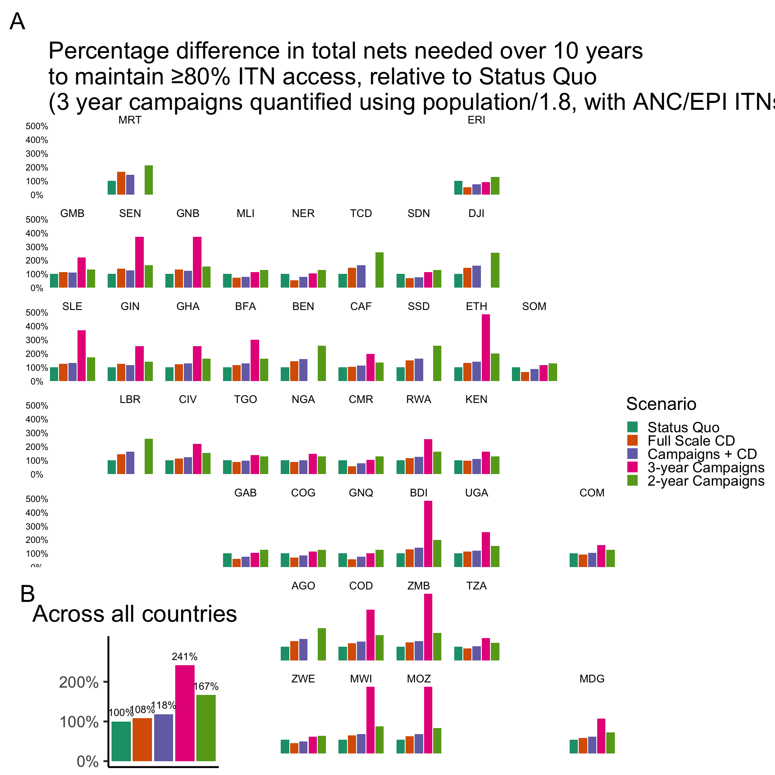

Figure 5: Total nets needed over 10 years, relative to full scale continuous distribution

To assess feasibility of primary school channels delivering the recommended numbers of nets to households, the proportion of the population currently attending primary school was calculated for each region or province in DHS surveys and compared to the population quantifiers needed to achieve 70% and 80% ITN access targets in Scenario 2. The proportion of regions/provinces within each country where primary school students attending school met or exceeded the population quantifier are shown in Fig. 6, as an indication of the extent within a country where annual school distribution would be feasible. This assumes that only one ITN is given per pupil; for the countries in Fig. 6 with a limited proportion of regions where the primary-school-attending population is large enough, giving more than 1 ITN per pupil could provide a solution. Alternatively, additional community-based channels could be designed to distribute ITNs alongside school-based distribution.

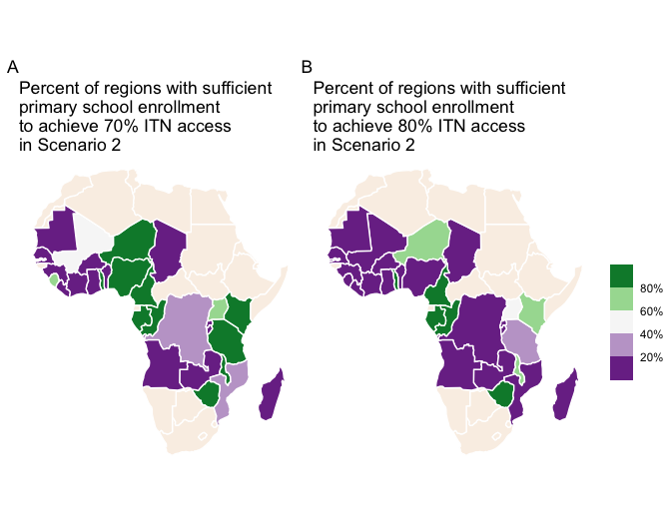

Figure 6: Percentage of regions/provinces per country where large-scale annual school distribution to achieve ITN access targets for A) 70% and B) 80% is feasible, assuming one ITN is given per child.

Finally, person-years of protection, expressed as person-years of ITN access, can be compared to total nets delivered to assess value for money of different ITN distribution strategies and within them, different quantification factors. Figure 7 shows the quantification options within each scenario that provided the maximum person-years of protection, against the total nets required, for two countries representing shorter and longer retention times, over a 10-year period. While status quo strategies of 3-yearly campaigns quantified using population/1.8 with ANC/EPI at 7% require the least number of ITNs, they also provide the fewest person-years of ITN access. Moving rightward along the x-axis in Fig. 7A, we find options that provide more person-years of ITN access, each with slightly more total nets required. However, in Fig. 7B, with a nearly three-year retention time, annual CD quantified at population x 23% provides just over 200 million person-years of ITN access over 10 years, with other options requiring more total nets but providing only minimal, if any, benefits in protection. Moreover, countries with shorter retention times require far more nets overall in order to provide similar levels of protection compared to countries with longer retention times: a full-scale CD program in country A achieves less than 184 million person-years of ITN access for around 107.7 million ITNs, compared to country B, where full scale CD provides 197.5 million person-years of ITN access for around 58.7 million ITNs. Frontier plots for all countries are included in Supplemental File 2.

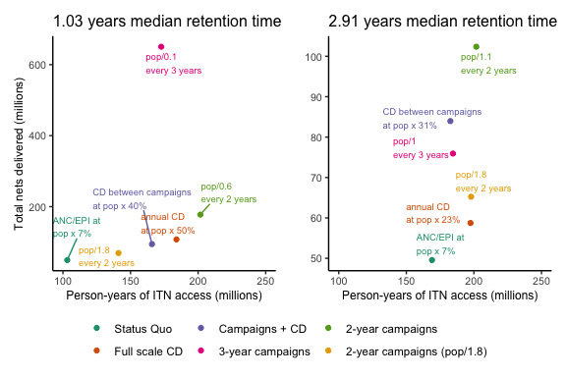

Figure 7: Frontier plots of person-years of ITN access vs total nets delivered, in illustrative populations of 10 million people for comparability

# Discussion

This analysis shows that the current status quo of conducting mass campaigns every three years using a population/1.8 quantifier is insufficient to achieve targets of 80% population access to ITNs in the majority of malaria-endemic countries, given overall retention times are estimated at below three years.

Second, the impulse to conduct mass campaigns every two years in places where nets have an estimated retention time or durability of two years, however intuitive, ultimately requires far more ITNs to maintain 80% population ITN access than under a strategy of continuous distribution. Compared to the current status quo, full scale continuous distribution of nets could provide continuous ITN access at 80% or higher, for 8% more nets, while a strategy of 2-year mass campaigns using a quantification factor tailored for net retention rates would require 67% more nets than status quo with similar coverage outcomes.

Third, after examining whether population/1.8 is appropriate in all settings, we find that in order to maintain population ITN access at target levels of 80%, tailoring of the quantification factor to the demographic profile and net durability profile of each country is necessary. As described in Bertozzi-Villa et al and shown here, the relationship between nets-per-capita and population ITN access is sensitive to average household size, with countries with average household size below 5 getting less ITN access for the same number of nets-per-capita than countries with average household size of 5 or more. Net retention time is however the major driving factor behind the calculations for the optimal quantification factor. Countries with retention times of less than 2 years could not maintain ITN access at 80% between campaigns even when one ITN per person was delivered in the model, and countries with retention time of around 2.5 years required population/1.5 or population/1.2 to offset the rapid loss of nets post-campaign and still maintain sufficient ITN coverage. However, even these approaches would introduce what most planners and donors would consider a vast “oversupply” of ITNs at each campaign.

It is worth noting that the model assumes that all distributed nets decay at the same rates; that is, nets are not stored for later use. There are few, if any, studies on what households do with their nets when they are oversupplied. Should households retain extra nets for later use, this would greatly improve rates of ITN access in the model. Conversely, if all oversupplied households immediately diverted extra nets for e.g. misuse, net lifetimes would be further reduced and ITN access much lower than the estimates presented here. Given that “saving for later” is a key reason why nets go unused in households that own “too many”, the reality may be closer to the former case, but results are likely between these two extremes.

Fourthly, optimal quantification factors, are presented here for a variety of ITN distribution strategies, along with the total number of nets that would be required, in an effort to facilitate decision making for national programmes and their partners.

The global malaria community faces significant challenges, with limited funding to implement life-saving interventions potentially the greatest immediate threat to malaria control efforts. Countries are advised to generate subnational strategies to tailor intervention packages to specific settings, but resources are inadequate to implement the desired combinations of interventions that would have the greatest impact. Countries are advised to prioritize activities in the face of limited funding, leaving national programmes with difficult choices about which population segments to cover fully, and which to leave with suboptimal protection. These recommendations to “do more with less” are not tenable. Insufficient vector control coverage is a key driver of malaria transmission; malaria cases decrease for only a year between campaigns before rising again [19]. The challenges of delivering more ITNs are clear - funding for both the nets and their distribution costs; donor appetite; not to mention the additional cost of new types of ITNs recommended for areas with insecticide resistance. However, the costs of continuing to deliver insufficient quantities of ITNs and providing only intermittent protection are also clear - continued loss of life, educational achievement, quality of life due to malaria.

There is a growing call to improve the retention time and/or durability of ITNs through improved physical specifications for ITNs and through improvements in household-level behaviors related to net care. Improvements in both areas would contribute substantially towards increasing retention times, but it is unlikely that this would offset the general and continued challenges of keeping nets in good condition for long periods of time across settings in malaria-endemic areas. Net durability is driven by behavioral factors in part, but these relatively fragile products are subject to numerous stresses on a daily basis in most household environments [20]. This is particularly true for people living through humanitarian emergencies, and this population is projected to increase due to climate change and climate-related emergencies among other factors.

All of these results hinge on the estimated retention times. It’s important to highlight that ITN durability studies, while largely in line with retention times used in this paper, do diverge in several cases. Most notably, Liberia’s retention time was estimated at 1.0 years, but an ITN durability study completed in 2021 in two counties observed a median survival in serviceable condition of 4 years. Countries like Liberia with divergent data for net lifespan need to weigh these results carefully. Likewise, net retention times and durability have been demonstrated to vary subnationally; durability monitoring of ITNs in northern Nigeria showed they median lifespans of over five years, while the same product monitored simultaneously in southern zones of Nigeria had a lifespan of just over three years [11], consistent with findings from an earlier cross-sectional durability study in similar areas of Nigeria [12]. Programmes must consider potential differences in net retention behavior and net durability as they weigh their quantification decisions, and plan for additional data collection where information is not available or insufficient.

Two countries currently implement large-scale continuous distribution: Ghana distributes ITNs to school children in grades 2 and 6 between 3-year campaigns, while Tanzania has implemented full scale school distribution in 14 mainland regions since 2016, and expanded the programme to 5 additional regions in 2022. The quantities of ITNs distributed to school children in Ghana amount to 4.4% of the population (1.4 million ITNs in the [2020 school distribution](https://allianceformalariaprevention.com/wp-content/uploads/2021/06/CD_Ghana_SBD_Case_Study_0620201.pdf)) - far from the 20% estimated to be needed to maintain ITN access at levels of 80%. Tanzania’s school net programme (SNP) has delivered ITNs equivalent to 12-16% of the population in SNP zones over recent years, but they may require quantification of population x 20% to maintain ITN access at 80%, discussed in detail elsewhere [6].

School distribution, conducted annually to all or selected primary school classes, is a promising approach to delivering ITNs [5, 6, 21, 22]. Studies estimate that school-age children drive at least 60% of malaria transmission [23, 24], due in part to their lower rates of ITN use, especially when households do not own enough nets [24, 25]. Ensuring that these children - and their family members - are prioritized for protection with ITNs, along with vulnerable pregnant women and children, is a hallmark of the school distribution strategy. Annualized distributions also facilitate planning, avoiding the 3-yearly overload of mass campaign planning among national malaria programmes and their implementing partners, and the platform leverages Ministry of Education personnel, providing opportunities for additional integration of other school health interventions.

This analysis uses a target of 80% population ITN access, but it must be noted that for ITN use levels to reach 80%, ITN access must be at least 90%, given the persistent yet small gap between ITN access and ITN use [2, 15, 26]. Targeting ITN access at 80% will max out ITN use around 70% or lower. Donors and programmes must therefore evaluate what target levels of ITN use are necessary for success, and adjust ITN access targets upwards accordingly.

## Limitations

The analysis is faced with several limitations. First, the estimated retention times for certain countries are based on a limited number of surveys, described further in Bertozzi-Villa et al [2]. We account for the uncertainty of these estimates in the calculations of ITN access. Second, localized durability monitoring studies sometimes find significantly longer median survival of ITNs than the retention time estimates, which could indicate subnational differences in ITN longevity or be evidence of analytical challenges in the ITN retention times or conversely, Hawthorne effect in the durability monitoring studies, leading households to retain their nets longer when they expect to be visited by study teams. Third, the relationship between nets-per-capita and ITN access is assumed to be consistent regardless of ITN distribution strategy, but it is likely that it would be influenced by oversaturation of ITNs in certain types of households, as occurs with school distribution of ITNs. It will be important to explore this relationship further as additional data become available. Fourth, retention behavior is influenced by net availability (or lack thereof); with increasing availability of nets, households could be disincentivized to take care of their nets for longer, if new nets are readily available. Frankly, we should be so lucky - but programmes must watch out for perverse incentives that may drive up the number of nets required unnecessarily.

# Conclusion

Given variation in ITN retention times across countries, tailored quantification approaches for mass campaigns and continuous distribution strategies are warranted. To reach target levels of ITN use of 80% of the population, ITN access must be maintained near 90% in most settings. The quantity of ITNs required to meet these goals are substantially larger than current plans, but strategies with continuous/annual distributions are likely to provide higher ITN access with fewer nets than tailored universal coverage campaigns. Strategies with continuous/annual distributions may also provide better ITN access with only 8% more ITNs needed than current status quo of 3-year campaigns quantified using population/1.8. National programmes and their funding partners should work to increase the number of ITNs distributed to those vulnerable to malaria, while at the same time working to extend the useful life of these critical commodities.

# Declarations

## Ethics approval and consent to participate

Not applicable

## Consent for publication

Not applicable

## Availability of data and materials

Code is available at <https://github.com/hkoenker/Quantification>

## Competing interests

The authors declare that they have no competing interests.

## Funding

This work was supported, in whole or in part, by the Bill & Melinda Gates Foundation INV-016322. Under the grant conditions of the Foundation, a Creative Commons Attribution 4.0 Generic License has already been assigned to the Author Accepted Manuscript version that might arise from this submission.

## Authors’ contributions

HK designed and conducted the analysis, and drafted the findings. ME, RO, ES, SN revised the draft. All authors reviewed and approved the final manuscript.

## Acknowledgements

The authors are grateful for the early feedback on this manuscript from Pete Gething and Amelia Bertozzi-Villa, and for Roger Koenker’s assistance in fitting the nets-per-capita and ITN access relationship.

# Supplementary information

Table 6: Recommended annual quantifiers for continuous distribution channels. All scenarios assume that ANC and EPI delivery of ITNs is ongoing and provides nets to 6% of the population. However, quantifiers listed in the table represent only the continuous distribution channel, e.g. Angola would require both ANC/EPI distribution as well as continuous distribution quantified using population x 27% to maintain ITN access at levels of 70%.

| **Minimum quantifier (population x quantifier, annually) to sustain ITN access at or above specified target level** | | | | | | | |
| --- | --- | --- | --- | --- | --- | --- | --- |
|  | | **Scenario 2 (full continuous distribution strategy)** | | | **Scenario 3 (continuous distribution between mass campaigns)** | | |
|  | | **Targeted ITN access level:** | | | | | |
| **Country Code** | **Retention time (years)** | **70%** | **80%** | **90%** | **70%** | **80%** | **90%** |
| DJI | 1.0 | 29% | 36% | 43% | 27% | 34% | 37% |
| LBR | 1.0 | 28% | 36% | 46% | 27% | 35% | 39% |
| SSD | 1.0 | 29% | 37% | 44% | 28% | 35% | 38% |
| TCD | 1.0 | 29% | 36% | 44% | 27% | 35% | 38% |
| AGO | 1.1 | 27% | 35% | 45% | 25% | 32% | 39% |
| BEN | 1.1 | 28% | 36% | 43% | 26% | 33% | 40% |
| MRT | 1.1 | 23% | 42% | 46% | 21% | 27% | 38% |
| BDI | 1.3 | 25% | 32% | 41% | 19% | 26% | 36% |
| ETH | 1.3 | 25% | 32% | 38% | 19% | 26% | 27% |
| MWI | 1.3 | 24% | 32% | 41% | 19% | 26% | 35% |
| MOZ | 1.3 | 24% | 31% | 40% | 18% | 26% | 35% |
| ZMB | 1.3 | 24% | 32% | 41% | 19% | 26% | 35% |
| COD | 1.4 | 24% | 30% | 37% | 17% | 24% | 25% |
| GNB | 1.4 | 20% | 33% | 40% | 13% | 19% | 34% |
| SEN | 1.4 | 20% | 34% | 41% | 14% | 20% | 35% |
| GIN | 1.5 | 20% | 30% | 38% | 11% | 16% | 31% |
| SLE | 1.5 | 23% | 30% | 36% | 16% | 22% | 24% |
| BFA | 1.6 | 22% | 28% | 34% | 14% | 20% | 21% |
| GMB | 1.6 | 17% | 27% | 37% | 8% | 14% | 28% |
| MDG | 1.6 | 23% | 27% | 36% | 12% | 19% | 26% |
| RWA | 1.6 | 24% | 28% | 37% | 13% | 20% | 28% |
| CIV | 1.7 | 20% | 27% | 29% | 12% | 18% | 19% |
| UGA | 1.7 | 23% | 27% | 35% | 12% | 18% | 26% |
| GHA | 1.8 | 22% | 29% | 32% | 13% | 20% | 27% |
| CAF | 1.9 | 18% | 24% | 27% | 8% | 14% | 20% |
| COM | 2.1 | 15% | 21% | 24% | 5% | 11% | 17% |
| TZA | 2.1 | 14% | 20% | 29% | 4% | 11% | 19% |
| NGA | 2.2 | 14% | 20% | 28% | 3% | 10% | 18% |
| KEN | 2.3 | 16% | 23% | 26% | 6% | 13% | 20% |
| SOM | 2.4 | 10% | 14% | 27% | 0% | 4% | 13% |
| TGO | 2.4 | 12% | 20% | 25% | 1% | 8% | 16% |
| MLI | 2.8 | 11% | 16% | 20% | 0% | 1% | 0% |
| ZWE | 2.8 | 10% | 16% | 22% | 0% | 5% | 12% |
| COG | 2.9 | 10% | 15% | 21% | 0% | 4% | 0% |
| SDN | 2.9 | 10% | 15% | 19% | 0% | 0% | 0% |
| ERI | 3.0 | 7% | 10% | 21% | 0% | 0% | 6% |
| GAB | 3.3 | 8% | 12% | 18% | 0% | 0% | 0% |
| CMR | 3.5 | 8% | 11% | 15% | 0% | 1% | 0% |
| NER | 3.5 | 8% | 11% | 15% | 0% | 1% | 0% |
| GNQ | 3.6 | 8% | 11% | 14% | 0% | 0% | 0% |

## [1] "/Users/hannahkoenker/Dropbox/R Directory/Quantification/figs/Scenario_23.png"

Table 7: Lowest level of ITN access between 3-year campaigns at different population quantifiers for all countries. Green color reflects higher ITN access while red indicates lower ITN access reached between campaigns. Routine ITN delivery to pregnant women and infants is assumed.

| **Lowest ITN access between 3-year campaigns for each quantifier** | | | | | | | | | | | | |
| --- | --- | --- | --- | --- | --- | --- | --- | --- | --- | --- | --- | --- |
|  | | **Population divided by:** | | | | | | | | | | |
| **Cty** | **Retention time (years)** | **1.0** | **1.1** | **1.2** | **1.3** | **1.4** | **1.5** | **1.6** | **1.7** | **1.8** | **1.9** | **2.0** |
| AGO | 1.1 | 27 | 25 | 24 | 24 | 22 | 22 | 22 | 21 | 21 | 21 | 21 |
| BFA | 1.6 | 59 | 55 | 53 | 50 | 47 | 46 | 45 | 42 | 41 | 41 | 40 |
| BDI | 1.3 | 42 | 40 | 37 | 36 | 35 | 35 | 33 | 32 | 32 | 30 | 30 |
| BEN | 1.1 | 23 | 23 | 22 | 22 | 20 | 20 | 20 | 20 | 19 | 19 | 19 |
| COD | 1.4 | 47 | 45 | 42 | 41 | 38 | 37 | 37 | 36 | 34 | 33 | 33 |
| CAF | 1.9 | 75 | 71 | 68 | 66 | 63 | 60 | 58 | 55 | 54 | 51 | 50 |
| COG | 2.9 | 96 | 92 | 88 | 86 | 83 | 81 | 79 | 78 | 76 | 74 | 73 |
| CIV | 1.7 | 66 | 62 | 59 | 55 | 53 | 51 | 49 | 47 | 46 | 45 | 43 |
| CMR | 3.5 | 100 | 100 | 99 | 95 | 91 | 88 | 85 | 82 | 80 | 78 | 76 |
| DJI | 1.0 | 22 | 22 | 20 | 20 | 20 | 19 | 19 | 19 | 19 | 19 | 17 |
| ERI | 3.0 | 93 | 91 | 90 | 88 | 87 | 86 | 85 | 84 | 84 | 83 | 81 |
| ETH | 1.3 | 41 | 40 | 37 | 36 | 34 | 33 | 33 | 32 | 30 | 30 | 29 |
| GAB | 3.3 | 100 | 96 | 93 | 90 | 87 | 84 | 82 | 81 | 79 | 78 | 76 |
| GHA | 1.8 | 66 | 63 | 60 | 58 | 57 | 55 | 52 | 51 | 48 | 47 | 46 |
| GMB | 1.6 | 70 | 67 | 64 | 61 | 59 | 56 | 54 | 53 | 52 | 50 | 49 |
| GIN | 1.5 | 63 | 60 | 57 | 54 | 53 | 50 | 49 | 47 | 46 | 44 | 44 |
| GNQ | 3.6 | 100 | 100 | 100 | 96 | 92 | 89 | 86 | 83 | 80 | 79 | 77 |
| GNB | 1.4 | 53 | 50 | 49 | 46 | 44 | 43 | 41 | 41 | 40 | 38 | 38 |
| KEN | 2.3 | 81 | 77 | 73 | 71 | 68 | 66 | 64 | 63 | 61 | 59 | 58 |
| COM | 2.1 | 83 | 79 | 76 | 72 | 69 | 67 | 66 | 63 | 60 | 59 | 57 |
| LBR | 1.0 | 22 | 21 | 21 | 19 | 19 | 19 | 19 | 18 | 18 | 18 | 18 |
| MDG | 1.6 | 66 | 62 | 60 | 57 | 54 | 51 | 50 | 49 | 47 | 46 | 44 |
| MLI | 2.8 | 100 | 95 | 91 | 86 | 83 | 80 | 78 | 75 | 73 | 71 | 69 |
| MRT | 1.1 | 29 | 29 | 27 | 27 | 26 | 26 | 26 | 26 | 24 | 24 | 24 |
| MWI | 1.3 | 43 | 42 | 39 | 37 | 36 | 35 | 35 | 33 | 32 | 32 | 30 |
| MOZ | 1.3 | 44 | 42 | 40 | 39 | 37 | 36 | 35 | 33 | 33 | 32 | 32 |
| NER | 3.5 | 100 | 100 | 99 | 95 | 91 | 88 | 85 | 82 | 80 | 78 | 76 |
| NGA | 2.2 | 84 | 81 | 79 | 76 | 74 | 71 | 69 | 67 | 65 | 64 | 62 |
| RWA | 1.6 | 62 | 60 | 56 | 53 | 51 | 49 | 47 | 46 | 44 | 43 | 42 |
| SDN | 2.9 | 100 | 97 | 92 | 88 | 84 | 81 | 79 | 77 | 74 | 72 | 71 |
| SLE | 1.5 | 51 | 49 | 46 | 43 | 42 | 41 | 40 | 38 | 37 | 36 | 36 |
| SEN | 1.4 | 52 | 49 | 46 | 44 | 43 | 41 | 40 | 40 | 38 | 37 | 37 |
| SOM | 2.4 | 88 | 87 | 85 | 84 | 83 | 81 | 79 | 77 | 74 | 72 | 71 |
| SSD | 1.0 | 20 | 20 | 19 | 19 | 19 | 19 | 17 | 17 | 17 | 17 | 17 |
| TCD | 1.0 | 22 | 20 | 20 | 19 | 19 | 19 | 19 | 17 | 17 | 17 | 17 |
| TGO | 2.4 | 88 | 85 | 82 | 80 | 77 | 76 | 73 | 71 | 69 | 67 | 66 |
| TZA | 2.1 | 83 | 80 | 77 | 75 | 72 | 69 | 67 | 65 | 64 | 62 | 61 |
| UGA | 1.7 | 66 | 63 | 60 | 57 | 54 | 53 | 50 | 49 | 47 | 46 | 44 |
| ZMB | 1.3 | 43 | 40 | 39 | 37 | 36 | 35 | 33 | 33 | 32 | 30 | 30 |
| ZWE | 2.8 | 94 | 90 | 87 | 84 | 82 | 80 | 78 | 76 | 75 | 73 | 71 |

## [1] "/Users/hannahkoenker/Dropbox/R Directory/Quantification/figs/Scenario_4.png"

Table 8: Lowest level of ITN access between 2-year campaigns at different population quantifiers for all countries. Green color reflects higher ITN access while red indicates lower ITN access reached between campaigns. Values of 100 indicate excess nets in the system (for example Cameroon). Routine ITN delivery to pregnant women and infants is assumed.

| **Lowest ITN access between 2-year campaigns for each quantifier** | | | | | | | | | | | | |
| --- | --- | --- | --- | --- | --- | --- | --- | --- | --- | --- | --- | --- |
|  | | **Population divided by:** | | | | | | | | | | |
| **Cty** | **Retention time (years)** | **1.0** | **1.1** | **1.2** | **1.3** | **1.4** | **1.5** | **1.6** | **1.7** | **1.8** | **1.9** | **2.0** |
| AGO | 1.1 | 81 | 78 | 75 | 71 | 68 | 65 | 63 | 61 | 58 | 57 | 54 |
| BFA | 1.6 | 100 | 100 | 94 | 90 | 86 | 82 | 80 | 77 | 74 | 72 | 70 |
| BDI | 1.3 | 90 | 85 | 82 | 79 | 77 | 74 | 72 | 69 | 67 | 65 | 63 |
| BEN | 1.1 | 80 | 75 | 71 | 68 | 66 | 62 | 59 | 57 | 54 | 53 | 50 |
| COD | 1.4 | 98 | 93 | 87 | 83 | 80 | 76 | 73 | 71 | 68 | 66 | 64 |
| CAF | 1.9 | 100 | 100 | 100 | 100 | 97 | 93 | 90 | 86 | 83 | 80 | 79 |
| COG | 2.9 | 100 | 100 | 100 | 100 | 100 | 100 | 100 | 100 | 99 | 96 | 94 |
| CIV | 1.7 | 100 | 100 | 99 | 94 | 90 | 86 | 82 | 80 | 78 | 75 | 73 |
| CMR | 3.5 | 100 | 100 | 100 | 100 | 100 | 100 | 100 | 100 | 100 | 100 | 100 |
| DJI | 1.0 | 78 | 74 | 70 | 66 | 64 | 60 | 58 | 55 | 53 | 51 | 49 |
| ERI | 3.0 | 100 | 100 | 100 | 100 | 100 | 100 | 100 | 96 | 95 | 93 | 92 |
| ETH | 1.3 | 94 | 89 | 83 | 80 | 76 | 73 | 70 | 68 | 66 | 64 | 62 |
| GAB | 3.3 | 100 | 100 | 100 | 100 | 100 | 100 | 100 | 100 | 100 | 100 | 98 |
| GHA | 1.8 | 100 | 100 | 95 | 91 | 86 | 82 | 80 | 77 | 74 | 72 | 71 |
| GMB | 1.6 | 95 | 92 | 90 | 89 | 87 | 86 | 85 | 84 | 83 | 82 | 80 |
| GIN | 1.5 | 93 | 91 | 89 | 87 | 86 | 85 | 84 | 83 | 81 | 78 | 75 |
| GNQ | 3.6 | 100 | 100 | 100 | 100 | 100 | 100 | 100 | 100 | 100 | 100 | 100 |
| GNB | 1.4 | 90 | 89 | 87 | 85 | 84 | 83 | 81 | 79 | 75 | 73 | 71 |
| KEN | 2.3 | 100 | 100 | 100 | 100 | 100 | 96 | 92 | 89 | 86 | 83 | 81 |
| COM | 2.1 | 100 | 100 | 100 | 100 | 100 | 100 | 96 | 93 | 90 | 87 | 84 |
| LBR | 1.0 | 78 | 74 | 71 | 67 | 65 | 62 | 60 | 57 | 54 | 53 | 51 |
| MDG | 1.6 | 100 | 97 | 92 | 89 | 86 | 84 | 81 | 79 | 77 | 76 | 74 |
| MLI | 2.8 | 100 | 100 | 100 | 100 | 100 | 100 | 100 | 100 | 100 | 100 | 98 |
| MRT | 1.1 | 85 | 83 | 80 | 77 | 73 | 70 | 68 | 66 | 63 | 61 | 59 |
| MWI | 1.3 | 90 | 86 | 82 | 80 | 77 | 75 | 72 | 70 | 68 | 66 | 64 |
| MOZ | 1.3 | 90 | 86 | 83 | 81 | 78 | 76 | 73 | 70 | 68 | 66 | 64 |
| NER | 3.5 | 100 | 100 | 100 | 100 | 100 | 100 | 100 | 100 | 100 | 100 | 100 |
| NGA | 2.2 | 100 | 100 | 100 | 100 | 100 | 97 | 94 | 91 | 89 | 86 | 85 |
| RWA | 1.6 | 99 | 95 | 91 | 87 | 84 | 82 | 80 | 78 | 76 | 74 | 72 |
| SDN | 2.9 | 100 | 100 | 100 | 100 | 100 | 100 | 100 | 100 | 100 | 100 | 100 |
| SLE | 1.5 | 100 | 95 | 90 | 85 | 81 | 79 | 75 | 73 | 70 | 68 | 66 |
| SEN | 1.4 | 90 | 88 | 86 | 85 | 84 | 83 | 80 | 78 | 74 | 72 | 71 |
| SOM | 2.4 | 100 | 100 | 100 | 100 | 96 | 94 | 93 | 91 | 90 | 89 | 88 |
| SSD | 1.0 | 76 | 72 | 68 | 66 | 62 | 59 | 57 | 54 | 51 | 50 | 47 |
| TCD | 1.0 | 77 | 72 | 69 | 66 | 63 | 59 | 57 | 54 | 51 | 50 | 49 |
| TGO | 2.4 | 100 | 100 | 100 | 100 | 100 | 100 | 98 | 95 | 92 | 90 | 88 |
| TZA | 2.1 | 100 | 100 | 100 | 100 | 99 | 96 | 92 | 90 | 88 | 86 | 84 |
| UGA | 1.7 | 100 | 97 | 93 | 89 | 86 | 84 | 81 | 79 | 78 | 76 | 74 |
| ZMB | 1.3 | 90 | 86 | 82 | 80 | 77 | 75 | 72 | 69 | 67 | 65 | 64 |
| ZWE | 2.8 | 100 | 100 | 100 | 100 | 100 | 100 | 100 | 100 | 98 | 95 | 93 |

## [1] "/Users/hannahkoenker/Dropbox/R Directory/Quantification/figs/Scenario_5.png"

Table 9: Summary of recommended quantifiers for all countries and scenarios, to maintain ITN access at or above 80%. The quantifiers are for only the continuous distribution channel or mass campaign; annual ANC/EPI distribution equivalent to 6% of the population is assumed in each scenario, but is not part of the listed quantifiers

|  | | **Continuous Distribution ITNs = Population x X, annually** | | **Mass Campaign ITNs = Population / X** | |
| --- | --- | --- | --- | --- | --- |
| **Country** | **Retention time (years)** | **Full-scale continuous + routine** | **Campaign + routine + continuous between campaigns** | **3-yearly campaigns** | **2-yearly campaigns** |
| AGO | 1.1 | 35% | 32% | 0.1 | 1.0 |
| BDI | 1.3 | 32% | 26% | 0.3 | 1.2 |
| BEN | 1.1 | 36% | 33% | 0.1 | 0.9 |
| BFA | 1.6 | 28% | 20% | 0.5 | 1.5 |
| CAF | 1.9 | 24% | 14% | 0.8 | 1.9 |
| CIV | 1.7 | 27% | 18% | 0.7 | 1.6 |
| CMR | 3.5 | 11% | 1% | 1.7 | 2.0 |
| COD | 1.4 | 30% | 24% | 0.4 | 1.3 |
| COG | 2.9 | 15% | 4% | 1.5 | 2.0 |
| COM | 2.1 | 21% | 11% | 1.0 | 2.0 |
| DJI | 1.0 | 36% | 34% | 0.1 | 0.9 |
| ERI | 3.0 | 10% | 0% | 2.0 | 2.0 |
| ETH | 1.3 | 32% | 26% | 0.3 | 1.2 |
| GAB | 3.3 | 12% | 0% | 1.7 | 2.0 |
| GHA | 1.8 | 29% | 20% | 0.6 | 1.5 |
| GIN | 1.5 | 30% | 16% | 0.6 | 1.8 |
| GMB | 1.6 | 27% | 14% | 0.7 | 1.9 |
| GNB | 1.4 | 33% | 19% | 0.4 | 1.6 |
| GNQ | 3.6 | 11% | 0% | 1.8 | 2.0 |
| KEN | 2.3 | 23% | 13% | 1.0 | 2.0 |
| LBR | 1.0 | 36% | 35% |  | 0.9 |
| MDG | 1.6 | 27% | 19% | 0.6 | 1.6 |
| MLI | 2.8 | 16% | 1% | 1.5 | 2.0 |
| MOZ | 1.3 | 31% | 26% | 0.3 | 1.3 |
| MRT | 1.1 | 42% | 27% | 0.1 | 1.1 |
| MWI | 1.3 | 32% | 26% | 0.3 | 1.2 |
| NER | 3.5 | 11% | 1% | 1.7 | 2.0 |
| NGA | 2.2 | 20% | 10% | 1.1 | 2.0 |
| RWA | 1.6 | 28% | 20% | 0.6 | 1.5 |
| SDN | 2.9 | 15% | 0% | 1.5 | 2.0 |
| SEN | 1.4 | 34% | 20% | 0.4 | 1.5 |
| SLE | 1.5 | 30% | 22% | 0.4 | 1.4 |
| SOM | 2.4 | 14% | 4% | 1.5 | 2.0 |
| SSD | 1.0 | 37% | 35% |  | 0.9 |
| TCD | 1.0 | 36% | 35% |  | 0.9 |
| TGO | 2.4 | 20% | 8% | 1.2 | 2.0 |
| TZA | 2.1 | 20% | 11% | 1.0 | 2.0 |
| UGA | 1.7 | 27% | 18% | 0.6 | 1.6 |
| ZMB | 1.3 | 32% | 26% | 0.3 | 1.2 |
| ZWE | 2.8 | 16% | 5% | 1.4 | 2.0 |

## [1] "/Users/hannahkoenker/Dropbox/R Directory/Quantification/figs/Reccs_long.png"

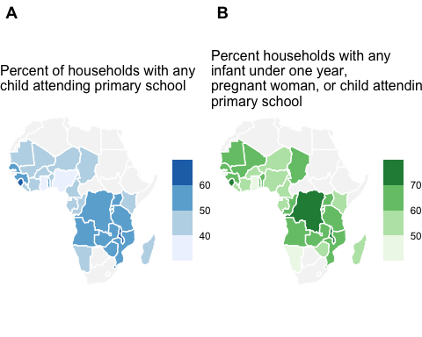

Figure 8: A) Percent of households with a child attending primary school; B) Percent of households with a pregnant woman, child under 12 months, or child attending primary school. Data from most recent Demographic and Health Survey

## Supplementary File 1 - Estimated ITN access under five ITN distributions scenarios and at varying quantification approaches

[Link to file](https://github.com/hkoenker/Quantification/blob/master/04_Quant_Plots.html)

## Supplementary File 2 - Frontier plots of Person-years of ITN access vs Total nets delivered

[Link to file](https://github.com/hkoenker/Quantification/blob/master/07_SI_2_PYP.html)

# References

1. Milliner J. [Net Mapping Project](https://allianceformalariaprevention.com/working-groups/net-mapping/). 2021.

2. Bertozzi-Villa A, Bever CA, Koenker H, Weiss DJ, Vargas-Ruiz C, Nandi AK, et al. [Maps and metrics of insecticide-treated net access, use, and nets-per-capita in Africa from 2000-2020](https://doi.org/10.1038/s41467-021-23707-7). Nature Communications. 2021;12:3589.

3. Kilian A, Boulay M, Koenker H, Lynch M. [How many mosquito nets are needed to achieve universal coverage? Recommendations for the quantification and allocation of long-lasting insecticidal nets for mass campaigns](https://doi.org/10.1186/1475-2875-9-330). Malar J. 2010;9:330.

4. Guidelines for malaria vector control. 2019.

5. Koenker HM, Yukich JO, Mkindi A, Mandike R, Brown N, Kilian A, et al. [Analysing and recommending options for maintaining universal coverage with long-lasting insecticidal nets: the case of Tanzania in 2011.](https://doi.org/10.1186/1475-2875-12-150) Malar J. 2013;12:150.

6. Koenker H, Worges M, Kamala B, Gitanya P, Chacky F, Lazaro S, et al. [Annual distributions of insecticide-treated nets to schoolchildren and other key populations to maintain higher ITN access than with mass campaigns: a modelling study for mainland Tanzania](https://doi.org/10.1186/s12936-022-04272-w). Malaria Journal. 2022;21:246.

7. Abílio AP, Obi E, Koenker H, Babalola S, Saifodine A, Zulliger R, et al. [Monitoring the durability of the long-lasting insecticidal nets MAGNet and Royal Sentry in three ecological zones of Mozambique](https://doi.org/10.1186/s12936-020-03282-w). Malar J. 2020;1–17.

8. Kilian A, Obi E, Mansiangi P, Abílio AP, Haji KA, Blaufuss S, et al. [Variation of physical durability between LLIN products and net use environments: summary of findings from four African countries](https://doi.org/10.1186/s12936-020-03549-2). Malar J. 2020;1–11.

9. Mansiangi P, Umesumbu S, Etewa I, Zandibeni J, Bafwa N, Blaufuss S, et al. [Comparing the durability of the long-lasting insecticidal nets DawaPlus® 2.0 and DuraNet© in northwest Democratic Republic of Congo](https://doi.org/10.1186/s12936-020-03262-0). Malar J. 2020;1–17.

10. Haji KA, Khatib BO, Obi E, Dimoso K, Koenker H, Babalola S, et al. [Monitoring the durability of the long-lasting insecticidal nets Olyset® and PermaNet® 2.0 in similar use environments in Zanzibar](https://doi.org/10.1186/s12936-020-03258-w). Malar J. 2020;1–17.

11. Obi E, Okoh F, Blaufuss S, Olapeju B, Akilah J, Okoko OO, et al. [Monitoring the physical and insecticidal durability of the long-lasting insecticidal net DawaPlus® 2.0 in three States in Nigeria](https://doi.org/10.1186/s12936-020-03194-9). Malar J. 2020;1–19.

12. Kilian A, Koenker H, Obi E, Selby RA, Fotheringham M, Lynch M. [Field durability of the same type of long-lasting insecticidal net varies between regions in Nigeria due to differences in household behaviour and living conditions](https://doi.org/10.1186/s12936-015-0640-4). Malaria Journal. 2015;14:253.

13. Lorenz LM, Bradley J, Yukich J, Massue DJ, Mboma ZM, Pigeon O, et al. [Comparative functional survival and equivalent annual cost of 3 long-lasting insecticidal net (LLIN) products in Tanzania: A randomised trial with 3-year follow up](https://doi.org/10.1371/journal.pmed.1003248). PLOS Medicine. 2020;17:e1003248.

14. Randriamaherijaona S, Raharinjatovo J, Boyer S. [Durability monitoring of long-lasting insecticidal (mosquito) nets (LLINs) in Madagascar: physical integrity and insecticidal activity](https://doi.org/10.1186/s13071-017-2419-7). Parasites & Vectors. 2017;10:1–11.

15. Bhatt S, Weiss DJ, Mappin B, Dalrymple U, Cameron E. Coverage and system efficiencies of insecticide-treated nets in Africa from 2000 to 2017. eLife. 2015. <https://doi.org/10.7554/elife.09672.001>.

16. Koenker R, Bassett G. [Regression Quantiles](https://doi.org/10.2307/1913643). Econometrica. 1978;46:33.

17. Koenker R, Hallock KF. [Quantile Regression](https://doi.org/10.1257/jep.15.4.143). Journal of Economic Perspectives. 2001;15:143–56.

18. Koenker R. [Quantile Regression](https://doi.org/10.1017/CCOL0521845734.007). 2005;222–49.

19. Girond F, Madec Y, Kesteman T, Randrianarivelojosia M, Randremanana R, Randriamampionona L, et al. [Evaluating Effectiveness of Mass and Continuous Long-lasting Insecticidal Net Distributions Over Time in Madagascar: A Sentinel Surveillance Based Epidemiological Study](https://doi.org/10.1016/j.eclinm.2018.07.003). EClinicalMedicine. 2018;1 C:62–9.

20. Wheldrake A, Guillemois E, Arouni H, Chetty V, Russell SJ. [The causes of holes and loss of physical integrity in long‐lasting insecticidal nets](https://doi.org/10.1186/s12936-020-03567-0). Malaria Journal. 2021;20:45.

21. Stuck L, Chacky F, Festo C, Lutambi A, Abdul R, Greer G, et al. Evaluation of Long-Lasting Insecticidal Net Distribution Through Schools in Southern Tanzania. Health Policy and Planning. 2021. <https://doi.org/10.1093/heapol/czab140>.

22. Yukich J, Stuck L, Scates S, Wisniewski J, Chacky F, Festo C, et al. [Sustaining LLIN coverage with continuous distribution: the school net programme in Tanzania.](https://doi.org/10.1186/s12936-020-03222-8) Malar J. 2020;19:158–12.

23. Coalson JE, Cohee LM, Buchwald AG, Nyambalo A, Kubale J, Seydel KB, et al. [Simulation models predict that school-age children are responsible for most human-to-mosquito Plasmodium falciparum transmission in southern Malawi](https://doi.org/10.1186/s12936-018-2295-4). Malaria Journal. 2018;17:147.

24. Cohee LM, Goupeyou-Youmsi J, Seydel KB, Mangani C, Ntenda P, Sixpence A, et al. [Understanding the Intransigence of Malaria in Malawi](https://doi.org/10.4269/ajtmh.21-1263). The American Journal of Tropical Medicine and Hygiene. 2022;107:40–8.

25. Olapeju B, Choiriyyah I, Lynch M, Acosta A, Blaufuss S, Filemyr E, et al. [Age and gender trends in insecticide-treated net use in sub-Saharan Africa: a multi-country analysis](https://doi.org/10.1186/s12936-018-2575-z). Malar J. 2018;1–12.

26. Koenker H, Kilian A. [Recalculating the Net Use Gap: A Multi-Country Comparison of ITN Use versus ITN Access](https://doi.org/10.1371/journal.pone.0097496). PLoS One. 2014;9:e97496.

1. Tropical Health LLP, [hannah@trophealth.com](mailto:hannah@trophealth.com)
2. Tulane University Center for Applied Malaria Research and Evaluation, [jyukich@tulane.edu](mailto:jyukich@tulane.edu)
3. International Federation of the Red Cross and Red Crescent Societies, [marcy.erskine@ifrc.org](mailto:marcy.erskine@ifrc.org)
4. International Federation of the Red Cross and Red Crescent Societies, [robert.opoku@ifrc.org](mailto:robert.opoku@ifrc.org)
5. Tropical Health LLP, [eleanore@trophealth.com](mailto:eleanore@trophealth.com)
6. Tropical Health LLP, [albert@trophealth.com](mailto:albert@trophealth.com)