Reported reasons for non-use of insecticide-treated nets in large national household surveys

Hannah Koenkera, Marcy Erskine1, Robert Opoku1, Zainab Ali1, Eleanore Sternberga, Cameron Taylor1

*aBaltimore USA*

# Abstract

Insecticide-treated nets (ITN) are the cornerstone of modern malaria vector control, with over 2 billion ITNs delivered to households in endemic areas since 2000. ITN access, i.e. availability within the household, based on the number of ITNs and number of household members, is the sine qua non of ITN use. Once ITNs are in a given household, however, individuals may choose to use or not use them on a given night, with structural, cultural, opportunistic, and social barriers impeding optimal use. Factors determining ITN use are frequently examined in published literature, but to date, large household survey data on reasons given for non-use of nets have not been explored.

A total of 155 DHS, MIS, and MICS surveys since 2003 were downloaded with permission and reviewed for presence of questions on reasons why nets were not used the previous night, and twenty-four surveys were identified. The percent of nets that were reported used the previous night was calculated for 155 surveys, and frequencies and proportions of reasons for non-use were calculated within the twenty-four surveys. Results were stratified by household supply of ITNs in three categories (not enough”, “enough”, and “more than enough”).

The percent of nets used the previous night averaged 70.4% across the 155 surveys conducted since 2003. Stratifying by households ITN supply, this was 75%, 71%, and 53% for households with not enough, enough, and more than enough ITNs, respectively. Population ITN use within these households was 51%, 74%, and 76%, respectively. Reported reasons for non-use of ITNs were primarily nets being extra or being saved for later, followed by low perceived risk of malaria (no mosquitoes/no malaria). The least frequent categories cited as reasons for nets not being used were “net attributes” (size, shape, color, etc) and “fears”. Using continuous DHS data from Senegal, the proportions of nets used peaked during high transmission season, while “no/few mosquitoes” responses peaked during the dry season.

The proportion of nets used the previous night has averaged over 70% since 2003, with no discernible change over this period. Reported reasons for why a net goes unused fall largely into three categories - nets that are extra/being saved for future use; the perception that there is little risk of malaria (particularly in dry season); and “other” responses. Net attributes such as color, size, shape, and texture, and fears related to chemicals were the least frequent reasons given. Classifying reasons for non-use into broader categories facilitates the design of appropriate social and behaviour change interventions to address the major underlying reasons for non-use, where this is feasible. Finally, national malaria programs should request the inclusion of this question in future surveys to provide actionable data to inform SBC programming. [Meant to be 350 words max; it’s over currently]

*Keywords:* insecticide-treated nets, long-lasting insecticidal nets, net use

# 1. Introduction

Insecticide-treated nets (ITN) are the cornerstone of modern malaria vector control, with over 2 billion ITNs delivered to households in endemic areas since 2000 [1]. Consistent use of ITNs provides the most protection from malaria vectors, but households may only have enough nets for all household members for the several months immediately following mass ITN distributions, as nets begin to wear out [2–5]. ITN access,

i.e. availability within the household, based on the number of ITNs and number of household members, is the sine qua non of ITN use. Once ITNs are in a given household, however, individuals may choose to use or not use them on a given night, with structural, cultural, opportunistic, and social barriers impeding optimal use [6, 7].

Many papers evaluate determinants of ITN use, although not all control for ITN access. Primary factors influencing use of available nets include perception of risk of malaria, due to seasonality of transmission ITN use among those with access is typically lower during long, hot, dry seasons, when malaria vectors and other nuisance biting insects are less abundant [8]. Perceptions of heat and feeling closed in are frequently cited alongside each other [6, 9]. ITN use is also affected by who within a given household can share a single ITN, as well as space available to hang ITNs [10–13]. The condition of an ITN, related to its age along with the development of holes and tears, is associated with early discarding of ITNs and therefore lack of use [14–17]; the decay rate of ITNs is a critical component of overall trends in ITN access, determining how quickly coverage declines following mass distribution campaigns and other large-scale distributions [2, 5].

Pulford et al [6] reviewed 22 available studies in 2011 for reasons why nets went unused, finding that discomfort due to heat and perceived low risk of malaria due to low mosquito density were the primary

∗Corresponding author

*Email addresses:* hannah@trophealth.com (Hannah Koenker), marcy.erskine@ifrc.org (Marcy Erskine), robert.opoku@ifrc.org (Robert Opoku), zainab.ali@ifrc.org (Zainab Ali), eleanore@trophealth.com (Eleanore Sternberg), cameron.taylor@icf.com (Cameron Taylor)

*For submission to Malaria Journal August 31, 2022*

reasons cited, but noted that findings were tentative given the dearth of published studies. Since this time, large national household surveys including Malaria Indicator Surveys and Demographic and Health Surveys have in several cases added questions about reasons for not using nets. This paper summarizes available data in these MIS and DHS surveys and explores trends in the percentage of ITNs used. Finally, recommendations are given for further exploration of reasons for non-use of ITNs.

*1.1. Study objectives*

The study objectives are to use national population-based household survey data characterize reasons underlying non-use of ITNs. The goal of the analysis is to explore the reasons for not using an ITN during the previous night in relation to net supply at household level, and how these reasons vary over time (where possible) and by country. The primary research questions are:

1. What proportion of nets were used the night prior to the survey?
2. Of nets that went unused, what are the primary reported reasons for non-use, and how do reasons vary by country and net supply?

# 2. Methods

For the first study objective, 155 DHS, MIS, and MICS surveys since 2003 were downloaded with permission from dhsprogram.com and mics.unicef.org. Each dataset was reshaped to a long format to create a net file that included whether the net was observed by the interviewer, its age, whether it was an ITN, the number of users, and whether it was reported to have been used the previous night. The Roll Back Malaria indicator of percent of nets used the previous night was calculated for all surveys and linear regression used to assess temporal changes for each type of survey. To evaluate net use in the context of household ITN supply, a variable was computed with supply levels where “not enough” indicated less than 0.5 nets available per person (<1 ITN per 2 people), “enough” indicated 0.5 to 0.75 nets available per person (1 ITN per 2 people), and “more than enough” nets indicated a supply of 0.75 or more nets available per person (i.e. at least 2 nets per 3 people). Households consisting of one person with one net were categorized as ‘enough’, rather than “more than enough”. For this variable, both untreated nets and ITNs were included.

For the second study objective, all DHS and MIS surveys were reviewed and twenty-four surveys from nine countries were identified as having included a follow-up question for unused nets about why they were not used. All were Malaria Indicator Surveys, conducted during peak malaria transmission season, with the exception of the Madagascar 2021 DHS, Nigeria 2018 DHS, the Tanzania 2015-16 DHS/MIS, and eight

continuous DHS surveys from Senegal (2011-2019), where fieldwork is conducted throughout the year. Nets that were not observed by the interviewer were excluded from analysis. The “svy” family of commands in Stata 17 was used to appropriately weight results within each country. Plots were produced with R.

# 3. Results

The percent of nets used the previous night averaged 70.4% across all available (n=155) DHS, MIS, and MICS surveys since 2003 (Fig. 1). Linear regression stratified by survey type indicates that there was no significant change over time in the percentage of nets used the previous night for MIS (p=0.772), DHS (p=0.499) or MICS (p=0.235). MIS surveys, conducted during high transmission season, were associated with a 6.8-point increase in rates of net use when compared to DHS surveys (p=0.046), which are generally conducted during dry season when malaria transmission is lower. Net use rates in MICS surveys did not differ significantly from DHS surveys (0.872).

Figure 1: Percentage of nets used the night before, DHS, MICS, MIS surveys 2003-2020

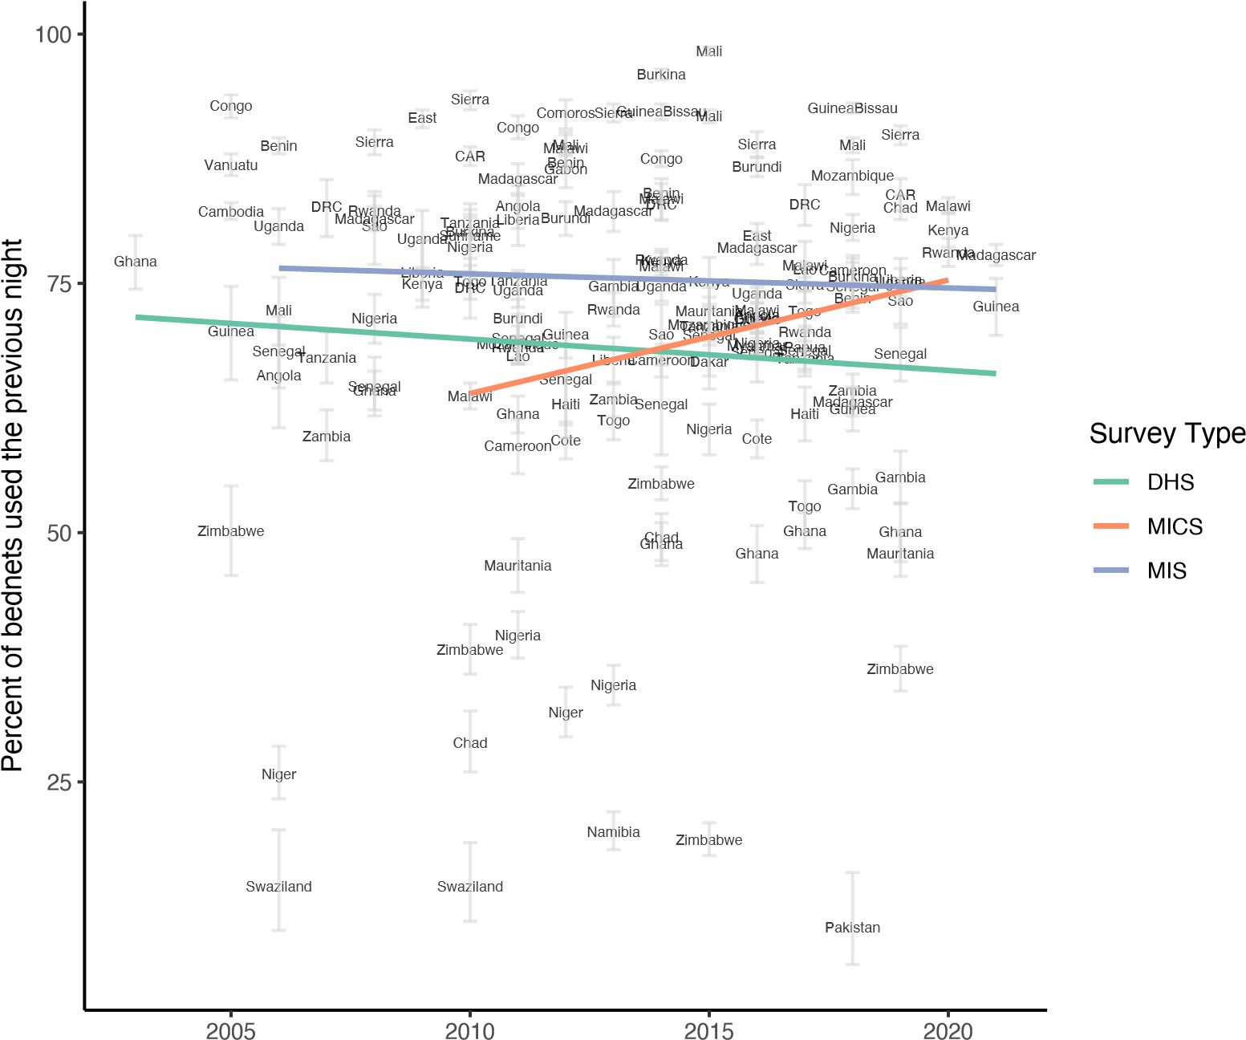

The percent of nets used the previous night was 75% for households with not enough nets (at least one,

but less than 1 net for 2 people) and 71% for households with at least 1 net for 2 people but less than 2 nets for 3 people (net:person ratio between 0.5 and 0.75), shown in Fig. 2. In contrast, in households with at least 2 nets for 3 people 53.2% of nets were used, potentially reflecting excess nets within the household or different net use behaviours by households with excess nets. Nonetheless, in these same households with “more than enough” nets, the percent of individuals using an ITN the previous night was 76%, on par with those living in households with sufficient ITNs (73.5%). For people living within households owning at least one but not enough ITNs, population ITN use was 51.2%.

Figure 2: Violin plots with means for ITNs used the previous night and population use of ITNs, by household net supply level.

75

51.2

71

73.5

53.2

76

0

25

50

75

100

Not enough

Just right

More than enough

Household ITN supply

Percent

Percent of nets used Percent population that used an ITN the previous night

*3.1. Reported reasons for not using nets*

Response options for reasons why a net was not used the previous night were inconsistent between countries and sometimes changed over time within a given country. Table 1 summarizes the response options for the question “Why was this net not used the previous night?” and categorizes them into seven broad categories: ‘extra’ (nets being saved for later, or extra), ‘fears’ (chemicals are unsafe or toxic), ‘net attributes’ (size, shape, or textile), ‘objective’ (usual user not here; net being washed; no space to hang; net too torn), ‘risk perception’ (no mosquitoes or no malaria), ‘subjective’ (related to heat, smell, etc), and ‘other’ (capturing ‘other’ as well as ‘not hung’ and ‘net not needed last night’, all of which fail to provide useful information about the respondent’s reasoning). Risk perception and subjective reasons for a net going unused may be more amenable to certain social behaviour change interventions, while objective reasons are not. In eight surveys, multiple responses were possible, while in sixteen, only a single response could be

selected.

Table 1: Categorization of reasons why nets were not used

|  |  |
| --- | --- |
| Category | Answer options from MIS |
| extra | extra; saving for later; stored away |
| fears | chemicals not safe; net is bad for health; superstition/witchcraft |
| net attributes | too rough/hard; too small; don’t like color/shape/size; brought bedbugs; prefer other method |
| objective | too old/torn/dirty; no place to hang; usual user didn’t sleep here; net being washed; too weak/difficult to hang |
| risk perception | no mosquitoes; no malaria; saving for rainy season; |
| subjective | too hot; don’t like smell; feel closed in/afraid; no longer kills/repels mosquitoes; child doesn’t like; net never used; causes itching/coughing; slept outdoors |
| other | not needed last night; not hung; other; don’t know |

Figure 3 below shows the proportion of nets used the previous night across twenty-four surveys in nine countries, and the reasons why certain nets were not used. The percentage of nets reported used ranged from 50% in Ghana 2019 to 85% in Mozambique 2018. Senegal’s continuous DHS surveys showed the highest proportions of reasons related to risk perception, with up to 25% of nets going unused due to “no mosquitoes” or “no malaria”. However, this category was relatively infrequent in other surveys, with the exception of Tanzania where up to 11% of nets were unused due to risk perception, and was more pronounced in lower transmission areas (Supplemental Material). “Extra/saving for later” nets were reported most frequently in Ghana 2019 (19%), Liberia 2016 (19%), and in Tanzania (12-14% of nets). Senegal and Uganda had the highest rates of ‘other’ responses. In 2018, Uganda updated answer options for this question to be more detailed, resulting in the ‘extra’ and ‘objective’ categories becoming more prominent; ‘extra’ category was comprised largely of ‘saving to replace other net’, while ‘objective’ was a combination of ‘usual user not here’ and ‘too old/torn’ (Supplemental Material). Subsequent surveys (Ghana, Guinea, Mozambique,

Madagascar) adopted similar answer options.

Figure 3: Summary of reasons nets were not used, across surveys

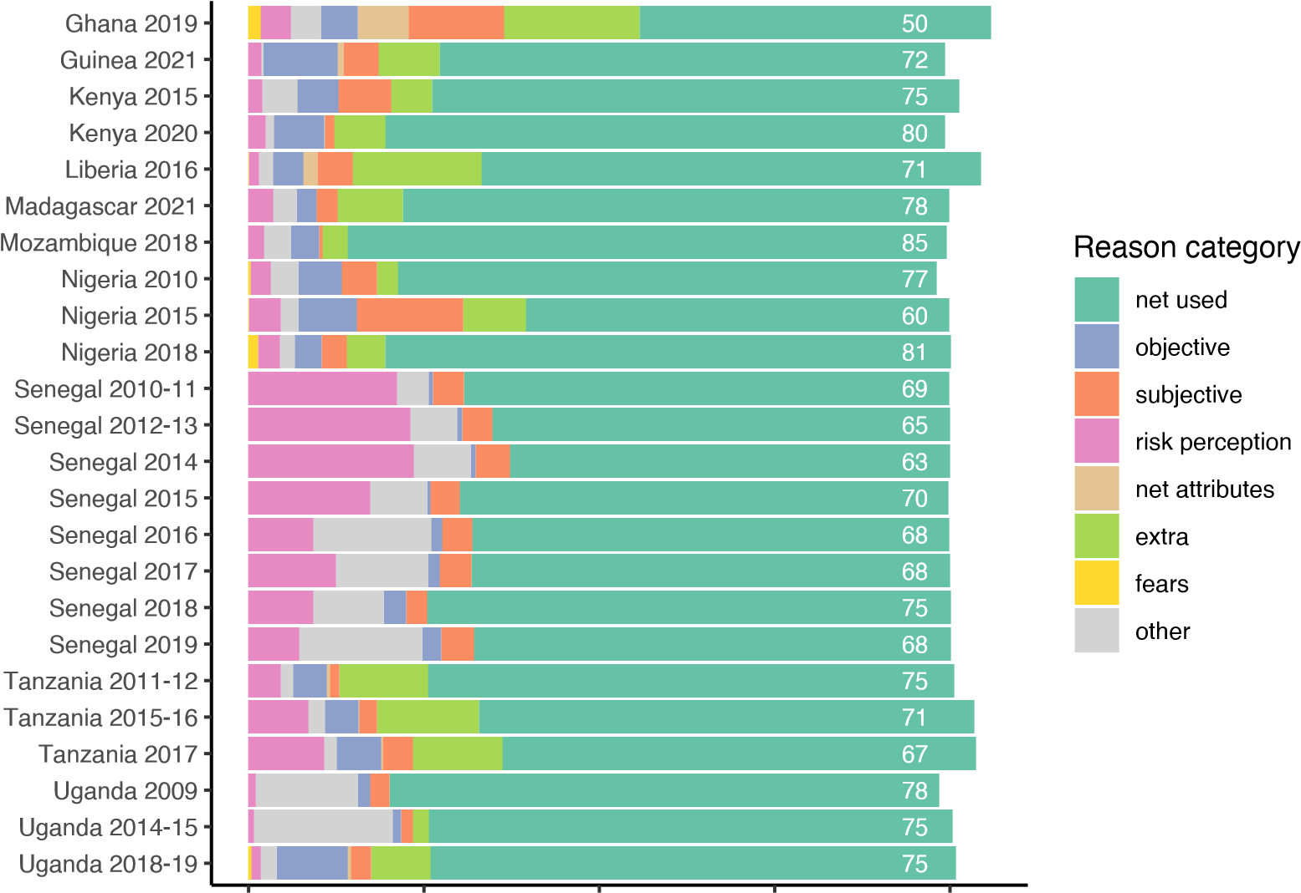

0 25 50 75 100

Percent

Figure 4A summarizes the categories of reasons for non-use across the twenty-four surveys, demonstrating that an average of 71.5% of nets were used, and that the leading category for non-use was “extra”, followed by

“risk perception”. The least frequent categories cited as reasons for nets not being used were “net attributes” and “fears”. Figure 4B presents reasons for nets not being used in the context of household net supply.

Figure 4: Summary of reasons across surveys, by household supply of ITNs

**A** Overall reasons for net not being used **B** Reasons by household supply of ITNs

HH with <1 ITN for 2 pp

9.4

0.7

1.4

71.5

4.2

6.5

7.4

4.5

fears

net attributes

objective

subjective

other

risk perception

extra

net used

HH with

≥

ITN for 2 pp

1

Percent

Reason category

HH with ≥2 ITN for 3 pp

0 20 40 60 80 100 120

net used net attributes objective extra subjective fears

0 20 40 60 80 100 risk perception other

Percent

Not surprisingly, “extra” nets comprised a higher proportion of reasons for non-use among households with at least 2 ITN for 3 people (21.6%) compared to households with not enough nets (3%) or households with at least 1 ITN for 2 people (7.7%). “Other” responses were more frequent in households with at least 2 ITNs for 3 people (11.4% vs 5.7% and 3.9%), indicating that ‘other’ reasons are likely related to having extra nets, particularly in surveys prior to 2018 when response options did not capture extra nets well. The “risk perception” category was stable across ITN supply categories, ranging between 6.8% and 8.4%, as were “subjective” reasons, ranging from 4.2% to 5%. Reasons for non-use related to net attributes or fears comprised less than 2% across all ITN supply categories.

In each of the eight surveys from Senegal two questions were asked. First, in households that owned at least one net, respondents were asked “do members of this household use nets all year round” (5A below). The proportion of respondents reporting people in their household do use nets year-round increased from 47.4% to 72.9% over the 2008-2019 period (p<0.001 for trend) and generally tracked with increasing levels of population access to ITNs. Next, for households responding “no”, a follow-up question was asked:

“what are the reasons household members do not use nets year round?”. The most frequent answer was “no/few mosquitoes” (5B), which fell from a high of 29.1% in 2012 to 14.5% in 2019, as a proportion of all households in the survey. “Heat” was the next most common response, ranging between 2.1-4.9%. Not liking the net and forgetfulness were relatively uncommon (less than 2.6% and 1.2% of all households in any survey, respectively).

Figure 5: Year-round net use and reasons for not using nets, Senegal 2008-2019 **A** Self-reported year-round net use **B** Reasons for not using nets all year

0

20

40

60

80

100

2006

2007

2008

2009

2010

2011

2012

2013

2014

2015

2016

2017

2018

2019

Percent

Population ITN Access

Respondents reporting net use all year

0

20

40

60

80

100

2008

2009

2010

2011

2012

2013

2014

2015

2016

2017

2018

2019

Percent

use all year

no/few mosquitoes

heat

forgetfulness

don't like

don't know

other

Figure 6: Reported net use and reasons for non-use, Senegal 2011-2019

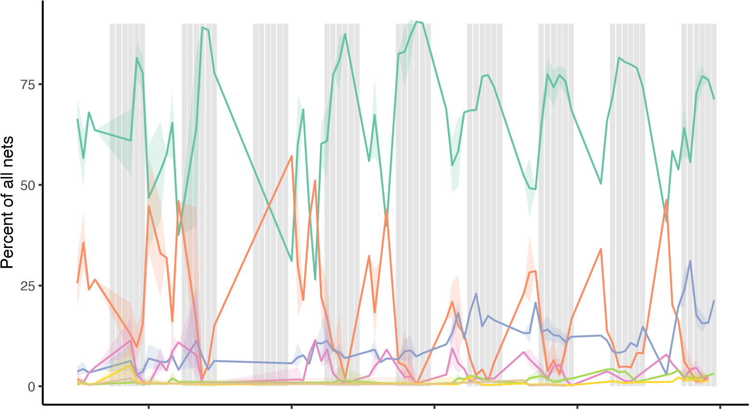

2012 2014 2016 2018 2020

net was used torn don't know high transmission season

other

heat

no mosquitoesnot effective

Seasonal trends in reasons for not using nets in Senegal were apparent, as illustrated in Fig. 6 above. The percentage of nets used the previous night peaked during high transmission season (shown approximatively above as July-December), falling to lower levels during the drier months of February-May. Correspondingly, the proportion of nets not used due to “no mosquitoes” peaked during the drier months.

# 4. Discussion

Over the past nearly twenty years, an average of over 70% of ITNs were reported used the previous night in large household surveys. Questions about why nets go unused have only been included in twenty-four surveys from nine countries, but among these, the primary reasons given are that unused nets are surplus to immediate requirements, or not needed due to perceived low risk of malaria and/or mosquito bites. Responses related to extra nets were more frequent among households owning more ITNs than strictly deemed necessary by WHO (1 ITN per 2 people) [18]. Unsurprisingly, the proportion of nets used the previous night in households with “more than enough” nets was lower than for households with less than enough or “enough” nets, while at the same time, the proportion of people that used an ITN the previous night was highest in households with “enough” or “more than enough” ITNs. Households with more than one ITN per two people may have acquired additional nets to cover individual sleeping spaces or to accommodate sleepers who cannot share a sleeping space; other households may have extra nets being saved for later use, when current nets wear out, and thus are able to have most household members sleep under one. Households with “not enough” ITNs had lower rates of population use, but high rates of nets being used - indicating that these households are using the nets they have, and are challenged primarily by not having enough for other members of the family. It should be noted that having ‘extra’ nets is reflective of the inherent inefficiencies of ITN distribution systems, wherein some households will have too few while others may receive additional nets slightly earlier than required [2]. The authors view having extra nets on hand within households as a positive, given the unpredictability of net replacement timing.

Reasons related to net attributes - including size, shape, color, texture, and mosquito-killing ability were inconsistently included in survey questionnaires, but represented a negligible fraction of reasons for not using nets. While this does not preclude these issues from contributing to net non-use, it provides some evidence that these issues are not top of mind when families are making net use decisions. The 2011 Pulford review findings [6] that discomfort due to heat and perceived low mosquito density were the most widely identified reasons for non-use are partially confirmed here; heat per se was not widely reported in more recent surveys, but risk perception as a category, particularly for Senegal, was a key driver. Pulford et al also use categories such as “social factors” (sleeping elsewhere), “technical factors” (not being able to hang a net), which are considered “objective” reasons for non-use in our study. Pulford’s review, conducted just as universal coverage campaigns were scaling up, was limited to 22 studies between 1990 and 2010. Since this time, a number of qualitative research studies have also been conducted, in which respondents cite being bothered by net attributes including smell, itching, shape, and size [12, 19–21]. However, these reasons are only rarely cited during quantitative surveys included in this study. Research from Senegal indicates that initial itching or smell are transitory, noticeable when nets are first received, but subsiding over time, not impeding net use [20]. Other less preferable attributes of nets may similarly be less noticeable over time, and are no longer a key reason for non-use, particularly when, as in most countries distributing ITNs, there are seldom enough nets in good condition for everyone to use. Families are thus obliged to use the imperfect ITNs they have, or risk contracting malaria.

Nearly 80 unique answer options were included across the surveys. The categorization of responses into “extra”, “risk perception”, “objective”, “subjective”, etc., is intended to facilitate interpretation and guide national malaria programmes and their partners in designing appropriate responses for improving net use. Where the majority of unused nets are not used due to subjective reasons, social behaviour change may be able to change attitudes and behaviours; however, if most nets are unused due to being too old or torn, programmes may need to focus on net maintenance behaviours and/or additional ITN distribution to improve ITN use rates.

As one example, Senegal has focused messaging over the last decade to address the perceived lower risk of malaria in the hot/dry season, in part because of findings in these surveys, through the “Trois Toutes” campaign (“Toute la famille, toutes les nuits, toute l’année” or “Every family member; every night; all year round”). Self-reported use of nets all year round has increased over time, although it remains unclear whether this is driven primarily by corresponding increases in overall access to ITNs with the household, or represent real changes in behaviour for more consistent ITN use. The continuous DHS in Senegal, conducted annually for the last eight years over multiple months, present a unique opportunity for assessing trends over time in year-round use as well as evaluating the associations between seasons and frequency of certain responses, notably “no/few mosquitoes”. Indeed, net use peaks in high transmission season, while the proportion of nets not used due to “no mosquitoes” peaks during the hot dry season when mosquito densities are substantially

lower.

Another example of refining this question to better inform programming is Uganda. Following the 2009 survey Uganda implemented “hang up campaigns” to ensure nets were hung and used, partially in response to low hanging rates observed in the 2009 and other surveys. Operational research showed that these hangup campaigns did not improve hanging or use rates, as net hanging increased at similar rates over time in control and intervention groups [22]. In its most recent surveys, Uganda teased apart the nebulous “not hung” answer option to better focus on specific barriers to net use, enabling the programme to understand what lies behind the non-use of nets; key reasons for non-use in 2018 were “saving net for later”, “user not here”, and “too old/torn”, none of which are best addressed with SBC efforts to hang up nets. This pragmatic specification of reasons for non-use enables programmes and their SBC partners to better design and target net use interventions. However, the absence of these types of questions even in many recent surveys is a missed opportunity, particularly as ITNs remain the primary tool for malaria vector control across the globe. National malaria programmes would do well to ensure this question is included in their upcoming household surveys, following the lead of Uganda, Mozambique, Nigeria, and Madagascar.

These findings also highlight that there may be more limited “room for improvement” in ITN use than previously thought. Nets not used for ‘objective’ reasons and those that are ‘extra’ are relatively impervious to social behaviour change communication, leaving the areas of ‘risk perception’, ‘subjective’, ‘fears’, ‘net attributes’, and some portion of ‘other’ left to address. These “objective” and “extra” categories explain non-use for, on average, 14% of all nets in the included surveys, but range from 0.5% to 24.6% of all nets depending on the country and survey. Even with highly effective social behaviour change, not all nets can be reasonably expected to be used.

*4.1. Limitations*

The study has several limitations. First, the question of reasons why nets were not used was included in only twenty-four surveys in nine countries. It is not possible to generalize reasons for non-use of nets to other countries; however, the present findings show that there are substantial similarities in overall percentage of nets used and relative importance of certain types of reasons. Second, response options vary considerably across surveys that do include this question, and number of reasons vary by country, from seven in Senegal to seventeen in Liberia and Mozambique. Nonetheless, some of the differences in response options are minimal changes in wording, and major categories of reasons are generally included in each survey. Third, the categorization of the reasons for non-use into broader categories relies on assumptions about which barriers are similar, and opinions may differ depending on subject familiarity, lived experience, and other factors. Some reasons may also belong in multiple categories. Fourth, around half the surveys posed the question about reasons for why a net wasn’t used the previous night as a multiple choice question, while the other half restricted it to a single response. This may introduce some unequal weighting into the results, or put more emphasis on single-choice responses to the exclusion of other possible reasons for not using nets. Finally, there were a substantial number of responses recorded as “other” in many of the surveys; it cannot be determined what type of reason this may have been, although it seems likely that they are at least in part related to extra nets or saving for future use, given the increase in other responses among households with “more than enough” nets.

# 5. Conclusion

The proportion of nets used the previous night has averaged over 70% since 2003, with no discernible change over this period. Reported reasons for why a net goes unused fall largely into three categories - nets that are extra/being saved for future use; the perception that there is little risk of malaria (particularly in dry season); and “other” responses. Net attributes such as color, size, shape, and texture, and fears related to chemicals were the least frequent reasons given. Classifying reasons for non-use into broader categories facilitates the design of appropriate social and behaviour change interventions to address the major underlying reasons for non-use, where this is feasible. Finally, national malaria programs should request the inclusion of this question in future surveys to provide actionable data to inform SBC programming.

**6. References**

# 7. Supplemental Material

Figure 7: Reported net use and reasons for non-use by low and high transmission zones, Tanzania 2017-18 MIS

high high high

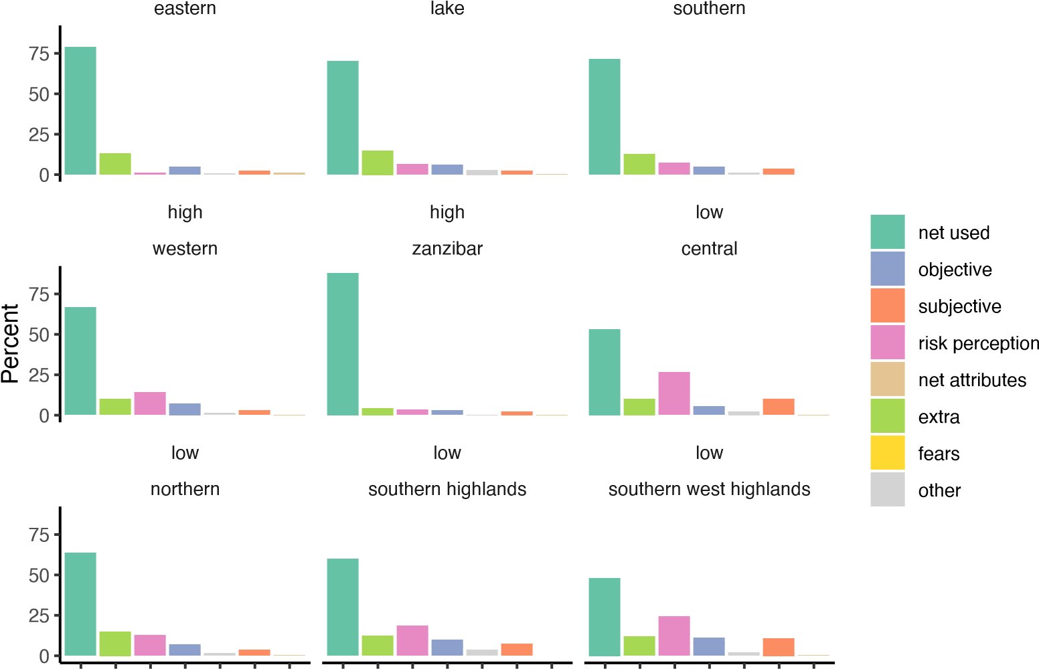

Figure 8: Reasons nets were not used the previous night, Ghana, Guinea, Kenya

net used

objective

subjective

risk perception

net attributes

extra

fears

other

Ghana 2019

other

don't like shape/color/size

slept outside

too hot

no mosquitoes / no malaria

don't like smell

used/perforated

usual user not here

dirty/being washed

unable to hang

extra/saved for later

net was used the previous night

Guinea 2021

extra/saving for later too hot prefer other method other no mosquitoes net was being washed chemicals are unsafe net too old/torn usual user not here don't like smell don't like shape slept outside no malaria net too short/small net brought bugs

0 10 20 30 40 50

0 20 40 60

Kenya 2015

net was used the previous night net never used excess nets usual user not here other no mosquitoes net being washed too hot

0 20 40 60

Kenya 2020

net was used the previous night extra/saving for later usual user not here no mosquitoes/no malaria net in poor condition unable to hang other too hot slept outdoors net too small/short net brought bedbugs don't like smell don't like shape/color/size

0 20 40 60 80

Figure 9: Reasons nets were not used the previous night, Liberia, Madagascar, and Mozambique

# Reason type

net used

objective

subjective

risk perception

net attributes

extra

fears

other

Liberia 2016

don't like color

don't like shape

don't like size

don't like smell

slept outside

unable to hang

too hot

usual user not here

other

no mosquitoes/no malaria

extra/saving for later

net was used the previous night

Madagascar 2021

not hung up/stored away saving for later too hot

usual user(s) didn't sleep here other

not in good condition no mosquitoes size of the bed skin irritation

materiall too hard/rough too weak to hang child doesn't like chemical smell/toxic superstition/witchcraft don't know bad for health

0 20 40 60 0 20 40 60 80

Mozambique 2018

net was used the previous night reserved-for future use-new not needed last night no mosquitoes usual user not here other

net too old/torn no hanging space net not available (washing) too hot difficult to hang don't know net too dirty feel closed in no malaria don't like smell causes itching

0 25 50 75

Figure 10: Reasons nets were not used the previous night, Nigeria

too hot difficult to hang other

net not needed last night no mosquitoes don't know net too old/torn net too dirty feel closed in

usual user did not sleep here net not available (washing) don't like smell

feel itn chemicals are unsafe itn provokes coughing no malaria

20 40 60 80 0 20 40 60

net used

objective

subjective

risk perception

net attributes

extra

0

Nigeria 2010

feel itn chemicals are unsafe

itn provokes coughing

no malaria

net too dirty

feel closed in

don't know

don't like smell

net not available (washing)

no space to hang

net too old/torn

other

usual user did not sleep here

difficult to hang

no mosquitoes

net not needed last night

too hot

net was used the previous night

Nigeria 2015

Nigeria 2018

net was used the previous night net not needed last night no mosquitoes too hot other

feel itn chemicals are unsafe usual user did not sleep here net too old/torn no space to hang difficult to hang don't like smell feel closed in no malaria net too dirty

net not available (washing) itn provokes coughing

don't know

0 20 40 60 80

Figure 11: Reasons nets were not used the previous night, Senegal

net used

objective

subjective

risk perception

net attributes

extra

don't know

torn

not effective

heat

other

no mosquitoes

Senegal 2010-11

don't know

not effective

torn

heat

other

no mosquitoes

net was used the previous night

Senegal 2012-13

|  |  |  |  |
| --- | --- | --- | --- |
| 0 20 40 | 60 | 0 20 40 | 60 |
| Senegal 2014 |  | Senegal 2015 |  |

don't know

not effective

torn

heat

other

no mosquitoes

net was used the previous night

not effective

don't know

torn

heat

other

no mosquitoes

net was used the previous night

|  |  |  |  |
| --- | --- | --- | --- |
| 0 20 40 | 60 | 0 20 40 | 60 |
| Senegal 2016 |  | Senegal 2017 |  |

don't know

not effective

torn

heat

no mosquitoes

other

net was used the previous night

don't know

not effective

torn

heat

no mosquitoes

other

net was used the previous night

|  |  |  |  |
| --- | --- | --- | --- |
| 0 20 40 | 60 | 0 20 40 | 60 |
| Senegal 2018 |  | Senegal 2019 |  |

don't know

not effective

heat

torn

no mosquitoes

other

net was used the previous night

don't know

not effective

torn

heat

no mosquitoes

other

net was used the previous night

0 20 40 60 0 20 40 60

Figure 12: Reasons nets were not used the previous night, Tanzania

net used

objective

subjective

risk perception

net attributes

extra

Tanzania 2011-12

don't know

feel closed in/afraid

no longer kills/repels mosquitoes

net too small

no malaria now

don't like smell

net not available last night/washed

net too dirty

too old/torn

too hot

usual user was not here

other

no mosquitoes

saving it for later

net was used the previous night

Tanzania 2015-16

net was used the previous night saving it for later no mosquitoes usual user was not here other too old/torn too hot net too dirty net too small

net not available last night/washed don't like smell no malaria now feel closed in/afraid don't know

no longer kills/repels mosquitoes

0 20 40 60

net was used the previous night saving it for later no mosquitoes too hot usual user was not here too old/torn other net too dirty no malaria now net not available last night/washed net too small feel closed in/afraid don't like smell don't know

0

20

40

60

Tanzania 2017

no longer kills/repels mosquitoes

0 20 40 60

Figure 13: Reasons nets were not used the previous night, Uganda

subjectivenet attributes

net used

objective

Uganda 2009

too hot

other

Uganda 2014-15

risk perceptionextra

net was used the previous nightnet was used the previous night

not hungnot hung

extra net/for visitors

other too hot

too old/too many holes too old/torn

no mosquitoes

no mosquitoes

don't like smelldon't like smell

don't knowdon't know

0 20 40 60 80 0 20 40 60

net was used the previous night saving to replace other net usual user didn't sleep here too old/torn too hot other reason no place to hang unable to hang no mosquitoes material too hard/rough chemicals not safe don't like smell saving for rainy season

0

20

40

60

Uganda 2018-19

don't know

## References

1. Milliner, J.. Net Mapping Project. Tech. Rep.; 2021. URL: [https://allianceformalariaprevention.com/working-](https://allianceformalariaprevention.com/working-groups/net-mapping/)

[groups/net-mapping/](https://allianceformalariaprevention.com/working-groups/net-mapping/).

1. Bhatt, S., Weiss, D.J., Mappin, B., Dalrymple, U., Cameron, E.. Coverage and system efficiencies of insecticide-treated

nets in Africa from 2000 to 2017. *eLife* 2015;doi:[10.7554/elife.09672.001](http://dx.doi.org/10.7554/elife.09672.001).

1. Koenker, H., Arnold, F., Ba, F., Cisse, M., Diouf, L., Eckert, E., Erskine, M., Florey, L., Fotheringham, M., Gerberg,

L., Lengeler, C., Lynch, M., Mnzava, A., Nasr, S., Ndiop, M., Poyer, S., Renshaw, M., Shargie, E., Taylor, C.,

Thwing, J., Hulle, S.V., Ye, Y., Yukich, J., Kilian, A.. Assessing whether universal coverage with insecticide-treated

nets has been achieved: is the right indicator being used? *Malar J* 2018;:1 – 11doi:[10.1186/s12936-018-2505-0](http://dx.doi.org/10.1186/s12936-018-2505-0).

1. Girond, F., Madec, Y., Kesteman, T., Randrianarivelojosia, M., Randremanana, R., Randriamampionona, L., Randrianasolo, L., Ratsitorahina, M., Herbreteau, V., Hedje, J., Rogier, C., Piola, P.. Evaluating Effectiveness of Mass and Continuous Long-lasting Insecticidal Net Distributions Over Time in Madagascar: A Sentinel Surveillance Based Epidemiological Study. *EClinicalMedicine* 2018;1(C):62 – 69. doi:[10.1016/j.eclinm.2018.07.003](http://dx.doi.org/10.1016/j.eclinm.2018.07.003).
2. Bertozzi-Villa, A., Bever, C.A., Koenker, H., Weiss, D.J., Vargas-Ruiz, C., Nandi, A.K., Gibson, H.S., Harris, J.,

Battle, K.E., Rumisha, S.F., Keddie, S., Amratia, P., Arambepola, R., Cameron, E., Chestnutt, E.G., Collins, E.L., Millar, J., Mishra, S., Rozier, J., Symons, T., Twohig, K.A., Hollingsworth, T.D., Gething, P.W., Bhatt, S.. Maps and metrics of insecticide-treated net access, use, and nets-per-capita in Africa from 2000-2020. *Nature Communications* 2021;12(1):3589. doi:[10.1038/s41467-021-23707-7](http://dx.doi.org/10.1038/s41467-021-23707-7).

1. Pulford, J., Hetzel, M.W., Bryant, M., Siba, P.M., Mueller, I.. Reported reasons for not using a mosquito net when

one is available: a review of the published literature. *Malar J* 2011;10:83. doi:[10.1186/1475-2875-10-83](http://dx.doi.org/10.1186/1475-2875-10-83).

1. Guglielmo, F., Ranson, H., Sagnon, N., Jones, C.. The issue is not ‘compliance’: exploring exposure to malaria vector

bites through social dynamics in Burkina Faso. *Anthropology & Medicine* 2021;:1–18doi:[10.1080/13648470.2021.1884185](http://dx.doi.org/10.1080/13648470.2021.1884185). 8. Koenker, H., Taylor, C., Burgert-Brucker, C.R., Thwing, J., Fish, T., Kilian, A.. Quantifying Seasonal Variation in Insecticide-Treated Net Use among Those with Access. *Habitat targeting for controlling aquatic stages of malaria vectors*

*in Africa* 2019;101(2):371 – 382. doi:[10.4269/ajtmh.19-0249](http://dx.doi.org/10.4269/ajtmh.19-0249).

1. Ahorlu, C.S., Adongo, P., Koenker, H., Zigirumugabe, S., Sika-Bright, S., Koka, E., Tabong, P.T.N., Piccinini, D., Segbaya, S., Olapeju, B., Monroe, A.. Understanding the gap between access and use: a qualitative study on barriers

and facilitators to insecticide-treated net use in Ghana. *Malar J* 2019;:1 – 13doi:[10.1186/s12936-019-3051-0](http://dx.doi.org/10.1186/s12936-019-3051-0).

1. Toé, L.P., Skovmand, O., Dabiré, K.R., Diabaté, A., Diallo, Y., Guiguemdé, T.R., Doannio, J.M.C., Akogbéto, M.,

Baldet, T., Gruénais, M.E.. Decreased motivation in the use of insecticide-treated nets in a malaria endemic area in Burkina Faso. *Malar J* 2009;8(1):175. URL: [http://malariajournal.biomedcentral.com/articles/10.1186/1475-28758-175](http://malariajournal.biomedcentral.com/articles/10.1186/1475-2875-8-175). doi:[10.1186/1475-2875-8-175](http://dx.doi.org/10.1186/1475-2875-8-175).

1. Lam, Y., Harvey, S.A., Monroe, A., Muhangi, D., Loll, D., Kabali, A.T., Weber, R.. Decision-making on intra-household allocation of bed nets in Uganda: do households prioritize the most vulnerable members? *Malar J* 2014;13(1):183. doi:[10.1186/1475-2875-13-183.](http://dx.doi.org/10.1186/1475-2875-13-183)
2. Galvin, K.T., Petford, N., Ajose, F., Davies, D.. An exploratory qualitative study on perceptions about mosquito bed nets

in the Niger Delta: what are the barriers to sustained use? *J Multidiscip Healthc* 2011;4:73 – 83. doi:[10.2147/jmdh.s15917](http://dx.doi.org/10.2147/jmdh.s15917).

1. Njatosoa, A.F., Mattern, C., Pourette, D., Kesteman, T., Rakotomanana, E., Rahaivondrafahitra, B., Andriamananjara, M., Harimanana, A., Razafindrakoto, J., Raboanary, E., Andrianasolo, A., Rogier, C.. Family, social and cultural determinants of long-lasting insecticidal net (LLIN) use in Madagascar: secondary analysis of three qualitative

studies focused on children aged 5–15 years. *Malaria Journal* 2021;20(1):168. doi:[10.1186/s12936-021-03705-2](http://dx.doi.org/10.1186/s12936-021-03705-2).

1. Madumla, E.P., Moore, S.J., Moore, J., Mbuba, E., Mbeyela, E.M., Kibondo, U.A., C, S., Mmbaga, , Kobe, D., Baraka, J., Msellemu, D., Swai, J.K., Mboma, Z.M., Odufuwa, O.G.. “In starvation, a bone can also be meat”: a

mixed methods evaluation of factors associated with discarding of long-lasting insecticidal nets in Bagamoyo, Tanzania. *Malaria Journal* 2022;21(1):101. doi:[10.1186/s12936-022-04126-5](http://dx.doi.org/10.1186/s12936-022-04126-5).

1. Lorenz, L.M., Bradley, J., Yukich, J., Massue, D.J., Mboma, Z.M., Pigeon, O., Moore, J., Kilian, A., Lines,

J., Kisinza, W., Overgaard, H.J., Moore, S.J.. Comparative functional survival and equivalent annual cost of 3 long-lasting insecticidal net (LLIN) products in Tanzania: A randomised trial with 3-year follow up. *PLOS Medicine* 2020;17(9):e1003248. doi:[10.1371/journal.pmed.1003248.](http://dx.doi.org/10.1371/journal.pmed.1003248)

1. Mboma, Z.M., Festo, C., Lorenz, L.M., Massue, D.J., Kisinza, W.N., Bradley, J., Moore, J.D., Mandike, R., Akim,

I., Lines, J., Overgaard, H.J., Moore, S.J.. The consequences of declining population access to insecticide-treated nets

(ITNs) on net use patterns and physical degradation of nets after 22 months of ownership. *Malaria Journal* 2021;20(1):171. doi:[10.1186/s12936-021-03686-2](http://dx.doi.org/10.1186/s12936-021-03686-2).

1. Hiruy, H.N., Zewde, A., Irish, S.R., Abdelmenan, S., Woyessa, A., Wuletaw, Y., Solomon, H., Haile, M., Sisay, A., Chibsa, S., Worku, A., Yukich, J., Berhane, Y., Keating, J.. The effect of long-lasting insecticidal nets (LLINs)

physical integrity on utilization. *Malaria Journal* 2021;20(1). doi:[10.1186/s12936-021-03976-9](http://dx.doi.org/10.1186/s12936-021-03976-9).

1. Guidelines for malaria vector control. Tech. Rep.; 2019.
2. Mattern, C., Pourette, D., Raboanary, E., Kesteman, T., Piola, P., Randrianarivelojosia, M., Rogier, C.. “Tazomoka Is Not a Problem”. Local Perspectives on Malaria, Fever Case Management and Bed Net Use in Madagascar. *PloS*

*one* 2016;11(3):e0151068 – 14. URL: <http://journals.plos.org/plosone/article?id=10.1371/journal.pone.0151068>. doi:[10.1371/journal.pone.0151068](http://dx.doi.org/10.1371/journal.pone.0151068).

1. Berthe, S., Loll, D., Faye, S.L., Wone, I., Koenker, H., Arnold, B., Weber, R.. ”When I sleep under the net, nothing bothers me; I sleep well and I’m happy”: Senegal’s culture of net use and how inconveniences to net use do not translate to net abandonment. *Malar J* 2014;13(1):357. URL: [http://malariajournal.biomedcentral.com/articles/10.1186/14752875-13-357.](http://malariajournal.biomedcentral.com/articles/10.1186/1475-2875-13-357) doi:[10.1186/1475-2875-13-357](http://dx.doi.org/10.1186/1475-2875-13-357).
2. Sande, S., Jagals, P., Mupeta, B.. An investigation of the use of rectangular insecticide-treated nets for malaria control

in Chipinge District, Zimbabwe: a descriptive study. *Pan Afr Med J* 2012;13(5).

1. Kilian, A., Balayo, C., Feldman, M., Koenker, H., Lokko, K., Ashton, R.A., Bruce, J., Lynch, M., Boulay, M.. The Effect of Single or Repeated Home Visits on the Hanging and Use of Insecticide-Treated Mosquito Nets following a Mass Distribution Campaign - A Cluster Randomized, Controlled Trial. *PLoS One* 2015;10(3):e0119078. URL: [http:](http://journals.plos.org/plosone/article?id=10.1371/journal.pone.0119078)

[//journals.plos.org/plosone/article?id=10.1371/journal.pone.0119078](http://journals.plos.org/plosone/article?id=10.1371/journal.pone.0119078). doi:[10.1371/journal.pone.0119078](http://dx.doi.org/10.1371/journal.pone.0119078).