|  |  |
| --- | --- |
| **Assignment:** | PS 09 |
| **Name:** | Harith Kolaganti, hkolagan@purdue.edu |
| **Team-ID** | 005-12 |

# Reynolds Number

Paired Programming

**Paired Partner**

|  |  |
| --- | --- |
| Partner: | Tyler Huter, thuter@purdue.edu |

**Test Cases**

Fill out the table with test case information.

* The *Test Case Description* is an English description of the path being tested and the variable value(s) needed to be on that path.
* The *Input Arguments* are numerical values.
* The *Flowchart Output* is an English description of the flowchart output; it is not code or MATLAB generated results.
* Add as many rows as necessary to test all possible flowchart paths.
* An example test case is included.

|  |  |  |
| --- | --- | --- |
| **Test Case Description**  **in English** | **Test Values** ( $ρ\left(\frac{kg}{m^{3}}\right), v\left(\frac{m}{s}\right), D\left(m\right), μ\left(\frac{kg}{m.s}\right))$ | **Flowchart Output** |
| Test the validity of the density input by using an invalid density value $$ρ<0.5 or ρ>1500$$ All other inputs are valid | $ρ$ = 0.1 $v$ = 1 $D$ = 0.1 $μ$ = 1 | Error: invalid density |
| Test the validity of the velocity input by using an invalid velocity value $$v<10 or v>0$$ Test the validity of the diameter input by using an invalid diameter value $$D<0.2 or D>0.05$$ All other inputs are valid | $ρ$ = 0.5 $v$ = 11 $D$ = 0.01 $μ$ = 1 | Error: invalid velocity |
| Test the validity of the diameter input by using an invalid diameter value $$D<0.2 or D>0.05$$ Test the validity of the diameter input by using an invalid diameter value $$D<0.2 or D>0.05$$ All other inputs are valid | $ρ$ = 0.5 $v$ = 1 $D$ = 0.03 $μ$ = 1 | Error: invalid diameter |
| Test the validity of the viscosity input by using an invalid viscosity value $$μ<25 or μ>0.001$$ Test the validity of the diameter input by using an invalid diameter value $$D<0.2 or D>0.05$$ All other inputs are valid | $ρ$ = 0.5 $v$ = 1 $D$ = 0.01 $μ$ = 26 | Error: invalid viscosity |
| All valid inputs to produce a laminar type | $ρ$ = 0.5 $v$ = 1 $D$ = 0.05 $μ$ = 25 | Flow type: laminar |
| All valid inputs to produce a turbulent type | $ρ$ = 1500 $v$ = 10 $D$ = 0.2 $μ$ = 0.001 | Flow type: turbulent |
| All valid inputs to produce a transitional type | $ρ$ = 75 $v$ = 5 $D$ = 0.07 $μ$ = 0.01 | Flow type: transitional |

# US Standard Atmosphere, 1976

Paired Flowchart Creation

Individual Programming

**Paired Partner (Flowchart Only)**

|  |  |
| --- | --- |
| Partner: | Tyler Huter, thuter@purdue.edu |

**PS09_atm_temp_login.m Flowchart**

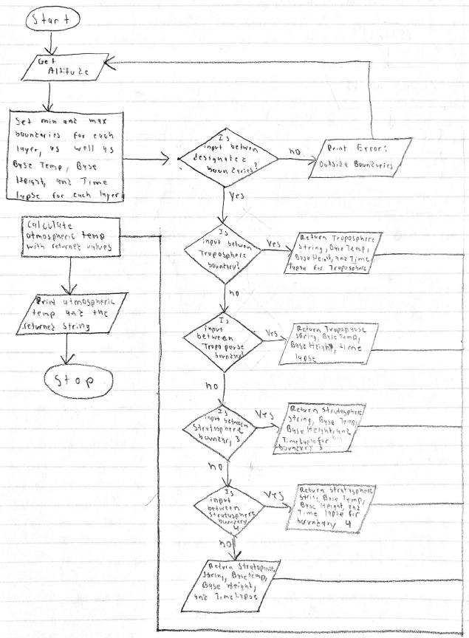

**Test Cases**

Fill out the table with test case information.

* The *Test Case Description* is an English description what is being tested.
* The *Input Argument* is a numerical value.
* The *Flowchart Output* is an English description of the flowchart; it should not be code or numbers.
* Add as many rows as necessary to test all possible flowchart paths.
* An example test case is included.

|  |  |  |
| --- | --- | --- |
| **Test Case Description**  **in English** | **Input Argument**  **(altitude (km))** | **Flowchart Output**  **in English** |
| Test when altitude is valid and in the troposphere  0 ≤ h < 11 | h = 10 | Calculated Temperature  Atmospheric layer: troposphere |
| Test when altitude is valid and in the tropopause  11 ≤ h < 20 | h = 19 | Calculated Temperature  Atmospheric layer: tropopause |
| Test when altitude is valid and in the stratosphere boundary 3  20 ≤ h < 32 | h = 30 | Calculated Temperature  Atmospheric layer: stratosphere boundary 3 |
| Test when altitude is valid and in the stratosphere boundary 4  32 ≤ h < 47 | h = 34 | Calculated Temperature  Atmospheric layer: stratosphere boundary 4 |
| Test when altitude is valid and in the stratopause  47 ≤ h < 51 | h = 50 | Calculated Temperature  Atmospheric layer: stratopause |
| Test when altitude is invalid if h is below the minimum boundary  h < 0 | h = -1 | Outside Boundaries |
| Test when altitude is invalid if h is above the maximum boundary  h > 51 | h = 52 | Outside Boundaries |

# Contact Lens Decision

Individual Programming

**(2.a) Flowchart**

