🔐Encrypted EC2 Backup Automation & Disaster Recovery System (AWS)
-mini project documentation
- Introduction:
This project demonstrates Building of an automated encrypted backup and disaster recovery system using AWS Lambda, EBS, KMS, and Event-Bridge. Implemented daily encrypted snapshots, retention policy cleanup, least-privilege IAM roles, and recovery testing to ensure secure data protection and compliance-ready architecture SECURELY.

- Waterfall SDLC MODEL:
    - The Software Development Life Cycle {SDLC} followed for this project is with automation monitoring cloud operations similar to DevOps practices.

1. Requirement Analysis - Identified risks:
• Data loss
• Unencrypted backups
• Manual errors
• No alerting

2. System Design -
EC2 → EBS → Lambda → KMS → Encrypted Snapshot
Event Bridge → Automation
CloudWatch → Monitoring
SNS → Email Alerts
Recovery EC2 → Restore volume
3. Implementation -
✅ EC2 instances
✅ Lambda snapshot automation
✅ KMS encryption
✅ Event Bridge scheduling
✅ CloudWatch alarms
✅ SNS notifications
✅ Volume restore & mount
4. Testing -
✔ Lambda execution success
✔ Encrypted snapshot creation
✔ Alarm trigger behaviour
✔ Restore volume mounting
✔ Data visibility in /recovery
5. Deployment –
System went live with:
• Daily automated encrypted backups
• Active monitoring
• Email alerts enabled

6. Maintenance & Optimization –
✔ Resource cleanup
✔ Cost control
✔ Error monitoring
✔ Backup verification

- Architecture overview:
- This project implements an automated, encrypted EC2 backup and disaster recovery system on AWS.
The architecture uses AWS Lambda to automatically create EBS snapshots, encrypt them using AWS KMS, and monitor the backup process using Amazon CloudWatch.
Amazon SNS is integrated to send email notifications in case of failures or alerts.
In a disaster scenario, encrypted snapshots can be used to restore EBS volumes and recover EC2 instances, ensuring data durability and business continuity.

- Architecture Flow:

EC2 Instance
↓
EBS Volume (Source Data)
↓
Event-Bridge (Daily Schedule)
↓
Lambda Function
├─ Create Snapshot
├─ Encrypt with KMS
└─ Store Secure Snapshot
↓
CloudWatch Monitors Lambda Errors
↓
SNS Sends Email Alert on Failure

Disaster Scenario:
Encrypted Snapshot → New EBS Volume → Mounted on Recovery EC2

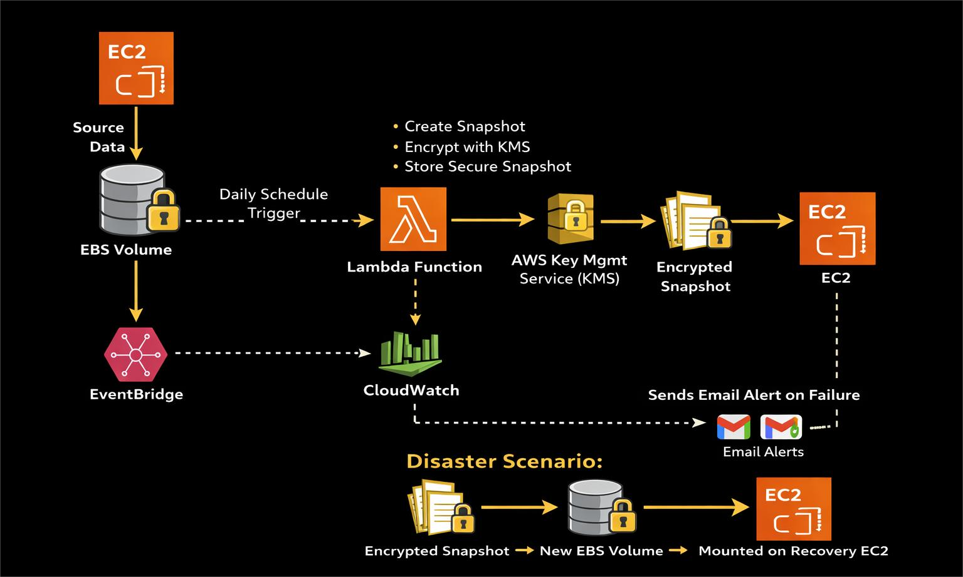
- Implementation:
• KMS CMK for encryption
• IAM least-privilege policies
• Snapshot Lock to prevent deletion
• Read-only recovery mount

- CODING:
{Python}
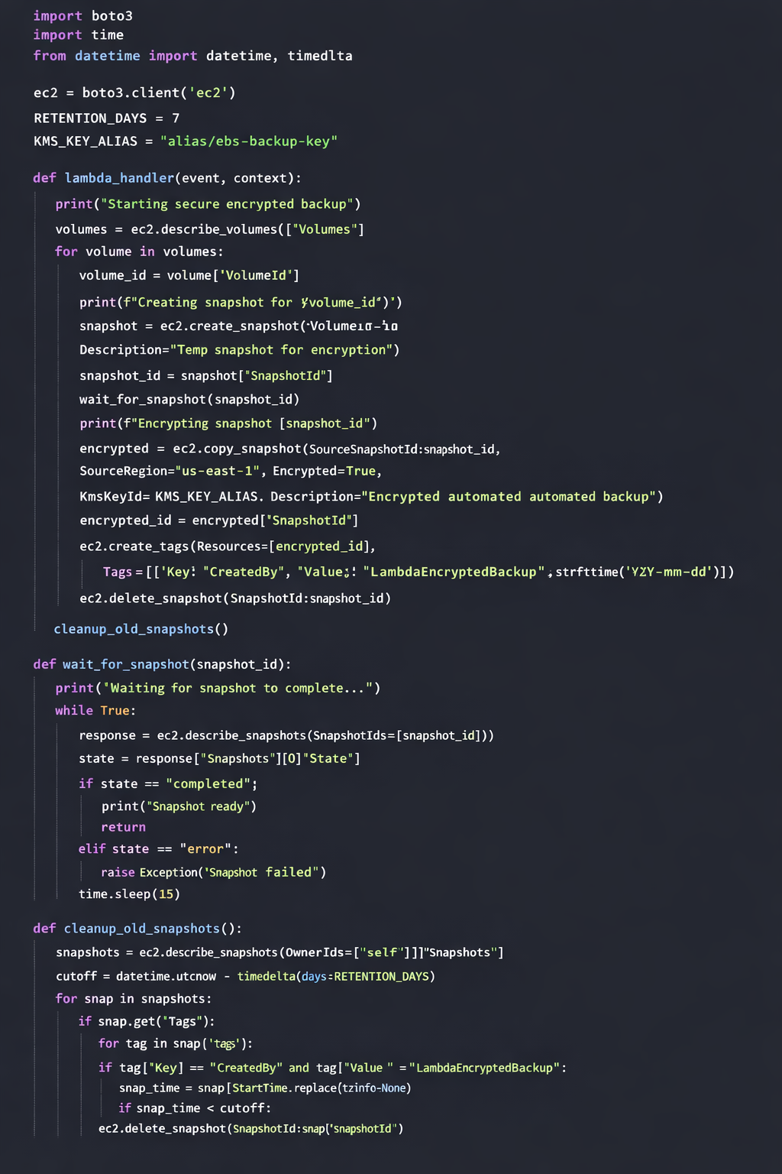
7.Testing:
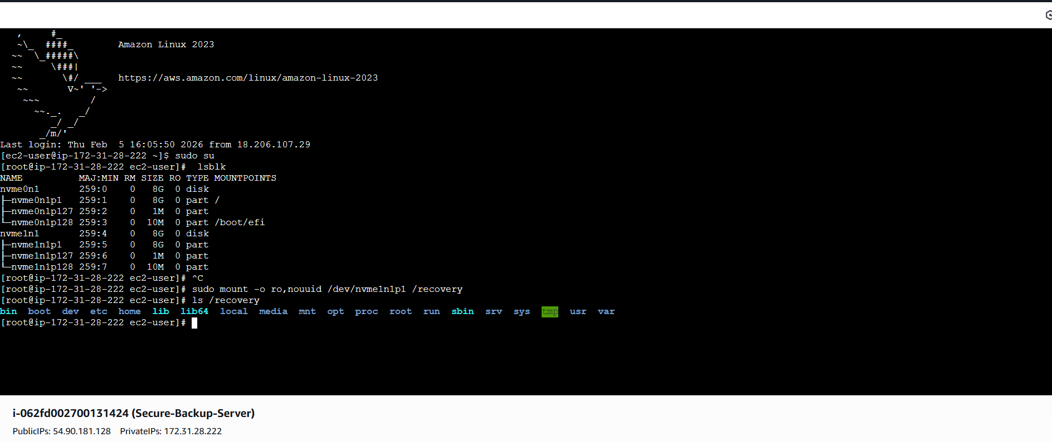
8.Security:
- SNS: Amazon Simple Notification Service
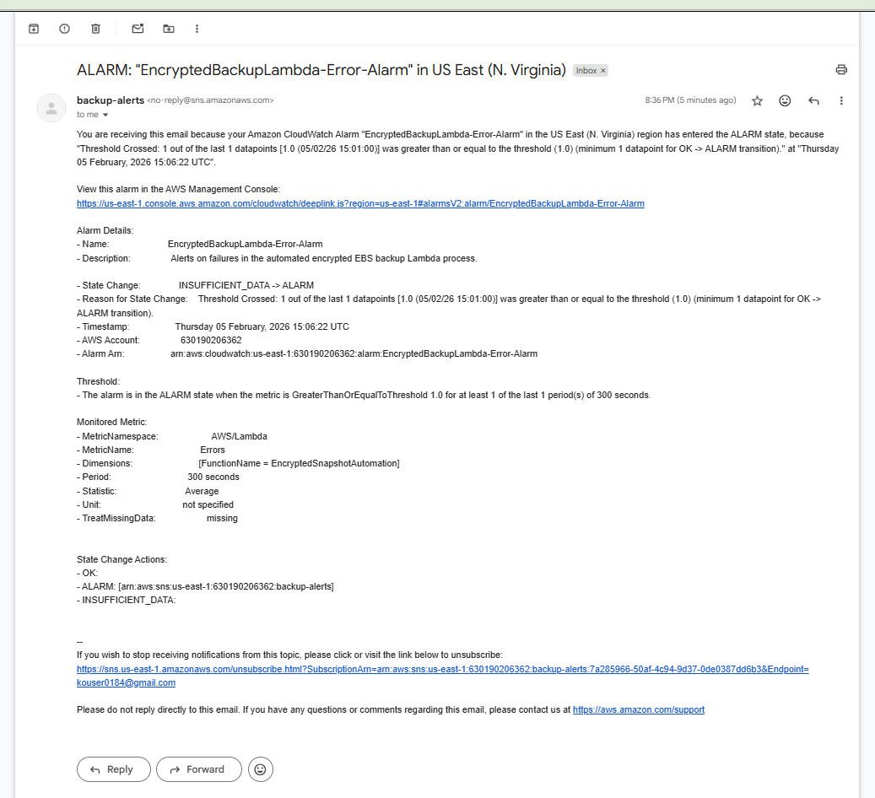
9. CONCLUSION:
“The encrypted EBS snapshot was successfully restored into a new volume and mounted on a recovery EC2 instance in read-only mode. The complete Linux filesystem was recovered, validating the automated encrypted backup and disaster recovery pipeline.”
🔒 Security
⚡ Automation
📦 Backup
🚨 Monitoring
🔁 Recovery

