**Embroidery Job Work Management Program**

Group number : 22

By : 21CEH007

: 21CEH012

: 21CEH031

**Objective :**

* Online data entry of Embroidery service company.
* Maintenance of work and purchase records.

**Introduction :**

Embroidery Job Work Management Program can be used by Embroidery Industries to maintain the records of statistical report of company. Achieving this objective is difficult using a manual system as the information is scattered, can be redundant and collecting relevant information may be very time consuming. All these problems are solved using this project.

**Flowchart :**

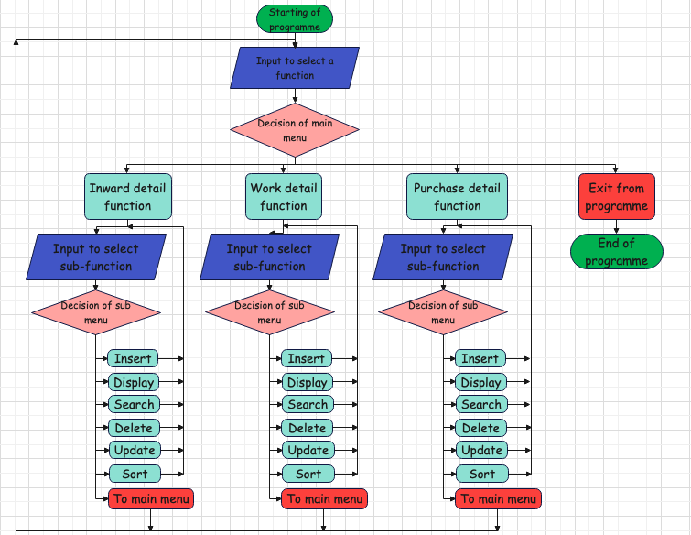

**Work done by me in my group :**

* Search functionality
* Delete functionality

**Pseudocode of functions :**

For search function :

Open the file

Take input (chalan number)

Compare input with file data

If matches then show that data

Else print no record found

Close the file

For delete function :

Open the file

Make new file

Show previous store data

Take input (chalan number)

While there is data in file

Compare the data with input

If data does not matches then copy it to new file

Else do nothing

Close both file

Remove old file

Rename new file to old name

**Code :**

For search and delete of inward :

void search_record_inward()

{

int ch_no, flag = 0;

FILE *fp;

fp = fopen("inward.txt", "rb");

if (fp == NULL)

{

printf("\n\t\tError : Cannot Open The File !!!");

return;

}

printf("\n\nEnter Inward Chalan Number Which You Want to Search : ");

scanf("%d", &ch_no);

while (fread(&a, sizeof(a), 1, fp) > 0 && flag == 0)

{

if (a.inwars_chalan_no == ch_no)

{

flag = 1;

printf("\n\nSearch Sucessfull And Record is as follow : \n");

printf("\n Date Inward Chalan No Party's Name Design No Pcs Rate\n\n");

printf("%12s%15d%15s%15s%12d%12d\n", a.in_date, a.inwars_chalan_no, a.in_party_name, a.in_design_no, a.in_pcs, a.in_rate);

}

}

if (flag == 0)

{

printf("\n\n\tNo Such Record Found !!!\n");

}

fclose(fp);

}

void del_record_inward()

{

int chalan_no;

unsigned flag = 0;

FILE *fp, *ft;

fp = fopen("inward.txt", "rb");

ft = fopen("inward1.txt", "ab+");

if (fp == NULL)

{

printf("\n\t\tError : Cannot Open The File !!!");

return;

}

printf("\n---- Previous Store data ----");

display_record_inward();

printf("\n\nEnter Inward Chalan Number Which You Want to Delete : ");

scanf("%d", &chalan_no);

while (fread(&a, sizeof(a), 1, fp) == 1)

{

if (a.inwars_chalan_no != chalan_no)

{

fwrite(&a, sizeof(a), 1, ft);

}

else

{

flag = 1;

}

}

printf("\nRecord Deleted Sucessfully \n");

if (flag == 0)

{

printf("\n\n\t\tNo such Record Found !!!");

}

fclose(fp);

fclose(ft);

remove("inward.txt");

rename("inward1.txt", "inward.txt");

printf("\n\t Update Record !!\n");

display_record_inward();

}

For search and delete of work :

void search_record_work()

{

int ro,flag=0;

FILE *fp;

fp=fopen("work.txt","rb");

if (fp==NULL)

{

printf("\n\t\tError : Cannot Open The File !!!");

return;

}

printf("\n\nEnter Chalan Number Which You Want to Search : ");

scanf("%d",&ro);

while (fread(&s,sizeof(s),1,fp)>0 && flag==0)

{

if(s.work_chalan_no==ro)

{

flag=1;

printf("\n\nSearch Sucessfull And Record is as follow : \n");

printf("\nDate\t\tChalan_no\tParty \t\tDesign\tInward\tPcs\tRate\tAmount\n\n");

printf("%d/%d/%d\t%d\t\t%-12s\t%-8s%d\t%-8d%-8d%d\n",s.d,s.m,s.y,s.work_chalan_no,s.work_party_name,s.work_design_no,s.work_inward_chalan_no,s.work_pcs,s.work_rate,s.work_amount);

}

}

if (flag==0)

{

printf("\n\n\tNo Such Record Found !!!\n");

}

fclose(fp);

}

void del_record_work()

{

int cache;

unsigned flag=0;

FILE *fp,*ft;

fp=fopen("work.txt","rb");

ft=fopen("work1.txt","ab+");

if (fp==NULL)

{

printf("\n\t\tError : Cannot Open The File !!!");

return;

}

printf("\n---- Previous Store data ----");

display_record_work();

printf("\n\nEnter Chalan Number Which You Want to Delete : ");

scanf("%d",&cache);

while (fread(&s,sizeof(s),1,fp)==1)

{

if (s.work_chalan_no!=cache)

{

fwrite(&s,sizeof(s),1,ft);

}

else

{

flag=1;

printf("\nRecord Deleted Sucessfully \n");

}

}

if (flag==0)

{

printf("\n\n\t\tNo such Record Found !!!");

}

fclose(fp);

fclose(ft);

remove("work.txt");

rename("work1.txt","work.txt");

printf("\n\t Update Record !!\n");

display_record_work();

}

For search and delete of purchase :

void search_record_Purch()

{

int ch_no, flag = 0;

FILE *fp;

fp = fopen("Purch.txt", "rb");

if (fp == NULL)

{

printf("\n\t\tError : Cannot Open The File !!!");

return;

}

printf("\n\nEnter Purchase Chalan Number Which You Want to Search : ");

scanf("%d", &ch_no);

while (fread(&c, sizeof(c), 1, fp) > 0 && flag == 0)

{

if (c.Purch_chalan_no == ch_no)

{

flag = 1;

printf("\n\nSearch Sucessful And Record is as follow : \n");

printf("\n\tDate\tChalan No Supplier Box No \tPcs Rate Amt\n\n");

printf("%12s%12d%12s%12d%11d%12d%8d\n", c.Purch_date, c.Purch_chalan_no, c.Purch_Supplier_name, c.Box_no, c.Purch_pcs, c.Purch_rate,c.Purch_pcs*c.Purch_rate);

}

}

if (flag == 0)

{

printf("\n\n\tNo Such Record Found !!!\n");

}

fclose(fp);

}

void del_record_Purch()

{

int chalan_no;

unsigned flag = 0;

FILE *fp, *ft;

fp = fopen("Purch.txt", "rb");

ft = fopen("Purch1.txt", "ab+");

if (fp == NULL)

{

printf("\n\t\tError : Cannot Open The File !!!");

return;

}

printf("\n---- Previous Store data ----");

display_record_Purch();

printf("\n\nEnter Purchase Chalan Number Which You Want to Delete : ");

scanf("%d", &chalan_no);

while (fread(&c,sizeof(c), 1, fp) == 1)

{

if (c.Purch_chalan_no != chalan_no)

{

fwrite(&c,sizeof(c), 1, ft);

}

else

{

flag = 1;

printf("\nRecord Deleted Sucessfully \n");

}

}

if (flag == 0)

{

printf("\n\n\t\tNo such Record Found !!!");

}

fclose(fp);

fclose(ft);

remove("Purch.txt");

rename("Purch1.txt", "Purch.txt");

printf("\n\t Record is updated!!\n");

display_record_Purch();

}

**Input :**

Both the function is working by chalan number so for both the function there is only one input.

**Output :**

Search functionality in Inward detail :

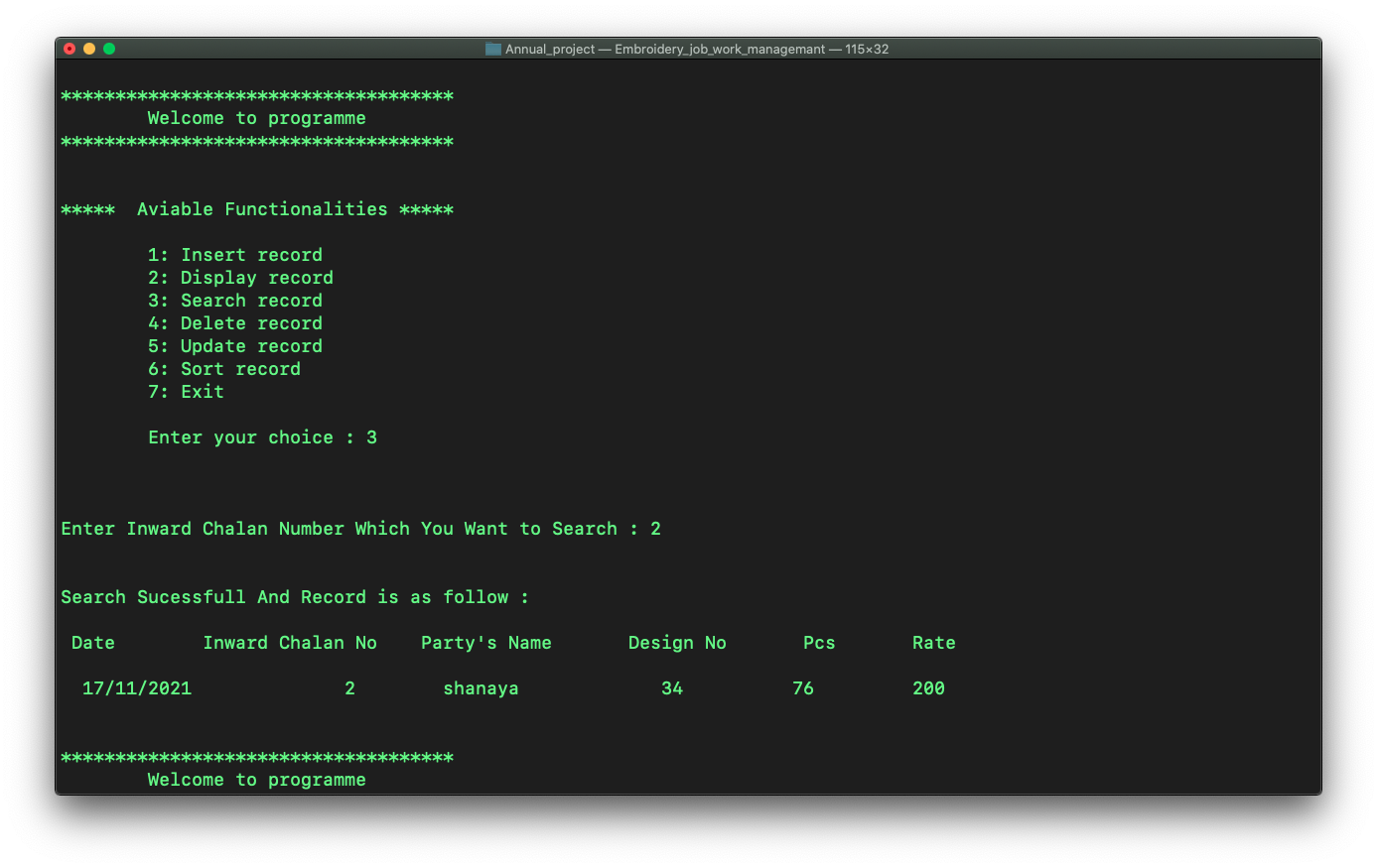

Delete functionality in Inward detail :

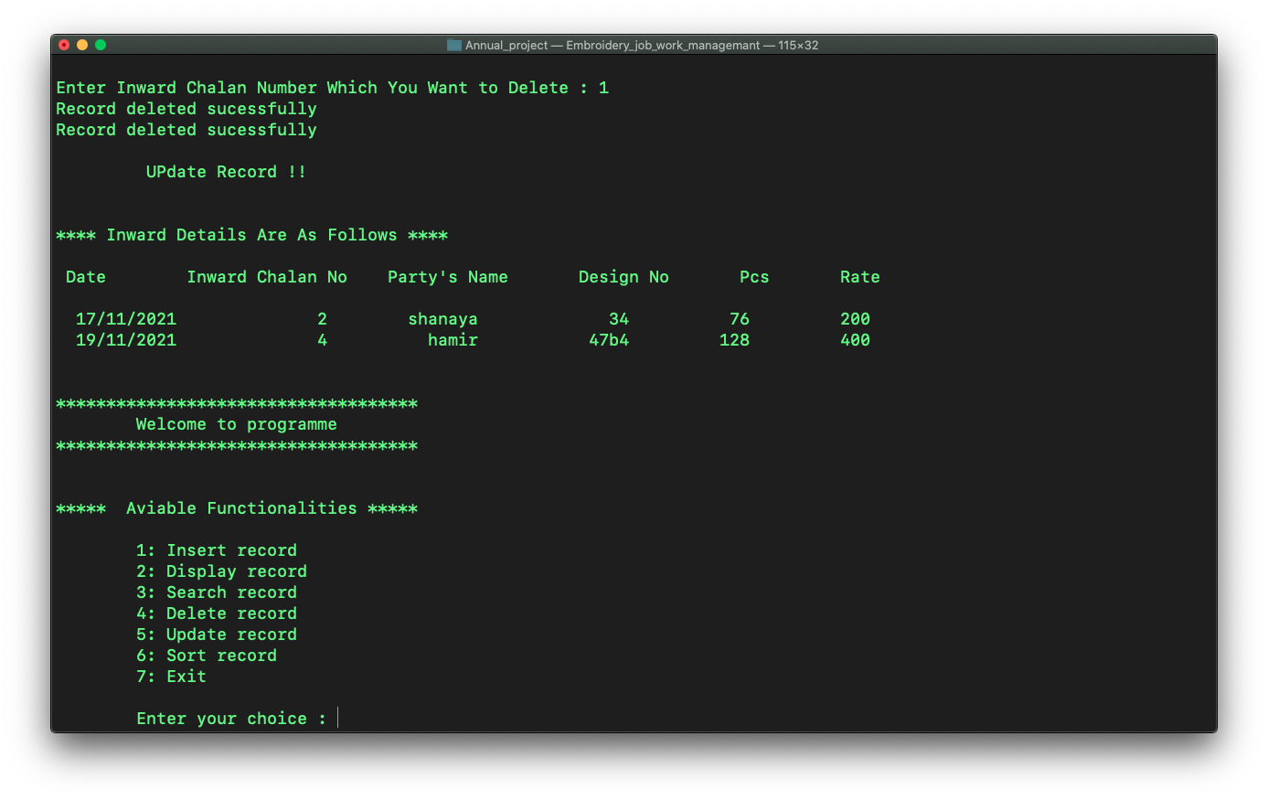

Search functionality in Workdetail :

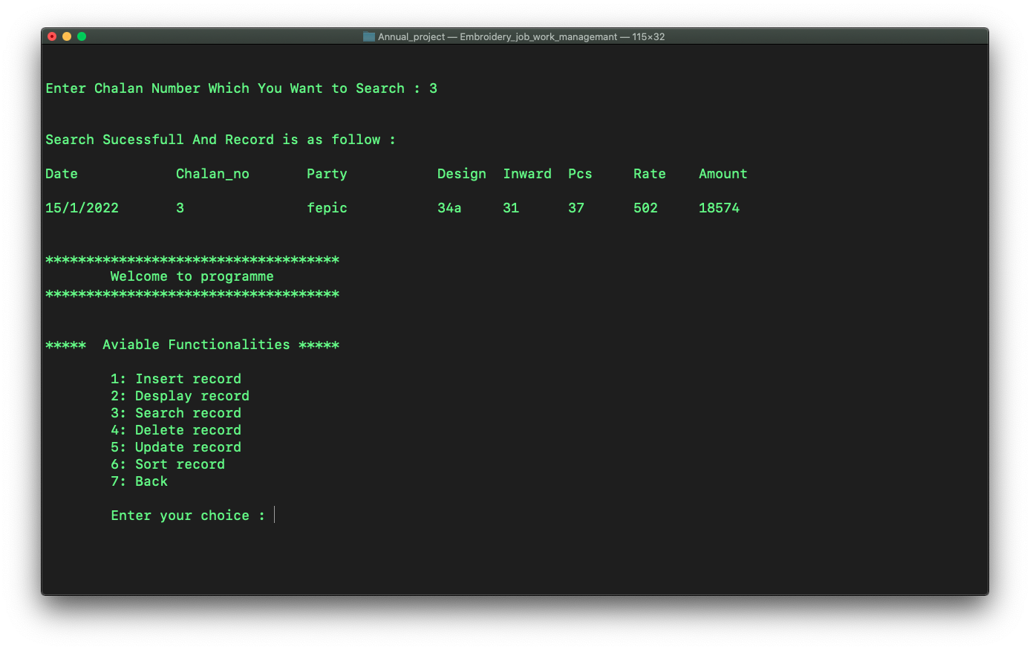

Delete functionality in Workdetail :

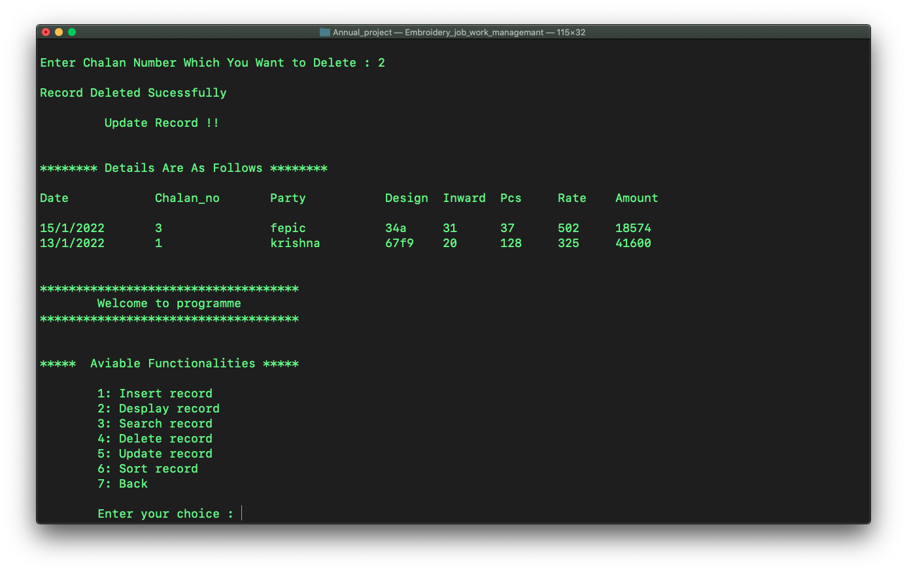

Search functionality in Purchasedetail :

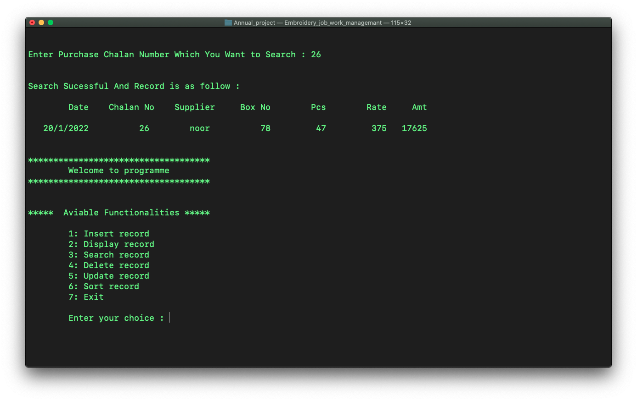

Delete functionality in Purchasedetail :

