Design and Implementation for Fancy-Whiteboard
Group 5
Version 5
21/12/2025

Woo Ryan 1155214118
Law Sau Ho 1155213041
Hung Tak Yeung 1155212400
Lau Tsan Long 1155203352
Hung Kwan Po 1155211743

Disclaimer: This document incorporated human writings and AI generated tools. Some writings are generated with AI tools. ALL code snippets and diagrams are derived from generative AI tools.

1. Introduction
People deal with hybrid learning and remote work these days. They need solid tools to handle visual brainstorming, note taking, and keeping schedules in order. Old fashioned whiteboards have that big drawback of needing everyone in the same room. Plenty of digital options fall short too. They miss out on built-in scheduling or demand a steady internet link all the time.
Users look for an app that feels reliable and simple to pick up. The thing works fine even offline. It saves data right on the device so nothing gets lost. Drawing and adding text comes across as straightforward and natural. Scheduling ties right into the visual area without any hassle. Real time teamwork happens smoothly whenever the connection kicks in. Privacy stays protected along with data security. That comes through solid authentication steps.

- Project Scope:
  - Stage 1: Offline functionality, including:
    - Drawing tools: Freehand drawing with pen, and eraser functionality
    - Text input: Type text directly onto the whiteboard
    - Save/load: Persist whiteboard content locally to allow users to save their work and reload it in future sessions
    - Local user authentication: User registration system with secure credential storage

  - Stage 2: Real-time collaboration for up to 10 users, with a server-client architecture and synchronization features.
    - Multi-User Collaboration: Support for up to 10 concurrent users working on the same whiteboard
    - Live Updates: Real-time synchronization of drawing actions, text inputs, and canvas modifications
    - Conflict Resolution: Mechanisms to handle simultaneous edits by multiple users

2. System Overview
Fancy-Whiteboard provides a space for multiple users to draw and collaborate with each other online. This system will be developed in 2 separate stages.
In the first stage, Fancy-Whiteboard will support only a single user to access the whiteboard project. Features such as draw, type, erase and save will be featured in this software. The user is allowed to make changes and save in the calendar feature.

Stage 1: Standalone Application
- Whiteboard Canvas: HTML5 Canvas-based drawing surface supporting freehand drawing, text insertion
- Drawing Tools: Pen tool, eraser, and selection tools
- Text Editor: Direct text input on canvas with customizable fonts and sizes
- Persistence Layer: Local SQLite database storing whiteboard states, user credentials, and schedule data
- User Authentication: Secure account creation, login, and logout with password hashing
- Calendar Interface: Full-featured scheduling system with CRUD operations for calendar events
- Data Management: Import/export functionality for whiteboard backups
In the second stage of development, Fancy-Whiteboard will support up to 10 users to work on the same whiteboard at the same time. Also adding more features such as notification systems.
Stage 2: Collaborative Extension
- Real-Time Synchronization: WebSocket-based bidirectional communication for instantaneous updates
- Conflict Resolution: Operational transformation or CRDT-based approach for concurrent edits
- Notification Engine: Push notifications for schedule reminders and collaboration events

The following diagrams show the structure of Fancy-Whiteboard.
Stage 1: Offline Architecture
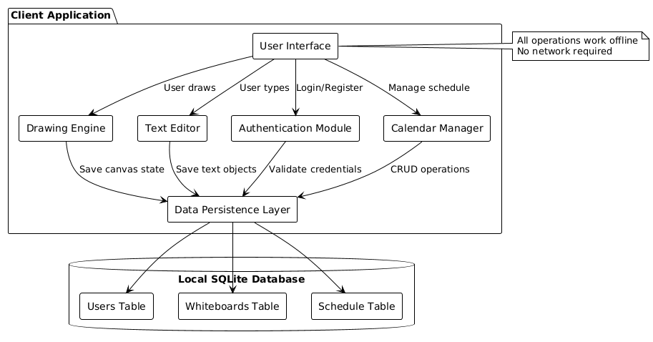

Stage 2: Real-Time
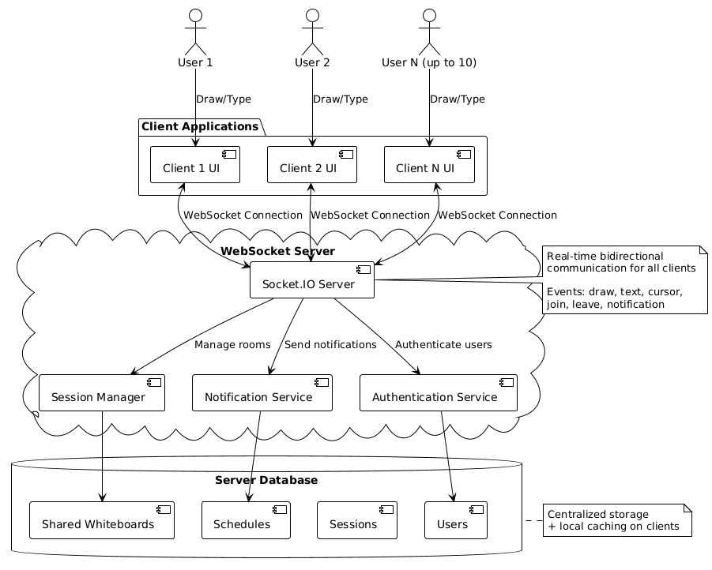

Component Interaction Diagram:
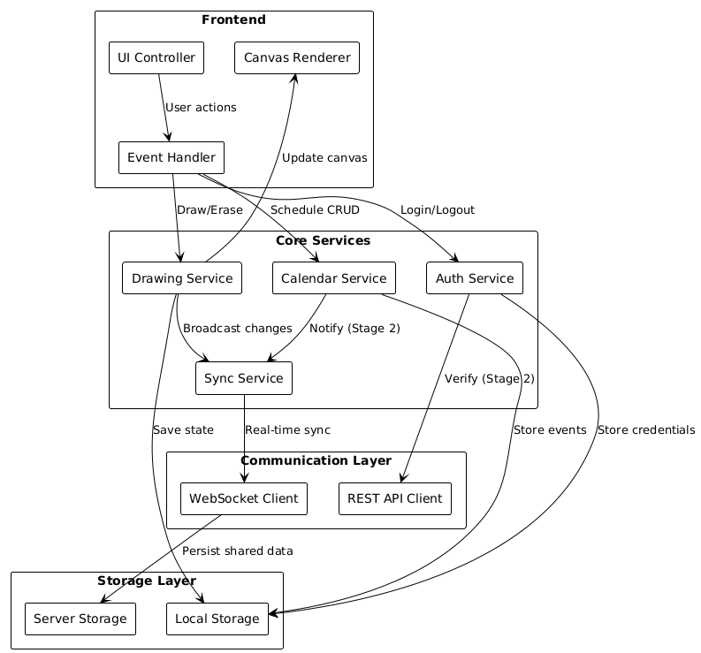

Data Model Diagram:
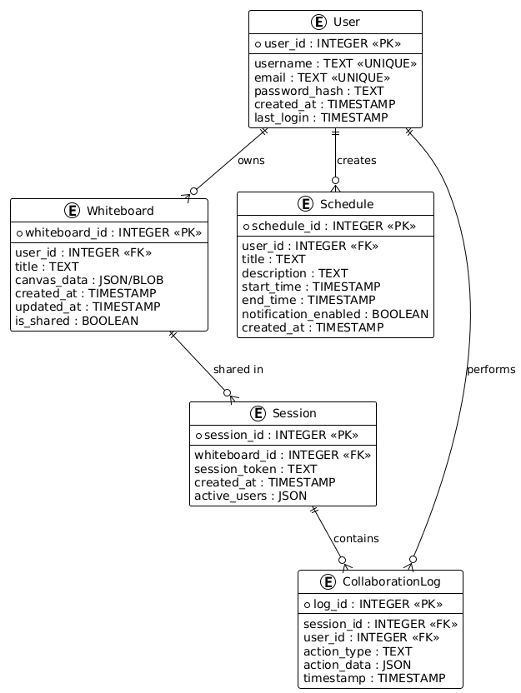

3. Architectural Design
Stage 1 Architecture
Components:
- Canvas Interface: HTML5 Canvas element for drawing and rendering
- Drawing Toolbar: Tool selection buttons (pen, eraser, text)
- Calendar View: Monthly/weekly calendar grid with schedule entries
- Authentication Forms: Login, registration, and logout interfaces
- Whiteboard Management: File browser for saved whiteboards (create, open, delete)

Technologies: HTML5, CSS3, JavaScript (vanilla or lightweight framework) and file management (save/load).
Storage Layer: Manages local storage for saving whiteboards as JSON files.

- Database Manager:
  - Executes SQL queries for users, whiteboards, and schedules
  - Manages database connections
  - Provides data access methods for upper layers
- Data Serialization:
  - Converts canvas state objects to JSON for storage
  - Deserializes JSON back to canvas objects on load
Technologies: SQLite (or browser IndexedDB as alternative), JSON for data format

Component diagram
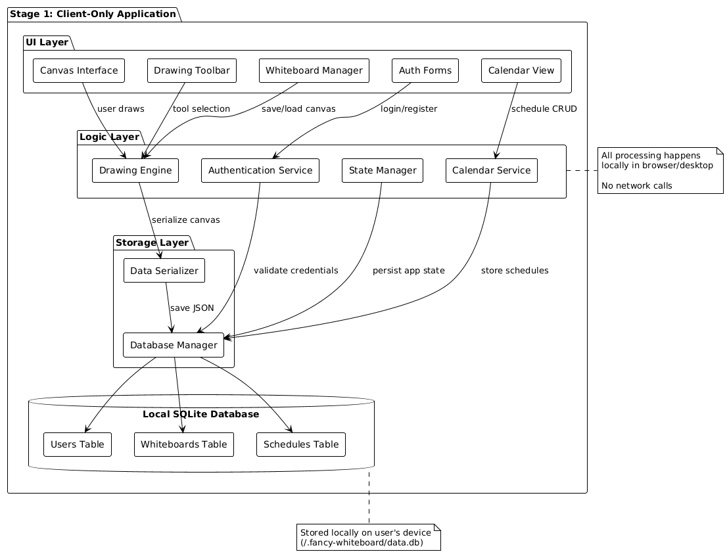
Data flow diagram
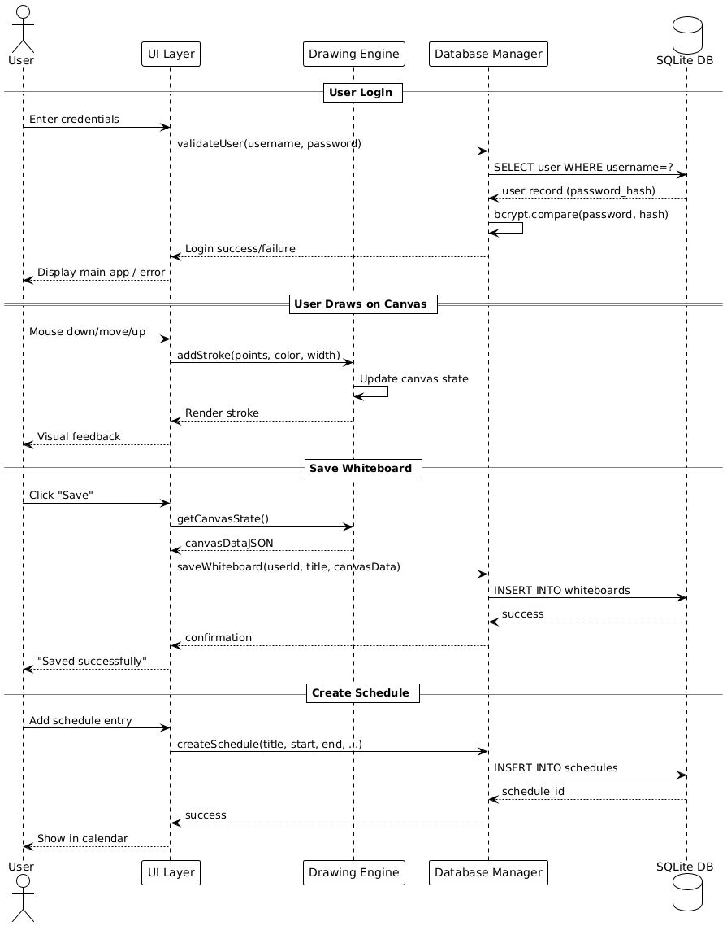

Stage 2 Architecture
Stage 2 introduces a server-client model for real-time collaboration.
  - Components:
    - Client: Handles the user interface and sends/receives updates to/from the server.
    - Server: Manages sessions and broadcasts updates to all clients.
  - Communication:
    - Use WebSocket for real-time, bidirectional communication.
    - JSON format for messages (e.g., user actions like "draw", "erase").

Client-Server Architecture
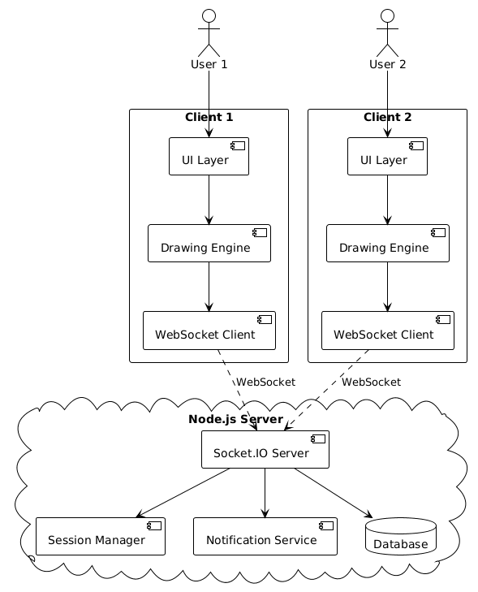
Real-time synchronization flow
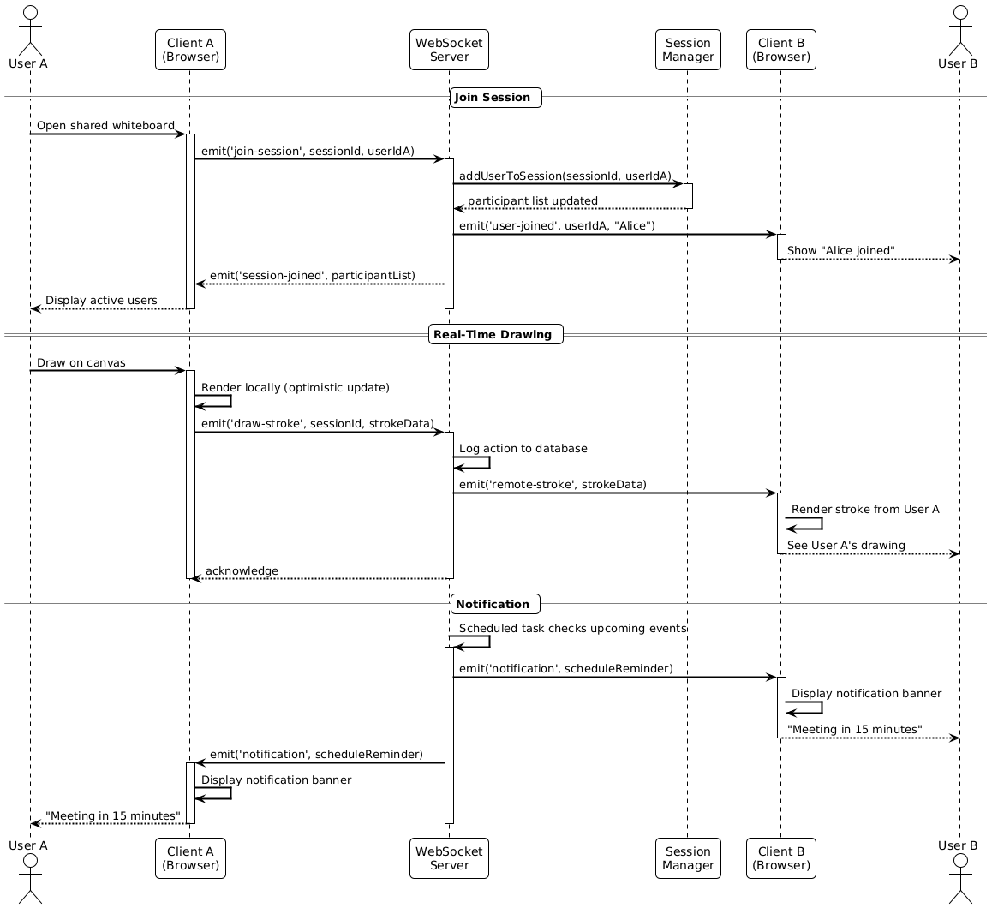

4. Detailed Design

Stage 1 Design
- Drawing Tools:
    - selectTool(toolType): Switches between pen, eraser, text, shapes
    - setColor(hexColor): Updates active drawing color
    - setStrokeWidth(width): Adjusts pen/brush thickness
    - handleMouseEvents(): Processes mouse down/move/up for drawing
Here is a diagram for the drawing process:
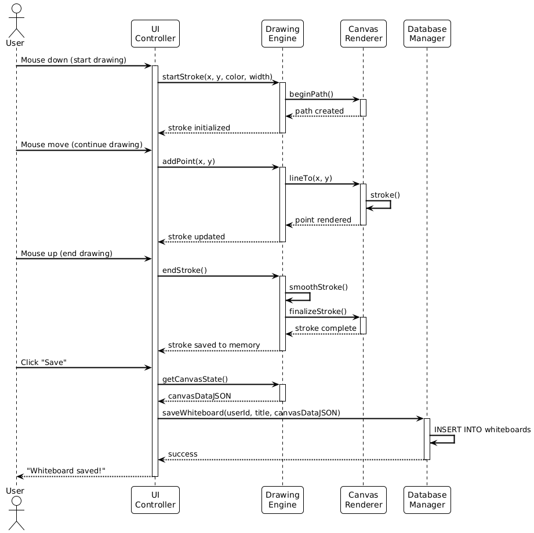

Here is a diagram for saving/loading operations:
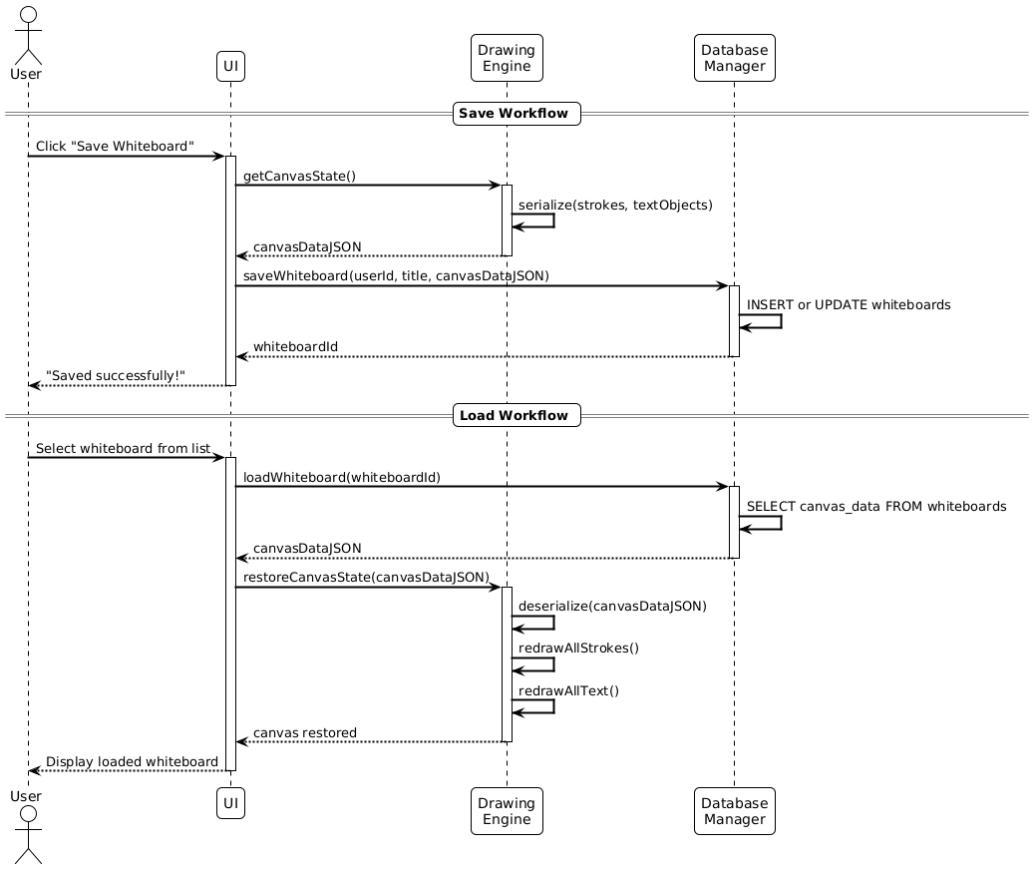
- User Authentication:
All the users’information is stored in SQLite. All usernames must be unique. If the user typed the correct information and matched with the database. A token will be granted to the user software to access the system by authentication service.
showLoginForm(): will displays the authentication interface for the system
showRegistrationForm(): will appear if the user is new to our system
handleLogout(): will be used to log out from the current user and returned to the log in page

  - 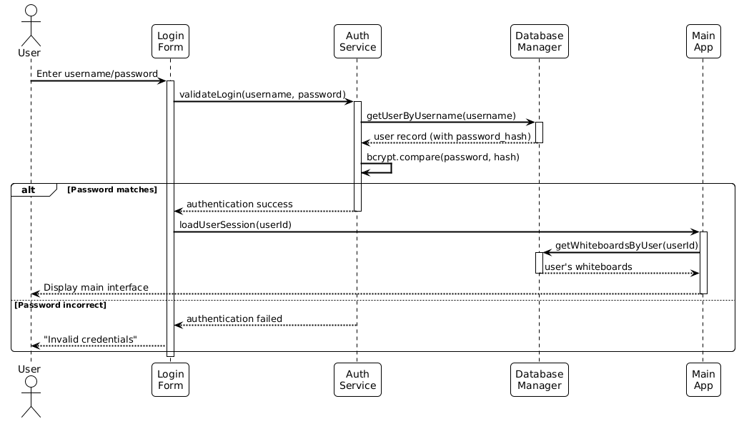

Stage 2 Design
- Real-Time Collaboration:
The system will notify each participant in the whiteboard when a new user joined/left the meeting board. When a user draws on the whiteboard, WebSocket sends the drawing action to the server as JSON messages. This allows real time changes to each user.
Here is the code snippet.
// Server-side event handlers
io.on('connection', (socket) => {
// User joins whiteboard session
socket.on('join-session', (sessionId, userId) => {
socket.join(sessionId);
notifySessionParticipants(sessionId, 'user-joined', userId);
});
// User draws on canvas
socket.on('draw-stroke', (sessionId, strokeData) => {
// Broadcast to all users in session except sender
socket.to(sessionId).emit('remote-stroke', strokeData);
saveCollaborationLog(sessionId, 'draw', strokeData);
});
// User adds text
socket.on('add-text', (sessionId, textData) => {
socket.to(sessionId).emit('remote-text', textData);
saveCollaborationLog(sessionId, 'text', textData);
});
// User leaves session
socket.on('disconnect', () => {
notifySessionParticipants(sessionId, 'user-left', userId);
});
});
- Server Design:
Each whiteboard has an unique ID that corresponds to it, with creation time and last activity stored. The server also record the username of the user and assign them unique socket ID for real time collaboration
Data Structure:
// Active sessions map
{
"session_uuid": {
whiteboardId: "whiteboard_uuid",
participants: [
{userId: "user1_uuid", socketId: "socket_id1"},
{userId: "user2_uuid", socketId: "socket_id2"}
],
createdAt: timestamp,
lastActivity: timestamp
}
}
Notification Service
Responsibility: Sends schedule reminders and collaboration alerts
class NotificationService {
// Schedule reminder checker (runs every minute)
checkUpcomingSchedules() {
const upcomingEvents = getSchedulesInNextHour();
upcomingEvents.forEach(event => {
if (shouldNotify(event)) {
sendNotification(event.user_id, {
type: 'schedule_reminder',
title: event.title,
time: event.start_time
});
}
});
}
// Collaboration notifications
notifyUserJoined(sessionId, userId) {
broadcastToSession(sessionId, 'notification', {
type: 'user_joined',
userId: userId,
message: `${getUserName(userId)} joined the whiteboard`
});
}
}
- Multi-User Management:
If multiple users draw on the spot at the same time, the latest drawing will be covered on top of the previous layer.
Collaborative drawing Sequence:
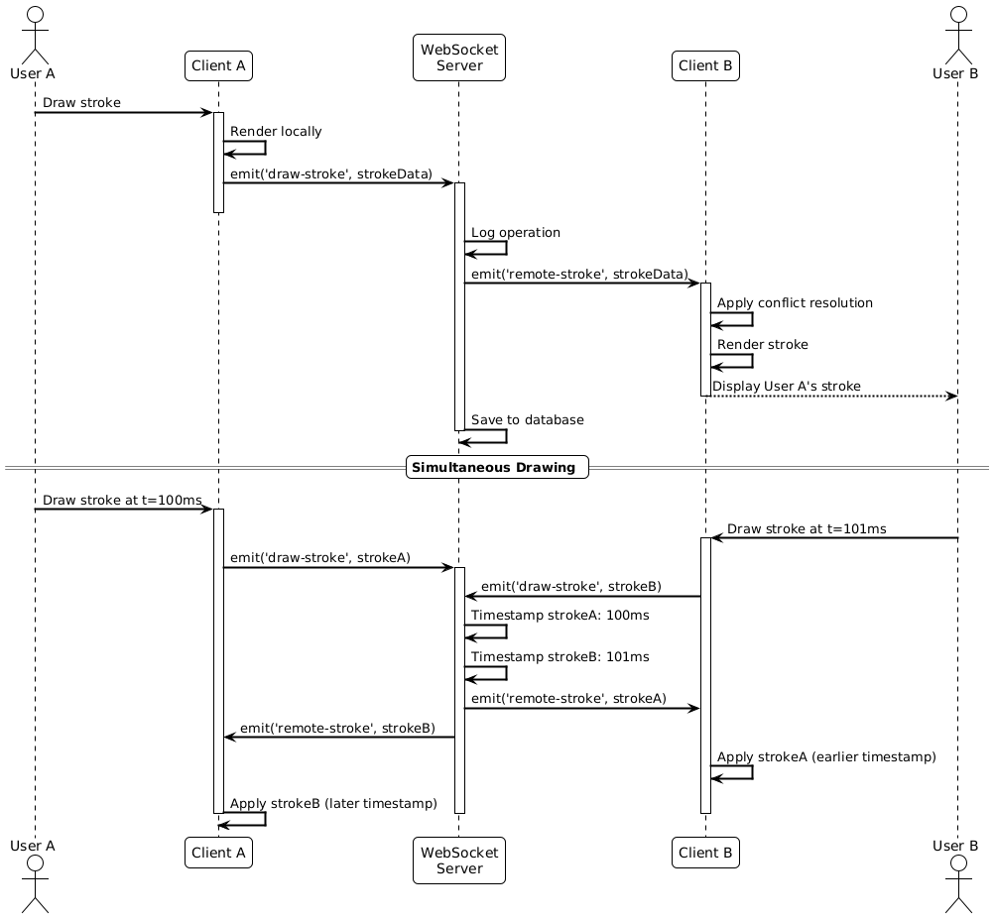
Schedule Reminder Flow 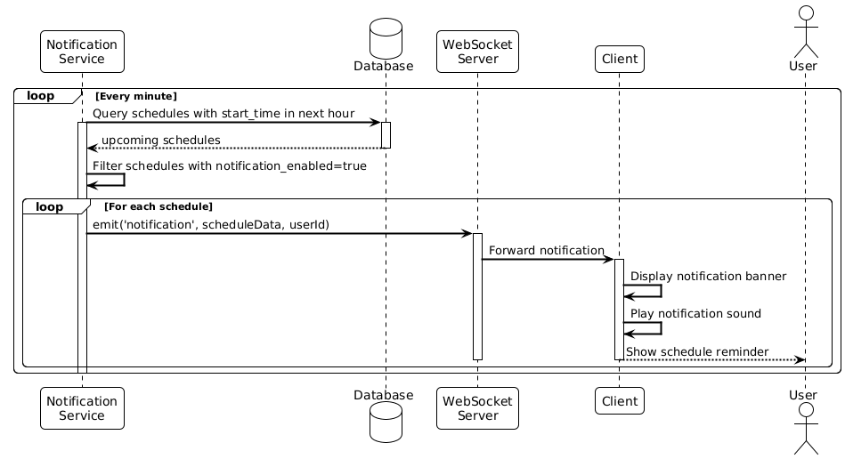

5.Implementation Details

Technologies Used:
HTML5
- Version: HTML5 (Latest Standard)
Key Features:
  - <canvas> element for drawing surface
  - Semantic elements (<header>, <main>, <section>)
  - Form elements for authentication and calendar inputs
CSS3
- Purpose: Styling and responsive design

Key Features:
- Flexbox and Grid for layouts
- CSS Variables for theming
- Media queries for responsive design
- Animations for UI feedback
JavaScript (ES6+)
- Version: ECMAScript 2015+
Key Features:
  - Classes and modules for code organization
  - Arrow functions and destructuring
  - Promises and async/await for asynchronous operations
  - Canvas API for drawing operations
Libraries:
- bcrypt.js - Password hashing (Stage 1)
- Socket.IO Client - WebSocket client library (Stage 2)
- Date-fns (optional) - Date/time manipulation for calendar
- Backend:
  - Stage 1: SQLite for local storage.
  - Stage 2: Node.js for the server, with WebSocket for real-time communication.
Node.js
- Version: v16.x or higher

Express.js
- Version: v4.x
- Features: Routing, middleware, HTTP utilities
Socket.IO
- Version: v4.x
- Features: WebSocket with fallback, room management, auto-reconnection
Additional Server Libraries:
- bcrypt - Password hashing
- jsonwebtoken (JWT) - Token-based authentication
- dotenv - Environment variable management
- cors - Cross-Origin Resource Sharing
- Tools:
  - Visual Studio Code for development.
  - Git for version control.

Development to Production Flow (PlantUML):
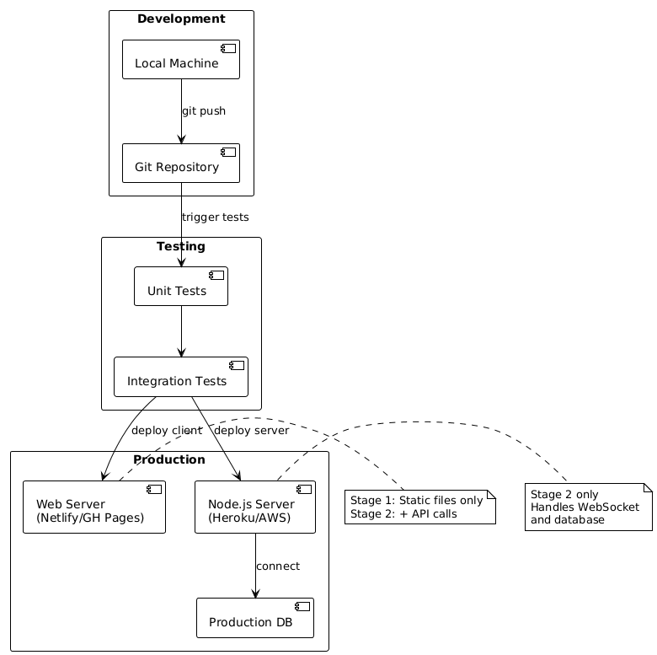
Simple System Architecture (PlantUML):
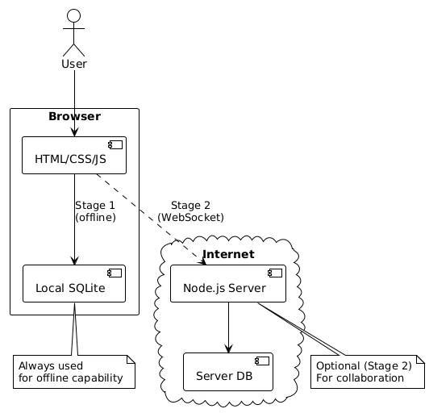

6. Testing Plan

Stage 1 Testing
- Functional Tests:
  - Verify drawing tools, text input, save/load functionality.
  - Verify security function
- Performance Tests:
  - Ensure smooth drawing with no lag.
- Error Handling:
  - Test invalid file loads or corrupted data.

Stage 2 Testing
- Functional Tests:
  - Verify real-time synchronization between multiple users.
- Performance Tests:
  - Measure latency and ensure it remains under 500ms.
