**Quizzy application**

**Flow diagram**

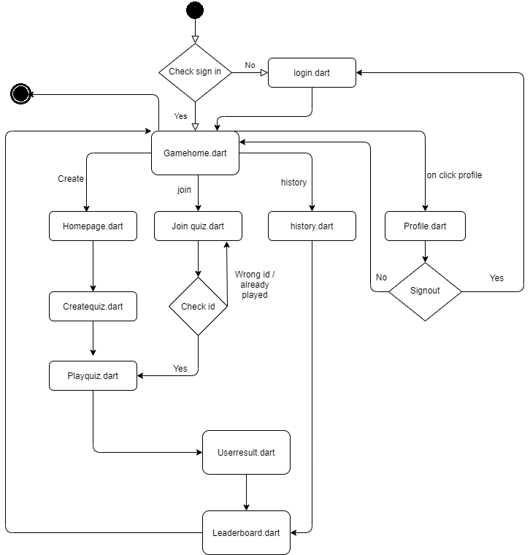

**Description of files:**

1. **Main.dart**: This is main file of project which contains all navigation paths and app loading details.
2. **Auth.dart :** This file contains all logic of authentication with g-mail and signout logic
3. **Login.dart**: This is starting page of app if user is opening game first time.
4. **Game_home**.**dart**: This is also home page of app if user is already signed in and opening game second time.
5. **Profile**.**dart**: In this page it will show current user profile so player can sign out from there or back to gamehome.
6. **Homepage**.**dart**: This is homepage of quiz when user click create quiz.where it will show all available quiz type.
7. **Createquiz**.**dart**: This file contain all methods of creating quiz time limit etc..
8. **Play_quiz**.**dart**: This is main logic of our app where all question and answer all load.
9. **User_result**.**dart**: At the end of quiz it will show result of particular user and he will able to check leaderboard.
10. **Leaderboard.dart:** It will show leaderboard of particular quiz.
11. **Joinquiz.dart**: When user is joining some quiz this file is invoke.
12. **History**.**dart**: This file show history of particular user which quiz played by him.

**Note:** There is one extra file(“generated_plugin_registrant.dart”) in folder which is used to authentication with firebase.