**Create RPackage**

**Steps:**

**In RStudio**

1. **New Package -> New Directory -> R Package**
2. **In consol:**

**install.packages(“devtools”) #for data**

**install.packages(“roxygen2”) #for NAMESPACE**

1. **Build ->Configure Build Tools**

**Choose Package and Generate documentation with Roxygen (choose all options)**

**Click “OK”**

1. **Optional (because normally not needed): Delete hello.R in folder /R and hello.Rd in folder /man**
2. **Create R-File with the coordinated preamble as follows:**

**#'**

**#'**

**#' @param <parameter> Description of parameter**

**#' @return Description of returned value(s)**

**#' @import packages, which should be installed**

**#'**

**#' @export**

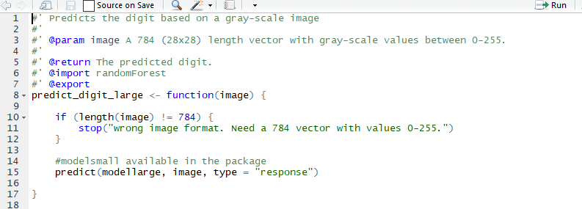

1. **Create DESCRIPTION as follows:**

**Package: MyPackageName**

**Type: Package**

**Title: What The Package Does (one line, title case required)**

**Version: 0.1.0**

**Author: YourName**

**Maintainer: YourName <e-mail address>**

**Description: What the package does (one paragraph)**

**License: What license is it under? (mostly GPL-3)**

**Encoding: UTF-8**

**LazyData: true**

**Depends: package (>= or <=version)**

**Suggests: package which is not needed but suggested**

**RoxygenNote: version**

