Client side (on your local machine)

1. Install R client on your laptop, available at:

<https://docs.microsoft.com/en-us/machine-learning-server/r-client/install-on-windows>

1. Use the MS R Open distribution instead of the open source version of R in RStudio:

Tools -> Global Options -> General -> R Version

Server side:

1. Mache Konto bei MS Azure (30 Tage und ~200 CHF gratis (4cores))
2. Template, to install a VM with R Server which is configured to operationalize is available at

<https://blogs.msdn.microsoft.com/mlserver/2017/05/14/configuring-r-server-to-operationalize-analytics-using-arm-templates/>

* One box configuration for windows
* Klick on deploy to azure button

Information to one-box and enterprise: (one-box for development only, enterprise for real production): To benefit from Machine Learning Server’s web service deployment and remote execution features, you must first configure the server after installation to act as a deployment server and host analytic web services

One-box configuration:

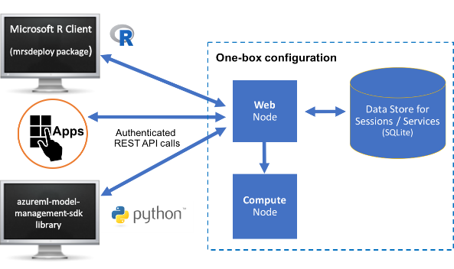

Enterprise configuration:

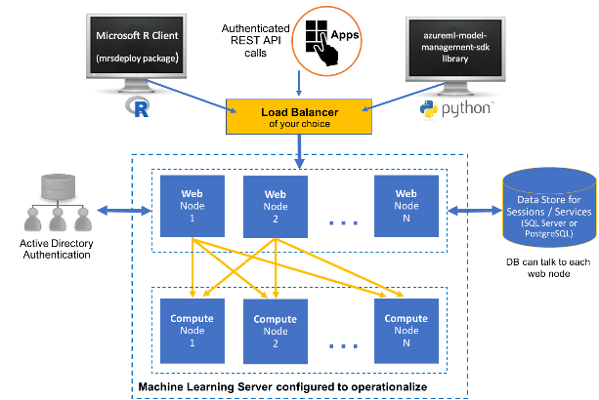

1. Fill out form appearing at azure portal
2. Check if you can connect to the Virtual machine (Verbinden-Button when you look at the VM in Azure portal):

**Important notice**: if you want to connect to your virtual machine , you need to make sure **not** to be connected to Zühlke-VPN, since otherwise this connection is blocked.

1. Deploy model as a service as described in <https://docs.microsoft.com/en-us/machine-learning-server/operationalize/quickstart-publish-r-web-service>
2. Shut down VM after usage (!!!): Go to overview (in azure dashboard) and klick on Beenden

<https://buildazure.com/2017/03/16/properly-shutdown-azure-vm-to-save-money/>

Be aware of the following: Since this causes Azure to release the server resources associated with the Virtual Machine, it not only releases the CPU and Memory resources but also the Dynamic IP Address allocation. Due to this, when you Start the VM back up again, the IP Address will likely change. If you require the IP Address to never change for your VM, then you’ll need to configure a Static IP Address for the VM.

Old

1. Install MS R Client on your local machine. A free version is available at Visual Studio Dev Essentials:

|  |  |  |
| --- | --- | --- |
| [Visual Studio Dev Essentials](http://go.microsoft.com/fwlink/?LinkId=717968&clcid=0x409) | Developer (free) | This option provides a zipped file, free when you sign up for Visual Studio Dev Essentials. Developer edition has the same features as Enterprise, except it is licensed for development scenarios.   1. Click **Join or Access Now** and enter your account information. 2. Make sure you're in the right place: my.visualstudio.com. 3. Click **Downloads**, and then search for Microsoft R.  Or after logging in go directly to my.visualstudio.com/downloads |

1. Install a Data Science Virtual Machine on Azure as described in

<https://docs.microsoft.com/en-us/sql/advanced-analytics/r/provision-the-r-server-only-sql-server-2016-enterprise-vm-on-azure>

<https://docs.microsoft.com/de-de/azure/machine-learning/data-science-virtual-machine/provision-vm>

<https://docs.microsoft.com/en-us/azure/virtual-machines/windows/quick-create-portal>

1. Configure R Server to operationalize analytics (one-box for development only, enterprise for real production): To benefit from Machine Learning Server’s web service deployment and remote execution features, you must first configure the server after installation to act as a deployment server and host analytic web services

<https://docs.microsoft.com/en-us/machine-learning-server/operationalize/configure-start-for-administrators#configure-server-for-operationalization>

One box configuration:

<https://docs.microsoft.com/en-us/machine-learning-server/operationalize/configure-machine-learning-server-one-box>

For your convenience, [Azure Resource Management (ARM) templates](https://docs.microsoft.com/en-us/azure/azure-resource-manager/resource-group-overview#template-deployment) are available to quickly deploy and configure the server for operationalization in Azure: <https://blogs.msdn.microsoft.com/mlserver/2017/05/14/configuring-r-server-to-operationalize-analytics-using-arm-templates/>