**OpenCPU**

**Local**

In R:

1. Create new R-package (e.g. “MyVeronicaP”) or use existing one
2. library(opencpu)
3. ocpu_start_app(“…”) (e.g. “MyVeronicaP”, which includes file “power.R” which includes function *square*) [this will run the whole time]

In POSTMAN:

1. POST
2. <http://localhost:5656/ocpu/library/MyVeronicaP/R/square> (eventually specify parameters through PARAMS)
3. Under BODY: select form data (x,2)
4. Push SEND
5. One get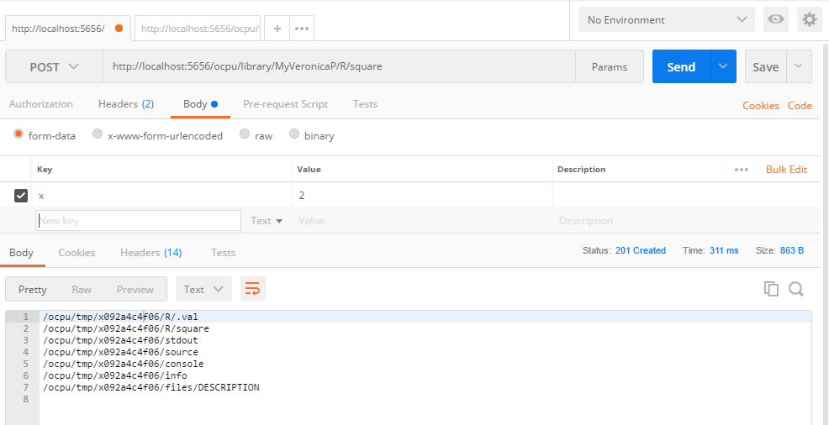
6. Click first row
7. In new Tab: Click SEND
8. Get the **result!**

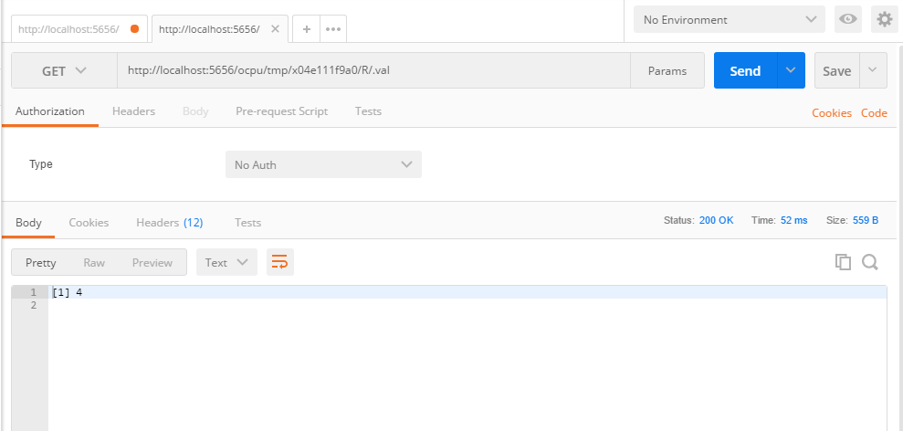

**Via public server**

1. Needs Ubuntu 16.04 or higher. Therefore, create virtual machine to install Ubuntu.
2. Needs IP address.