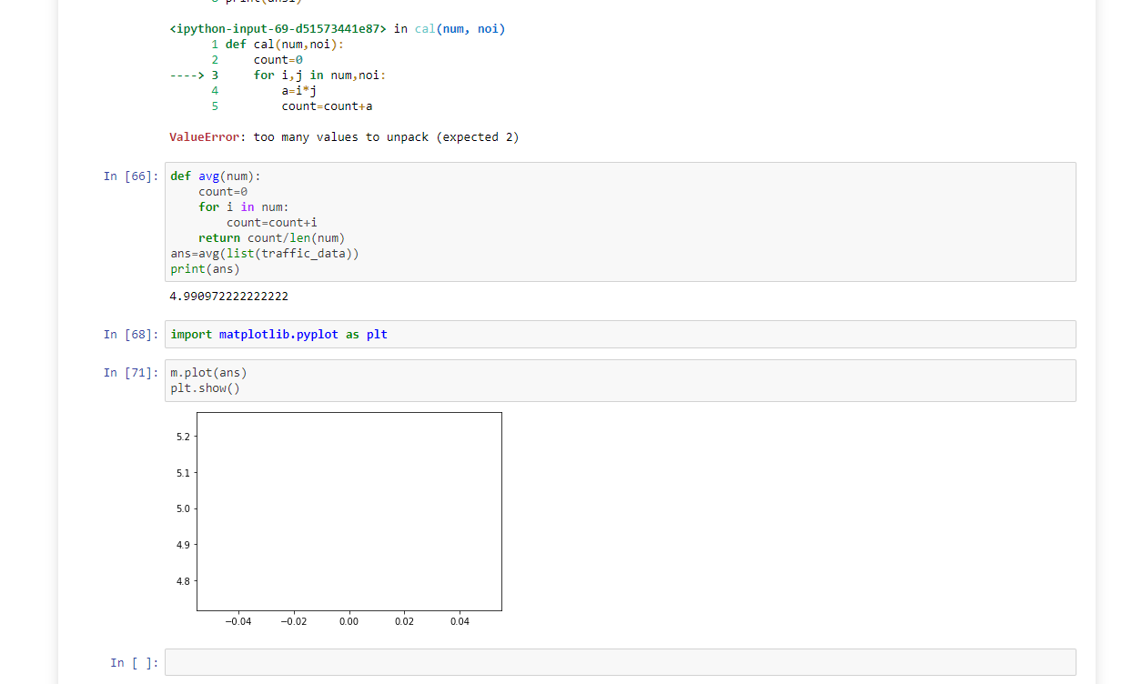

import scipy.signal as s
In [54]:
import numpy as np
In [52]:
size=1440
In [53]:
traffic_data=np.array(np.random.randint(1,10,size))
In [59]:
noise=np.random.normal(0,1,size)
In [60]:
print(noise)
[ 0.39951204 -0.18931419 -0.37351392 ... 0.26317687 1.73935808
1.15198591]
In [51]:
print(traffic_data)
[7 4 8 ... 9 8 7]
In [69]:
def cal(num,noi):
count=0
for i,j in num,noi:
a=i*j
count=count+a
return count/len(num)
ans1=cal(list(traffic_data),list(noise))
print(ans1)
---------------------------------------------------------------------------
ValueError Traceback (most recent call last)
<ipython-input-69-d51573441e87> in <module>
5 count=count+a
6 return count/len(num)
----> 7 ans1=cal(list(traffic_data),list(noise))
8 print(ans1)

<ipython-input-69-d51573441e87> in cal(num, noi)
1 def cal(num,noi):
2 count=0
----> 3 for i,j in num,noi:
4 a=i*j
5 count=count+a

ValueError: too many values to unpack (expected 2)
In [66]:
def avg(num):
count=0
for i in num:
count=count+i
return count/len(num)
ans=avg(list(traffic_data))
print(ans)
4.990972222222222
In [68]:
import matplotlib.pyplot as plt
In [71]:
m.plot(ans)
plt.show()
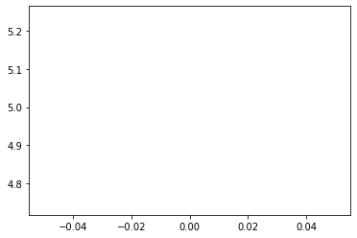
In [ ]:

