Abstract

Game Theory provides a mathematical framework for the decision making in processes. One of the simplest of these is two player zero sum games. Chess is a turn base two player zero sum game. There are many algorithms present for searching a move in two player zero sum game. In this paper we wish to compare the existing algorithms and the optimisations for the same. The various algorithms and techniques considered include Minimax, Alpha-Beta pruning, Move ordering, Use of transposition tables, Principle Variation Search, MTD-f algorithm. In this work, we use a basic piece matrix square table based evaluation function. Our comparison is based on time taken to make the move and also the number of positions evaluated before a making a move for different depth searches.

- Introduction

Chess is a board game played with two players on a board containing 64 squares each player has 16 pieces at the start of the game. They include 8 pawns, 2 Bishops, 2 Knights, 2 Rooks, 1 Queen and 1 King. The two sides are called Black and White where the player who has White side starts the game followed by Black and White and so on. Chess is a zero sum game. A zero-sum game is a mathematical representation of a situation in which each participant's gain or loss of utility is exactly balanced by the losses or gains of the utility of the other participants. The goal of each player is to checkmate the other player that is the king is threatened and the king has to have no other valid move to make. In Chessboard each column is named as a,b,c,d,e,f,g,h and each row is named as 1,2,3,4,5,6,7,8. So each cell in chessboard can be represented as unique combination of (a,b,c,d,e,f,g,h) and (1,2,3,4,5,6,7,8). For example - First square in White Queen side is named as a1.

Chess is similar to games like Tic Tac Toe, which is a game played on 3*3 grid where each player tries to make 3 consecutive X’s or O’s. In the regard that both games are two player games where the players alternate in making moves but Tic Tac Toe has very few games possible so a player can compute all the possible moves for the game in advance and come up with an optimal strategy for playing the game. In chess a player has 20 options in the first move which increases exponentially with the number of move. It is estimated that Chess has an estimated state-space complexity of 10^46. The game tree size is the total number of possible games that can be played. Chess has estimated game tree complexity of 10^123 which is based on an average branching factor of 35 and an average game length of 80 ply. This makes the strategy that we make use of in Tic Tac Toe impossible. Thus we have to use some different strategy for Chess.

We solve the problem by using algorithms like Alpha Beta Pruning which is an optimisation on top of MiniMax Algorithm. Minimax is a decision rule used in decision theory, game theory, statistics and philosophy for minimizing the possible loss for a worst case (maximum loss) scenario. When dealing with gains, it is referred to as "maximin"—to maximize the minimum gain. It was originally formulated for two-player zero-sum game theory. In zero-sum games, the minimax solution is the same as the Nash equilibrium. Alpha–beta pruning is a search algorithm that seeks to decrease the number of nodes that are evaluated by the minimax algorithm in its search tree. It is an adversarial search algorithm used commonly for machine playing of two-player games (Tic-tac-toe, Chess, Go, etc.). It stops completely evaluating a move when at least one possibility has been found that proves the move to be worse than a previously examined move. Such moves need not be evaluated further. When applied to a standard minimax tree, it returns the same move as minimax would, but prunes away branches that cannot possibly influence the final decision. Further we present two algorithms, namely Principle Variation Search and MTD (f) which are further enhancements over the Alpha-Beta Pruning. We compare the enhancement algorithms by two factors - number of moves and time taken to perform the moves.

- Literature Survey

This section contains details about the algorithms mentioned in introduction.
MiniMax Algorithm
In this algorithm the player tries to maximize his winning chances by maximizing minmax value. The player who moves first is called as maximizing player and other player is called as minimizing player. The maximin value of a player is the largest value that the player can be sure to get without knowing the actions of the other players; equivalently, it is the smallest value the other players can force the player to receive when they know the player's action.
Alpha Beta Pruning
It is an algorithm which is built on top of minimax algorithm. This algorithm maintains two values, alpha and beta, which represent the minimum score that the maximizing player is assured of and the maximum score that the minimizing player is assured of respectively. Initially alpha is negative infinity and beta is positive infinity, i.e. both players start with their worst possible score. Whenever the maximum score that the minimizing player is assured of becomes less than the minimum score that the maximizing player is assured of (i.e. beta <= alpha), the maximising player need not consider the descendants of this node as they will never be reached in actual play. This algorithm can reduce the complexity by a factor of square root.

Principle Variation Search
This algorithm is an enhancement over the Alpha-Beta Pruning, based on the null- or zero window searches. The main idea behind this algorithm is that for most of the nodes, we only need a bound to prove that the move is unacceptable for the player, and not the exact score. For the search tree, if we have established a sequence of moves acceptable for both the players (which does not cause beta-cutoff) at some lower depth then finding a sequence of moves with value greater than alpha and less than beta will not help us in any way. So we use this property to narrow down the search in comparison to basic Alpha-Beta Pruning.

MTD (f)
MTD (f) is a search algorithm that searches minimax trees using null-window alpha-beta with transposition table calls. In order to work, MTD(f) needs a first guess as to where the minimax value will turn out to be. To find the minimax value, MTD(f) calls AlphaBeta a number of times, converging towards it and eventually finding the exact value.
Heuristics
Heuristic is a type of approximation used to speed up move evaluation process and used to aid in optimisation. Heuristics are used to rate board positions based on local information.In Chess we can rate a position by examining who has more important pieces at important places on the board. The difference in black’s and white’s piece positions would be the evaluation of the position.

Move Ordering
Move ordering is used to get cut off fast with alpha beta pruning. If the best option is encountered first in alpha beta pruning then the algorithm cuts off at that position this improves the performance of the algorithm. The quality of move ordering thus is very important in this algorithm.
A typical move ordering consists as follows:
- Promotions
- Winning captures
- Equal captures
- Non-captures sorted by history

Transposition Table
The transposition table is used to speed up the search tree. The main idea here is to store the results of the previous searches so that if any similar condition occurs later during the search tree then we can directly use the value stored in the transposition table and we don’t need to perform a rigorous time-consuming search. The transposition table uses dynamic programming concept and uses the hash data structure for its implementation.

- Current Work

Overview
In this section we explain the details of our implementation. We use chessboardjs, an open source javascript library that provides us with with the necessary functions and tools for visualizing a chessboard using html and javascript. We use it to make a GUI based chessboard which we use for running our code on. We also use chess.js a move generation and validation library, to generate all the valid moves in a given scenario.

Evaluation Function
We use a evaluation function based on piece matrix tables which are a set of matrices which rate a position for a piece by considering the value at that position in the corresponding matrix these matrices are made keeping in mind the behaviour of various pieces used.In addition to that we have individual values for each piece on the board.We use the following piece values for the pieces on the board Pawn-10, Rook-50, Knight-30, Bishop-32, Queen-90, King-900.These values are decided based on the general importance of a piece in a game.
The final evaluation function looks like :-

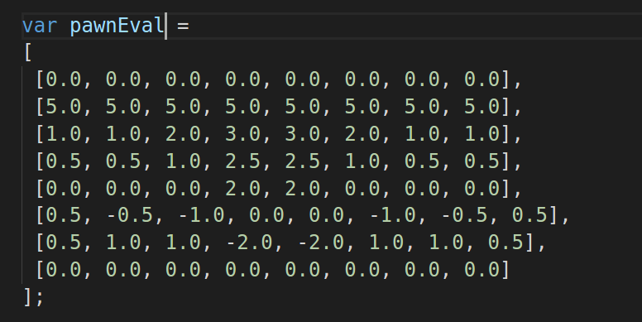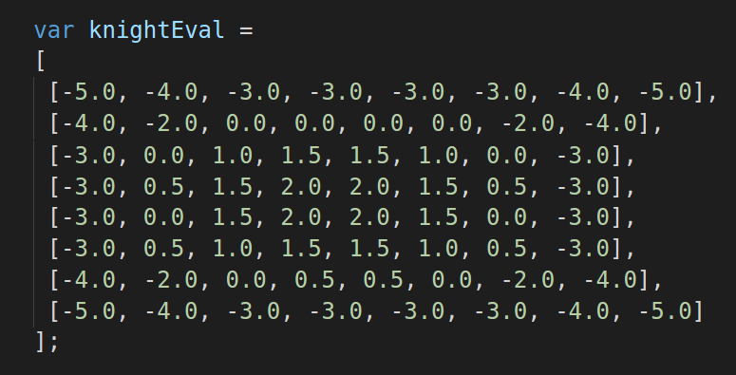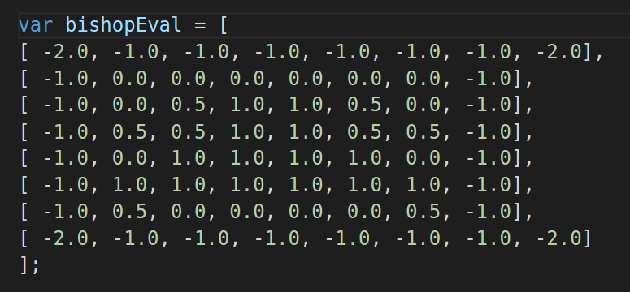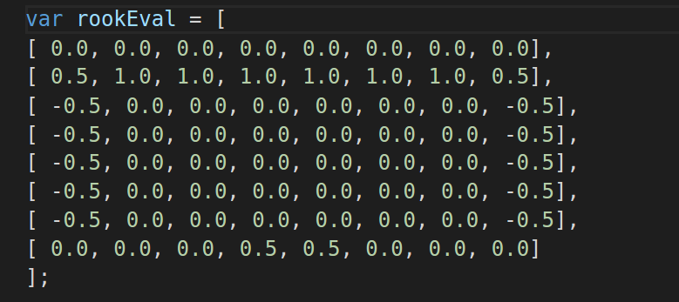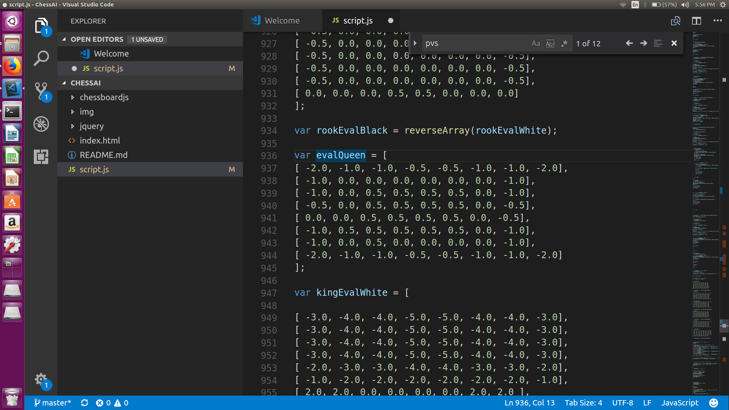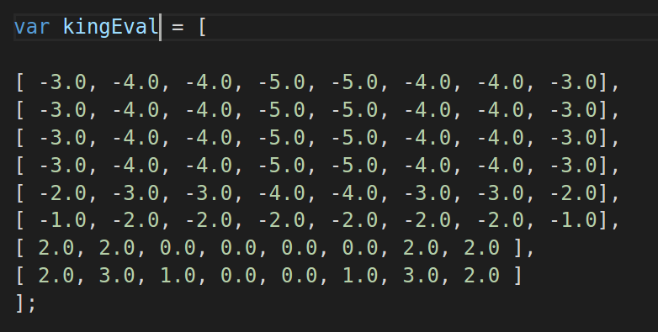

Openings
Openings are standard moves that are used at the start of the game the aim of using openings is to develop minor pieces and develop pawn structure to safeguard the king many times by using castling. We use some standard openings in our chess code which help in making the right move early on in the game which is difficult for the evaluation function to evaluate. We have include Giuoco Piano, Queen’s Gambit, English Opening, Tchigoran Defense, King’s Gambit.

Making a Move
In this section we will take a look at all the algorithms that we use to make a move
- Minimax- This is the most basic in which we try all the move sequences to certain depth and then pick the move sequence which gives the best final result.
- Alpha-Beta Pruning- In this we improve upon the Basic Minimax bby ignoring the branches in which we already know that a better move exists.
- Principle Variation Search- In this we use a move that we already know is very good to speed up the process.
- MTD-f

Pseudocodes (for now)

BasicMinimax (depth, game, isMaximisingPlayer)
if(depth=0) then
return result of Evaluation Function
end if
if(isMaximisingPlayer) then
bestValue = -INFINITY
for all the possible moves do
Perform the move
V = BasicMinimax(depth-1, game, !isMaximisingPlayer)
Undo the move
bestValue = maximum(bestValue, V)
end for
return bestValue
else
bestValue = INFINITY
for all the possible moves do
Perform the move
V = BasicMinimax(depth-1, game, !isMaximisingPlayer)
Undo the move
bestValue = minimum(bestValue, V)
end for
return bestValue
end if

MinimaxWithAB(depth, game, alpha, beta, isMaximisingPlayer)
if(depth=0) then
return result of evaluation function
end if
if(isMaximisingPLayer) then
bestMove = -INFINITY
for all the possible moves do
Perform the move
V = MinimaxWithAB(depth-1, game, alpha, beta, !isMaximisingPlayer)
Undo the move
bestMove = maximum(bestMove, V)
alpha = maximum(alpha, bestMove)
if (beta <= alpha) then
return bestMove
end if
end for
return bestMove
else
bestMove = INFINITY
for all the possible moves do
Perform the move
V = MinimaxWithAB(depth-1, game, alpha, beta, !isMaximisingPlayer)
Undo the move
bestMove = minimum(bestMove, V)
beta = minimum(beta, bestMove)
if (beta <= alpha) then
return bestMove
end if
end for
return bestMove
end if

PVS(depth, game, alpha, beta, isMaximisingPlayer)
if(depth = 0) then
return result of evaluation function
end if
if(isMaximisingPlayer) then
value = -INFINITY
if(child is the first child) then
Perform the move
value = pvs(depth-1, game, alpha, beta, !isMaximisingPlayer)
Undo the move
end if
if(value >= beta) then
return value
end if
if(value > alpha) then
alpha = value
end if
for all the possible moves except the first child do
Perform the move
score = pvs(depth-1, game, alpha, alpha+1, !isMaximisingPlayer)
if(score > alpha) then
score = pvs(depth-1, game, alpha, beta, !isMaximisingPlayer)
end if
Undo the move
if(score >= beta) then
return score
end if
if(score > alpha) then
alpha = score
end if
end for
return alpha
else
value = INFINITY
if(child is the first child) then
Perform the move
value = pvs(depth-1, game, alpha, beta, !isMaximisingPlayer)
Undo the move
end if
if(value <= alpha) then
return value
end if
if(value < beta) then
beta = value
end if
for all the possible moves except the first child do
Perform the move
score = pvs(depth-1, game, beta-1, beta, !isMaximisingPlayer)
if(score > alpha) then
score = pvs(depth-1, game, alpha, beta, !isMaximisingPlayer)
end if
Undo the move
if(score <= alpha) then
return score
end if
if(score < beta) then
beta = score
end if
end for
return beta
end if

MTDf(depth, game, alpha, beta, isMaximisingPlayer)
if(depth = 0) then
return result of evaluation function
end if

- Results

In this section, we will present the results obtained while comparing the above mentioned algorithms. We use a transposition table of size 1000000 elements to obtain these results.
Here we compare the four variations of the algorithm - Standard Minimax, Minimax with Alpha-Beta Pruning, Minimax with Alpha-Beta Pruning with PVS and Minimax with Alpha-Beta Pruning with MTD (f). The comparison of algorithms is done in two different ways. One is based on the number of positions evaluated and second is on the basis of the time taken to make the move.

- On the basis of number of positions evaluated
The results from the graph clearly suggest that the MTD (f) algorithm evaluates the least number of positions over a period of sequence of moves.
- On the basis of time taken
Here as well, we can see a clear result that the MTD (f) algorithm takes the least amount of time among all the algorithms and therefore, works fastest.

- Conclusion and Future Work

In this paper, we have described algorithms such as Minimax, Alpha-Beta Pruning, Principle Variation Search and MTD (f). The main conclusion from the experiments is that MTD (f) algorithm on top of Alpha-Beta Pruning on top of Minimax is the best MInimax algorithm of all. Our focus is to explain the existing work related to search tree algorithms for Chess game. Furthermore, people can test the mentioned algorithms with more elaborate evaluation function and a larger sized transposition table to generate even more accurate results.

