EXPERIMENT 10

**AIM:** Working with .dockerignore.

**Step 1 - Docker Ignore**

To prevent sensitive files or directories from being included by mistake in images,

you can add a file named *.*dockerignore.

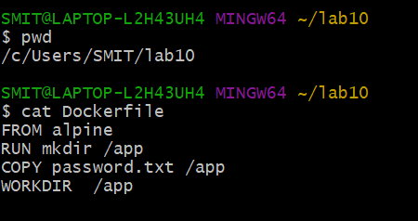

Build the image with docker build -t password .

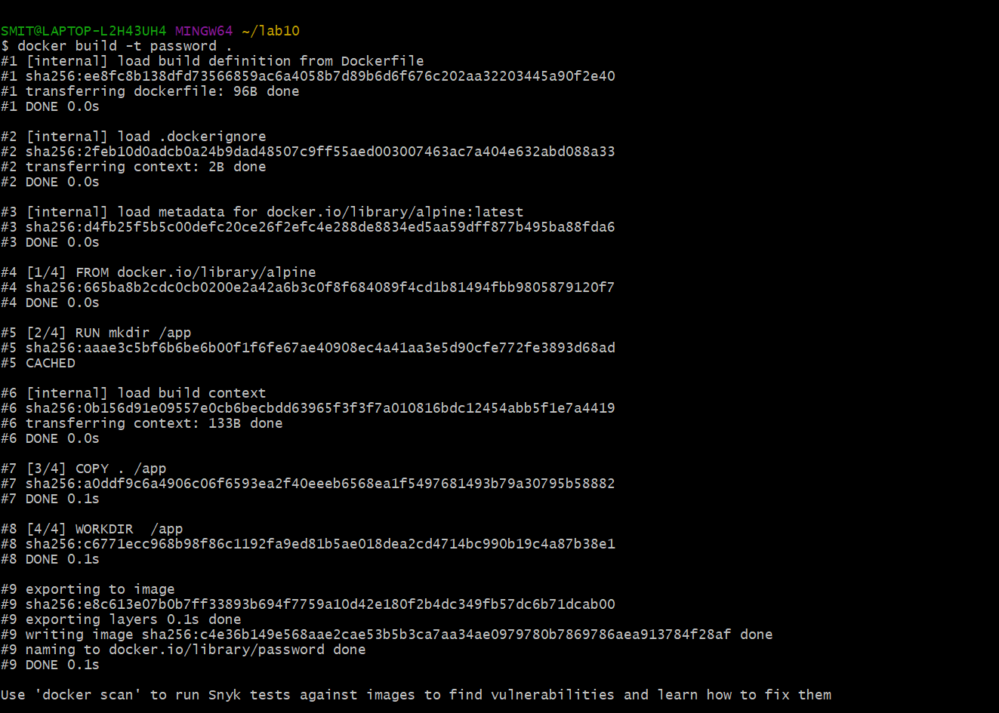

Look at the output using docker run password ls /app

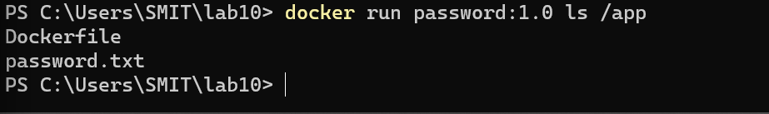

Ignore File

The following command would include passwords.txt in our *.dockerignore* file and

ensure that it didn't accidentally end up in a container. The *.dockerignore* file would

be stored in source control and share with the team to ensure that everyone is

consistent.

echo passwords.txt >> .dockerignore



The ignore file supports directories and Regular expressions to define the

restrictions, very similar to *.gitignore.* This file can also be used to improve build

times which we'll investigate in the next step.

Build the image, because of the Docker Ignore file it shouldn't include the passwords

file.

docker build -t password:1.1 .

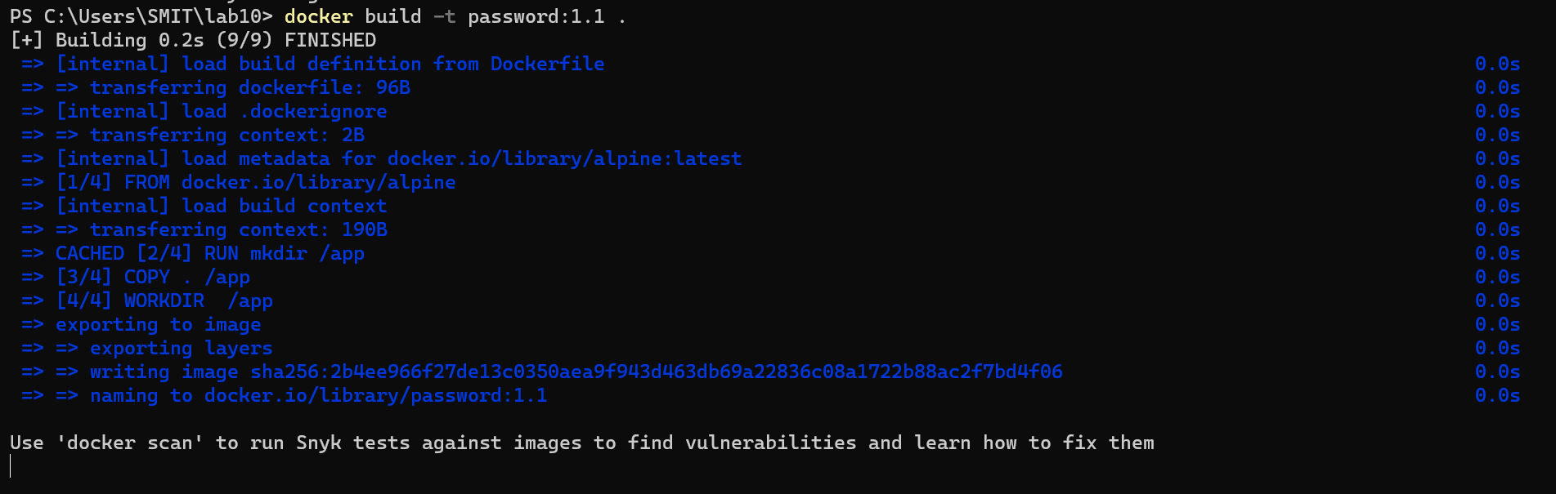

Look at the output using docker run password ls /app

