EXPERIMENT 8

**AIM:** Working with Kubernetes.

**Commands:**

kubectl apply -f pod.yml

kubectl apply -f deployment.yml

kubectl apply -f services.yml

kubectl apply -f replicaset.yml

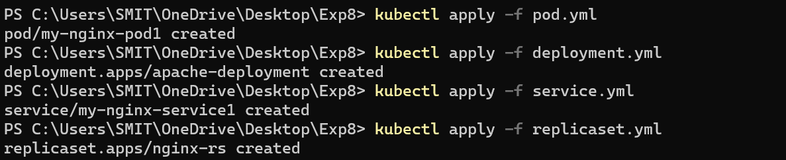

**Command:**

kubectl get all

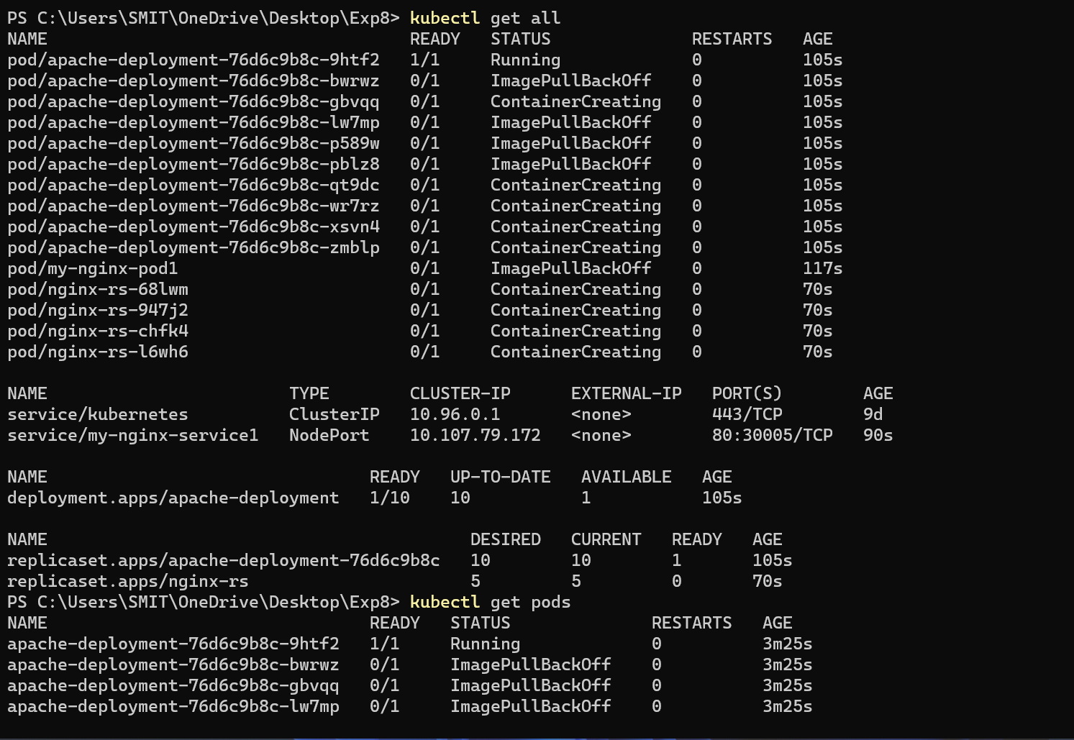

Removing the created replicaset.

**Command:**

kubectl delete -f replicaset.yml



**Command:**

kubectl get all

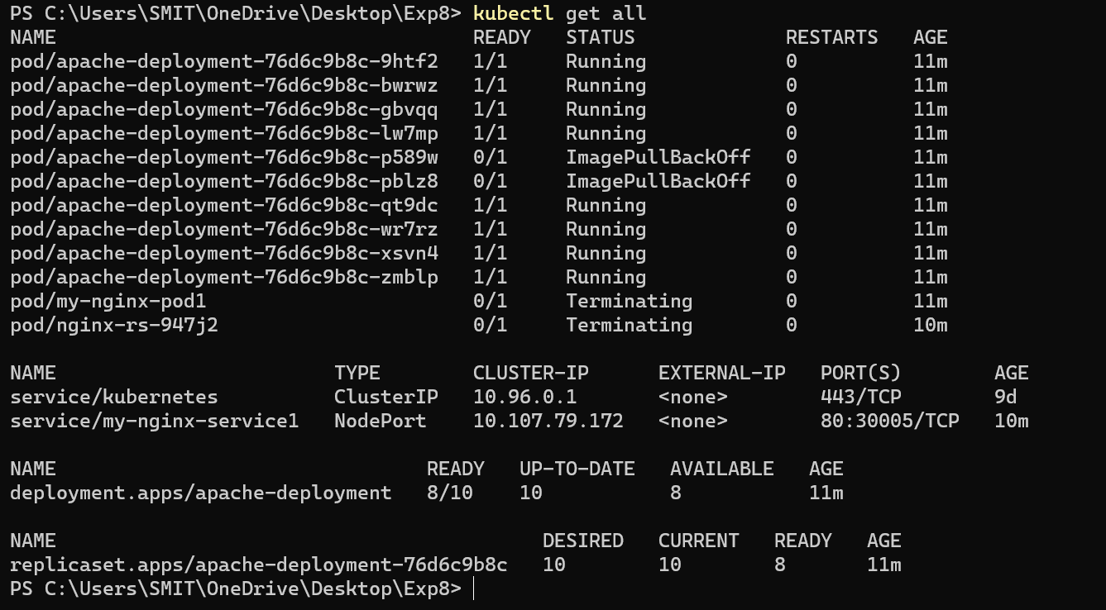

Remove the pod.yml file.

**Command:**

Kubectl delete -f pod.yml



Removing the deployment.yml file

**Command:**

Kubectl delete -f deployment.yml



Checking the differences and making sure that the files associated with respective files are deleted.

**Command:**

Kubectl get all

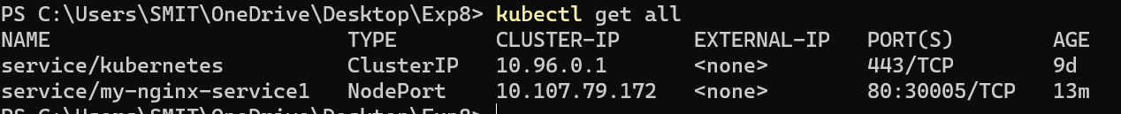

Removing the service.yml file.

**Command:**

Kubectl delete -f service.yml



Checking the changes made after the removal of the file to ensure that the files is deleted.

**Command:**

Kubectl get all

