Lesson 01 Demo 02

Launching an S3 Bucket Using CloudFormation

Objective: To create an S3 bucket on AWS using CloudFormation, with a focus on defining bucket properties, securing access, and ensuring proper configuration

Tools required: AWS Management Console

Prerequisites: None

Steps to be followed:
- Create a CloudFormation template

Step 1: Create a CloudFormation template

  - Navigate to the AWS console and search for and select CloudFormation

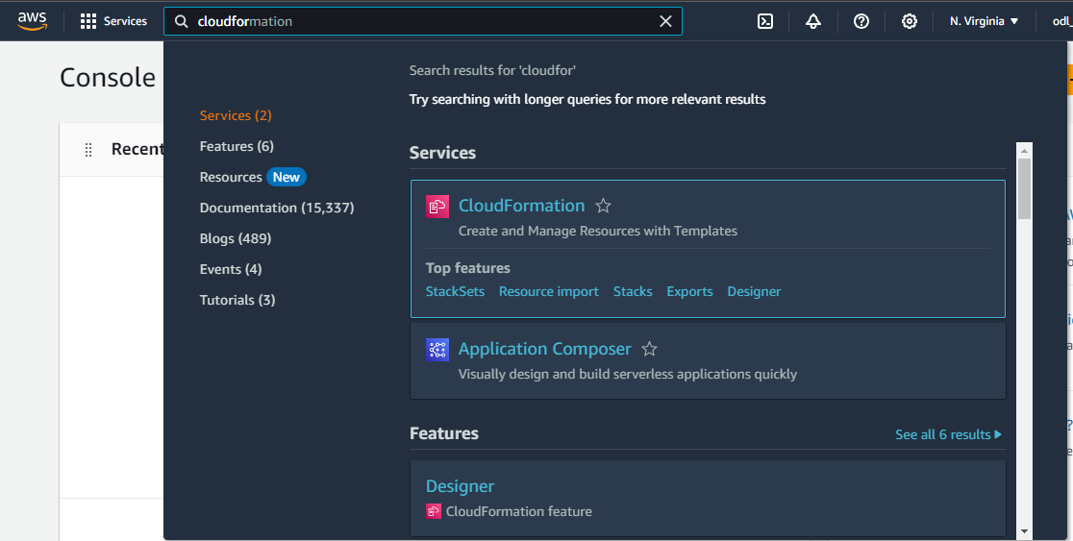

  - Click on Create stack and choose With new resources (standard)

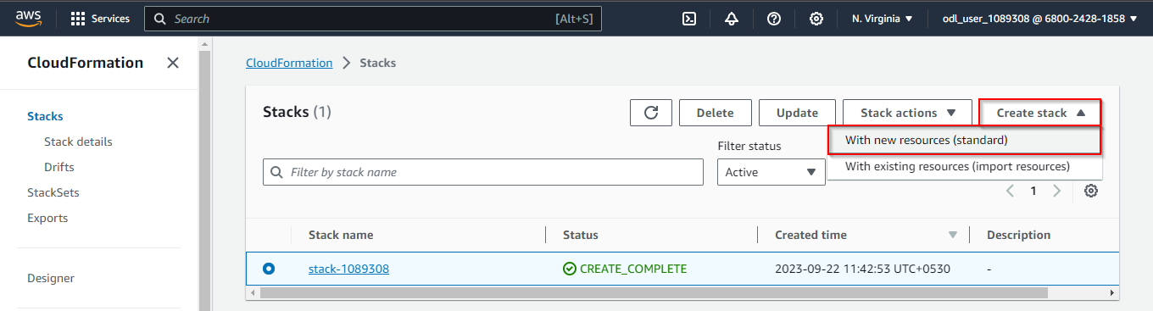

  - Select Create template in Designer to enter the template design interface

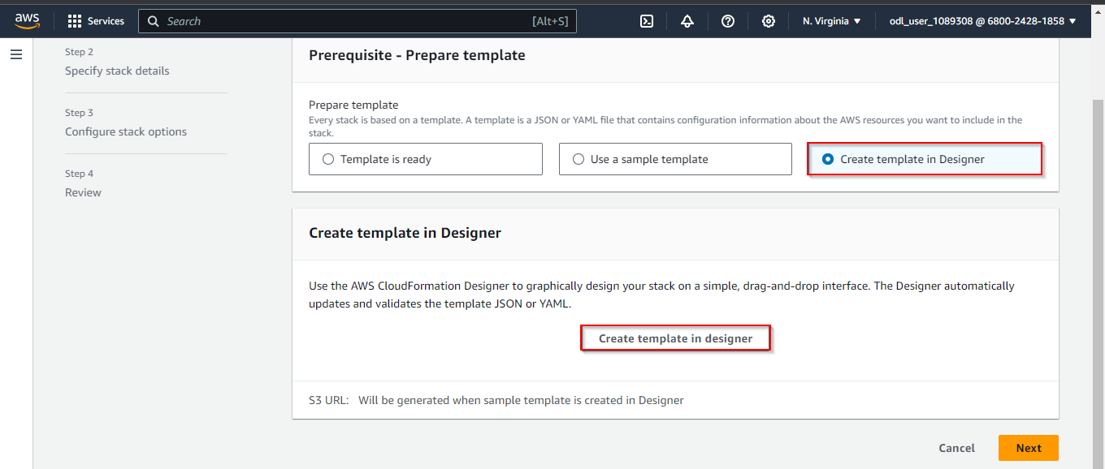

AWSTemplateFormatVersion: '2010-09-09'
Description: CloudFormation template to create an S3 bucket

Resources:
MyS3Bucket:
Type: AWS::S3::Bucket
Properties:
BucketName: my-unique-s3-bucket-name-123456
AccessControl: Private

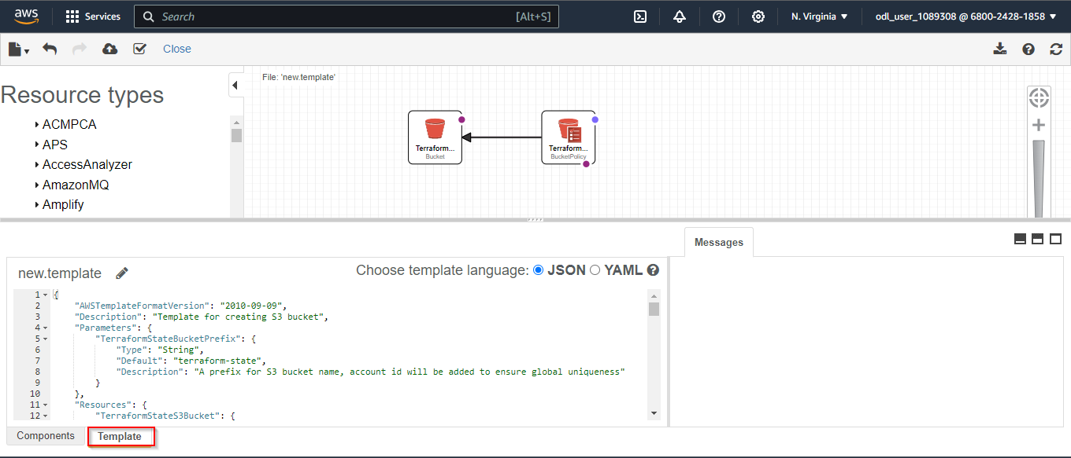

- Click the Validate template icon to ensure the template is correct

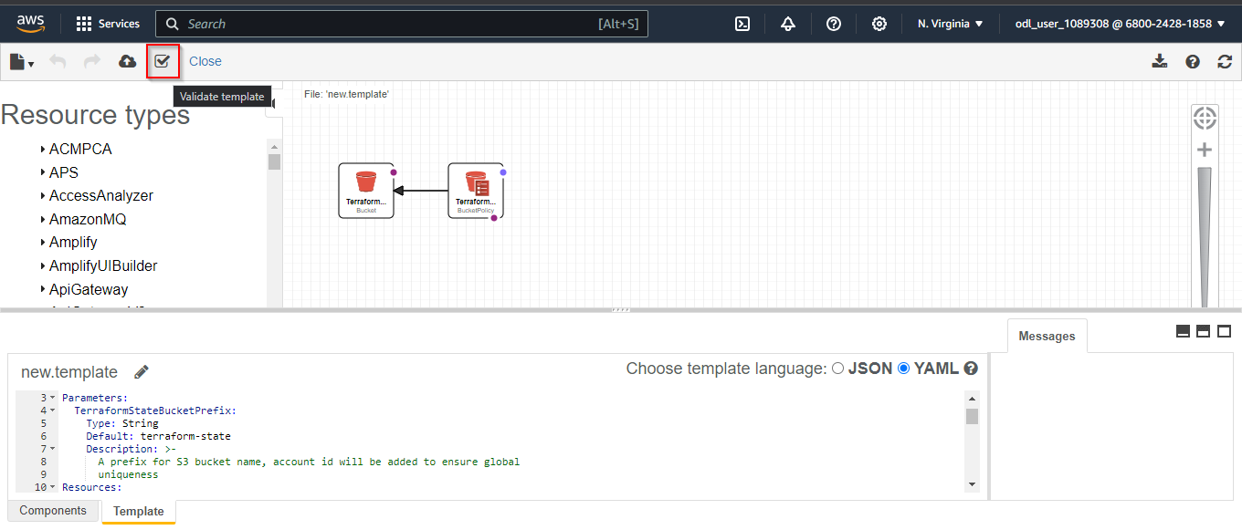

- Click on the Create stack icon

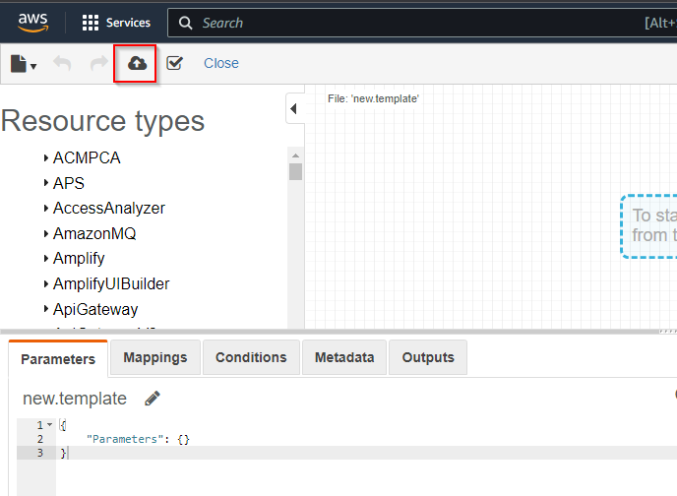

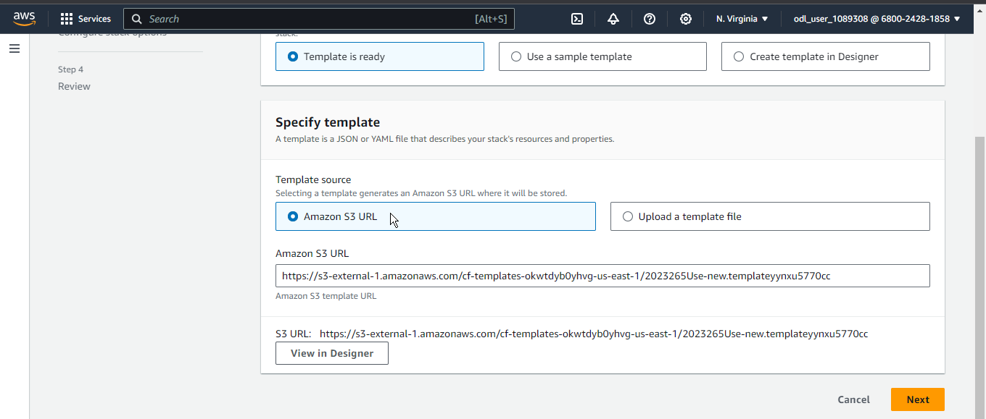

This will automatically open the Create stack window. Now, click on the Next button.

- In the Create stack window, enter the Stack name as CreateS3Bucket and click Next

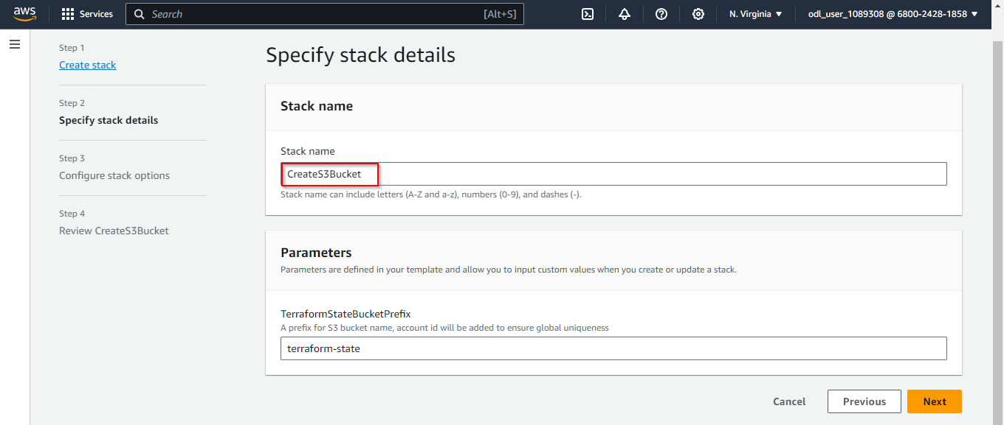

- Click Submit

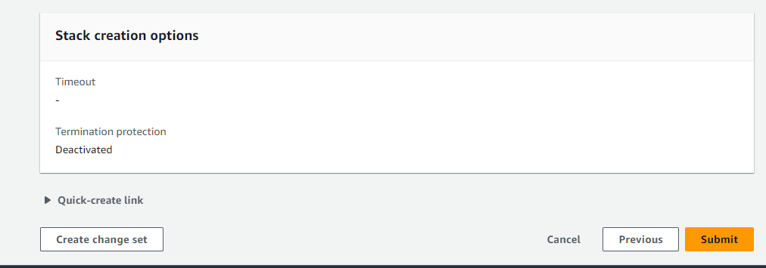

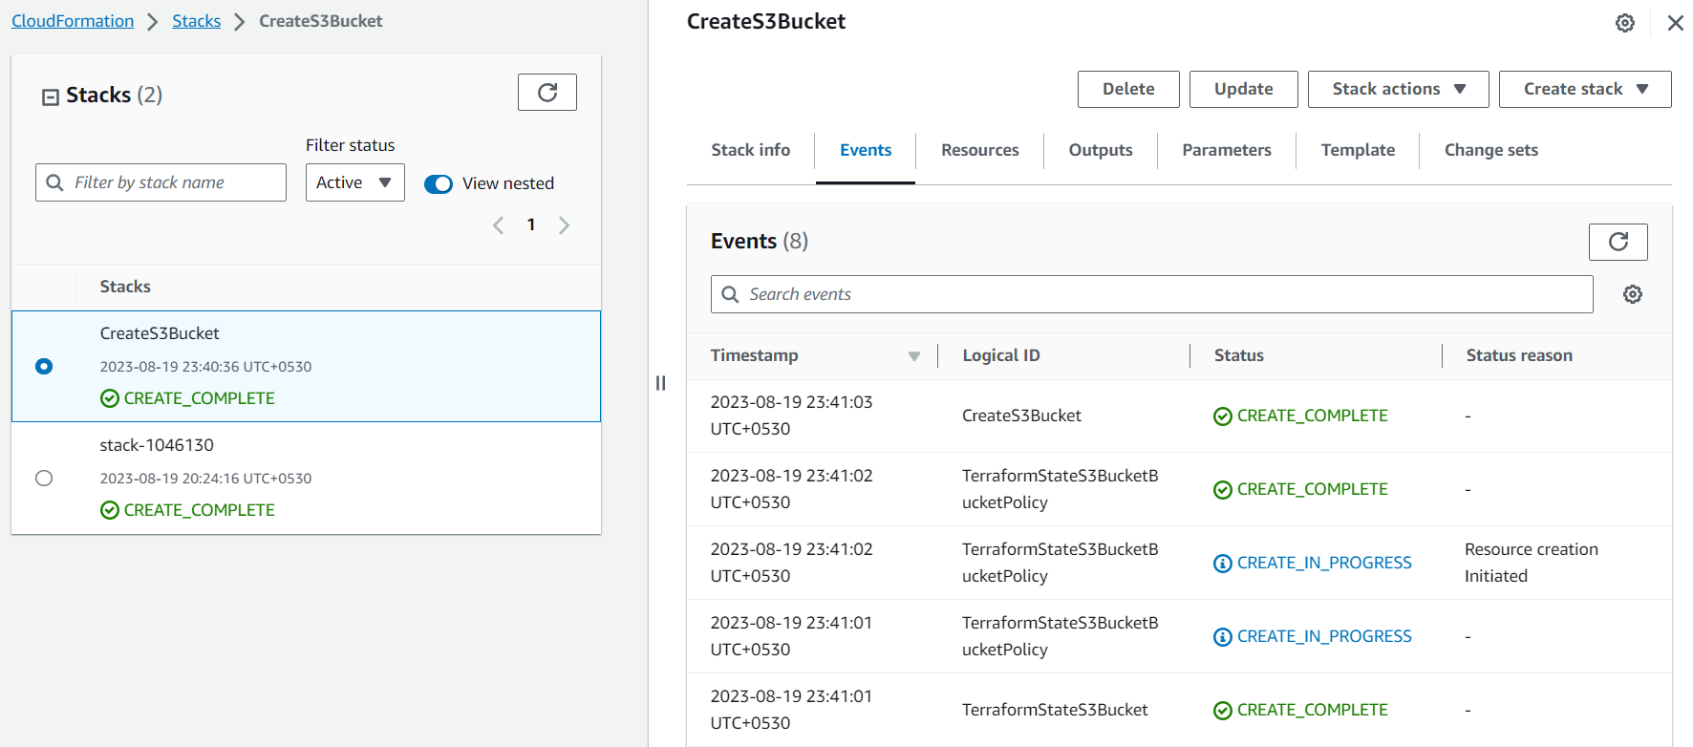

The S3Bucket has been created successfully.

After successfully completing it, navigate to the S3 service and click on Buckets to view the newly created bucket.

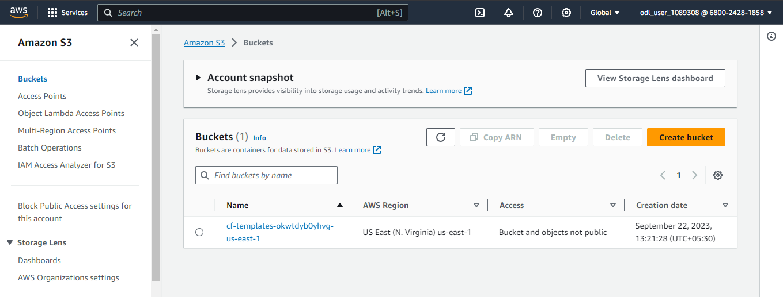

By following these steps, you have successfully created an S3 bucket with the specified configuration and access controls.

