Lesson 02 Demo 03

Setting up a Java-Based Elastic Beanstalk Environment
Objective: To automate Platform as a Service (PaaS) deployment without the need to create infrastructure components and host supported programming language artifacts using AWS Elastic Beanstalk
Tools required: AWS Identity and Access Management (IAM) and AWS Elastic Beanstalk

Prerequisites: None

Steps to be followed:
- Create an IAM role for AWS Elastic Beanstalk
- Create a Java-based Elastic Beanstalk application and environment

Step 1: Create an IAM role for AWS Elastic Beanstalk

- Sign in to the AWS Console from AWS Labs in the LMS portal

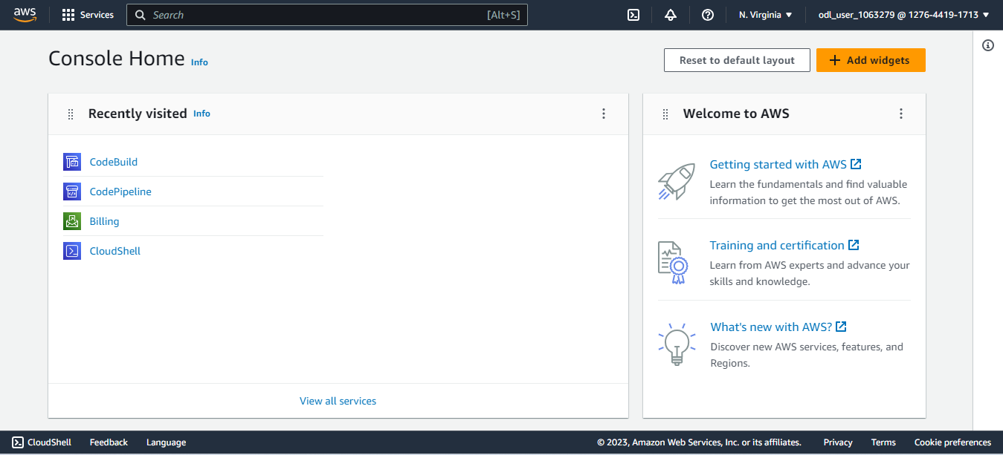

- Once logged in to the AWS portal, search for and click on IAM
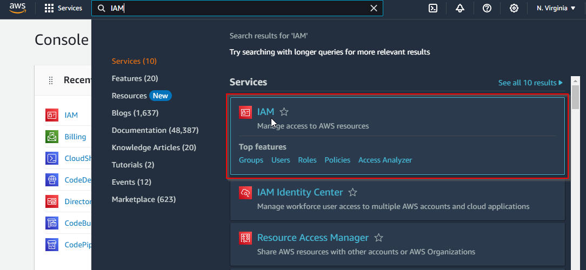

- In the list on the left side, click on Roles
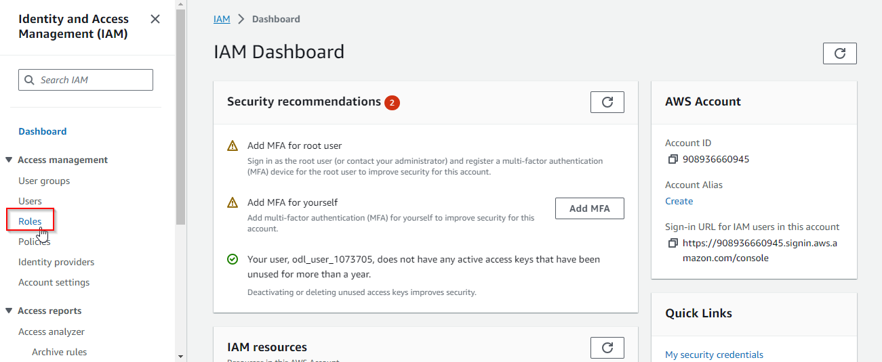

- Click on the Create role button
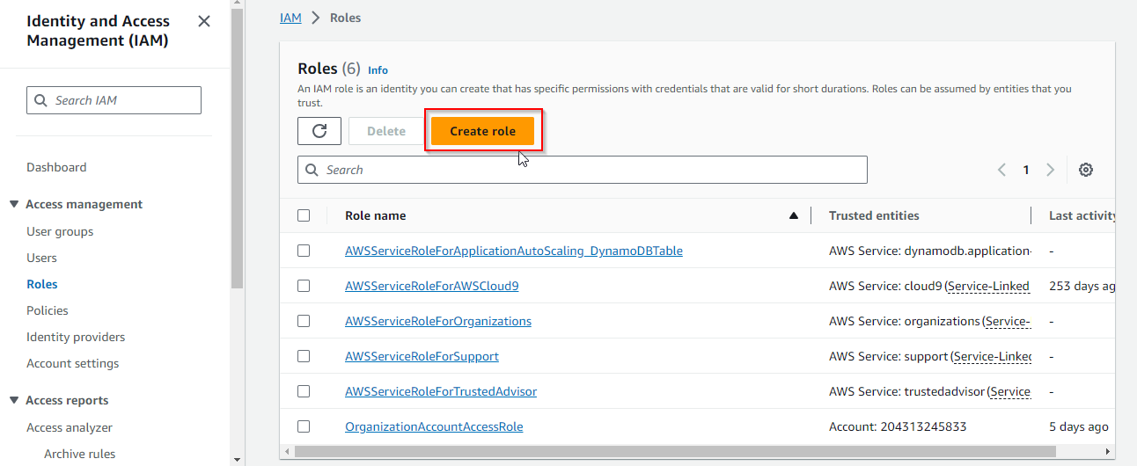
- In the Use case section, select EC2 service from the drop-down list
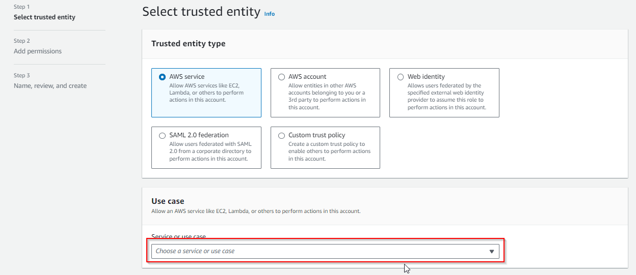

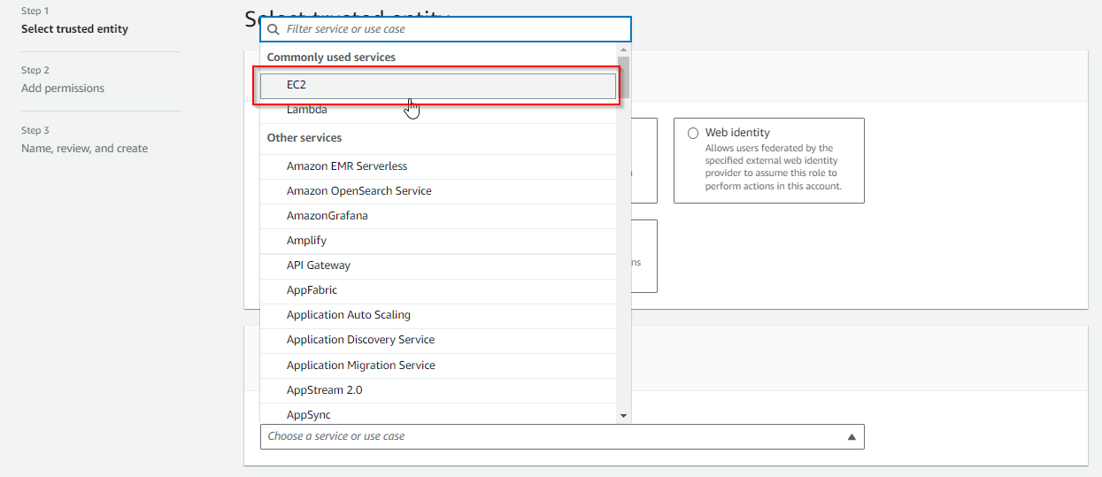
- Click the Next button
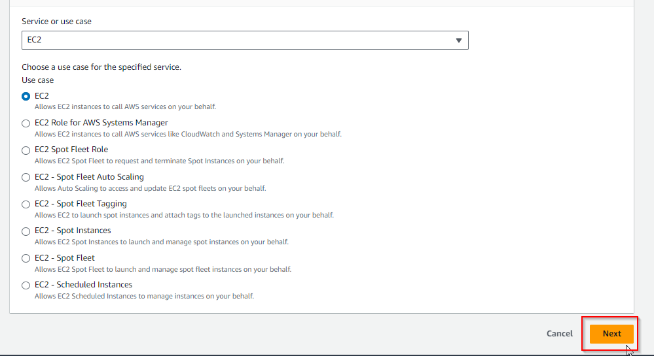

- In the search bar, enter the policy name as AdministratorAccess-AWSElasticBeanstalk, and click on the checkbox to add the policy
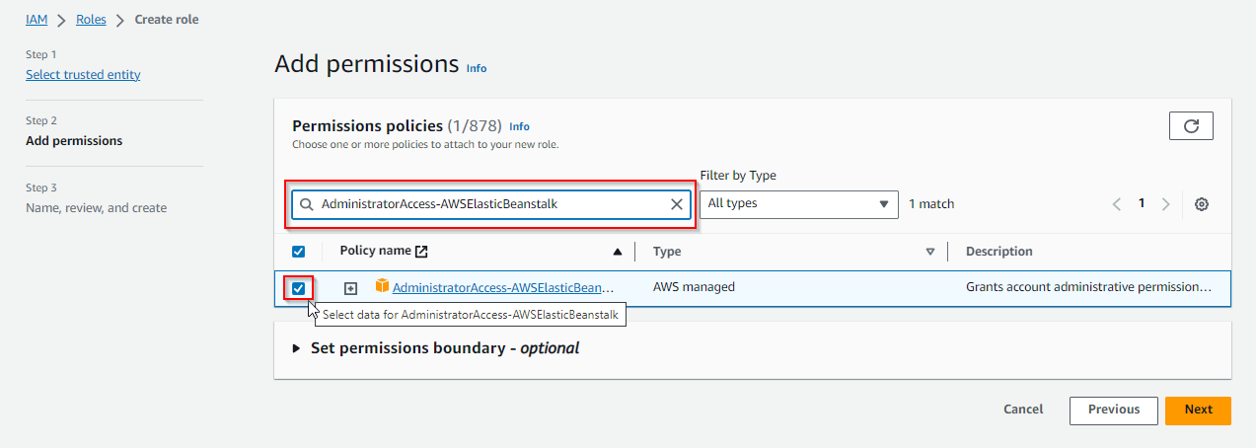
- Click the Next button
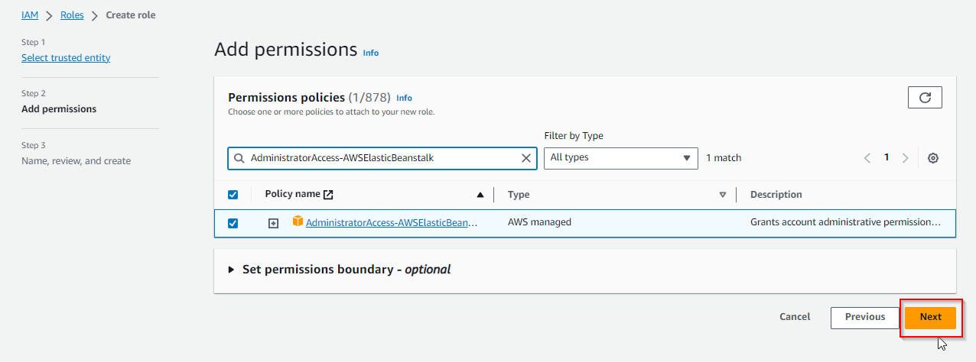

- Enter the Role name as elasticbeanstalk-instance-profile
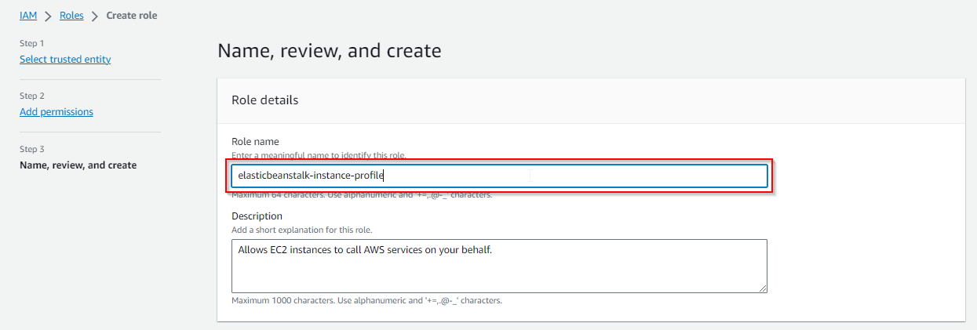
- Scroll to the bottom of the page and click the Create role button
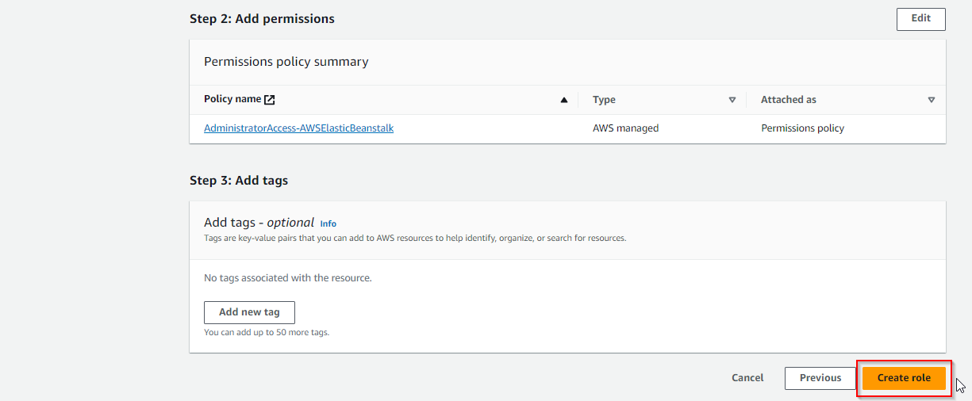

The role is created successfully as shown below:
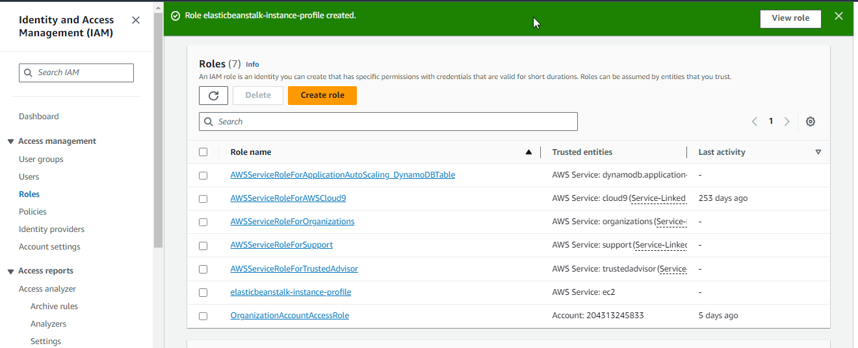

Step 2: Create a Java-based Elastic Beanstalk application and environment
- Search for and click on Elastic Beanstalk
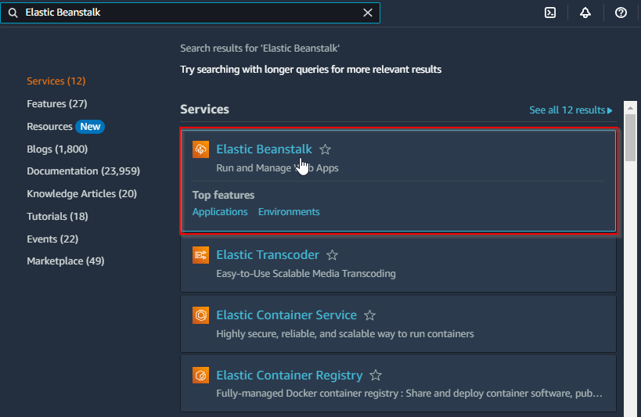

- On the top left corner, click on the list icon
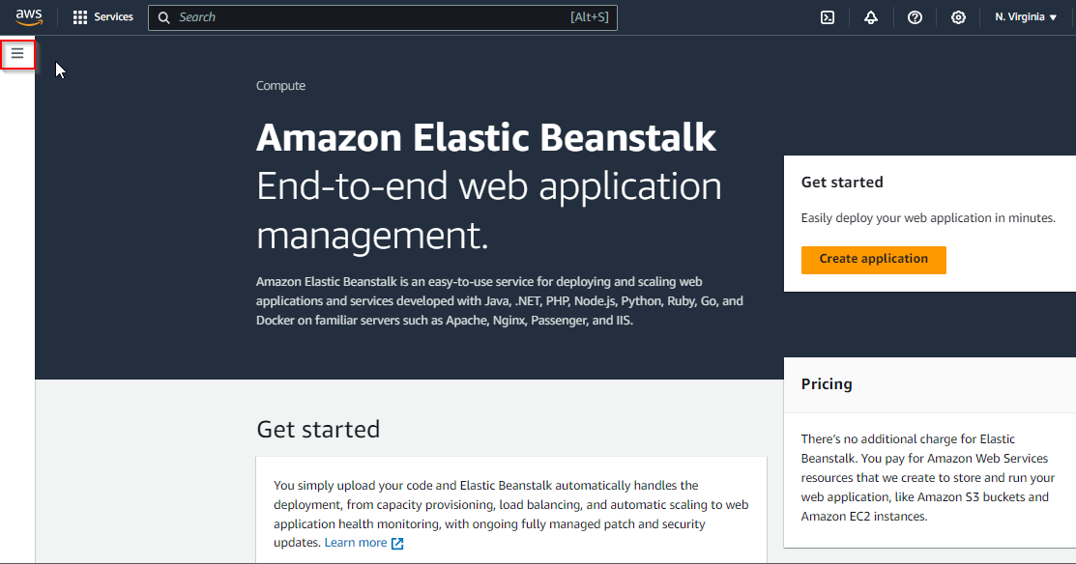
- Click on Applications
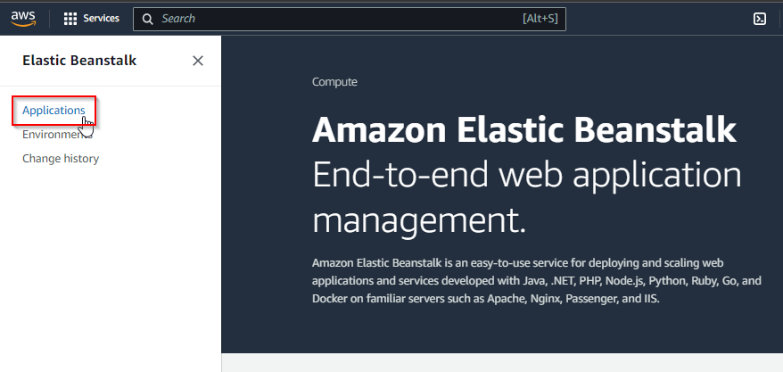

- Now, click on the Create application button
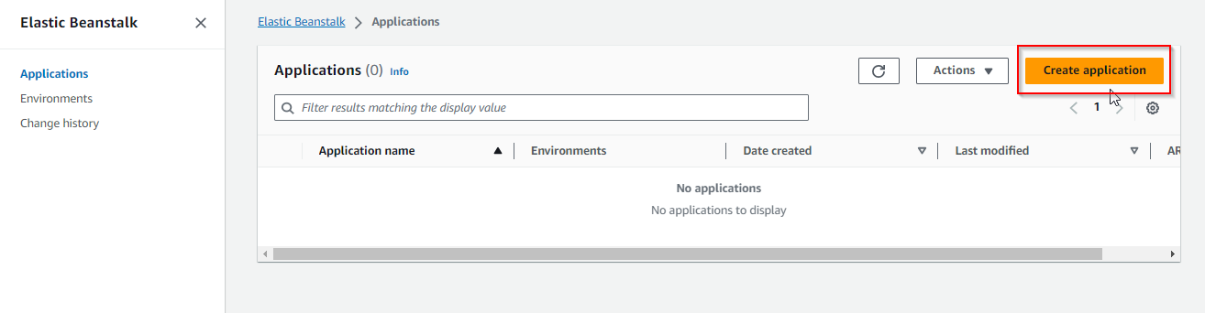
- Enter the Application name as CounterApplication
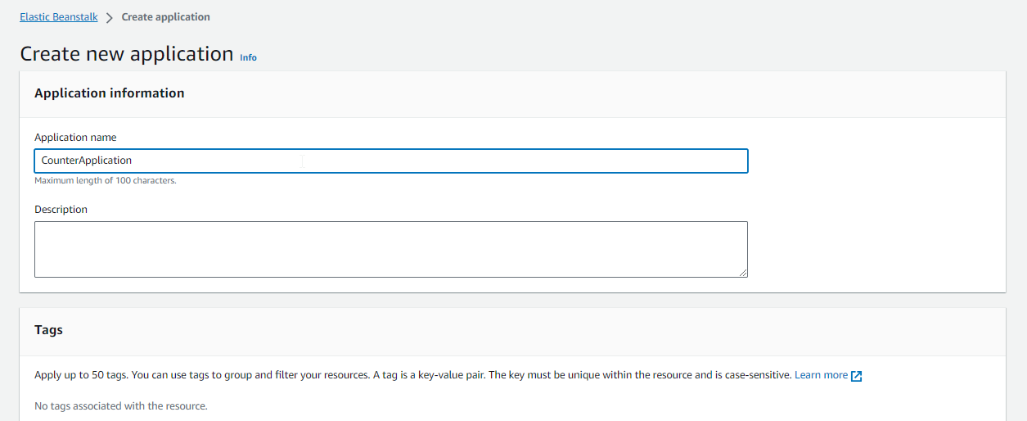

- Click the Create button
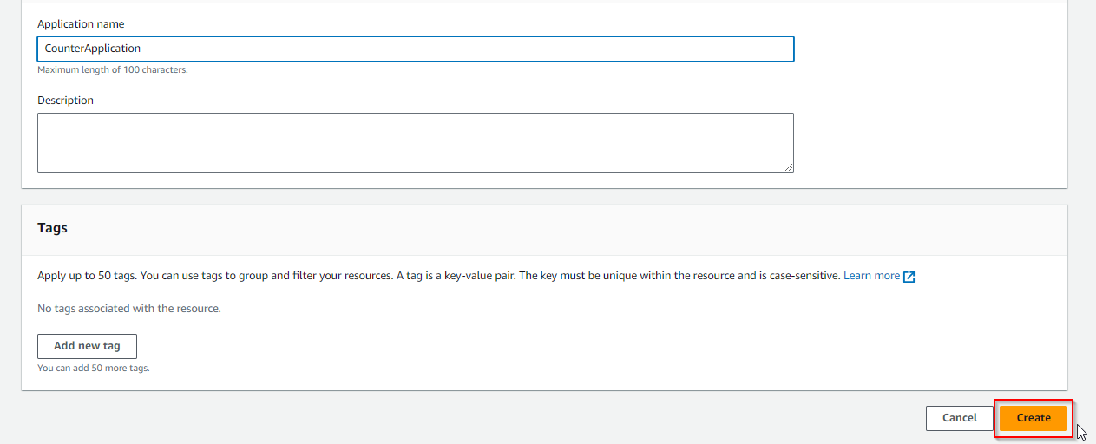
- Now, click on the Create new environment button
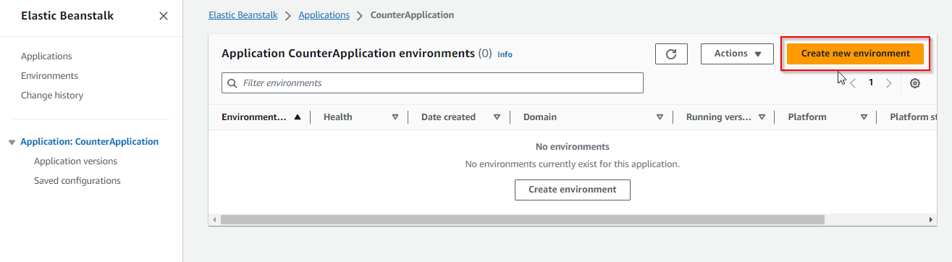

You will now be able to view the interface shown below:
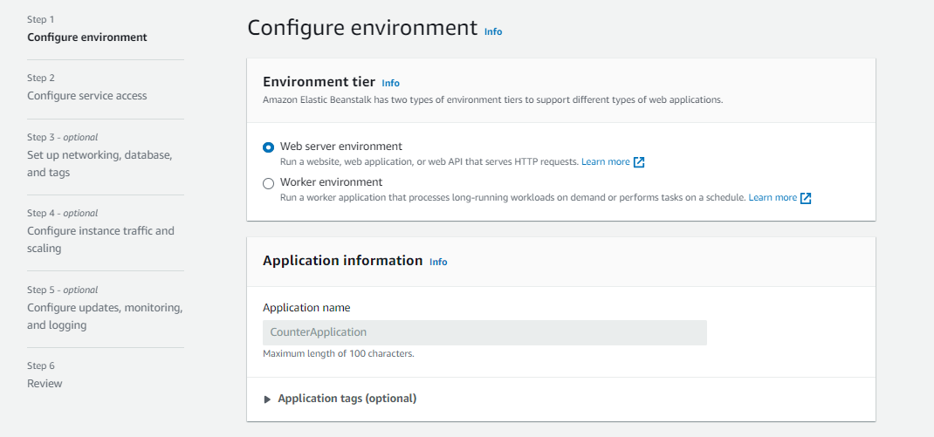
  - In the Environment information section, enter the Environment name
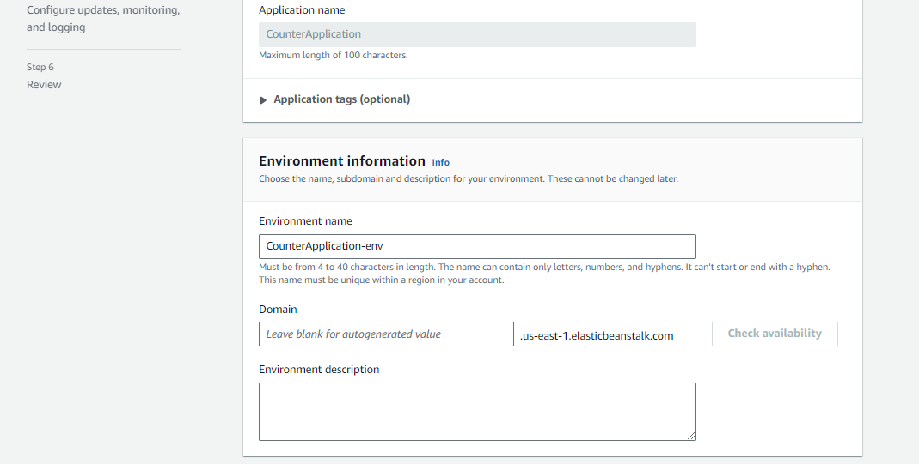

  - In the Platform section, specify the platform for deployment. For a Java application, select the Tomcat-based platform as shown below:
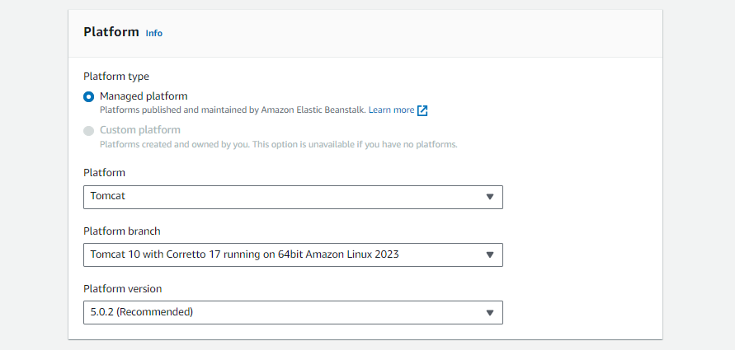
  - Configure the infrastructure Presets based on your infrastructure requirements and
click on the Next button
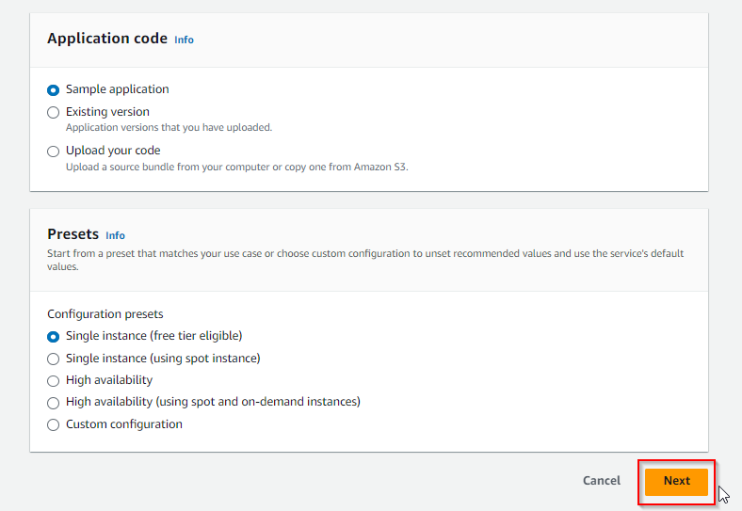

  - Set up a service account and integrate it with your environment as shown below:
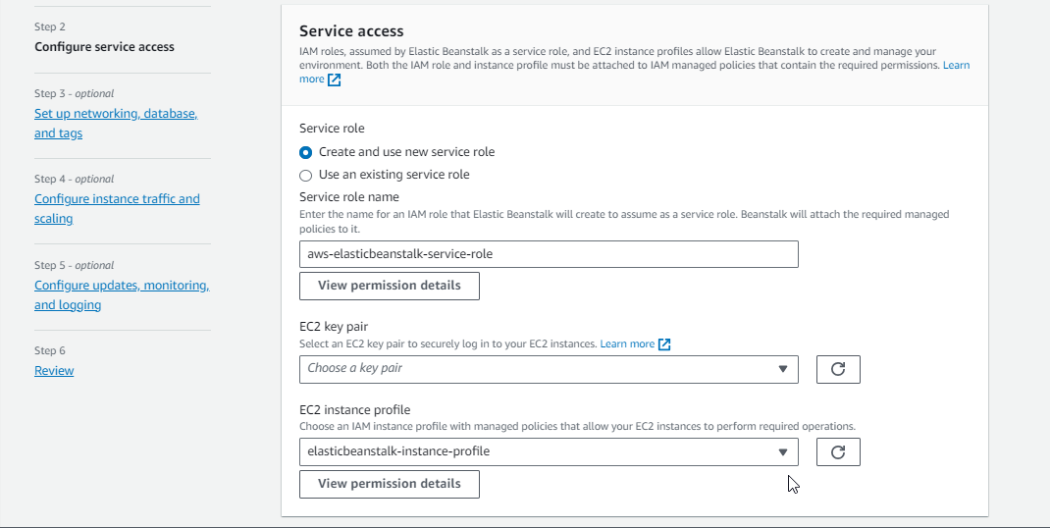
2.12 After setting up the service access, click on the Next button
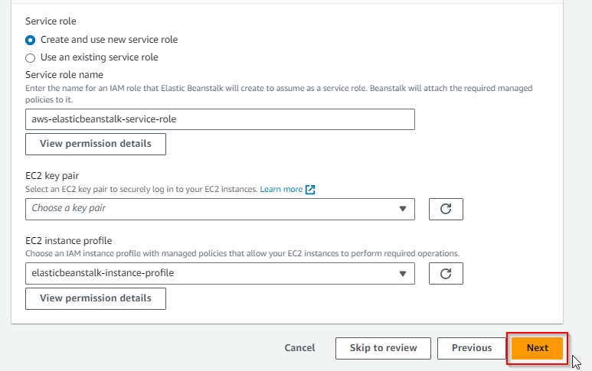

  - Configure the networking settings as shown below:
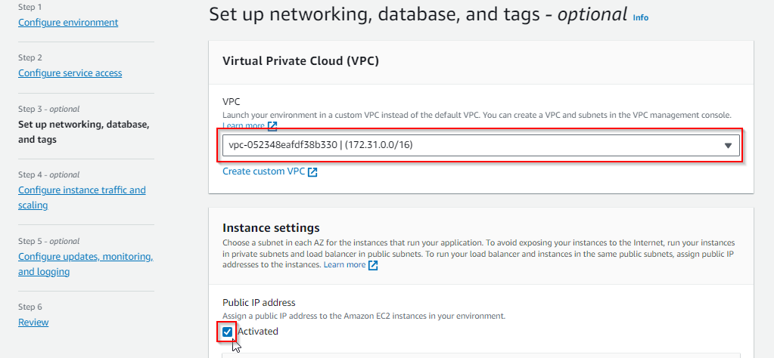
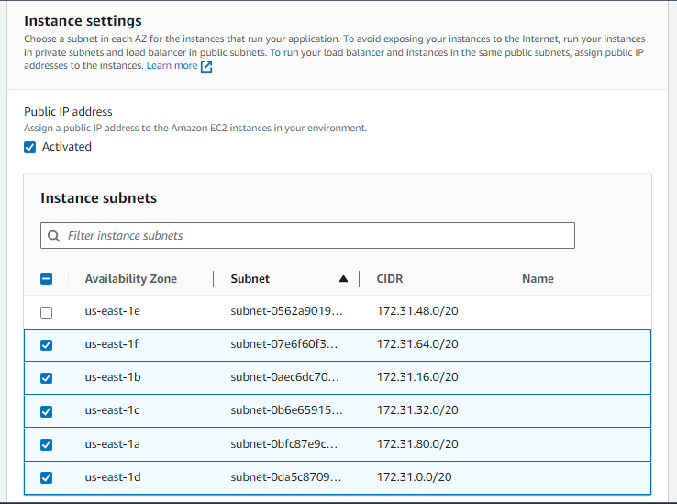
Note: In case you have database configuration, you can enable the database and configure the same.

  - Scroll to the bottom of the page and click the Next button
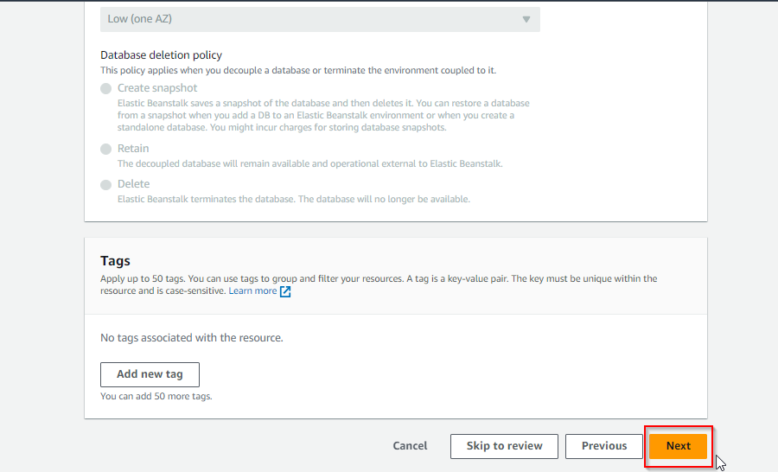

  - Select optional settings, such as security group configurations, based on the
requirements
Note: If you are not aware of the requirements of the security group configuration, proceed further by enabling the default option as shown in the screenshot below:
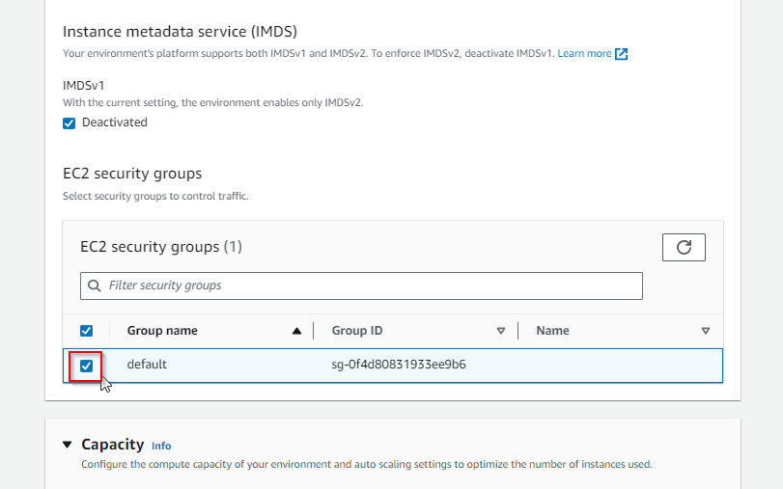
  - Scroll to the bottom of the page and click on the Next button
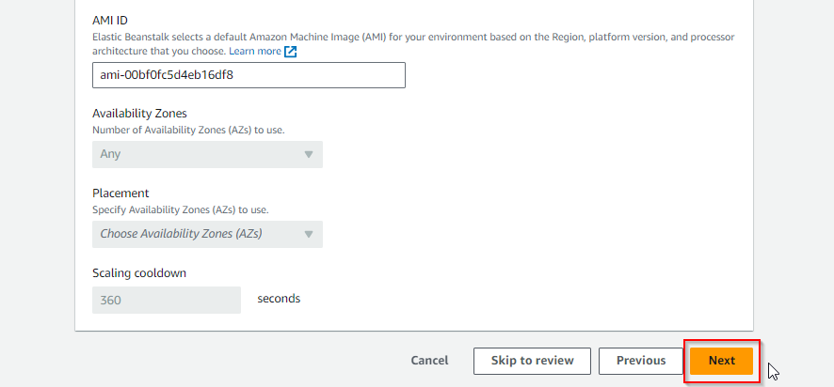

  - Configure updates, monitoring, and logging details, and enable managed platform
updates for automatic platform updates according to the screenshots below:
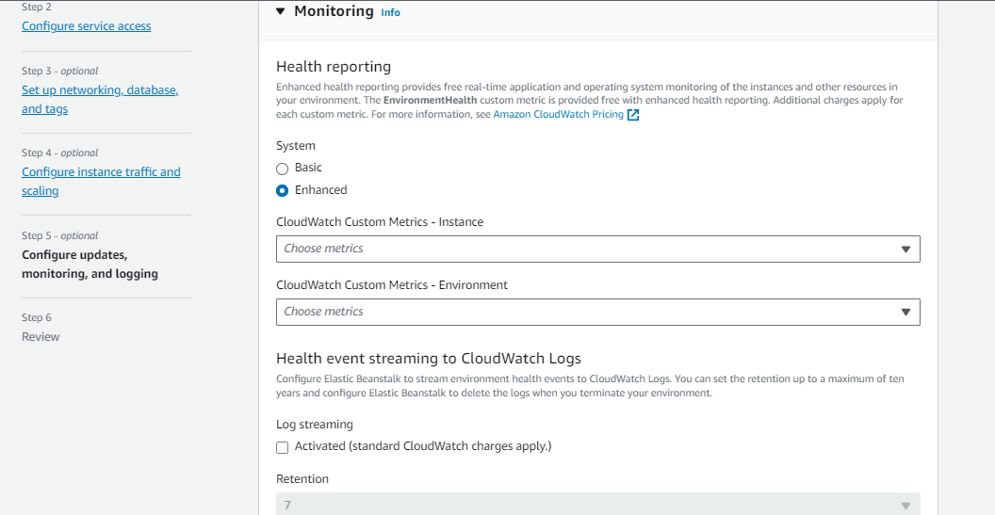
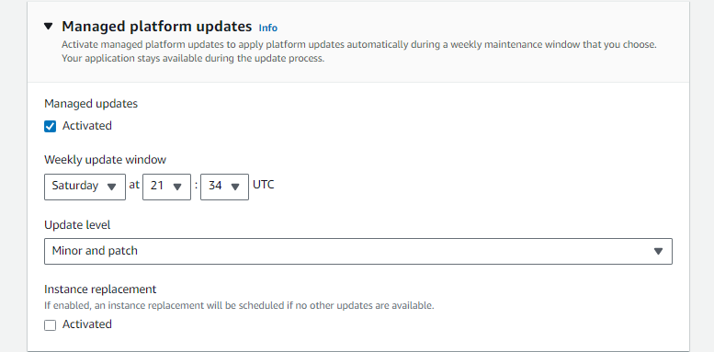

  - Scroll to the bottom of the page and click on the Next button
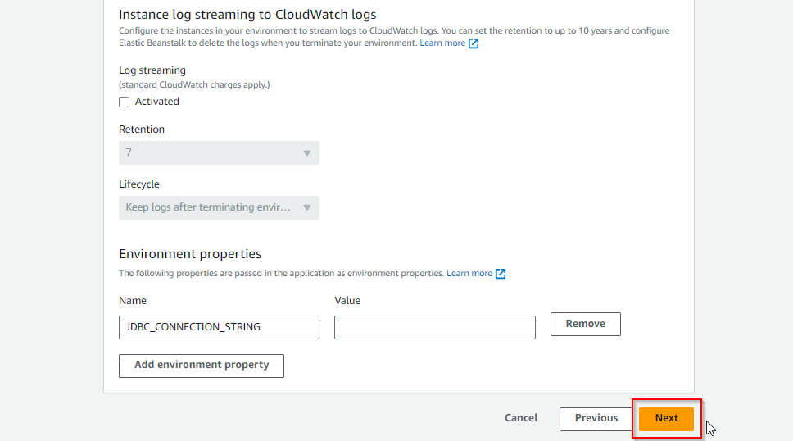

  - Review and validate all configurations
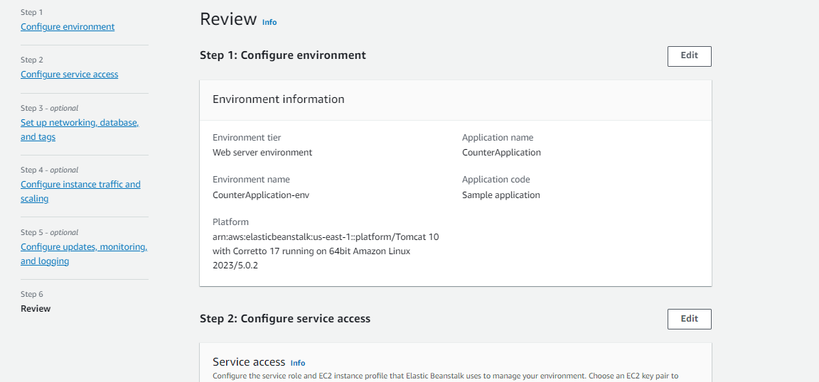
  - Once validated, click on the Submit button
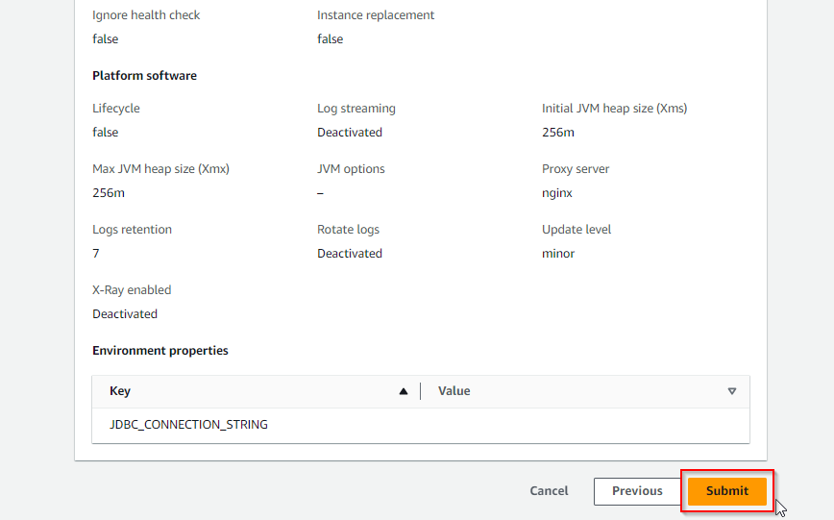

You will then be able to see the interface shown below:
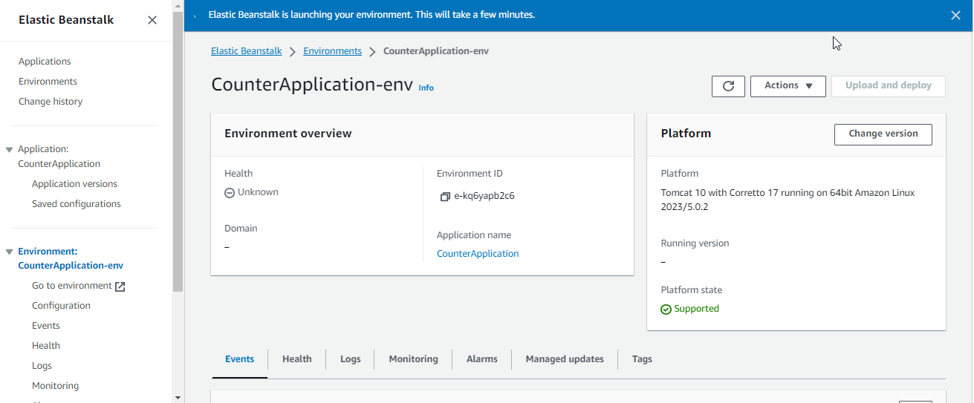
  - Once the environment is launched successfully, click on the Domain URL
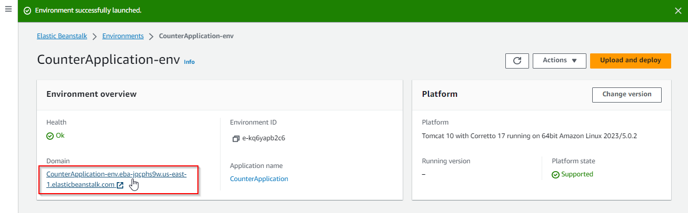

You will then be able to access the sample application deployed on Elastic Beanstalk as shown in the screenshot below:
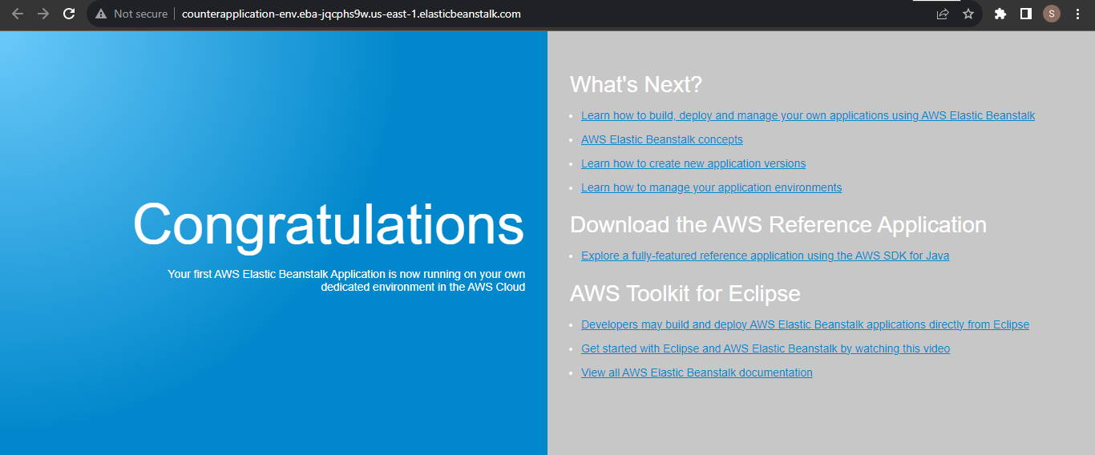
By following these steps, you have successfully set up a Java-based Elastic Beanstalk environment on AWS, which allows you to deploy and manage Java applications easily without the underlying infrastructure complexities.

