**EXPERIMENT 2**

**NAME: Aryan Karnwal**

**SAP : 500101796**

**AIM: Working with Docker (Basic Commands)**

**Steps to Complete:**

1. Search a Redis image on DockerHub



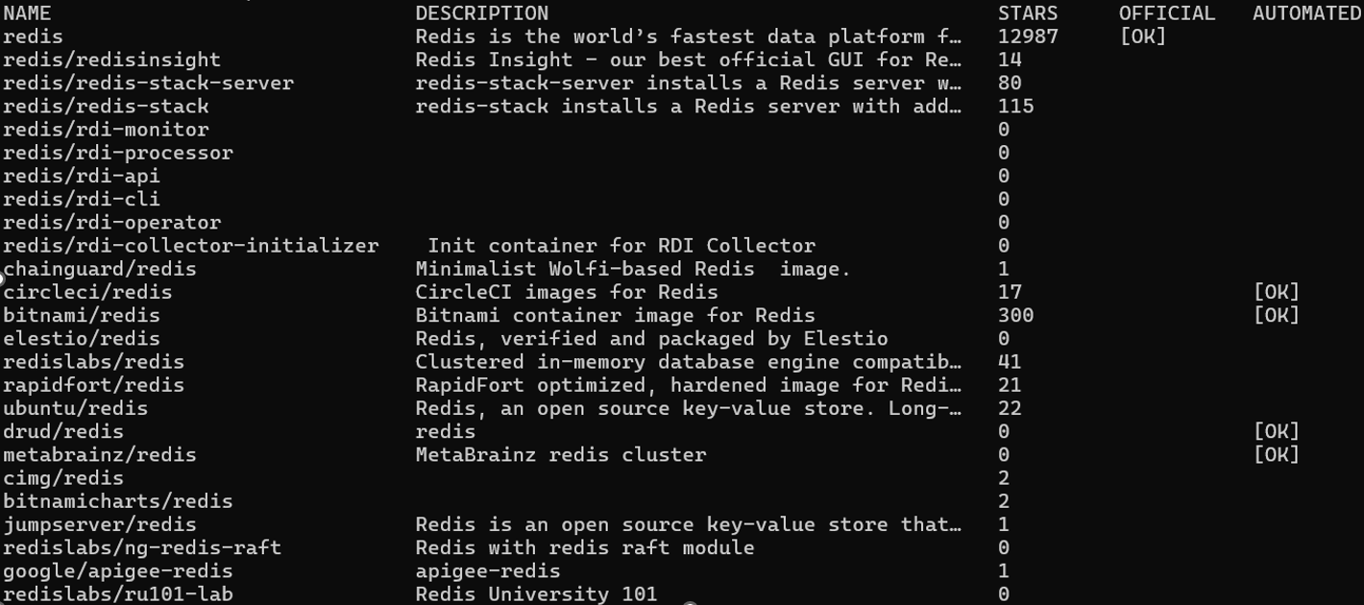

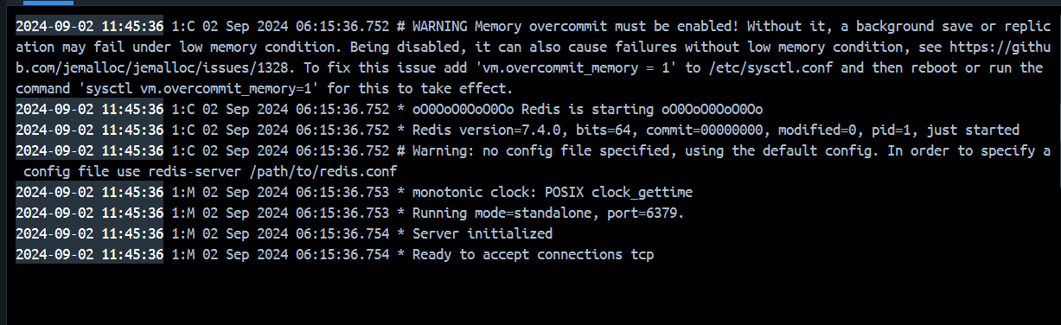

1. Run Docker Container of Redis Image in background



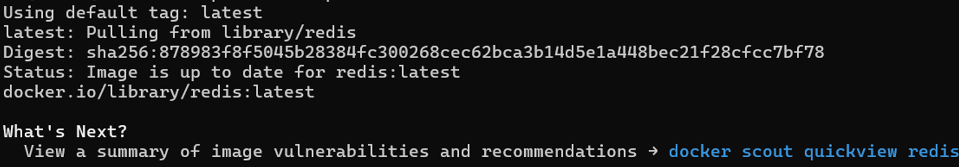

1. Run Docker PS and Docker PS –a
2. 







1. Run Docker Container and take its console



