**Name: Animesh Jain**

**Roll Number: R171218022**

**SAP ID: 500069453**

**Lab: 13**

**Docker Commands**

**Step1:** open your web browser and search katacoda

Or visit by clicking [here](https://www.katacoda.com/courses/docker/deploying-first-container)

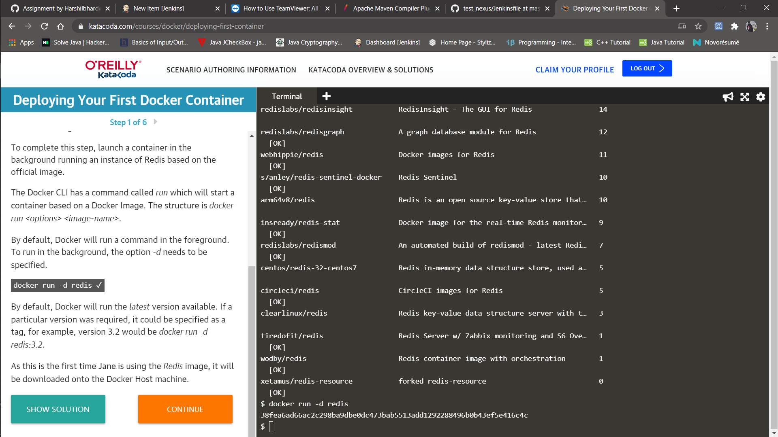

**Step2:** Move to the Step two of your katacoda practice of deploying your first container.

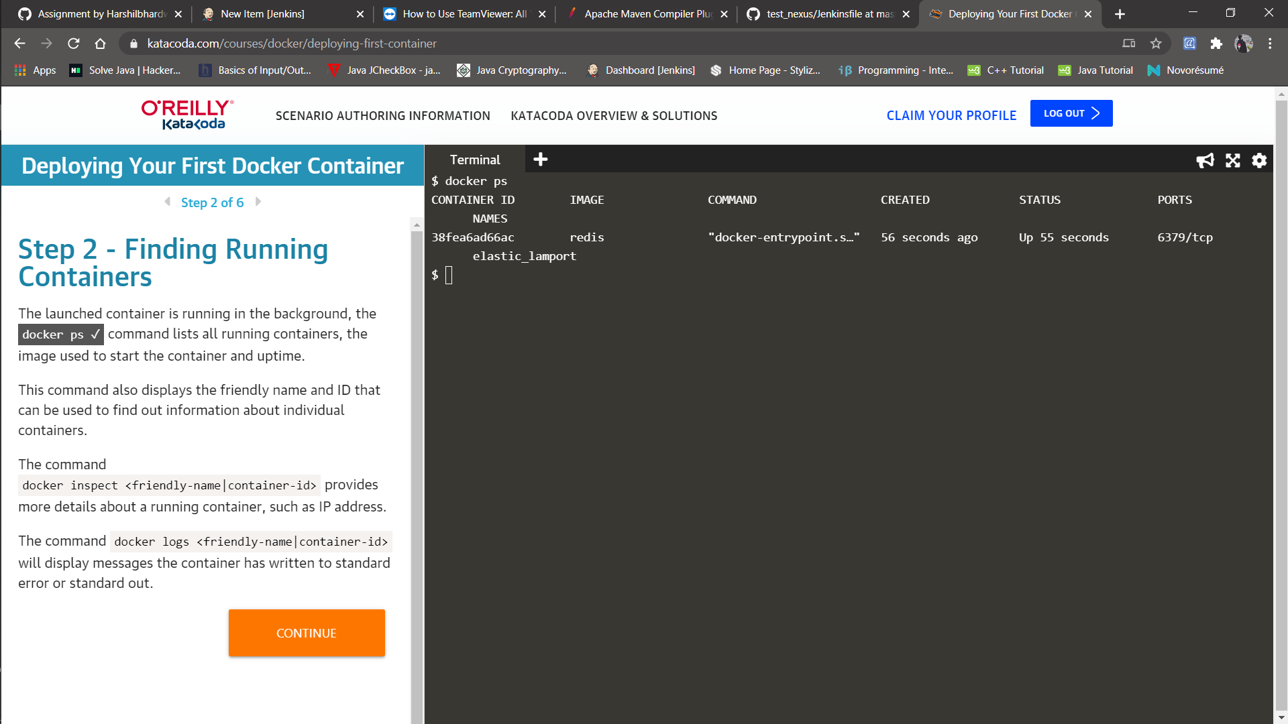

**Step3:**

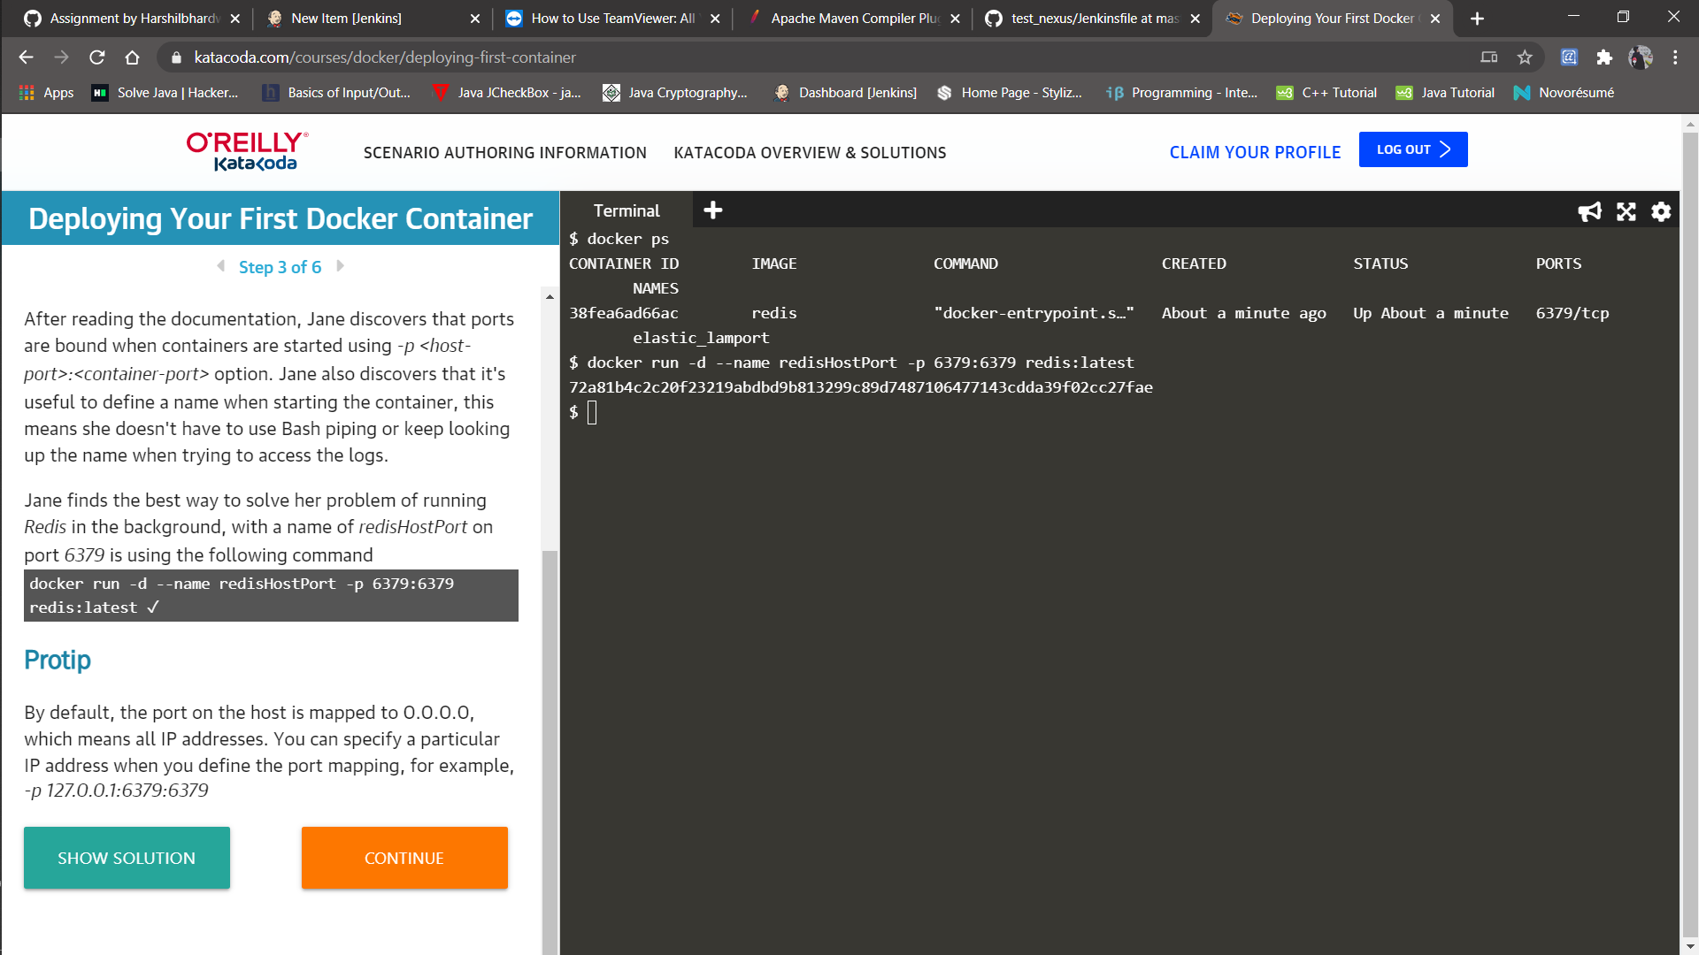

**Step4:**

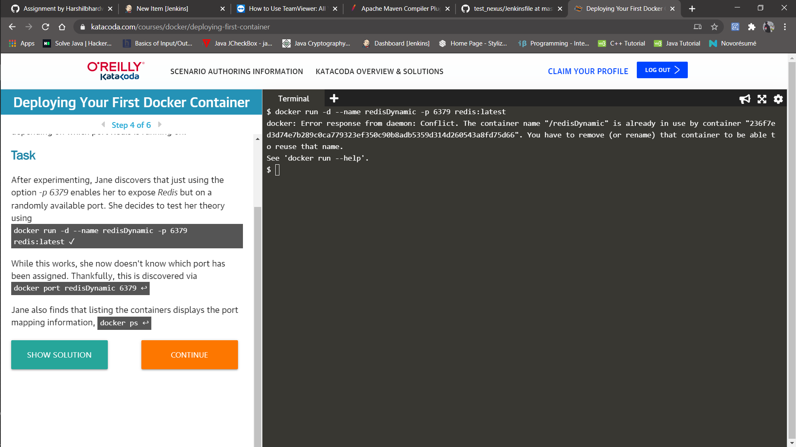

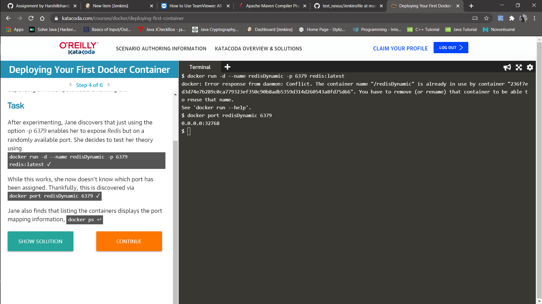

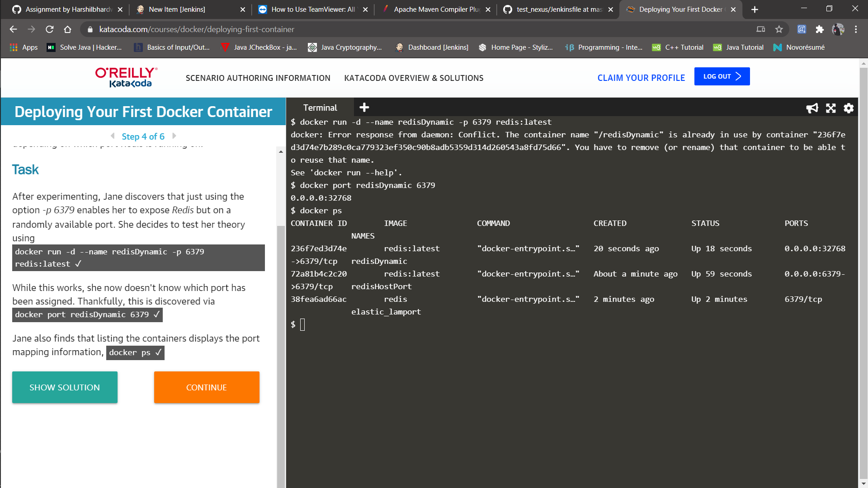

**Step-5:**

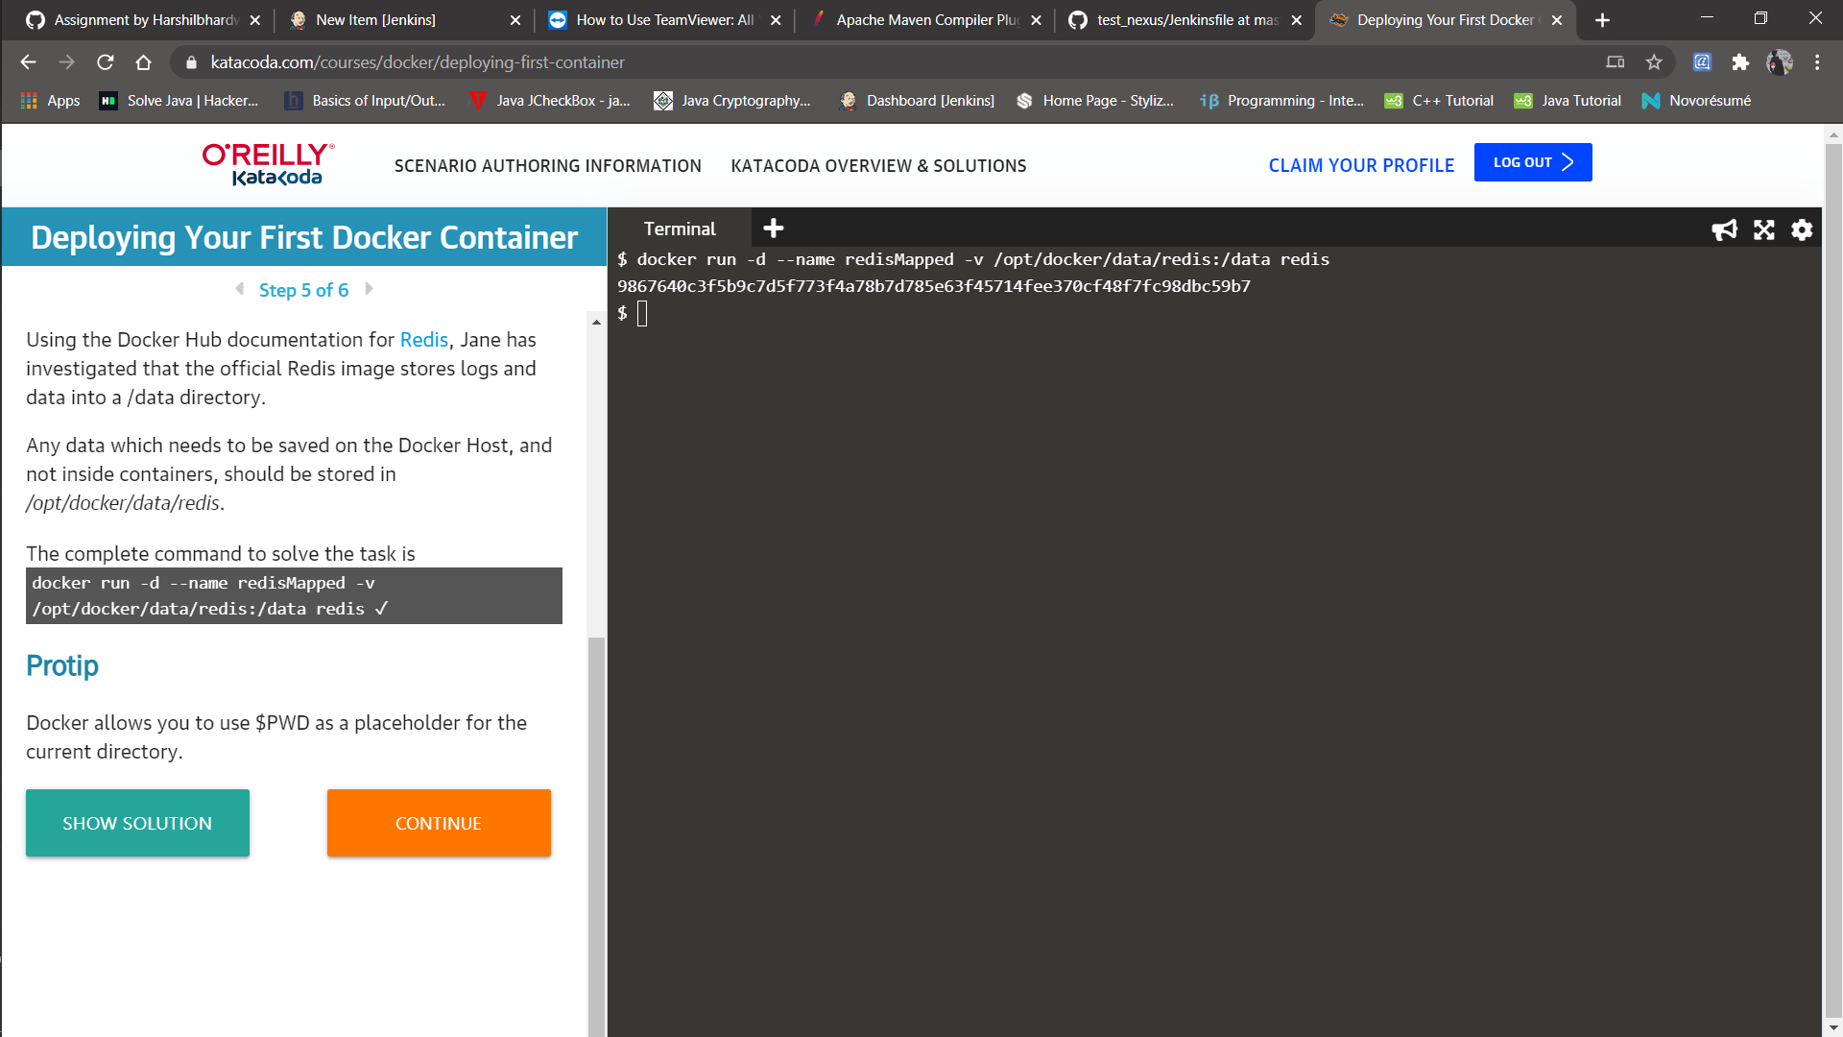

**Step-6:**

