**EXPERIMENT-14**

Ajay Kumar Tyagi  
500067403  
R171218008

**Aim:** To build custom Docker image of webserver using Dockerfile

1) Create a html file to deploy on webserver.  
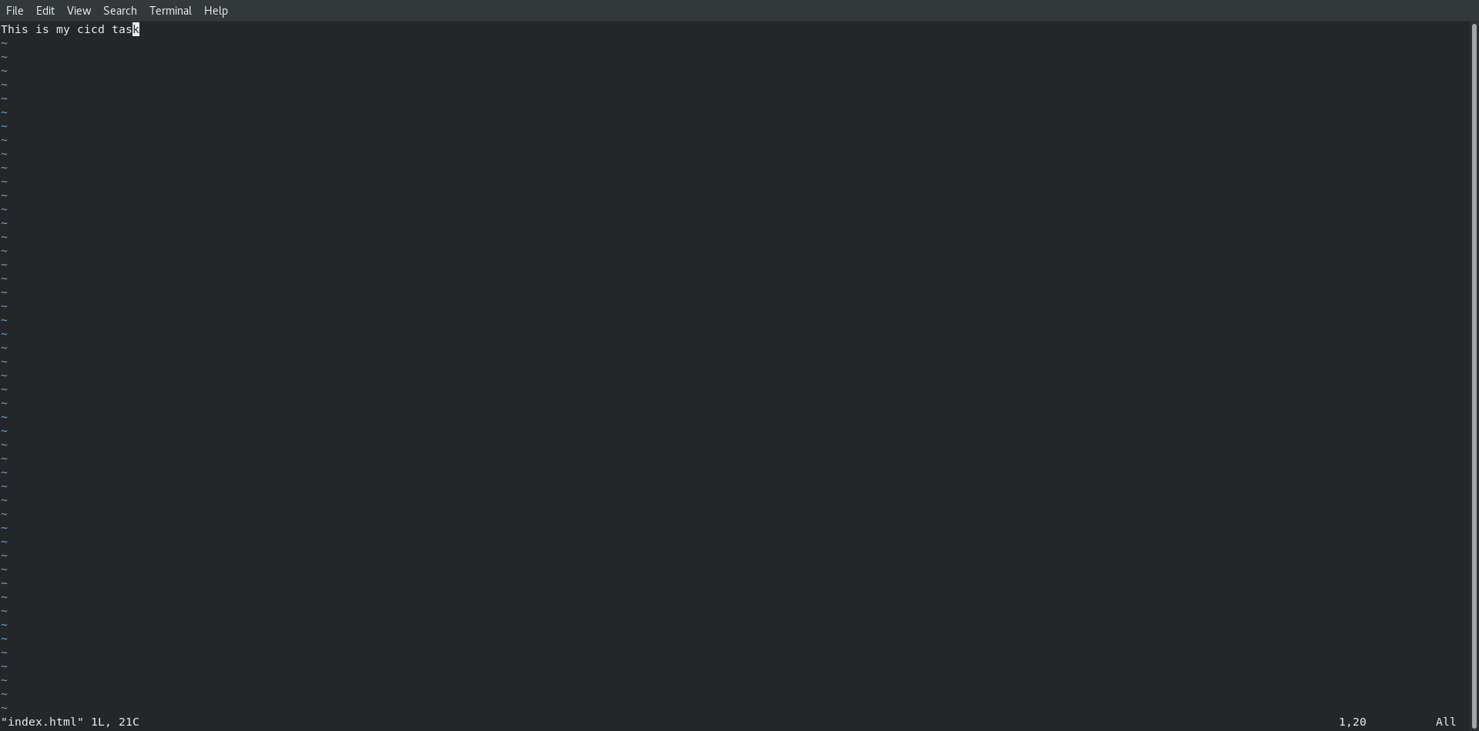

2) Create Dockerfile as shown below. We have create custom image from base image of httpd. And then to display html page on webserver we have copy our file in /usr/local/apache2/htdocs.  
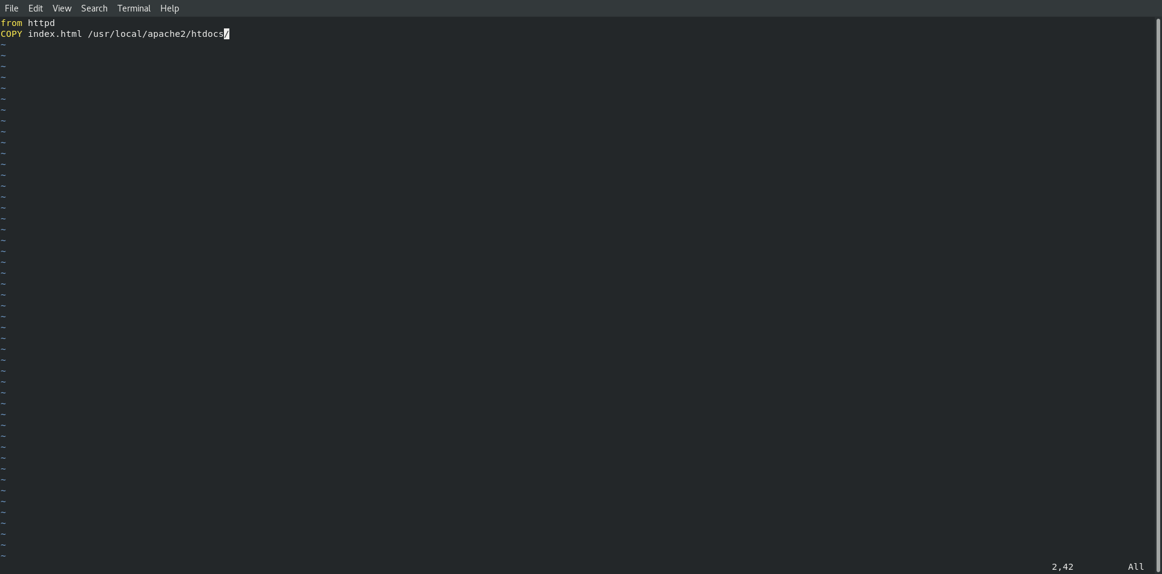

3) Now use command docker build –t <image-name> <path-of-Dockerfile> to build custom image.  
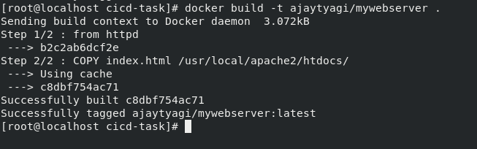

4) Use command docker push to push your image on DockerHub. For this your image should be names as <username/imagename> shown below.  
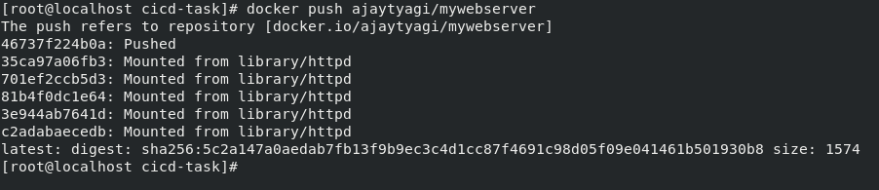

5) Now if everything runs successfully you could see your image on DockerHub.  
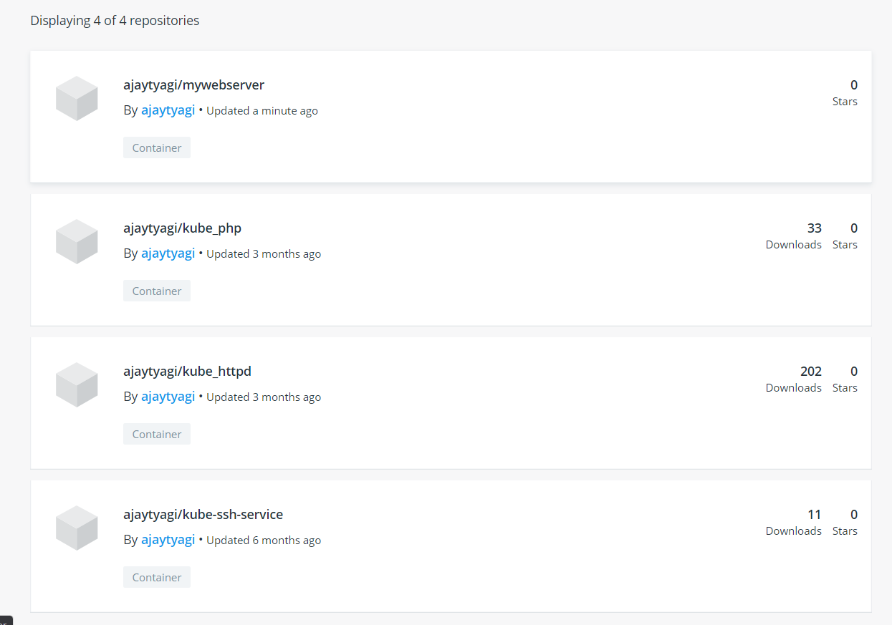

6) Now use command docker run –dit –p 8085:80 to run a container of your custom image and expose this container on 8085 port.  
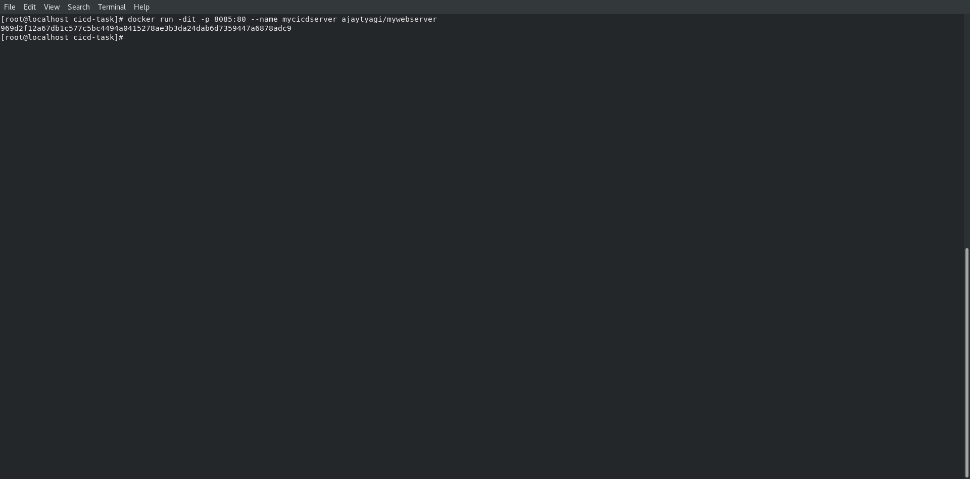

7) Now on a browser use IP and port 8085 to see the output.  
