**Name: Animesh Jain**

**Roll Number: R171218022**

**SAP ID: 500069453**

**Lab: 10**

**Step1:** Start and login to Jenkins

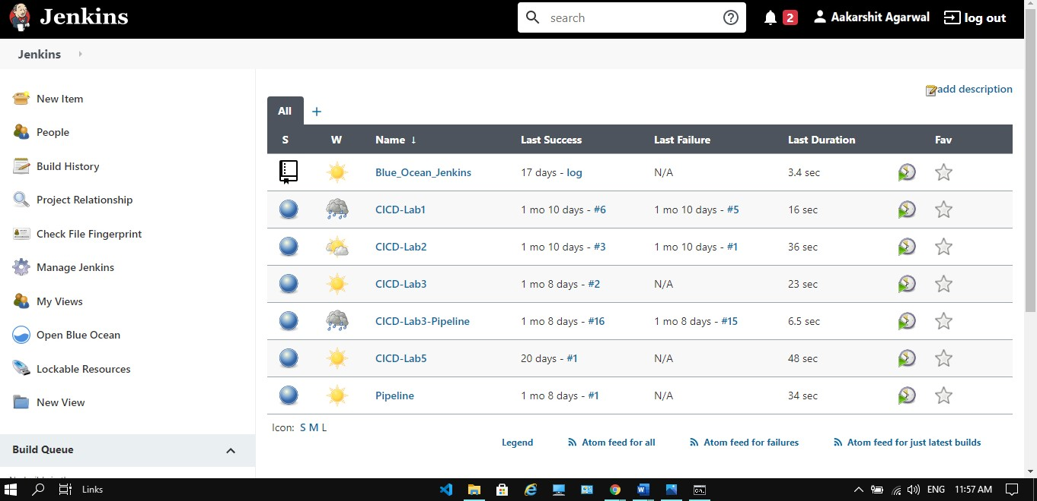

**Step2:** Install nexus plugin

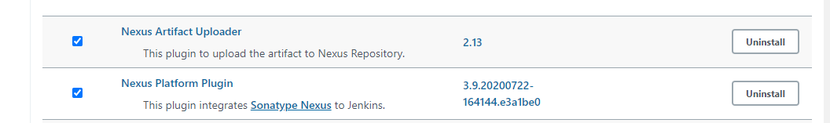

**Step3:** Then go to global tool configuration and provide JDK 8 path

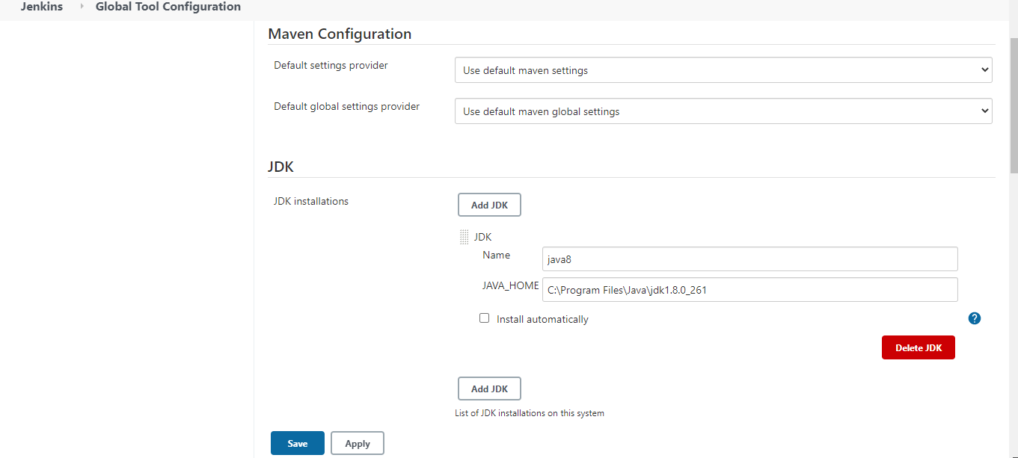

**Step4:** Provide Sonatype nexus details in Configure System

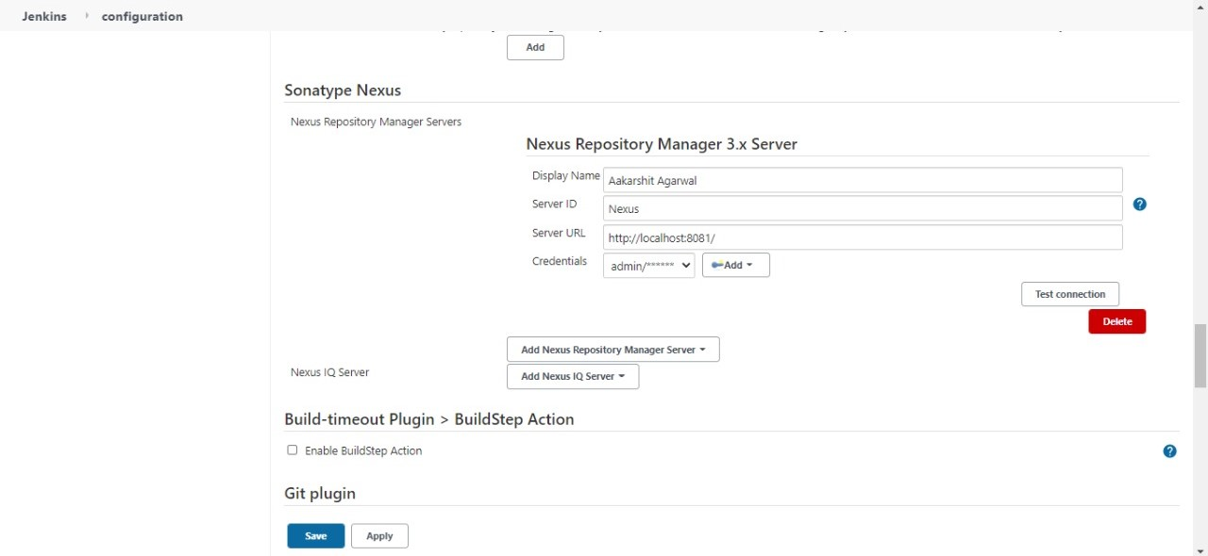

**Step5:** Make a new Project and provide the details.

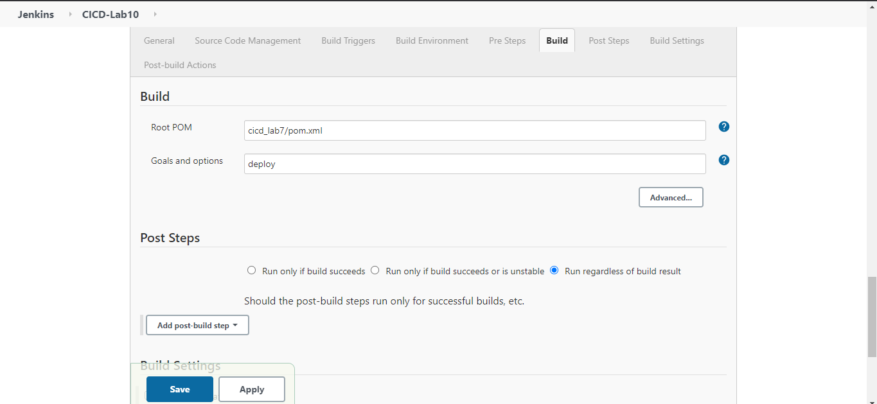

**Step6:** Build your Project

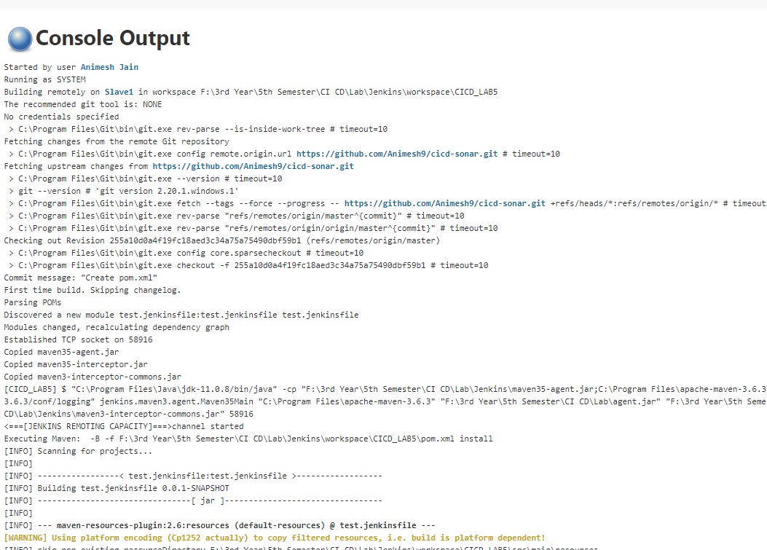

**Step7:** Check nexus for build artifact

