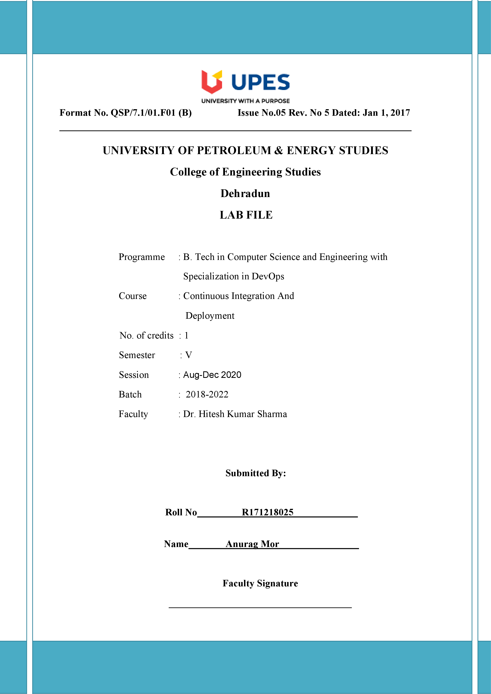In this experiment, we are going to create a Dockerfile in which we will specify the layers that will be used to build an image.

So, follow these steps below:

1. Let us check which images are currently available in our local machine.

**Command: sudo docker images**

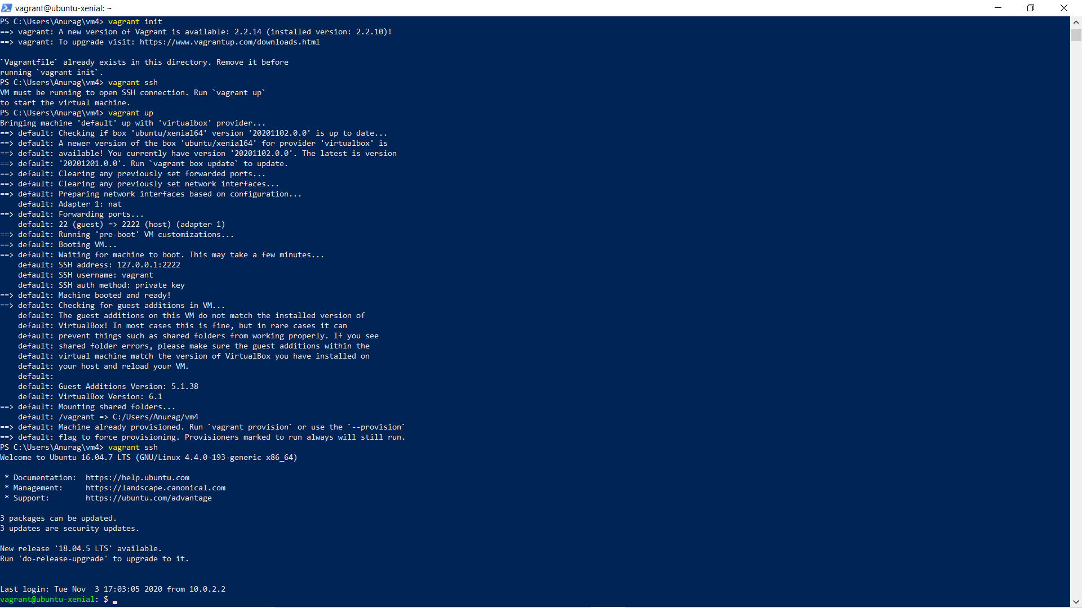

2. Create a Docker file in the directory. Name this file “Dockerfile”.

The first line specifies that nginx:alpine image will be used as the base image for our image.

The second line specifies that the contents of current directory will be copied in /usr/share/nginx/html directory.

3. Create a file named index.html with a simple hello world code as follows.

**Command: vim index.html**

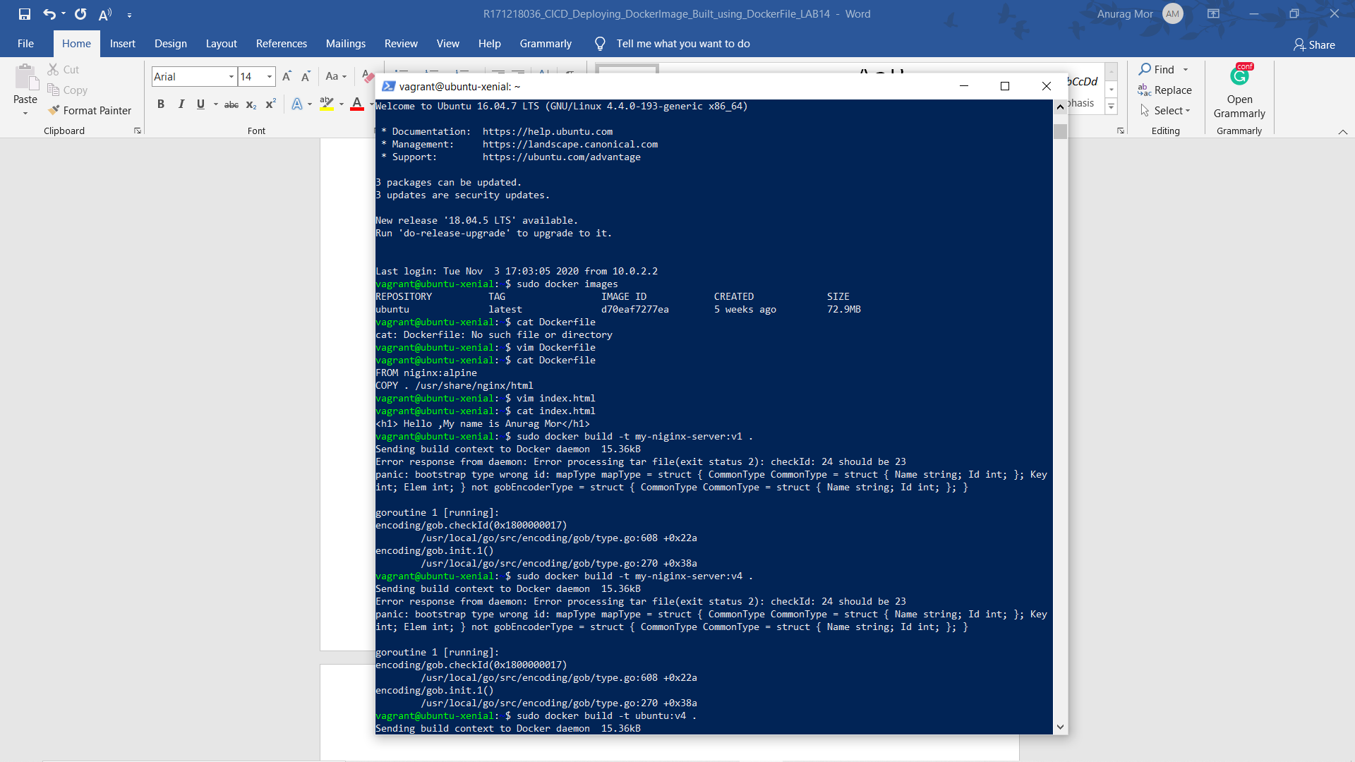

4. Now we are ready to build our Dockerfile to get the desired image in our local machine.

**Command: sudo docker build –t <image-name> .**

Here ‘.’ Specifies that the image will be built in current directory.

The image will be tagged with the specified name.

5. Let us verify that specified image is available now.

Command: **sudo docker images**

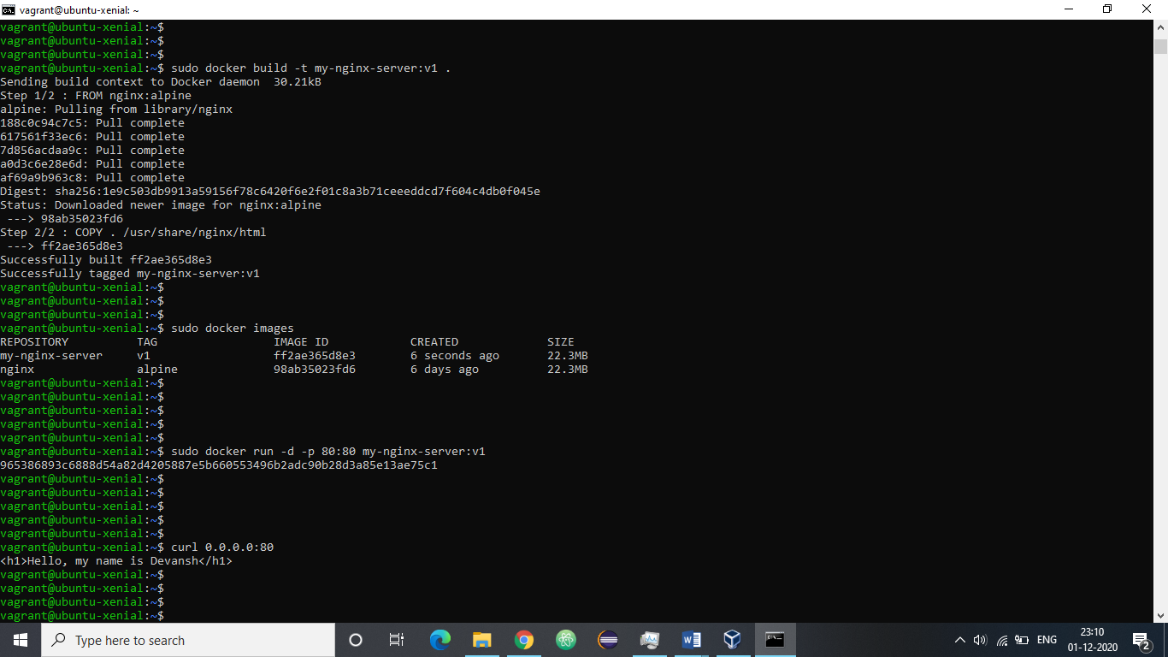

6. Let us run a container with this image to verify that the image is correctly formed.

**Command: sudo docker run –d –p 80:80 <image-name>**



7. Let us verify that intended working of the image is being fulfilled. For this, we can use the following command.

Command: curl 0.0.0.0:80

The above output specifies that the site is reachable.