**FINAL LAB ASSESSMENT**

* **Create a simple Maven Project and create its build using Jenkins dashboard.**

The steps to be followed are:

**1. Create a Maven Project in Eclipse.**

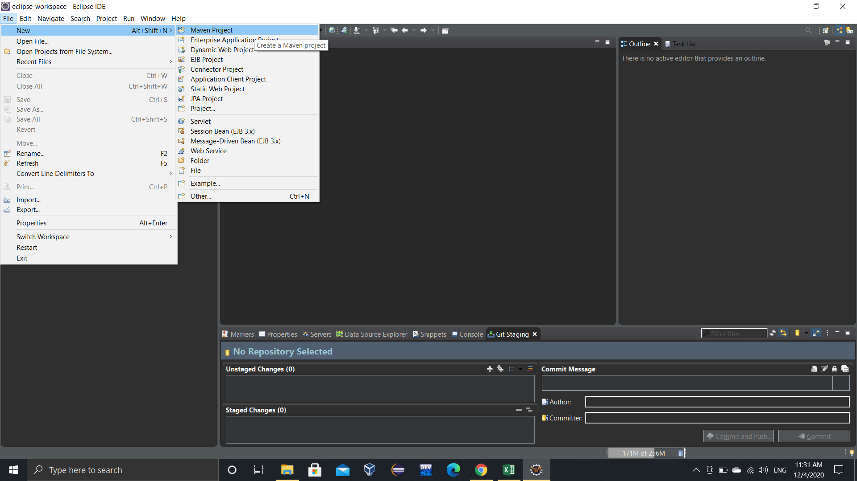

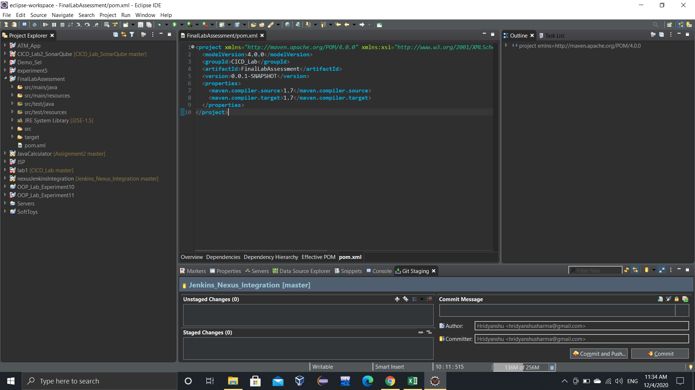

**2. Create a Java class in that project with some basic test code.**

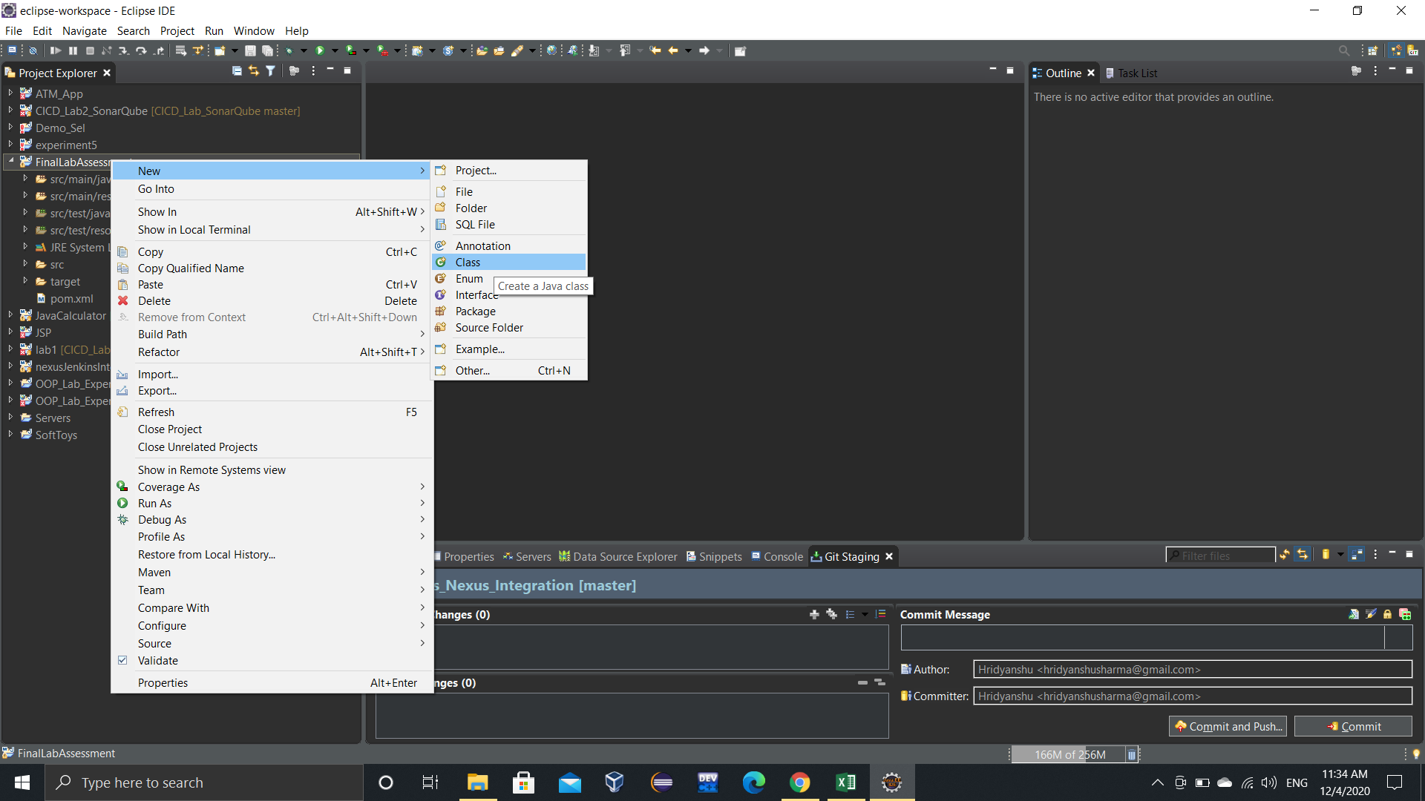

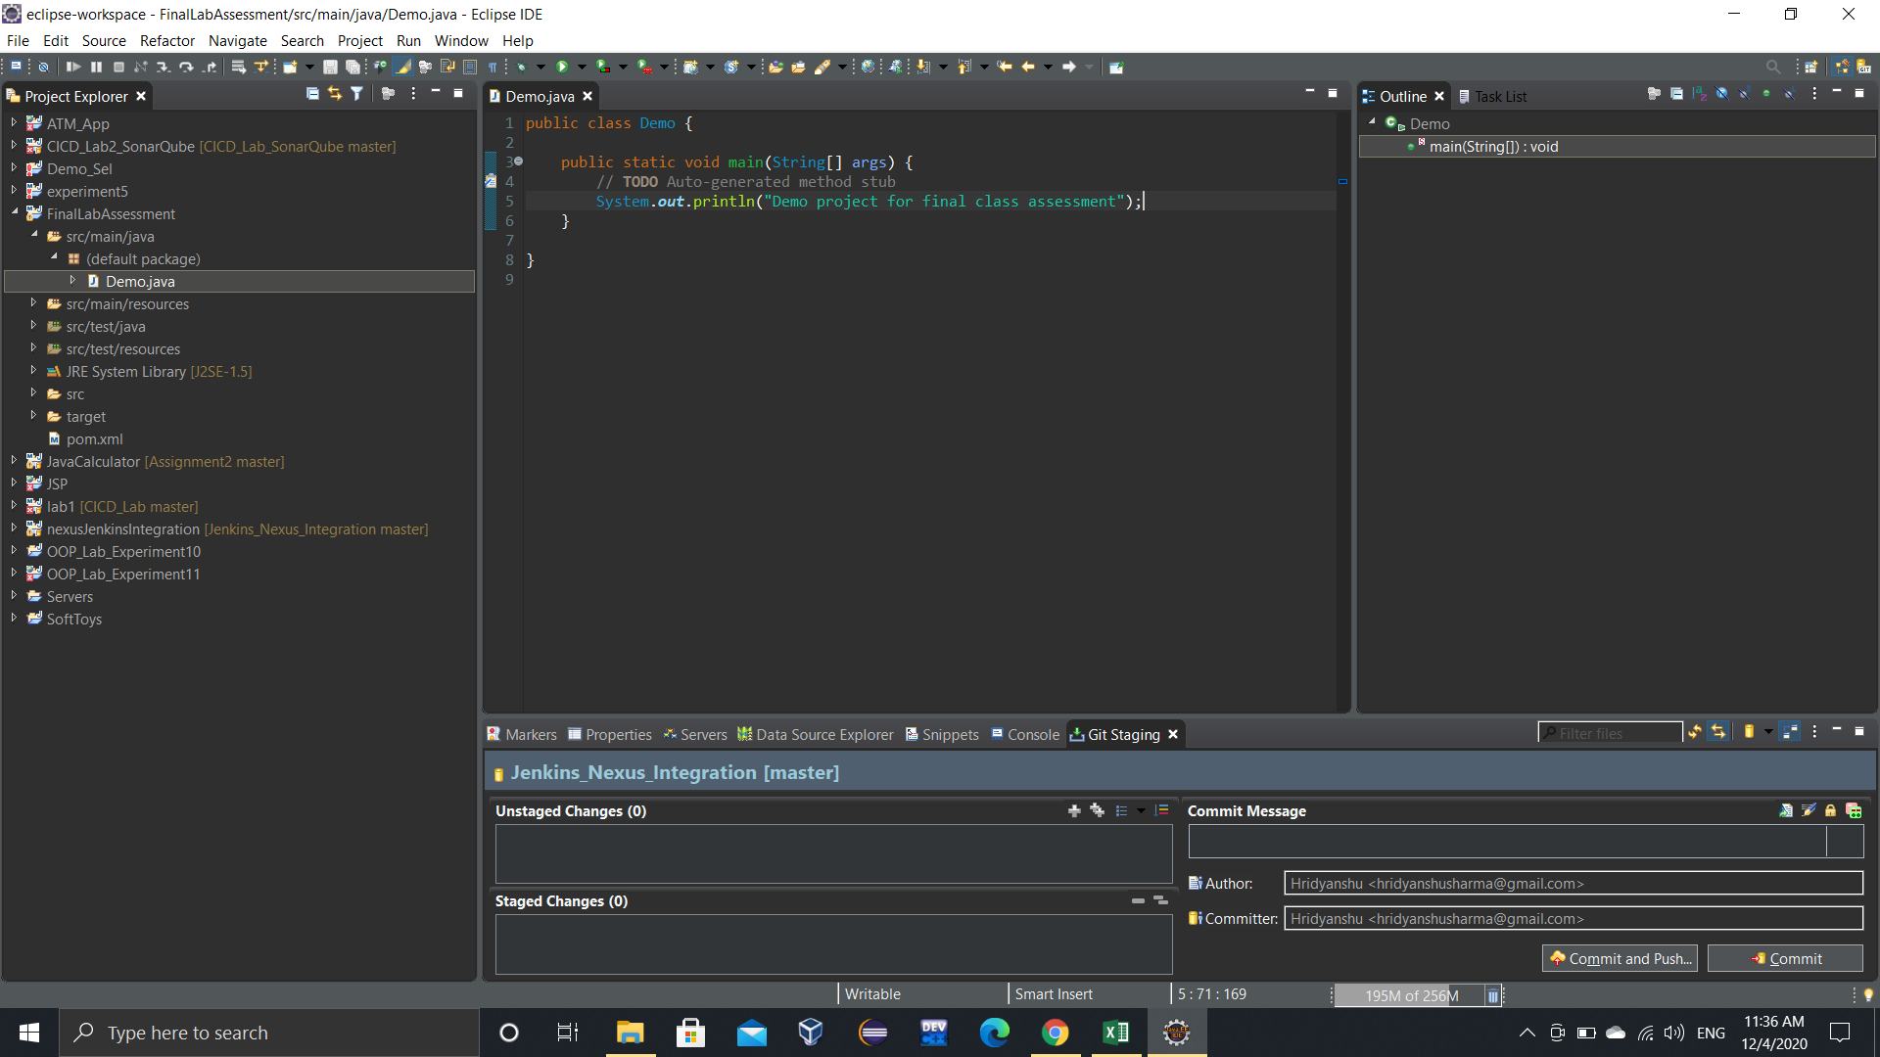

**3. Create a new GitHub repository.**

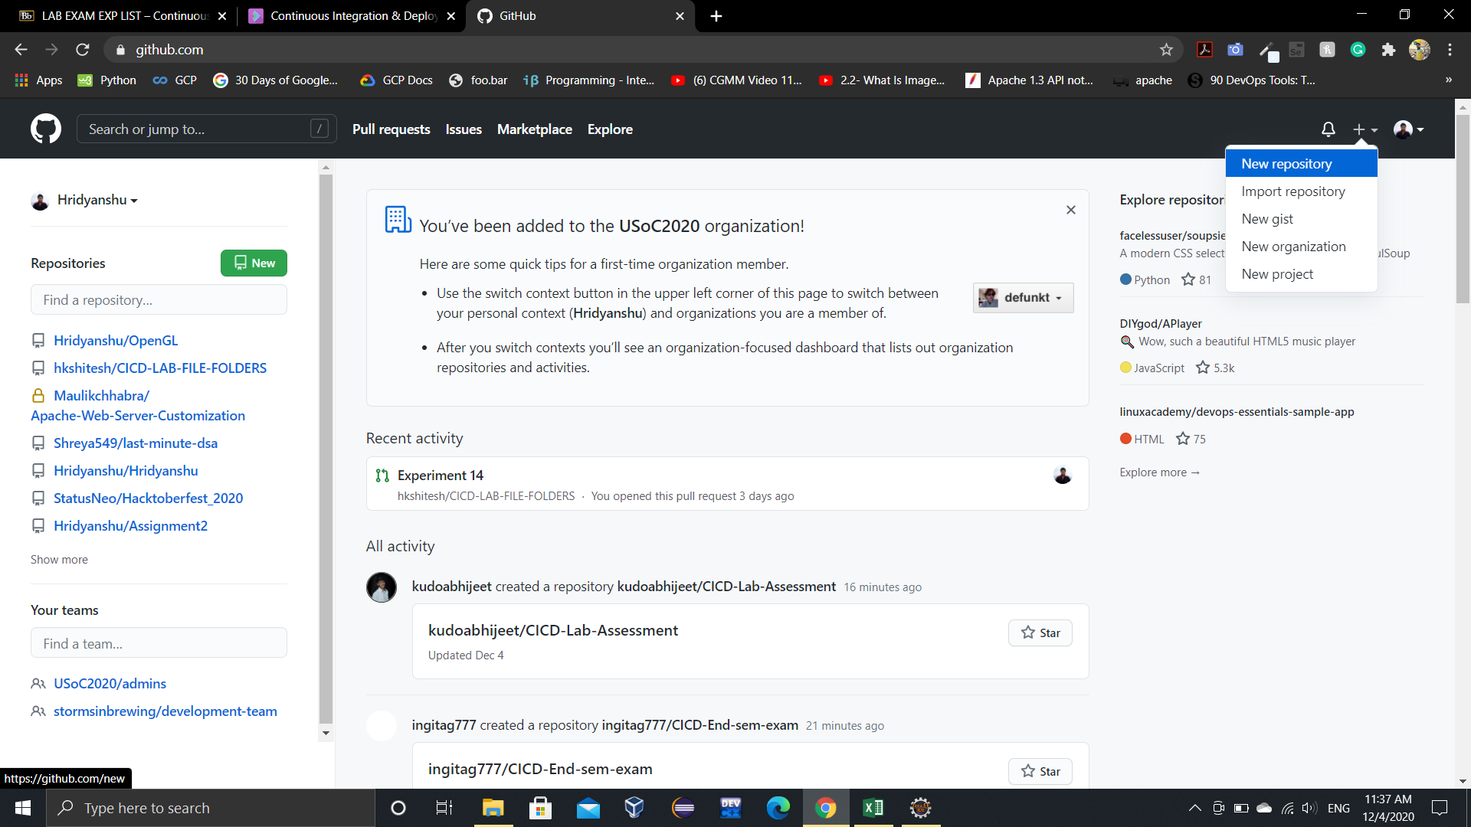

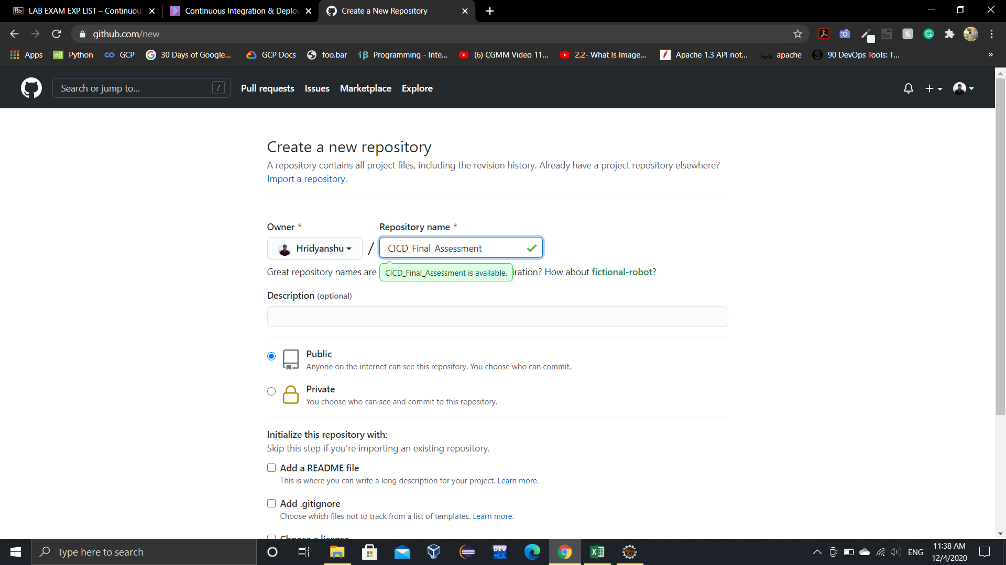

**4. Clone this repository in Eclipse.**

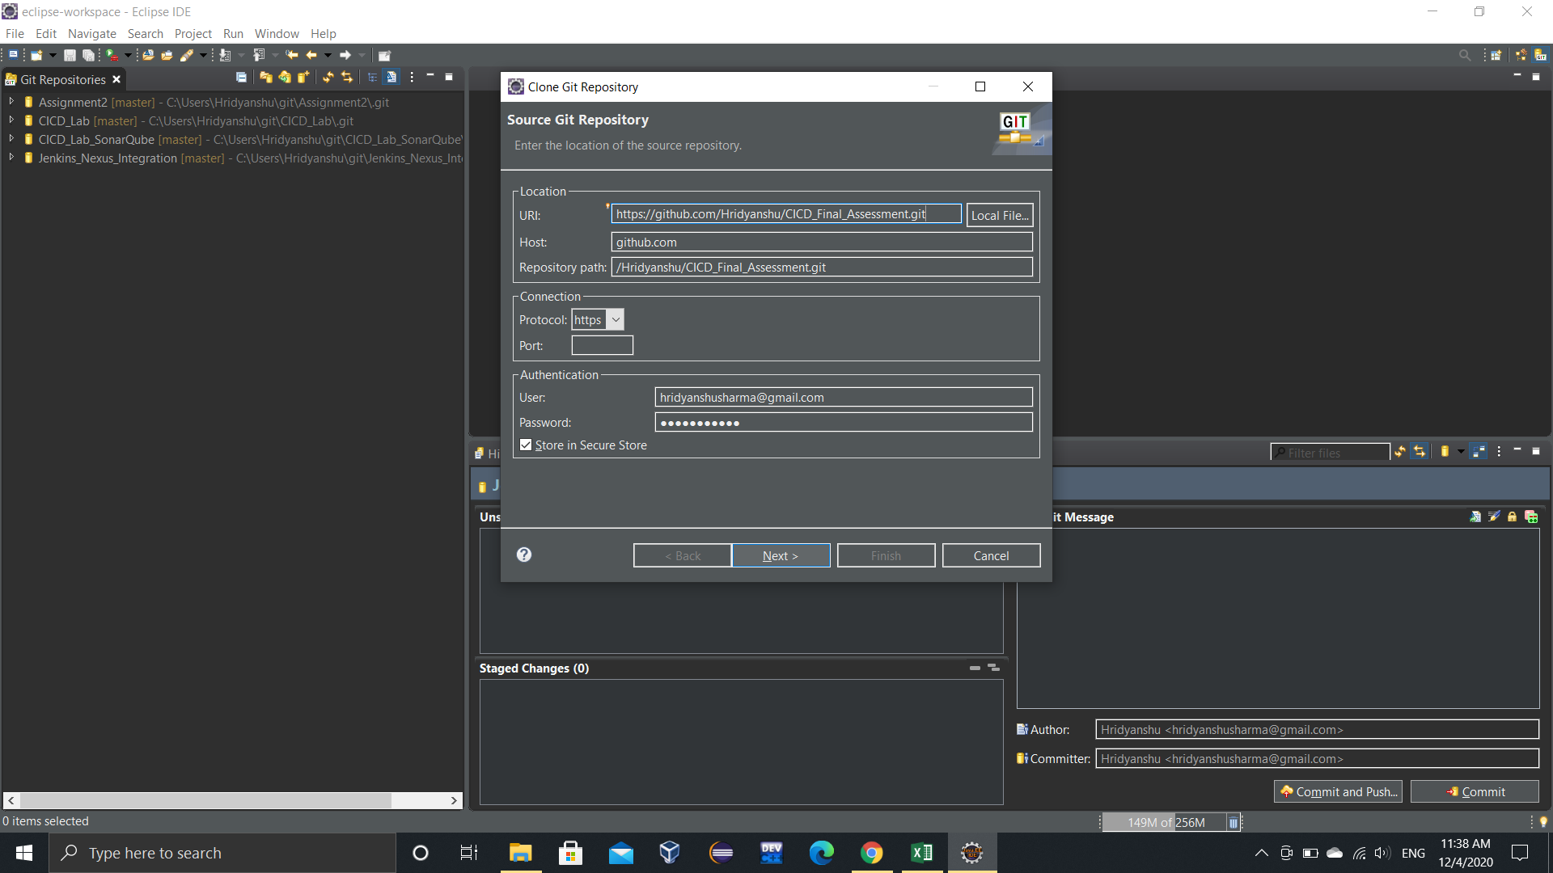

**5. Share the project to the newly cloned repository.**

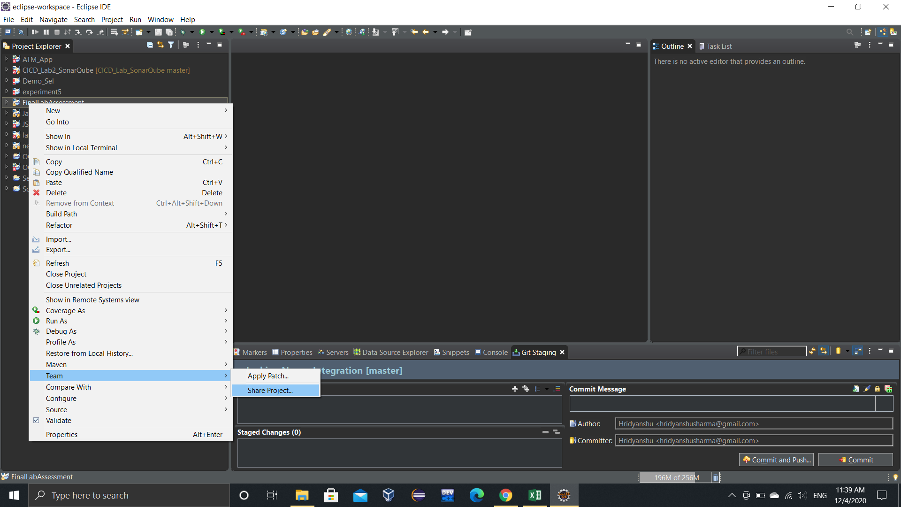

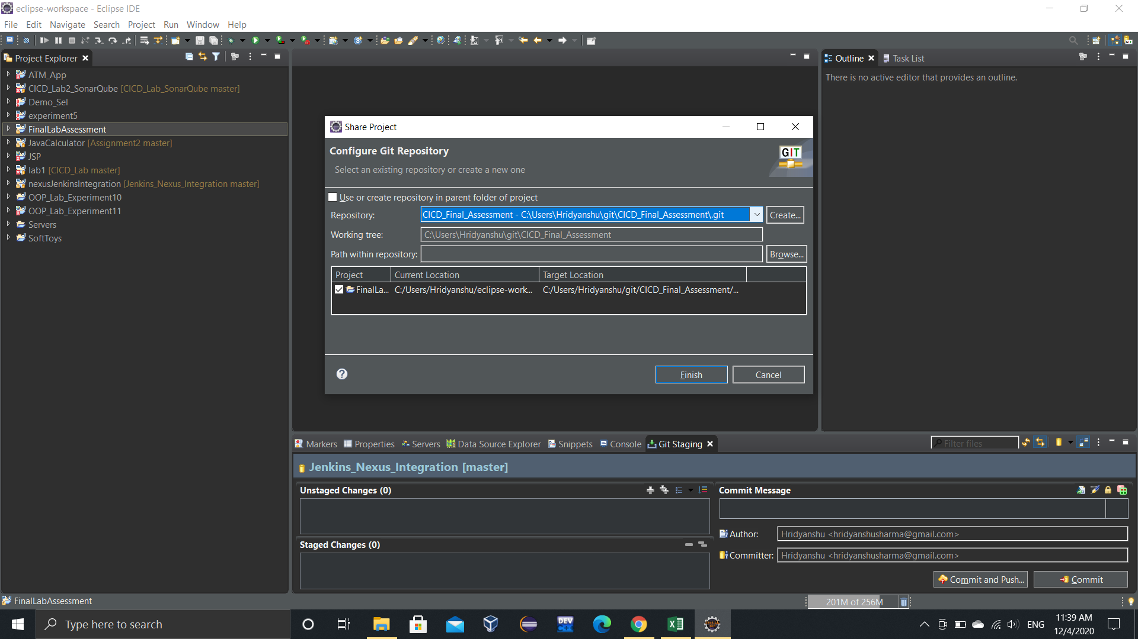

**6. Commit the changes and push them to GitHub.**

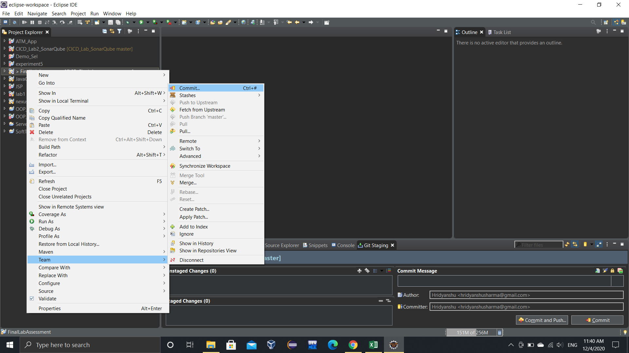

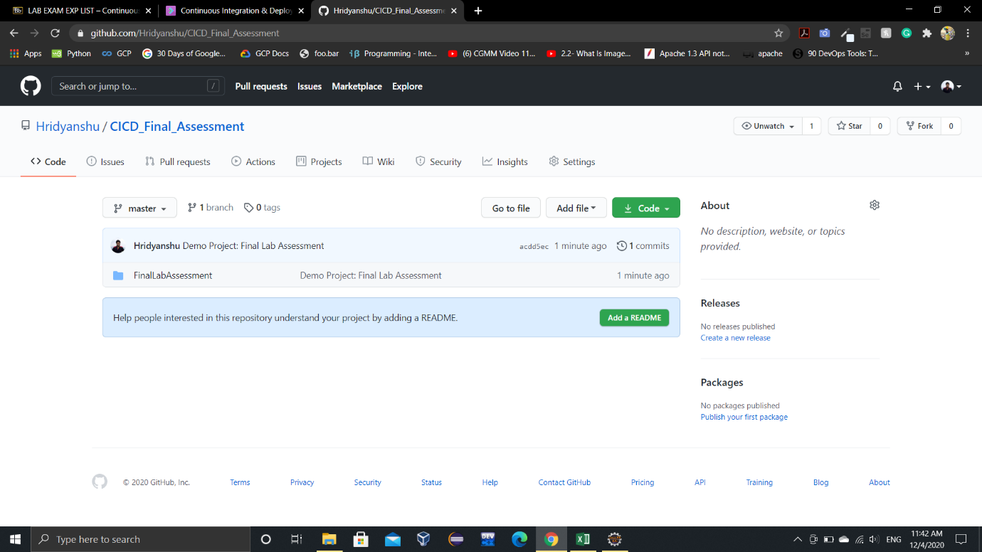

**7. Start Jenkins using the command: java –jar jenkins.war**

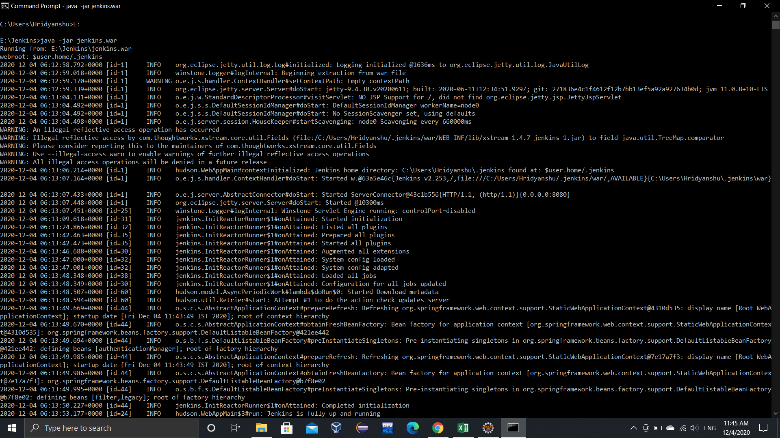

**8. Create a new Maven Project in Jenkins and provide the following configuration.**

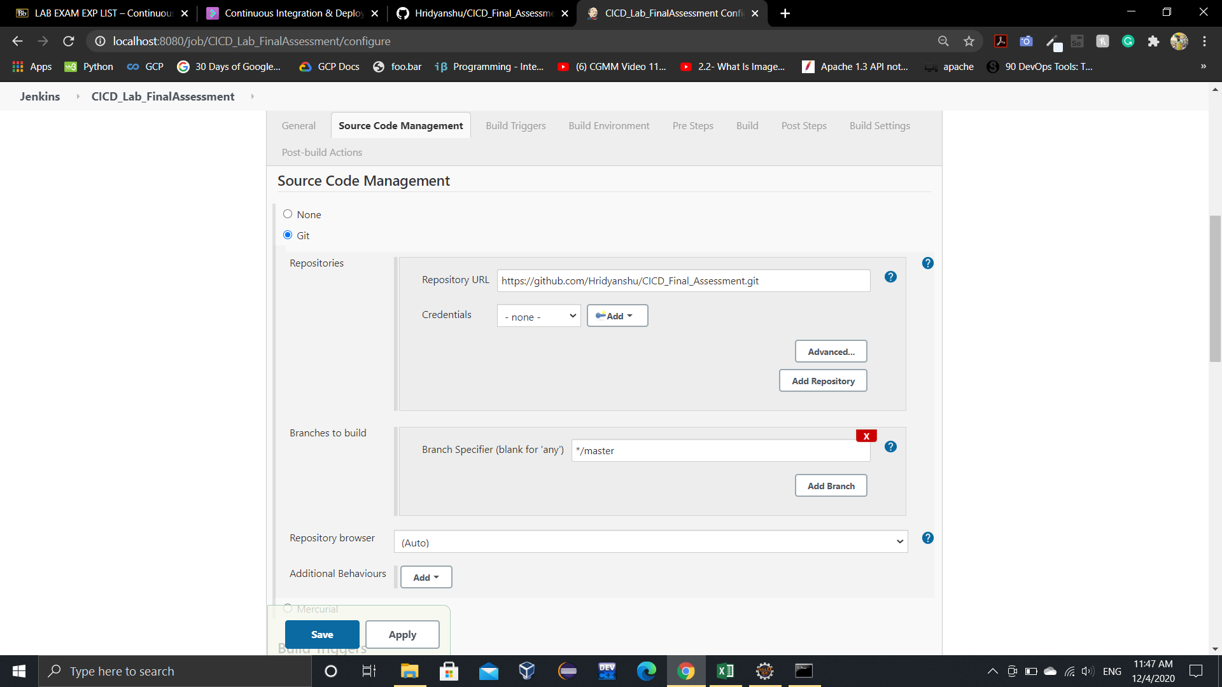

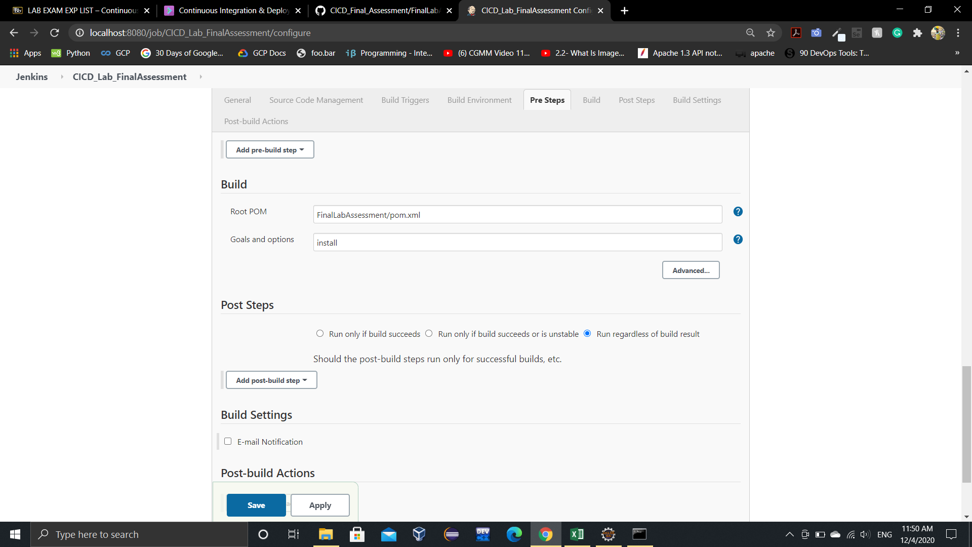

**9. Build the project.**

